Background GPS Route Tracking in Jetpack Compose with FusedLocationProviderClient and a Foreground Service
A CS5520 Final Tutorial Report Prepared by: An Nguyen Course: CS5520 — Mobile Application Development, Northeastern University (Summer 2026) Reference app: Roamly — https://github.com/aqn96/roamly

1. Introduction
Many mobile apps need to record where the user actually went — fitness trackers, delivery apps, and travel apps all log a GPS trail. Doing this correctly on Android requires two pieces that work together:
- FusedLocationProviderClient (from Google Play Services Location) — the modern, battery-aware API for receiving a stream of GPS fixes.
- A Foreground Service — so location keeps being logged while the user is in another app (e.g. navigating in Google Maps), with a persistent notification telling the user recording is active.
This report is a step-by-step tutorial for building exactly that: a feature that, on Start Trip, begins logging the device’s GPS path in the background, draws the route live, and saves it when the user taps Stop Trip. The working reference is Roamly, a travel app where contributing your own recorded routes unlocks recommendations from other travelers.
The report is organized as: why this utility is not part of the course (§2), background on the two APIs (§3), prerequisites (§4), a step-by-step implementation with code and screenshots (§5–6), a pointer to the full working app (§7), and a conclusion (§8).

2. Why this utility is not covered in the course
The eight course modules (docs/week1.pdf–week8.pdf) cover Kotlin, the Activity lifecycle, Jetpack Compose, Navigation, ViewModel/StateFlow, Notifications, runtime permissions, BroadcastReceiver, LazyColumn, and Retrofit networking. Neither the Google Play Services Location APIs (FusedLocationProviderClient) nor Android Service / Foreground Services appear anywhere in the course.
Course Week | Topic | Related but different
Week 6 | ViewModel, StateFlow, Notifications, runtime permissions, BroadcastReceiver | Teaches NotificationChannel and ActivityResultContracts.RequestPermission — but only for status-bar alerts, never tied to a Service or to location
Week 8 | Retrofit networking | Background work via coroutines, but no Service and no location
So while this tutorial reuses two course building blocks (a runtime-permission request and a notification channel), its novel core — receiving GPS updates with FusedLocationProviderClient inside a Service that runs in the foreground — is entirely new material.

3. Background: the two APIs
FusedLocationProviderClient fuses GPS, Wi-Fi, and cell signals into a single location stream. You describe what you want with a LocationRequest (update interval, priority/accuracy, minimum distance) and receive results through a LocationCallback. It lives in the com.google.android.gms:play-services-location artifact.
A Foreground Service is an Android Service promoted to “foreground” with startForeground(...), which requires an ongoing notification. The OS treats it as user-visible work and won’t casually kill it — essential for continuous location logging while the user is elsewhere.
The challenge that ties them together: a Service and the Compose UI are separate lifecycles, so we need a way to share the growing list of GPS points between them. We solve that with a process-wide StateFlow (§5.4).

4. Prerequisites
- Android Studio (recent stable), a device/emulator on API 28+.
- A Jetpack Compose project (the course’s standard setup).
- On an emulator, simulate movement with Extended Controls → Location or adb emu geo fix <lon> <lat>.

5. Step-by-step implementation

5.1 Add the dependency
In the version catalog (gradle/libs.versions.toml) and the app build.gradle.kts:
// libs.versions.toml
playServicesLocation = "21.3.0"
play-services-location = { group = "com.google.android.gms", name = "play-services-location", version.ref = "playServicesLocation" }
// app/build.gradle.kts — dependencies { }
implementation(libs.play.services.location)

5.2 Declare permissions and the service in AndroidManifest.xml
<!-- GPS route logging -->
<uses-permission android:name="android.permission.ACCESS_FINE_LOCATION" />
<uses-permission android:name="android.permission.ACCESS_COARSE_LOCATION" />
<!-- Foreground Service keeps logging while another app is in front -->
<uses-permission android:name="android.permission.FOREGROUND_SERVICE" />
<uses-permission android:name="android.permission.FOREGROUND_SERVICE_LOCATION" />
<!-- Android 13+ runtime permission for the ongoing notification -->
<uses-permission android:name="android.permission.POST_NOTIFICATIONS" />
<application ...>
<service
android:name=".location.TripLocationService"
android:exported="false"
android:foregroundServiceType="location" />
</application>
FOREGROUND_SERVICE_LOCATION and android:foregroundServiceType="location" are required on Android 14+ for a location-typed foreground service.

5.3 Model a single GPS sample
// data/TrackPoint.kt — one recorded GPS sample; a trip is an ordered list of these.
data class TrackPoint(
val latitude: Double,
val longitude: Double,
val timestampMs: Long,
)

5.4 A process-wide source of truth (StateFlow)
The Service writes points here; the UI observes them. A single object gives the Service and the UI one shared stream without dependency injection:
// location/TripSession.kt
object TripSession {
private val _points = MutableStateFlow<List<TrackPoint>>(emptyList())
val points: StateFlow<List<TrackPoint>> = _points.asStateFlow()
private val _isRecording = MutableStateFlow(false)
val isRecording: StateFlow<Boolean> = _isRecording.asStateFlow()
var startElapsedMs: Long = 0L; private set
fun begin() { _points.value = emptyList(); startElapsedMs = SystemClock.elapsedRealtime(); _isRecording.value = true }
fun addPoint(p: TrackPoint) { _points.update { it + p } } // new list -> StateFlow emits
fun end() { _isRecording.value = false }
/** Great-circle route length in metres. */
fun distanceMeters(pts: List<TrackPoint> = _points.value): Double {
if (pts.size < 2) return 0.0
var total = 0.0; val out = FloatArray(1)
for (i in 1 until pts.size) {
Location.distanceBetween(pts[i-1].latitude, pts[i-1].longitude, pts[i].latitude, pts[i].longitude, out)
total += out[0]
}
return total
}
}

5.5 The Foreground Service
This is the heart of the tutorial — a Service that requests location updates and feeds each fix into TripSession, while showing a persistent notification:
// location/TripLocationService.kt
class TripLocationService : Service() {
private lateinit var fusedClient: FusedLocationProviderClient
private val locationCallback = object : LocationCallback() {
override fun onLocationResult(result: LocationResult) {
result.locations.forEach { loc ->
TripSession.addPoint(TrackPoint(loc.latitude, loc.longitude, System.currentTimeMillis()))
}
}
}
override fun onCreate() {
super.onCreate()
fusedClient = LocationServices.getFusedLocationProviderClient(this)
}
@SuppressLint("MissingPermission") // permission verified by the UI before starting the service
override fun onStartCommand(intent: Intent?, flags: Int, startId: Int): Int {
startAsForeground()
val request = LocationRequest.Builder(Priority.PRIORITY_HIGH_ACCURACY, 4000L)
.setMinUpdateIntervalMillis(2000L)
.setMinUpdateDistanceMeters(5f)
.build()
fusedClient.requestLocationUpdates(request, locationCallback, Looper.getMainLooper())
return START_STICKY // restart if the OS kills us
}
override fun onDestroy() {
fusedClient.removeLocationUpdates(locationCallback)
super.onDestroy()
}
override fun onBind(intent: Intent?): IBinder? = null
private fun startAsForeground() {
val channel = NotificationChannel("trip_recording", "Trip Recording", NotificationManager.IMPORTANCE_LOW)
getSystemService(NotificationManager::class.java).createNotificationChannel(channel)
val notification = NotificationCompat.Builder(this, "trip_recording")
.setContentTitle("Roamly is recording your route")
.setContentText("Logging your path in the background 🛰")
.setSmallIcon(android.R.drawable.ic_menu_mylocation)
.setOngoing(true)
.build()
if (Build.VERSION.SDK_INT >= Build.VERSION_CODES.Q) {
ServiceCompat.startForeground(this, 2001, notification, ServiceInfo.FOREGROUND_SERVICE_TYPE_LOCATION)
} else {
ServiceCompat.startForeground(this, 2001, notification, 0)
}
}
}

5.6 Request location permission at runtime (Compose)
Before starting the service, ask for permission with the course’s rememberLauncherForActivityResult pattern (one of the reused building blocks):
// in LocationPermissionScreen.kt
val permissionLauncher = rememberLauncherForActivityResult(
ActivityResultContracts.RequestMultiplePermissions()
) { onAllowClicked() } // proceed once the user responds
val requested = buildList {
add(Manifest.permission.ACCESS_FINE_LOCATION)
add(Manifest.permission.ACCESS_COARSE_LOCATION)
if (Build.VERSION.SDK_INT >= Build.VERSION_CODES.TIRAMISU) add(Manifest.permission.POST_NOTIFICATIONS)
}.toTypedArray()
Button(onClick = { permissionLauncher.launch(requested) }) { Text("Allow Location Access") }
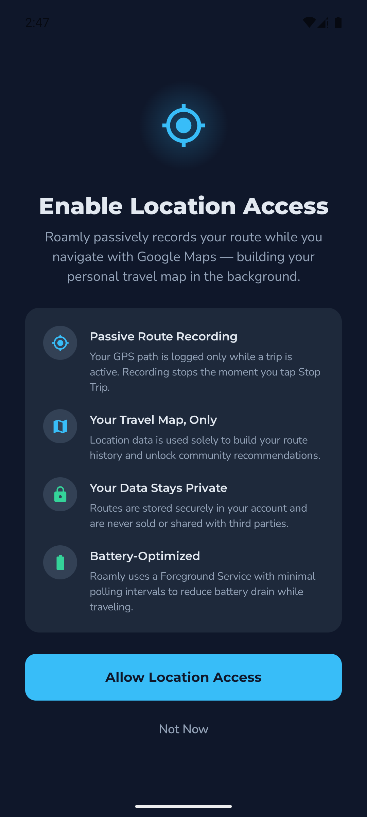
Location permission rationale screen

5.7 Start/stop the service from a ViewModel
The ViewModel launches the Foreground Service and exposes the live route + a derived distance as StateFlow (course Topic 6 pattern), so the UI just observes:
// ui/screens/trip/TripViewModel.kt
class TripViewModel : ViewModel() {
val routePoints: StateFlow<List<TrackPoint>> = TripSession.points
val isRecording: StateFlow<Boolean> = TripSession.isRecording
val distanceKm: StateFlow<Double> = TripSession.points
.map { TripSession.distanceMeters(it) / 1000.0 }
.stateIn(viewModelScope, SharingStarted.WhileSubscribed(5_000), 0.0)
fun startTrip(context: Context) {
if (isRecording.value) return
TripSession.begin()
ContextCompat.startForegroundService(context, Intent(context, TripLocationService::class.java))
}
fun stopTrip(context: Context) {
TripSession.end()
context.stopService(Intent(context, TripLocationService::class.java))
}
}

5.8 Render the live route with a Compose Canvas
The screen observes the ViewModel with collectAsStateWithLifecycle(), starts the service on first composition, and draws the points as a polyline. (Drawing on a Canvas keeps the app on Firebase’s free tier — in production this would be a Google Maps Polyline; the recorded data is identical.)
@Composable
fun ActiveTripScreen(tripViewModel: TripViewModel = viewModel()) {
val context = LocalContext.current
val routePoints by tripViewModel.routePoints.collectAsStateWithLifecycle()
LaunchedEffect(Unit) { tripViewModel.startTrip(context) } // begin logging when shown
// ... draw routePoints as connected lines on a Canvas (normalised to the box) ...
}
Canvas(modifier = Modifier.fillMaxSize().padding(28.dp)) {
val minLat = points.minOf { it.latitude }; val maxLat = points.maxOf { it.latitude }
val minLng = points.minOf { it.longitude }; val maxLng = points.maxOf { it.longitude }
val offsets = points.map {
Offset(
(((it.longitude - minLng) / (maxLng - minLng)) * size.width).toFloat(),
((1.0 - (it.latitude - minLat) / (maxLat - minLat)) * size.height).toFloat(), // flip Y (north = up)
)
}
for (i in 1 until offsets.size) drawLine(RoamlyElectric, offsets[i-1], offsets[i], strokeWidth = 10f, cap = StrokeCap.Round)
offsets.lastOrNull()?.let { drawCircle(RoamlyAurora, radius = 14f, center = it) }
}

6. Running it
- Tap Start Trip → grant Location (and, on Android 13+, Notification) permission.
- Move the device (or play a route on the emulator). The blue polyline draws live; duration, distance, and speed update in real time; the ongoing notification confirms background recording.
- Tap Stop Trip → the service stops and the recorded route + stats are shown.
Active recording (live polyline) | Trip summary (saved route)
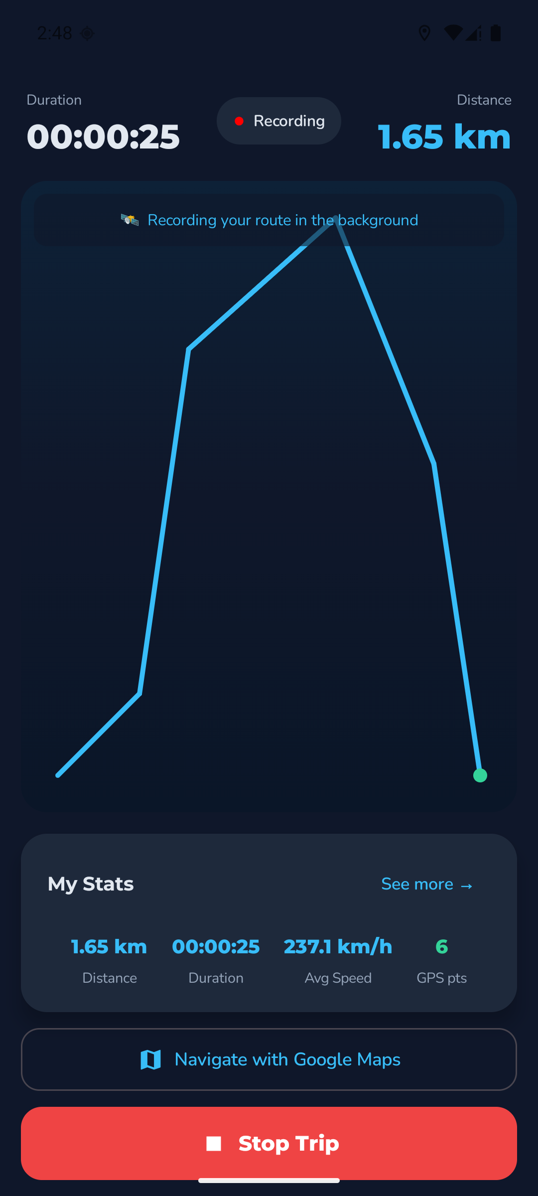 | 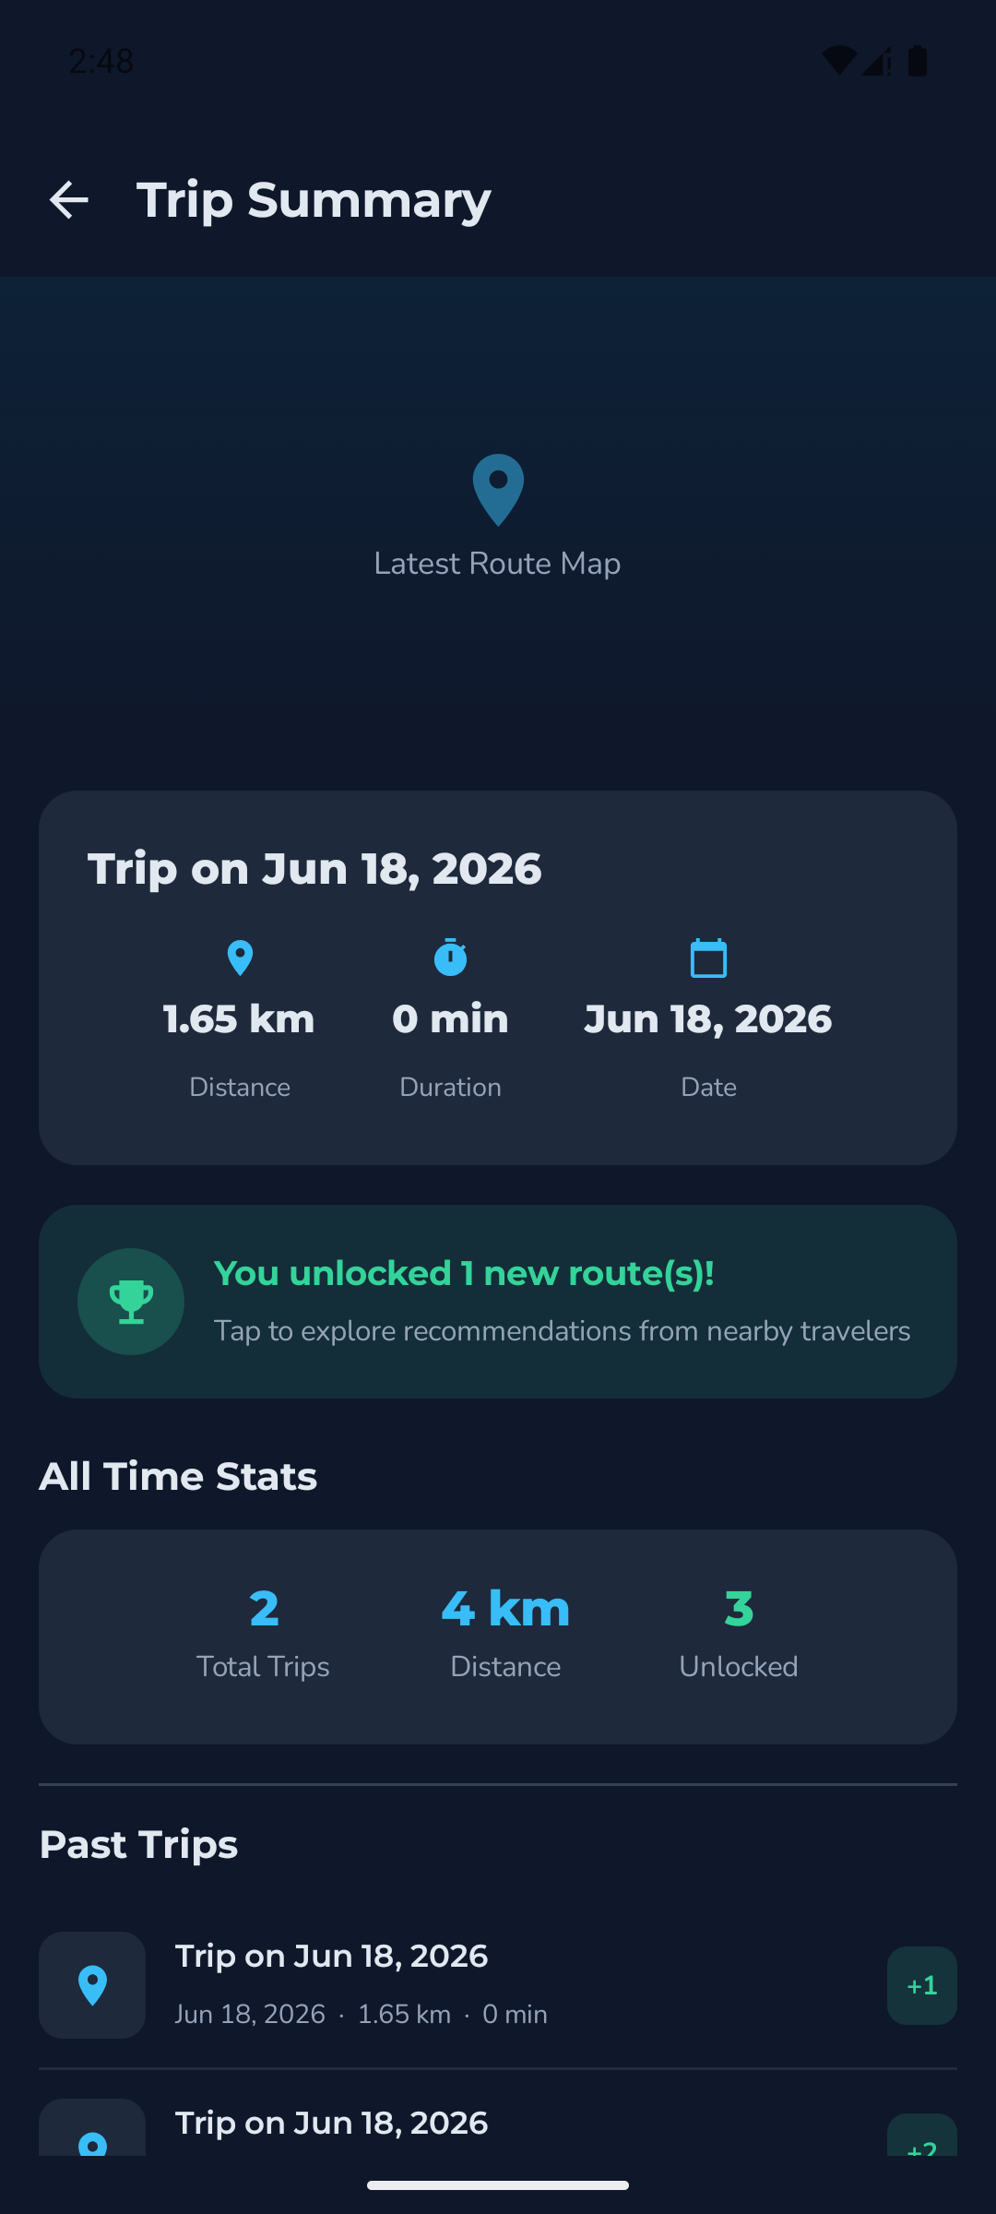

7. Reference code — a fully working app
The complete, runnable implementation is in Roamly: https://github.com/aqn96/roamly
The files that make up this utility:
File | Role
app/src/main/java/com/roamly/app/data/TrackPoint.kt | GPS sample model
app/src/main/java/com/roamly/app/location/TripSession.kt | Shared StateFlow source of truth
app/src/main/java/com/roamly/app/location/TripLocationService.kt | The Foreground Service + FusedLocationProviderClient
app/src/main/java/com/roamly/app/ui/screens/trip/TripViewModel.kt | Start/stop + derived distance
app/src/main/java/com/roamly/app/ui/screens/trip/ActiveTripScreen.kt | Live route Canvas + stats
app/src/main/java/com/roamly/app/ui/screens/home/LocationPermissionScreen.kt | Runtime permission request
app/src/main/AndroidManifest.xml | Permissions + service declaration
To run: clone the repo, add your own google-services.json to app/, open in Android Studio, and run on an API 28+ device/emulator (see the repo README.md).

8. Conclusion
This tutorial showed how to record a GPS route in the background by combining two technologies that the course does not cover: FusedLocationProviderClient for a battery-aware location stream and a Foreground Service for continuous, user-visible logging. The key design idea is decoupling the Service from the UI through a process-wide StateFlow (TripSession), which lets the recorded route flow cleanly into a ViewModel and a Compose Canvas. The result — a live, drawable, persistable route — is the sensing backbone of Roamly’s “contribute a trip to unlock recommendations” model, and the same pattern applies to any fitness, delivery, or navigation app that needs to answer the question “where did the user actually go?”

