Contents
Contents i
1 Introduction 1
1.1 System Introduction 1
1.2 Background of the System 1
1.3 Objectives of the System 1
2 Overall Description 2
2.1 Product Perspective 2
2.2 Product Scope 2
2.3 Product Functionality 2
2.4 Users and Characteristics 2
2.5 Operating Environment 2
3 Specific Requirements 3
3.1 Functional Requirements 3
3.2 Behaviour Requirements 3
4 Other Non-functional Requirements 5
4.1 Performance Requirements 5
4.2 Safety and Security Requirements 5
4.3 Software Quality Attributes 5
5 Design Description 6
5.1 Logical Viewpoint 6
5.4 Interaction Viewpoint 6
5.5 State Dynamics Viewpoint 6
5.6 Algorithm Viewpoint 6

1. Introduction

1.1 System Introduction
The Library Management System (LMS) is designed to streamline the operations of a library. It serves as a digital platform to manage the library’s catalog and facilitate user interactions with the library’s resources. The LMS will enable efficient handling of tasks such as book cataloging, user registration, and book lending services.
The primary purpose of the LMS is to provide a user-friendly interface for both librarians and students. Librarians will have the capability to manage book inventories, oversee borrowing transactions, and maintain user accounts. Students will be able to search for books, register and log in to their accounts, and manage their borrowings. The system aims to enhance the accessibility and management of library resources, making the borrowing process more convenient and efficient.

1.2 Background of the System
In the domain of library management, various software solutions exist that cater to the needs of different types of libraries. Common features among these systems include catalog management, user authentication, and transaction handling for book issues and returns.

1.3 Objectives of the System
This project aims to distinguish itself from existing software by focusing on simplicity and user experience, particularly for educational institutions with smaller-scale operations. The proposed Library Management System (LMS) will prioritize ease of use, with a clean and intuitive interface that requires minimal training for both librarians and students.

2. Overall Description

1.1 Product Perspective
The Library Management System (LMS) is designed to serve as a centralized platform for managing library operations efficiently. The scope of the LMS includes features such as user registration and login, role-specific access for librarians and students, catalog management, book search functionality, and a comprehensive borrowing system that
handles issue and return transactions. The software will provide librarians with tools to manage the library’s inventory and assist students in finding and borrowing books, thereby enhancing the library’s service quality.

1.2 Product Scope
The Library Management System will not encompass functionalities outside the realm of library management, such as academic course management, financial transactions unrelated to library fees, or personal communication services. It is strictly confined to library-related activities and aims to improve the user experience within this domain by providing a streamlined and user-friendly interface for all library interactions. The system is tailored to meet the needs of educational institutions and is designed with the intent to be adaptable to various library sizes and structures.

1.3 Product Functionality
- User Registration and Authentication:
Allow new users to register for an account.
Enable existing users to log in to the system.
- Role-Based Access Control:
Provide distinct access levels for librarians and students.
Ensure users can perform only the functions appropriate to their role.
- Catalog Management:
Facilitate the addition, update, and deletion of book records.
Maintain a comprehensive and searchable catalog of books.
- Search Functionality:
Offer a robust search engine for users to find books by various criteria.
Include advanced search options to refine search results.
- Borrowing System:
Manage the process of issuing books to students.
Track the return of borrowed books and manage due dates.
- Account Management:
Allow users to view and update their personal information.
Enable librarians to manage student accounts and permissions.

1.4 Users and Characteristics
Library Management System (LMS), the anticipated users can be categorized primarily into two groups: librarians and students.
- Librarians
Frequency of Use: High; librarians will use the system daily for various administrative tasks.
Functions Used: Full access to all system functions, including catalog management, account management, and transaction oversight.
Technical Expertise: Moderate to high; expected to have a good understanding of the system to assist students and manage library operations.
Security Privilege: High; librarians will have elevated privileges to edit the catalog and manage user accounts.
Educational Level: Typically a degree in Library Science or related fields.
Experience: Professional experience working in library settings.
Librarians are the most important users of the LMS as they are responsible for maintaining the integrity of the system and ensuring its effective operation.

- Students
Frequency of Use: Variable; depends on individual needs and academic requirements.
Functions Used: Subset of functions, primarily focused on searching for books, borrowing, and account management.
Technical Expertise: Low to moderate; the system should be intuitive enough for students with varying levels of technical proficiency.
Security Privilege: Standard; students can access their accounts and borrow books but cannot alter library records.
Educational Level: Ranges from undergraduate to postgraduate levels.
Experience: May vary widely; some students may be first-time users of a library management system.

1.5 Operating Environment
The Library Management System (LMS) is designed to operate in a versatile and adaptable environment, ensuring compatibility with a range of hardware and software configurations. The minimum platform requirements for the system are as follows:
Hardware Platform:
CPU: Intel Core i3 or equivalent
RAM: 4 GB minimum
Storage: 500 GB HDD or 256 GB SSD
Display: 1024x768 resolution minimum
Operating System:
Windows 10 or later.
The system should be accessible via web browsers on these platforms, ensuring cross-platform compatibility.
Software Components:
Java Runtime Environment (JRE) 8 or later for systems running the Java version of the LMS.

3. Specific Requirements

2.1 Functional Requirements
User Registration and Authentication
The system shall allow new users to register by providing a unique username, password, and email address.
The system shall verify the uniqueness of the username and email during registration.
The system shall send a verification email to confirm the user’s email address.
The system shall allow users to log in using their username and password.
The system shall provide a password reset function via the user’s registered email.
Role-Based Access Control
The system shall assign roles to users as either ‘Librarian’ or ‘Student’.
The system shall restrict access to certain functionalities based on the user’s role.
The system shall allow librarians to modify user roles.
Catalog Management
The system shall allow librarians to add new books to the catalog with relevant details.
The system shall allow librarians to update or delete book records.
The system shall maintain a history of changes made to each book record.
Search Functionality
The system shall provide a search function for users to find books by title, author, or ISBN.
The system shall offer advanced search filters such as genre, publication date, and language.
Borrowing System
The system shall manage the issuing of books to students with a due date for return.
The system shall track the return of books and update the catalog accordingly.
The system shall send reminders to users for overdue books.
Account Management
The system shall allow users to view and edit their profile information.
FR6.2: The system shall allow librarians to manage student accounts, including suspending accounts if necessary.

2.2 Behaviour Requirements
Library Management System (LMS), the use case diagram will encapsulate the interactions between the system and its actors. Here’s a description of the use cases along with the actors involved:

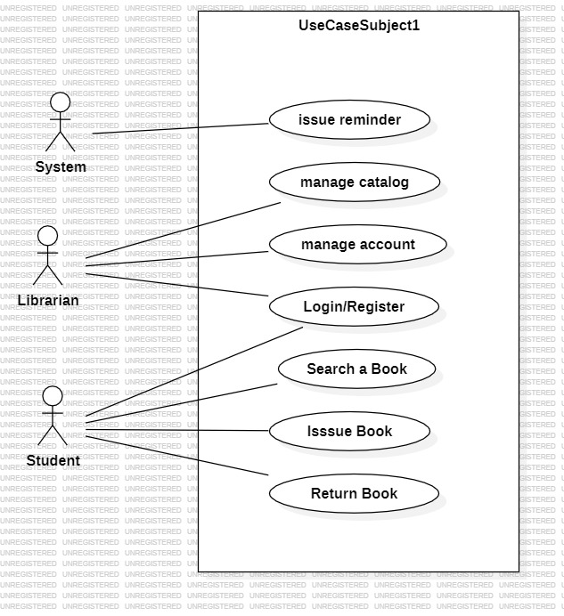

4. Other Non-functional Requirements

4.1 Performance Requirements
The performance of the Library Management System is critical to providing a seamless user experience. The system shall be designed to handle a high volume of simultaneous users and transactions efficiently. The following performance requirements have been established to ensure the system's responsiveness and reliability:

1. System Responsiveness: The system shall respond to user input within 2 seconds under normal operation conditions.
2. Transaction Time: Any transaction, such as issuing or returning a book, shall not take more than 10 seconds to complete.
3. Search Functionality: Search queries shall return results within 3 seconds, even with large datasets.
4. Concurrent Users: The system shall support up to 100 concurrent users without significant degradation of performance.
5. Data Processing: Batch processing of data, such as updating book records or generating reports, shall be completed within 1 hour.
6. System Availability: The system shall be available for use 99.9% of the time, excluding scheduled maintenance.
7. Backup and Recovery: The system shall perform daily backups and shall be capable of restoring operations within 4 hours following any critical failure.

4.2 Safety and Security Requirements
Safety and security requirements for the Library Management System (LMS):
Authentication and Authorization:
User identity authentication shall be mandatory for all users (students and librarians).
Passwords shall be securely hashed and stored.
Librarians shall have additional administrative privileges.
Access Control:
The system shall enforce role-based access control (RBAC).
Librarians shall have access to administrative features, while students shall have limited access.

4.3 Software Quality Attributes
Reliability
Availability: The system shall be available for use 24/7, with scheduled maintenance windows communicated in advance.
Fault Tolerance: The system shall recover gracefully from unexpected failures (e.g., server crashes) without data loss.
4.3.2 Maintainability
Modularity: The system shall be designed with clear module boundaries to facilitate future enhancements or bug fixes.
Code Documentation: All code shall be thoroughly documented to aid future developers in understanding and maintaining the system.
Version Control: The system’s codebase shall be managed using version control (e.g., Git) to track changes and manage collaboration.
4.3.3 Usability
User-Friendly Interface: The system shall have an intuitive and easy-to-use interface for both librarians and students.
Error Handling: Clear error messages shall be provided to guide users when they encounter issues.
4.3.4 Performance Efficiency
Response Time: The system shall respond to user actions (search, book issuance, etc.) within 2 seconds.
Scalability: The system shall handle increased load (e.g., during exam periods) without significant performance degradation.
4.3.5 Security
Authentication and Authorization: User authentication and role-based access control shall be enforced.
4.3.6 Portability
Cross-Browser Compatibility: The system shall function correctly on major web browsers (Chrome, Firefox, Edge, etc.).
Platform Independence: The system shall be platform-agnostic, allowing users to access it from different devices (Windows, macOS, mobile).
4.3.7 Testability
Unit Testing: Code shall be written with testability in mind, allowing for effective unit testing.
Test Automation: Automated test suites shall be developed to verify system functionality during development and maintenance.
4.3.8 Design for Change
Flexibility: The system architecture shall allow for future feature additions or modifications.
Component Reusability: Components shall be designed for reuse across different parts of the system.

5. Design Description

5.1 Composite Viewpoint
1. USER STORY:

Title: Search for Books by Author, Title, or Category
As a library user, I want to be able to search for books by author, title, or category,
So that I can easily find the books I am interested in.

Acceptance Criteria:

- As a user, I should be able to enter a search query containing either the author's name, book title, or category.
- The system should return a list of books that match the entered search query, displaying relevant details such as title, author, and category.
- If multiple books match the search criteria, they should be listed in a user-friendly format, sorted by relevance.
- If no books match the search criteria, the system should display a message indicating that no results were found.
- The search functionality should be accessible from any page within the library system interface.

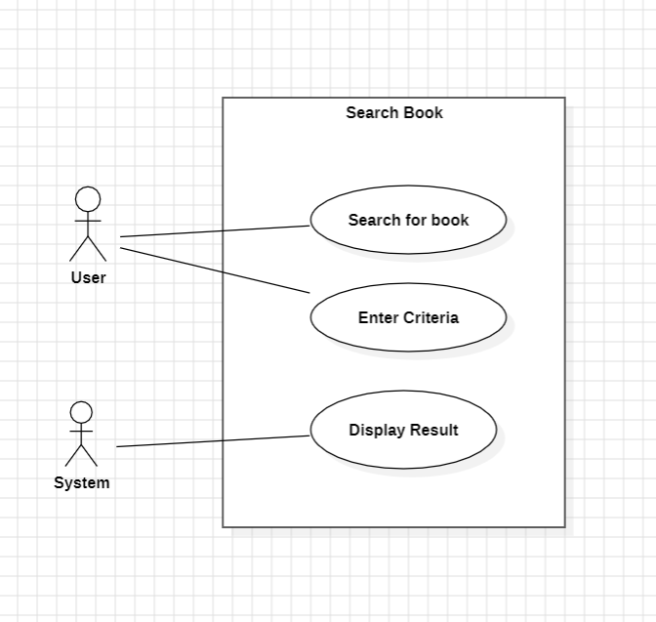

2. USER STORY:
Title: Return a Book

As a library user, I want to be able to return a book that I have borrowed,
So that it can be made available for other users to borrow.

Acceptance Criteria:

- As a user, I should be able to access my borrowed books from my account.
- The system should provide an option to select the book(s) I want to return.
- After selecting the book(s) to return, the system should confirm the return action.
- Once the return action is confirmed, the system should update the book's status as available for borrowing.
- The system should send a confirmation message to the user indicating that the return was successful.

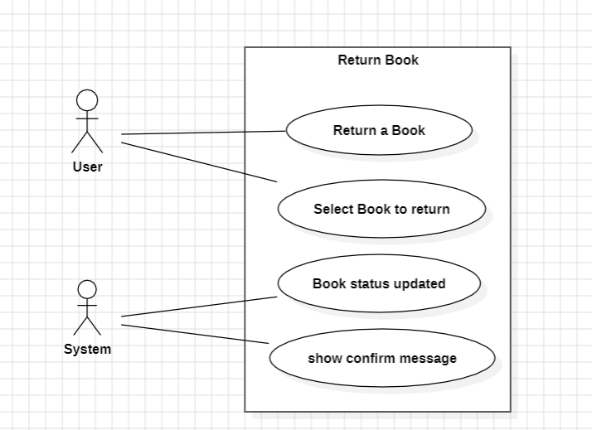

3. USER STORY:
Title: Borrow a book
As a library user, I want to be able to borrow books from the library,
So that I can read them at my convenience.
Acceptance Criteria:
As a user, I should be able to search for books available for borrowing.
The system should display the availability status of each book in the search results.
When I find a book I want to borrow, I should be able to select it for borrowing.
The system should check if the selected book is available for borrowing.
If the book is available, the system should allow me to borrow it.
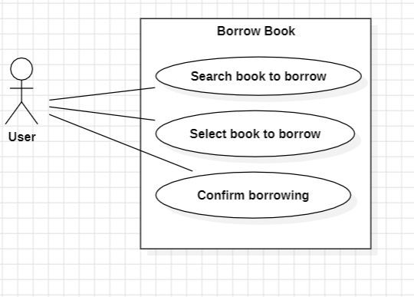

4. USER STORY
Title: Add a Book (Librarian)
As a librarian, I want to be able to add new books to the library's collection,
So that they are available for users to borrow.
Acceptance Criteria:
As a librarian, I should be able to access the system's admin interface for adding new books.
The system should provide fields to enter the book's title, author, ISBN, category, and other relevant details.
After entering the book details, the system should validate the information provided.
If the entered information is valid, the system should add the book to the library's collection.
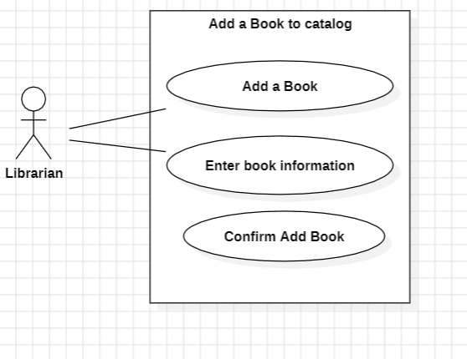

5. USER STORY
Title: Delete a Book (Librarian)
As a librarian, I want to be able to delete books to the library's collection,
So that outdated books can be removed from catalog
Acceptance Criteria:
- As a librarian, I should be able to access the system's admin interface for removing old books.
- The system should provide fields to enter the book's title, author, ISBN, category, and other relevant details.
- After entering the book details, the system should validate the information provided.
- If the entered information is valid, the system should delete the book from library's collection.

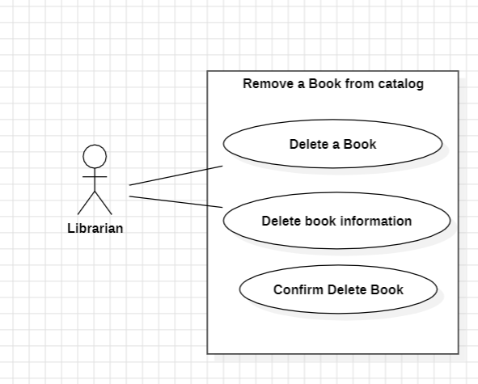

5.2 Logical Viewpoint

5.3 Interaction Viewpoint

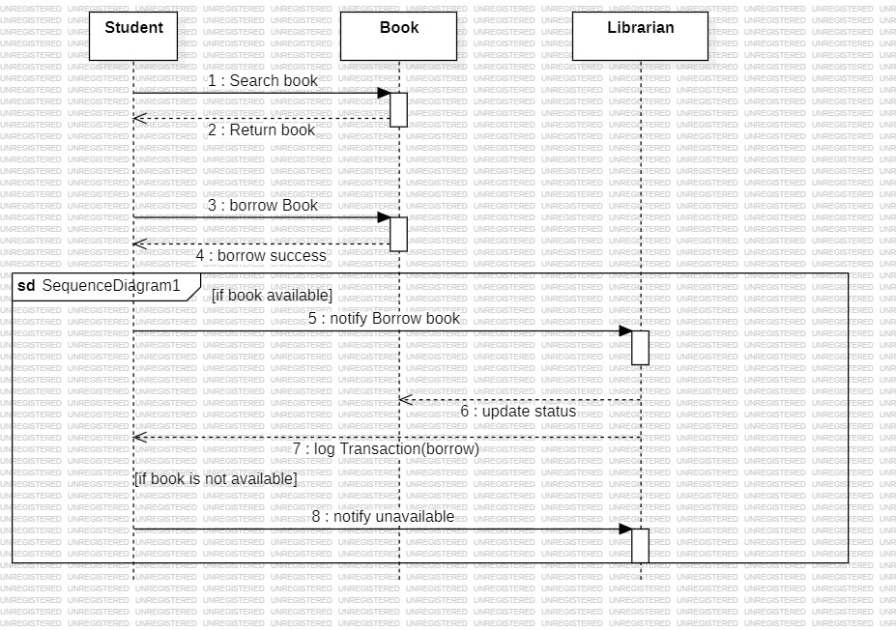

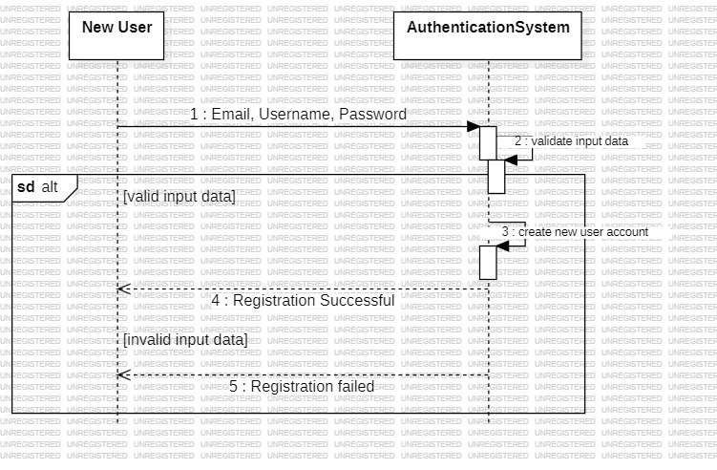

Decision Tree:

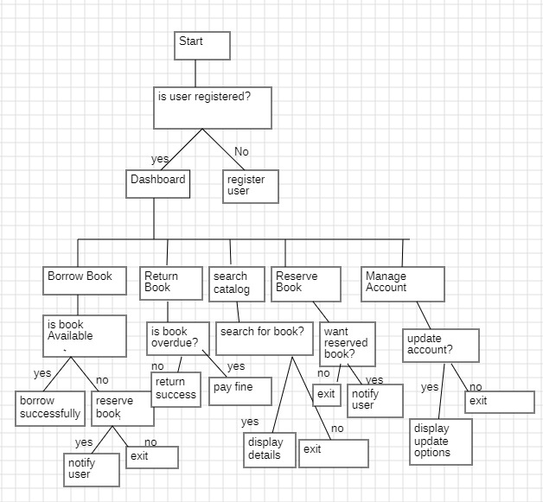

Entity Relationship diagram:

