**Lab Task – Python Programs**

**Name: Aqsa Gillani  
Roll No: 064  
Course: Artificial Intelligence (AI) Lab  
Semester: Fall 2025**

1. **LUHN Algorithm**

Objective: To validate credit/debit card numbers using the LUHN Algorithm.  
Description: This program checks the validity of a credit or debit card number using the LUHN formula. It helps in detecting errors in card numbers by performing a checksum calculation.

**Output**:

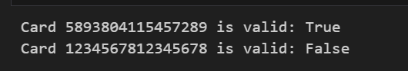

1. **Remove Punctuations**

Objective: To remove punctuations from a given string.  
Description: This program takes an input string and removes all punctuation marks, leaving only letters, numbers, and spaces. It is useful for text cleaning and preprocessing.

**Output:**

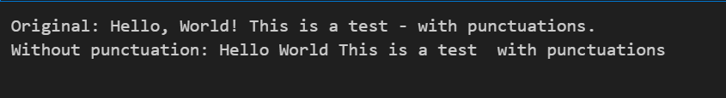

1. **Sort Sentence by Characters (ASCII)**

Objective: To sort all characters in a sentence according to ASCII values including spaces.  
Description: This program sorts the characters of a given sentence based on their ASCII values, which includes letters, digits, punctuation, and spaces. It demonstrates sorting at the character level rather than word level.

Output:

