**Step Ahead**

**An Inclusive System for Children with Autism**

Final Year Project

Session 2019-2023

A 4th Year Student

A project submitted in partial fulfilment of the

COMSATS University Degree

Of

BSc. (Hons.)BS in Software Engineering (CUI)

Department of Computer Science

COMSATS University Islamabad, Lahore Campus

09 June 2023

# Project Detail

|  |  |  |  |  |  |  |  |  |
| --- | --- | --- | --- | --- | --- | --- | --- | --- |
| Project ID  (for office use) | | |  | | |  | |  |
| Type of project | | | [ ] Traditional [ ] Industrial | | | [ ] Continuing | |  |
| Nature of project | | | [ ] **D**evelopment [ ] **R**esearch | | | [*] **R**&**D** | |  |
| Area of specialization | | | Mobile Application | | | | | |
| **Project Group Members** | | | | | | | | |
| Sr.# | Reg.# | Student Name | | CGPA | Email ID | | Phone# | Signature |
| (i) | FA19-BSE-068 | **Huma Nadir** | | 2.80 | [fa19-bse-068@cuilahore.edu.pk](mailto:fa19-bse-068@cuilahore.edu.pk) | | 0340-9807856 | Huma |
| (ii) | FA19-BSE-036 | **Aqsa Nawaz** | | 2.70 | [fa19-bse-036@cuilahore.edu.pk](mailto:fa19-bse-036@cuilahore.edu.pk) | | 0302-4065895 | Aqsa |
| **(**  (iii) | FA19-BSE-062 | **Durr-e-Sabeeh** | | 2.72 | [fa19-bse-062@cuilahore.edu.pk](mailto:fa19-bse-062@cuilahore.edu.pk) | | 0308-8649004 | Sabeeh |

*The candidates confirm that the work submitted is their own and appropriate credit has been given where reference has been made to work of others

# Plagiarism Free Certificate

# This is to certify that, I Huma Nadir D/O Nadir Khan, group leader of FYP under registration no CIIT/FA19-BSE-068/LHR at Computer Science Department, COMSATS Institute of Information Technology, Lahore. I declare that my FYP proposal is checked by my supervisor and the similarity index is [17] % which is less than 20%, an acceptable limit by HEC. The report is attached here as Appendix A.

# Date: 09/06/2023 Group Leader: Huma Nadir Signature: Huma

Name of Supervisor: Mam Sara Muneeb Co-Supervisor (if any):____________________

Designation: _____________________ Designation: _____________________

Signature: _____________________ Signature: _____________________

HoD: _____________________

# Signature: ____________________

# Abstract

Children with autism are unable to explain their issue which they face at school. They face difficulty to explain their mode, task done at school and home task to their parents. Parents, teachers, and school administrators face problems in communicating in between for a child’s progress. The main aim of our project will be to build a communication portal between parents, teachers, and school administration. This project will be a mobile app-based learning management system to benefit parents, teachers, and administration who are involved in the life of a child with autism. Admin will be able to register teachers, parents and create a class. Admin will assign ids to parent and teacher for login. Admin will make announcements and view the progress report of students. This system will help parents to view, like and comment on every announcement done by teachers or admin. This app helps parents to view attendance and progress report of their child updated by their teacher and they are also able to discuss every problem in chat.

Table of Contents

Final Year Project – Mid Report 1

Session 2019-2023 1

Project Detail 2

Plagiarism Free Certificate 2

Abstract 3

List of Tables 4

1 Chapter 1: Introduction 6

1.1 Introduction 6

1.1.1 Step ahead an inclusive learning management system for children with Autism 6

1.1.2 Mobile App 6

1.2 Objectives 7

1.3 Problem Statement 7

1.4 Assumptions & Constraints 7

1.4.1 Assumptions 7

1.4.2 Constraints 8

1.5 Project Scope 8

2 Chapter 2: Requirements Analysis 9

2.1 Literature review 9

2.1.1 OASIS.org.pk 9

2.1.2 Autismpak.com 9

2.1.3 ARCL.org.pk 9

2.1.4 Elemy 10

2.1.5 kingsinterhigh.co.uk 10

2.1.6 Gemm Learning 10

2.2 Stakeholder List 10

2.3 Requirements Elicitation 11

2.3.1 Functional Requirements 11

2.3.2 Non-Functional Requirements 14

2.3.3 Requirements Traceability Matrix 16

2.4 Use Case Descriptions 19

2.5 Use Case Designs 32

2.5.1 Login page 32

2.5.2 Today Activity 34

2.5.3 Profile 35

2.5.4 Attendance 36

2.5.5 Announcement 37

2.5.6 Progress Report 38

2.5.7 Chat 39

2.5.8 Register Student 40

2.5.9 Register Teacher 41

2.5.10 Create Class 42

2.6 Software development life cycle model 43

3 Chapter 3 System Design 44

3.1 Work Break down Structure (WBS) 44

3.2 Activity diagram 45

3.2.1 User Login 45

3.2.2 Add Student 46

3.2.3 Add Teacher 47

3.2.4 Attendance 48

3.2.5 Chat 49

3.2.6 Create Class 50

3.2.7 Profile 51

3.2.8 Progress Report 52

3.2.9 Today Activity 53

3.2.10 Recent Announcement 54

3.2.11 Logout 55

3.3 Sequence Diagram 56

3.3.1 Log in 56

3.3.2 Today Activity 57

3.3.3 Profile 58

3.3.4 Attendance 59

3.3.5 Announcement 60

3.3.6 Progress Report 61

3.3.7 Chat 62

3.3.8 Register Student 63

3.3.9 Register teacher 64

3.3.10 Create class 65

3.4 Software architecture 66

3.5 Class Diagram 67

3.6 ERD 68

3.7 Network Diagram/Gantt chart 69

4 Chapter 4: System Testing 70

4.1 Test Cases 70

4.1.1 Today Activity 70

4.1.2 Sign In 71

4.1.3 Attendance 72

4.1.4 Logout 73

4.1.5 Chat 74

4.1.6 Register Student 75

4.1.7 Register Teacher 76

4.1.8 Create Class 77

4.1.9 Progress Report 78

4.1.10 Recent Announcement 79

5 Conclusion 80

5.1 Problems faced and lessons learned 80

5.2 Project summary 80

5.3 Future work 81

6 References 82

7 Plagiarism Report 82

# List of Tables

Table 1 Stakeholder List 13

Table 2 functional requirement 15

Table 3 Parent functional requirement 16

Table 4 Teacher functional requirement 16

Table 5 Admin functional requirement 16

Table 6 Non-functional requirements 18

Table 7 Requirements traceability matrix 19

Table 8 Use case Sign In 20

Table 9 Use case Sign-out 21

Table 10 Use case Today Activity 22

Table 11 Use case Assign homework 23

Table 12 Use Case Recent announcement 24

Table 13 Use Case Like,Comment 25

Table 14 Use Case Chat 26

Table 15 Use Case Attendance 27

Table 16 Use Case Progress report 28

Table 17 Use Case Add teacher 29

Table 18 Use Case Register student 30

Table 19 Use Case Create class 31

Table 20 Use Case Profile 31

Table 21 Test case –Tdoay activity 66

Table 22 Test case – Sign In 67

Table 23 Test case –attendance 68

Table 24 Test case –Logout 69

Table 25 Test case –chat 69

Table 26 Test case –register student 69

Table 27 Test case –register teacher 69

Table 28 Test case –create class 69

Table 29 Test case –progress report 69

Table 30 Test case –recent announcement 69

**List of Figures**

Figure 1 Use Case 1 Sign In 32

Figure 2 Use Case 2 Sign Out 33

Figure 3 Use Case 3 Aoday Activity 34

Figure 4 Use Case 4 Assign Homework 35

Figure 5 Use case 5 Recent Announcement 36

Figure 6 Use Case 6 Like,Comment 37

Figure 7 Use Case 7 Chat 38

Figure 8 Use Case 8 Attendance 39

Figure 9 Use Case 9 Progress Report 40

Figure 10 Use Case 10 Add Teacher 41

Figure 11 Use Case 11Register Student 33

Figure 12 Use Case 12 Create Class 33

Figure 13 Use Case 13 Profile 33

Figure 14 Work Breakdown Structure 43

Figure 15 Activity Diagram Create Farm 44

Figure 16 Activity Diagram Farmer Login 46

Figure 17 Activity Diagram Chat 47

Figure 18 Activity Diagram Profile Setting 49

Figure 19 Activity Diagram Yield Estimation 52

Figure 20 Activity Diagram Register user 52

Figure 21 Activity Diagram Choose Plot 55

Figure 22 Sequence diagram Admin login 55

Figure 23 Sequence diagram Farmer login 56

Figure 24 Sequence diagram Profile 57

Figure 25 Sequence diagram Yield Estimation 58

Figure 26 Sequence diagram Create Farm 59

Figure 27 Sequence diagram Choose Plot 59

Figure 28 Sequence diagram Chat 60

Figure 29 software architecture 61

Figure 30 Class diagram 62

Figure 31 ERD 63

Figure 32 Network diagram/Gantt chart 64

Figure 33 Network Diagram 65

Figure 30 Collaboration Diagram(Optional) 65

# Chapter 1: Introduction

## 1.1 Introduction

### Step ahead an inclusive learning management system for children with Autism

Step ahead an inclusive learning management system for children with autism will be a mobile app. It is a mutual platform for both parents and school administration where they can communicate easily. The question that arises in mind by visualizing the idea of this mobile app is that why we need such a platform, as we know today life is super-fast and especially parents don’t have time to go through awaiting processes like PTM (parents teachers meeting) and rather, they would appreciate an online platform to communicate with teachers. In autistic schools, a lot of work is conducted manually by administration and teachers. The teacher gives a report of their daily activities to the admin. Then the admin delivers reports of every child to their parents. All of this seems very challenging, time taking and difficult to accomplish manually. This is hectic for parents as well to interact with teachers regarding their children's performance. Keeping these problems in mind our intent is to create a platform which is easily available for both parties and is time friendly. Through this platform, every task that is carried out manually will be managed automatically. This application will also help parents in many ways. Parents will directly communicate with the teachers; they will easily assign tasks and deliver daily reports to parents. Admin will monitor all these activities automated.

### Mobile App

This system will be mobile application. User (Admin, Teacher, Parent) must create an account on the app. This mobile app benefits parents, teachers and administration that is involved in life of child with autism. This system will help them to easily communicate and share data regarding children progress and activities in school. Mobile applications are turning out to be more well-known on the grounds that everybody can get to mobile apps from all over. It will be user friendly and will have an alluring graphical user interface. The principal objective to make such framework is to help parents to track child’s activities and to streamline communication with their teachers. This will also help teachers in handling and teaching children. For instance, autism schools don’t only focus on teaching course materials like the rest of schools but also focus on behavioral progress of children. Teachers will assign each child home tasks and activities, they will practice it at home. Admin can relate teachers and students, announce different activities, and see the progress of students. The teacher will give a daily progress report of the child to parents, what they did, and how they perform different activities so that parents remain familiar with their child's progress.

## Objectives

This mobile application will only be accessible from a particular domain which will not be publicly available. It will consist of three portals for teachers, parents, and admin. Every portal interface consists of the login page and the login credentials given by the admin. Upon logging into the system, the admin will get access to a panel from which he can perform different operations. For parents and teachers to get access to portal they will have to register an account by providing their personal details. The account will be first verified by admin and then get registered. They will get a message from admin side that “your account will be registered after it is verified by admin”. And will be verified within some time by admin if it is appropriate. They can log into the mobile app via email along with their verified password. After logging in, parents can see their child's progress, daily report, and what they did at school. Despite this, parents can also directly chat with teachers. Teachers will upload daily activities of their associated child and assigned tasks for homework. This mobile application will also hold the record of students' dues. At the end of the session, students will get their whole session progress in different formats like (PDF, words file, ABLLS).

## Problem Statement

Children with autism face problem in communication with their parents, classmates, and teachers. They are not even able to explain their problems properly which they face in school like any fight between students, any activity update, homework assigned to them. To tackle these types of problems we are creating a portal management system so that parents can communicate easily with teachers to know about their children daily activity, progress report, homework details, any mishap, any task assigned and any function or announcement from school through text messages, and images in chat.

## Assumptions & Constraints

### Assumptions

Assumptions of the project are following:

1. All the necessary tools will be available
2. Members will have grip on required technologies.
3. The scope of the project will be completed on time.
4. All the team members will be available.
5. Performance of project members will be adequate.
6. Skills of project members will improve during the development of this project.
7. We assume our project will help parents and teachers of children with autism.
8. Children with autism face problem in communication with their parents, classmates, and teachers. This mobile app will also motivate students to communicate their information between parents and teachers without physical interaction.

### Constraints

Constraints of the Projects are following:

1. Development of a project must be completed in given timeframes and deadlines.
2. The development of a project must fully follow defined project scope.
3. The language used in the mobile app will be English.
4. There are some limitations for image-based remote sensing application like restricted spectral range, very slow turnaround time and coarse spatial resolution
5. The application will work with internet connection.
6. Domain requirements must be addressed completely.

## Project Scope

Children with autism face problem in communication with their parents, classmates, and teachers. They are not even able to explain their problems properly which they face in school like any fight between students, any activity update, homework assigned to them. To tackle these types of problems we are creating a portal management system so that parents can communicate easily with teachers to know about their children activity improvement, homework details, any mishap, any task assigned and any function or announcement from school through text message and image sharing in chat.

The system will help users in various manners, a simple example of which is that if a student fight with a classmate and get injured and parents wants to know about the reason, they don’t need to visit school, they will get all information from teachers via our mobile app. This platform will also motivate students to communicate their information between parents and teachers without physical interaction.

# Chapter 2: Requirements Analysis

## Literature review

There are some related mobile apps working online for children with autism in Pakistan and other countries such as following:

### OASIS.org.pk

Oasis is a fully equipped school mobile application for children with Autism counseling like a mother's dream. Working with autism is a very intensive and complex endeavor that involves the child's entire family and our team of professionals. The Oasis School provides a high standard of education along with appropriate therapies to enable each child to develop to their full potential in a calm and relaxing environment that maximizes communication and learning for everyone. [1]

### Autismpak.com

In this application, you will successfully work on inclusive education in mainstream schools. Assist parents through education and support services (occupational therapy, speech therapy, behavioral management, sibling support, playgroup, etc. Develop trained staff for Autism Resource Center(s) Create team(s) to provide diagnosis, assessment and develop Individual Support Plan (ISP) for children Provide services to children and families. [2]

### ARCL.org.pk

ARCL (Autism Resource Center Lahore) is a non-profit organization providing services to poor and needy children at highly subsidized rates ranging from 50% fee to 100% service. .It operates as a non-profit organization. These services are matched by highly qualified professional staff, which the institution rewards for quality services. Speech therapy, which can help with speech, language, communication and swallowing problems. ARCL aims to become a nationally and internationally recognized center with distinction for implanting quality services combined with excellent results through a conducive learning environment of experienced staff and efficient and friendly management. [3]

### Elemy

Elemy.com is the online platform for online leering of children with autism. In this site online class are given to children. Teachers and parents directly contact with each other on daily bases and Elemy serves more than 30 cities, and we're striving to make autism care accessible to everyone. Our Project somehow relate with this platform but in this portal teachers will not give online lectures or training but what student learn or do activity in class daily report will be given to their parents. [4]

### kingsinterhigh.co.uk

Kings inter high is online platform for teaching the autistic students. Autistic students are guided through each interactive online lesson by our expert experienced teachers. Lectures are also available in pre- recorded form and also live session. On daily bases task are assign and child has to complete the task on time. Our portal will be similar to it, not for online classes but teacher will upload daily activates of child on portal and parents can see it also teacher will assign task on the portal and can chat with parents regarding student daily routine and work. [5]

### Gemm Learning

Gemm Learning provides Fast ForWord at home with remote monitoring and coaching. It’s an affordable home school program for children with autism that trains cognitive and reading skills, in self-paced exercises that you can manage at home without formal training. Our Project somehow relate with this platform but in this portal teachers will not give online lectures or training but what student learn or do activity in class daily report will be given. [6]

|  |  |  |
| --- | --- | --- |
| **Modules** | **FLAWS** | **SOLUTION** |
| Chat box | Most of the systems we visited for research point of view, majority of them do not have a chat box. | our system we will allow users to chat within the mobile so that they can communicate with each other and decide out the meeting time etc. |
| User friendly UI | Most of the systems lack in user friendly UI, a new user couldn’t figure out what’s happening where to go for next step etc. | For users we shall add animations and popup alerts so that he/she feel comfortable with the system. |
| Record | Many mobile apps we visited deal end to end with users, so they lack in keeping a proper record. | Record of student’s whole session progress will be stored in database by name and email. |
| Type of stuff | In some mobile applications system, we saw that you can upload the picture progress report only. | In our mobile app teachers can also attach child picture in chat for explain daily activity. |

## Stakeholder List

Following is the list of project stakeholders:

|  |  |
| --- | --- |
| **Name** | **Functionalities** |
| Admin | * Register students and teacher * Assign valid ids to registered students and teachers. * Add, like or comment new announcements, * Create class, * Edit profile, * Chat with teacher and parents * View progress report of students. |
| Teacher | * Add, like or comment new announcements, * Edit profile, * Update today activity, * Chat with admin and parents * Add attendance * Add Progress report of students. |
| Parent | * View, like, and comment on recent announcement * View attendance, today activity and progress report of their child * Edit profile * Chat with admin and teacher |

*Table 1 Stakeholder List*

## Requirements Elicitation

### Functional Requirements

#### Parent portal

|  |  |
| --- | --- |
| **FR1** | **Sign in** |
| FR1-01 | The system shall enable parent to access his/her account by entering email and password. |
| FR1-02 | The system will show error if something is not in input fields required to login. |
|  | |
| **FR2** | **Sign out** |
| FR2-01 | The system shall allow parents to logout successfully. |
|  | |
| **FR3** | **Access today activity page** |
| FR3-01 | The system shall enable parent to viewtoday activity pagefilled byteacher. |
|  | |
| **FR4** | **Receive update about daily activities done in school** |
| FR4-01 | The system shall enable parent to access his/her child’ updates about daily activities done in school from their teacher. |
|  | |
| **FR5** | **View home task** |
| FR5-01 | The system shall enable parent to view his/her child’ home task assigned by their teacher. |
|  | |
| **FR6ssss** | **Access report card of child** |
| FR6-01 | The system shall enable parent to view and review report card of his/her child. |
|  | |
| **FR7** | **View events upload by admin/teacher** |
| FR7-01 | The system shall enable parent to view events uploaded by admin or teacher. |
|  | |
| **FR8** | **Like and comment on announcement** |
| FR8-01 | The system shall enable parent to like and comment on announcements uploaded by admin or teacher. |
|  | |
| **FR9** | **View attendance** |
| FR9-01 | The system shall enable parent to view and review attendance of their child uploaded by their teacher. |
|  | |
| **FR10** | **View progress of child in ABLLS** |
| FR10-01 | The system shall enable parent to view progress of his/her child in every activity through ABLLS. |
|  | |
| **FR11** | **Contact with teacher** |
| FR11-01 | The system shall enable parent to contact with their child’ teacher through text message and image sharing in chat. |
|  | |
| **FR12** | **Contact with admin** |
| FR12-01 | The system shall enable parent to contact with admin through text message and image sharing in chat. |

#### Teacher portal

|  |  |
| --- | --- |
| **FR1** | **Sign in** |
| FR1-01 | The system shall enable teacher to access his/her account by entering email and password. |
| FR1-02 | The system will show error if something is not in input fields, required to login. |
|  | |
| **FR2** | **Sign out** |
| FR2-01 | The system shall allow teacher to logout successfully. |
|  | |
| **FR3** | **Fills today activities page** |
| FR3-01 | The system shall enable teacher to update today activity page of his/her students to inform their parents. |
|  | |
| **FR4** | **Inform parents about daily activities done in school** |
| FR4-01 | The system shall enable teacher to inform his/her student update about daily activities done in school to their parents. |
|  | |
| **FR5** | **Assign home task** |
| FR5-01 | The system shall enable teacher to assign his/her student home task. |
|  | |
| **FR6** | **Edit and give report cards to parents** |
| FR6-01 | The system shall enable teacher to edit and give report card of his/her student. |
|  | |
| **FR7** | **Make announcements** |
| FR7-01 | The system shall enable teacher to add announcements. |
|  | |
| **FR8** | **View events uploaded by admin** |
| FR8-01 | The system shall enable teacher to view events uploaded by admin. |
|  | |
| **FR9** | **Like and comment on announcement** |
| FR9-01 | The system shall enable teacher to like and comment on announcements uploaded by admin. |
|  | |
| **FR10** | **Mark attendance** |
| FR10-01 | The system shall enable teacher to mark attendance of their students and share with admin and parents. |
|  | |
| **FR11** | **Update progress of child in ABLLS** |
| FR11-01 | The system shall enable teacher to update progress of his/her student in every activity through ABLLS. |
|  | |
| **FR12** | **Contact with parents** |
| FR12-01 | The system shall enable teacher to contact with their student parents through text message and image sharing in chat. |
|  | |
| **FR13** | **Contact with admin** |
| FR13-01 | The system shall enable teacher to contact with admin through text message and image sharing in chat. |

#### Admin portal

|  |  |
| --- | --- |
| **FR1** | **Sign in** |
| FR1-01 | The system shall enable admin to access his/her account by entering email and password. |
| FR1-02 | The system will show error if something is not in input fields required to login. |
|  | |
| **FR2** | **Register student** |
| FR2-01 | The system shall enable admin to register students in school. |
|  | |
| **FR3** | **Register teacher** |
| FR3-01 | The system shall enable admin to register teacher for school. |
|  | |
| **FR4** | **Create class** |
| FR4-01 | The system shall enable admin to create classes for students. |
|  | |
| **FR5** | **Add/edit/delete students** |
| FR5-01 | The system shall enable admin to add/edit/delete students in their respective classes. |
|  | |
| **FR6** | **Assign teacher** |
| FR6-01 | The system shall enable admin to assign teacher to respective class. |
|  | |
| **FR7** | **Contact with teacher** |
| FR7-01 | The system shall enable admin to interact with teacher through text message and image sharing in chat. |
|  | |
| **FR8** | **Contact with parents** |
| FR8-01 | The system shall enable admin to interact with parents through text message and image sharing in chat. |
|  | |
| **FR9** | **Add/view/delete announcements/events** |
| FR9-01 | The system shall enable admin to add announcements. |
|  | |
| **FR10** | **Like and comment on announcements/events** |
| FR10-01 | The system shall enable admin to like and comment on announcements made by teachers. |
|  | |
| **FR11** | **Check student Progress** |
| FR11-01 | The system shall enable admin to check students’ progress in different activities through ABLLS. |

Table 2 Admin functional requirement

### Non-Functional Requirements

|  |  |
| --- | --- |
| **N-F-R** | **Definitions** |
| **NFR1** | **Security** |
| NFR1-01 | The system will run on safe server. |
| NFR1-02 | The system will not share user data with anyone |
| NFR1-03 | Validation should be done of every input from user. |
| NFR1-04 | Data integrity shall be checked. |
| NFR1-05 | The system will provide security updates regularly. |
|  | |
| **NFR2** | **Safety** |
| NFR2-01 | The system will work without failure. |
| NFR2-02 | Database should have backup as the data base might get crashed on critical condition of server or for unconscious reasons. |
| NFR2-03 | In the event of a system failure, data security can be insured as it continues to back up regularly. |
|  | |
| **NFR3** | **Maintainability** |
| NFR3-01 | The system should be maintainable. The system should deduct bugs and errors and notify the user. |
| NFR3-02 | The system should be updated regularly and maintained to avoid bugs. |
|  | |
| **NFR4** | **Performance** |
| NFR4-01 | Response time of software should not exceed more than 5 seconds. |
| NFR4-02 | The database should have capacity to save 100000 records of data. |
| NFR4-03 | Users will access the mobile app at any time. |
|  | |
| **NFR5** | **Implementation** |
| NFR5-01 | The software should be implemented in react native to work as a mobile application. |
|  | |
| **NFR6** | **Reliability** |
| NFR6-01 | The software shall be reliable. |
| NFR6-02 | Downtime of the mobile app should not exceed more than 6 hours. |
|  | |
| **NFR7** | **Compatibility** |
| NFR7-01 | The software shall be compatible with different devices. |
|  | |
| **NFR8** | **Usability** |
| NFR8-01 | Interface provided to user should not be complex; it should be simple and understandable.  The system design should be simple and friendly |
| NFR8-02 | The interface should be easy to learn. |

Table 3 Non-functional requirements

### Requirements Traceability Matrix

|  |  |  |  |  |  |  |  |
| --- | --- | --- | --- | --- | --- | --- | --- |
| **ID** | **Associated ID** | **Requirements Descriptions** | **Wbs Deliverables** | **Use** **Cases** | **Priority** | **Product design & development** | **Test** **Cases** |
| 001 | 1.0 | The parent must log in to his account | 1.4.1.1 | UC001 | High | In progress | 4.1.2 |
| 1.1 | the parent may sign-out into their account | 1.4.1.9 | UC002 | High | In progress | 4.1.4 |
| 1.2 | Parent may track their children record | 1.4.1.2 | UC003 | High | In progress | 4.1.1 |
| 1.2.1 | Parent may view the today activity of their children | 1.4.1.3 | UC003 | High | In progress | - |
| 1.3 | Parent may chat with the teacher and admin | 1.4.1.4 | UC007 | High | In progress | - |
| 1.4 | Parent may view the progress of their children | 1.4.1.5 | UC009 | High | In progress | 4.1.8 |
| 1.4.1 | Parent may view the daily dairy or home task of their children | 1.4.1.6 | UC004 | High | In progress | R44.1.5 |
| 1.5 | Parent may check the attendance of their children | 1.4.1.7 | UC008 | L  Low L | In progress | 4.1.3 |
| 1.6 | Parent may check the upcoming event and announcement for their children. | 1.4.1.8 | UC005 | Low | In progress | 4.1.7 |
| 002 | FR10 | Teacher must sign in to their account | 1.4.2.1 | UC001 | high | In progress | - |
| 2.0 | The teacher must view and update the progress report of students | 1.4.2.2 | UC009 | High | In progress | - |
| 2.1 | The teacher must view and update the attendance of student | 1.4.2.3 | UC008 | High | In progress | - |
| 2.2 | The teacher must view and update the activity of student. | 1.4.2.4 | UC003 | High | In progress | - |
| 2.3 | The teacher must view and update the daily dairy of student | 1.4.2.5 | UC003 | High | In progress | - |
| 2.4 | The teacher may chat with parent and admin | 1.4.2.6 | UC007 | High | In progress | - |
| 003 | 3.0 | Admin must sign in to their account | 1.4.3.1 | UC001 | High | In progress | - |
| 3.1 | Admin may enroll the student | 1.4.3.2 | UC011 | High | In progress | 4.1.6 |
| 3.2 | Admin may add teacher | 1.4.3.3 | UC010 | High | In progress | - |
| 3.3 | Admin may create class | 1.4.3.4 | UC012 | High | In progress | - |
| 3.4 | Admin may chat with teacher and parent | 1.4.3.5 | UC007 | High | In progress | - |
| 3.5 | Admin may add event and announcement | 1.4.3.6 | UC005 | low | In progress | - |
| 3.6 | Admin may check progress of the student | 1.4.3.7 | UC009 | low | In progress | - |

Table 4 Requirements traceability matrix

## Use Case Descriptions

|  |  |
| --- | --- |
| **Use Case ID** | UC001 |
| **Name** | Sign In |
| **Actors** | Admin, Parent, Teacher |
| **Summary** | Actors (Admin, Parent, Teacher) login to the mobile app with valid credentials. |
| **Pre-conditions** | |
| The Admin, Parent, Teacher must have an account on the Step Ahead app. | |
| **Post Conditions** | |
| Success | After the user is logged into the account then he will be redirected to the home page. |
| Failure | The user is unable to sign in due to some reasons. |
| **Normal Course of Events** | |
| The sign in process starts when the user clicks on Login page of the application he clicks “Login page” on the initial screen.   1. The portal required login credentials from user. 2. The Admin, Parent, Teacher fills in the required information 3. The portal checks and validates credentials from the database and logs the Admin, Parent, Teacher into their account. 4. Sign in process close. | |
| **Alternate Flows** | |
| 1. User login with invalid email and password. 2. The system allow user to access dashboard without login. 3. The Normal Flow continues. | |

Table 5 Use case Sign In

|  |  |
| --- | --- |
| **Use Case ID** | UC002 |
| **Name** | Log Out |
| **Actors** | Admin, Parent, Teacher |
| **Summary** | An actor (Admin, Parent, Teacher) logs out of his account from the mobile app. |
| **Pre-conditions** | |
| The user (Admin, Parent, Teacher) must first log into their account. | |
| **Post Conditions** | |
| Success | The user is logged out from his account successfully. |
| Failure | None |
| **Normal Course of Events** | |
| The use case starts when Admin, Parent, Teacher are logged into the portal and selects the “LogOut” button.   1. The portal logs out of the account once the actor (Admin, Parent, Teacher) selects the logout link. 2. The portal then pushes the actor (Admin, Parent, Teacher) to the first render sign In screen 3. The log out case ends. | |
| **Alternate Flows** | |
| None | |

Table 6 Use case Sign-out

|  |  |
| --- | --- |
| **Use Case ID** | UC003 |
| **Name** | Today Activity |
| **Actors** | Teacher, Parent |
| **Summary** | Teacher will fill and update parents about today activity. |
| **Pre-conditions** | |
| The teacher/parent should be signed into the account first | |
| **Post Conditions** | |
| Success | Parents view today activity. |
| Failure | None |
| **Normal Course of Events** | |
| This process starts when teacher fills today activity of child.   1. Teacher fills today activity form of students individually. 2. Teacher upload data by clicking upload button. | |
| **Alternate Flows** | |
| 1. Today activity does not save in database in teacher portal. 2. Not viewable on parent portal. | |

Table 7 Use case Today Activity

|  |  |
| --- | --- |
| **Use Case ID** | UC004 |
| **Name** | Assign home task |
| **Actor(s)** | Teacher, Parent |
| **Summary** | Teacher will assign home task by filling field in today activity. |
| **Pre-conditions** | |
| Teacher will open today activity page. | |
| **Post Conditions** | |
| Success | Parents successfully see assigned home task in today activity page. |
| Failure | None |
| **Normal Course of Events** | |
| This process starts when the actors log in to the account   1. Open today activity. 2. Teacher fill homework field and upload. 3. Parents see updated todays assigned homework. | |
| **Alternate Flows** | |
| 1. Home task does not update in database. 2. Parent view previous home task. | |

Table 8 Use case Assign Homework

|  |  |
| --- | --- |
| **Use Case ID** | UC005 |
| **Name** | Recent Announcements |
| **Actor(s)** | Admin, Teacher, Parent |
| **Summary** | Admin and teacher will be announced recent announcements and parents view these announcements. |
| **Pre-conditions** | |
| The teacher/parent/admin should be signed into the account first and open home page. | |
| **Post Conditions** | |
| Success | . Admin and teacher upload recent announcements. |
| Failure | None |
| **Normal Course of Events** | |
| The use case starts when the admin/teacher type something in recent announcement field to inform parents.   1. Parents will get updates of announcements in recent announcement field. 2. End. | |
| **Alternate Flows** | |
| 1. Announcement date incorrectly auto set. 2. Parent view previous announcement. | |

Table 9 Use Case Recent Announcements

|  |  |
| --- | --- |
| **Use Case ID** | UC006 |
| **Name** | Like, Comment |
| **Actors** | Admin, Teacher, Parent |
| **Summary** | Admin, teacher, and parent will like and comment on recent announcement. |
| **Pre-conditions** | |
| Recent announcement should be filled/uploaded. | |
| **Post Conditions** | |
| Success | Admin, teacher, and parent can like and comment. |
| Failure | None |
| **Normal Course of Events** | |
| The use case starts when admin/teacher upload recent announcement | |
| **Alternate Flows** | |
| None | |

Table 10 Use Case Like, Comment

|  |  |
| --- | --- |
| **Use Case ID** | UC007 |
| **Name** | Chat |
| **Actors** | Admin, Teacher, Parent |
| **Summary** | Parent can chat with the admin and teacher to get information and solve the problems. |
| **Pre-conditions** | |
| None | |
| **Post Conditions** | |
| Success | Parent can chat with Admin/Teacher. |
| Failure | None |
| **Normal Course of Events** | |
| This process starts when the parent is facing a problem and does not know how to resolve it.   1. Parents will click on the chat button and select the teachers. 2. Parent will send message. 3. Teacher will receive message. 4. End | |
| **Alternate Path** | |
| 1. User does not reload portal so not receive new messages on time. | |

Table 11 Use Case Chat

|  |  |
| --- | --- |
| **Use Case ID** | UC008 |
| **Name** | Attendance |
| **Actor(s)** | Parent, Teacher |
| **Summary** | Teacher will mark and upload attendance and parent will view attendance. |
| **Pre-conditions** | |
| Teacher should click attendance button and mark attendance. | |
| **Post Conditions** | |
| Success | Attendance uploaded and viewed by parents. |
| Failure | None |
| **Normal Course of Events** | |
| The use case starts when teacher open attendance page.   1. The teacher will mark attendance of assigned student. 2. Ends. | |
| **Alternate Path** | |
| 1. Attendance date incorrectly auto set. 2. Attendance does not save in database in teacher portal. 3. Not viewable on parent portal. | |

Table 12 Use Case Attendance

|  |  |
| --- | --- |
| **Use Case ID** | UC009 |
| **Name** | Progress Report |
| **Actor(s)** | Admin, Parent, Teacher |
| **Summary** | Teacher will update progress report of student which will be viewable for parent and admin. |
| **Pre-conditions** | |
| Teacher should click progress report button and update report. | |
| **Post Conditions** | |
| Success | Progress report uploaded and viewed by parent and admin. |
| Failure | None |
| **Normal Course of Events** | |
| The use case starts when teacher open report and fill ABLLS.   1. By clicking admin/parent will view report in full size or column wise. 2. Ends. | |
| **Alternate Path** | |
| 1. Fill wrong color in ABLLS. | |

Table 13 Use Case Progress report

|  |  |
| --- | --- |
| **Use Case ID** | UC010 |
| **Name** | Add Teacher |
| **Actors** | Admin |
| **Summary** | Admin will register teacher in Add Teacher page. |
| **Pre-conditions** | |
| Admin should collect all data from teacher to fill fields. | |
| **Post Conditions** | |
| Success | Added teacher show in registered teacher lists successfully. |
| Failure | None |
| **Normal Course of Events** | |
| This process starts when the admin click add teacher icon.   1. Admin will fill all field with teacher data. 2. Admin will click register button. 3. Ends. | |
| **Alternate Path** | |
| 1. Save incorrect teacher information. | |

Table 14 Use Case Add Teacher

|  |  |
| --- | --- |
| **Use Case ID** | UC011 |
| **Name** | Register Student |
| **Actors** | Admin |
| **Summary** | Admin will register student in Add Student page. |
| **Pre-conditions** | |
| Admin should collect all data from parent to fill fields. | |
| **Post Conditions** | |
| Success | Added student shown in registered students lists successfully. |
| Failure | None |
| **Normal Course of Events** | |
| This process starts when the admin click add student icon.   1. Admin will fill all field with student data. 2. Admin will click register button. 3. Ends. | |
| **Alternate Path** | |
|  | |
| 1. Save incorrect student information. | |

Table 15 Use Case Register Student

)

|  |  |
| --- | --- |
| **Use Case ID** | UC012 |
| **Use Case Name** | Create class |
| **Actor(s)** | Admin |
| **Summary** | Admin will write class name, assign teacher and select students to add in new created class. |
| **Pre-conditions** | |
| Admin should click create class icon. | |
| **Post Conditions** | |
| Success | Create class will be shown in teacher portal |
| Failure | None |
| **Normal Course of Events** | |
| The use case starts when admin click create class icon   1. Admin can choose name for class 2. Assign teacher 3. Add multiple students | |
| **Alternate Path** | |
|  | |
| 1. Enroll wrong student in class.   1. Don’t save class in database. 2. Class not viewable to teacher. | |

Table 16 Use Case Create Class

|  |  |
| --- | --- |
| **Use Case ID** | UC013 |
| **Use Case Name** | Profile |
| **Actor(s)** | Admin, Parent, Teacher |
| **Summary** | Admin/parent/teacher can edit and save their profile. |
| **Pre-conditions** | |
| Admin/parent/teacher should login and click profile icon. | |
| **Post Conditions** | |
| Success | Admin/parent/teacher can update email, password, and picture. |
| Failure | None |
| **Normal Course of Events** | |
| The use case starts when Admin/parent/teacher clicks on profile icon   1. Update data in fields 2. Click save button 3. Ends. | |
| **Alternate Path** | |
|  | |
| None | |

Table 17 Use Case Profile

## Use Case Designs

### Login page

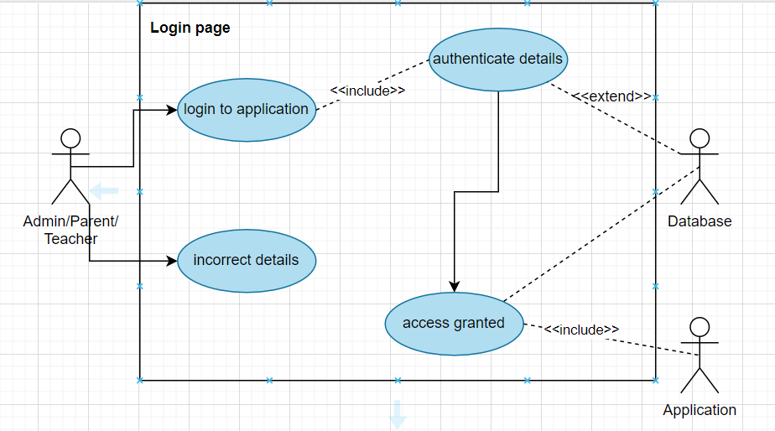

Figure 1 Use Case login page

### Today Activity

Figure 2 Use Case Today Activity

### Profile

Figure 3 Use Case Profile

### Attendance

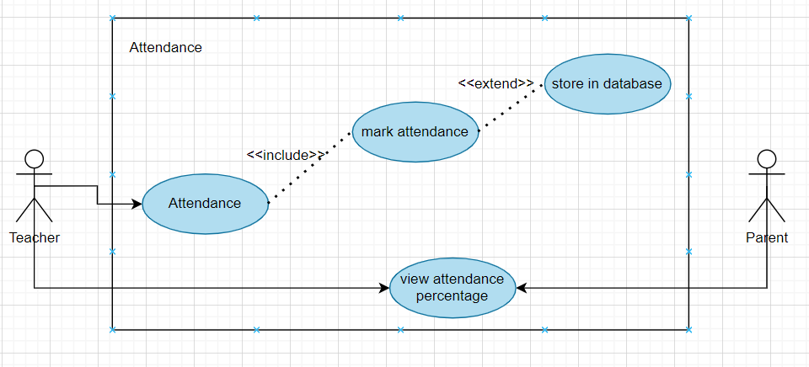

Figure 4 Use Case Attendance

### Announcement

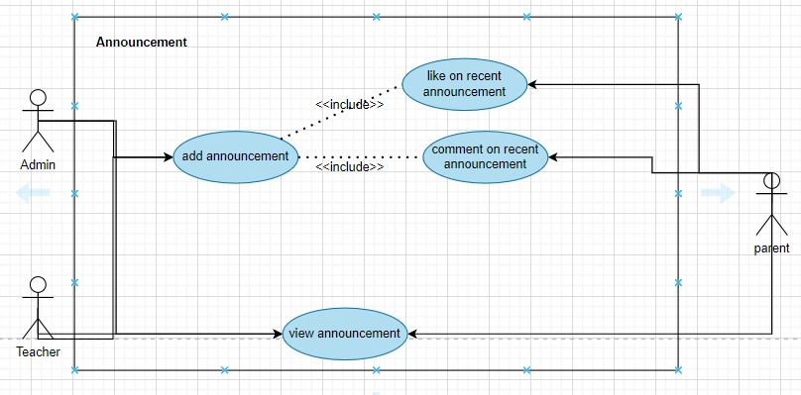

Figure 5 Use case Announcement

### Progress Report

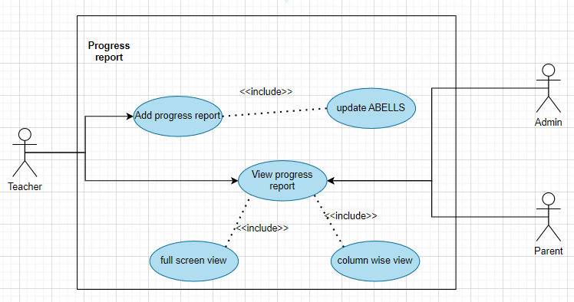

Figure 6 Use Case Progress Report

### Chat

Figure 7 Use Case Chat

### Register Student

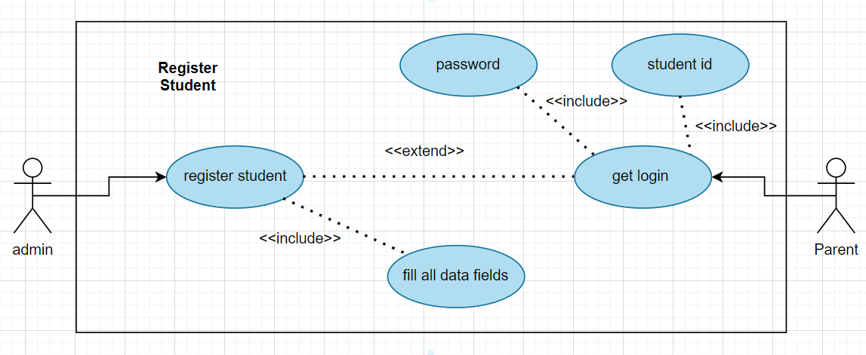

Figure 8 Use Case Register Student

### Register Teacher

Figure 9 Use Case Register Teacher

### Create Class

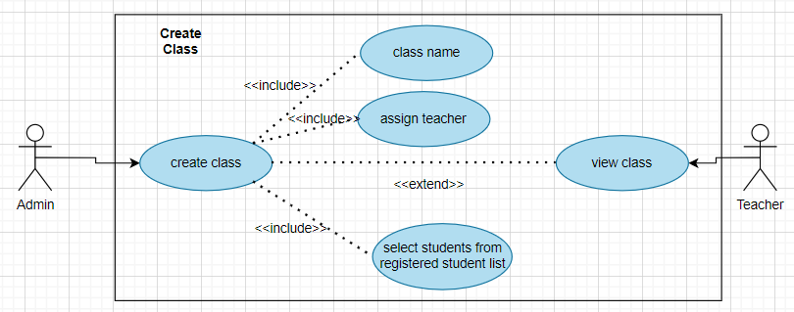

Figure 10 Use Case Create Class

## Software development life cycle model

After detailed research on our project we have decided to use Incremental Model. The reason for choosing this model is

1) There are multiple deliverables involved in between the process of software development.

2) The requirements have been properly drafted by the analyst, so there is no need to change any requirements.

3) The team is small, so they can start working on each module development by taking up one phase each member based on the priority set by stakeholder.

4) The software is broken into several independent functional units which are loosely coupled.

5) Each fragment can be delivered independently based on the deadline.

6) The team can split into groups for each phase and finish the build as required.

7) Highest priority requirement is tackled first.

# Chapter 3 System Design

## Work Break down Structure (WBS)

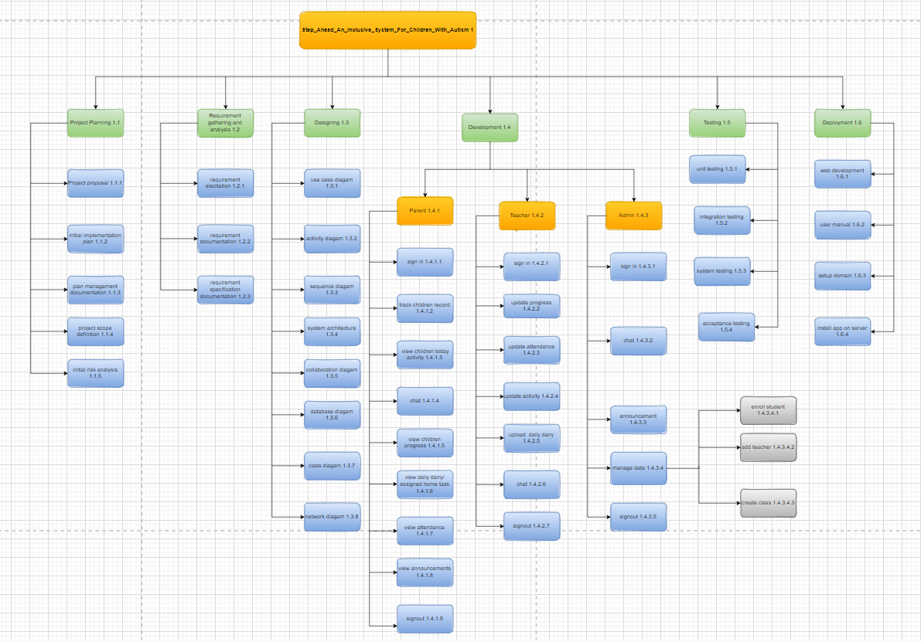

Figure 11 Work Breakdown Structure

## Activity diagram

### User Login

Figure 12 Activity Diagram User login

### Add Student

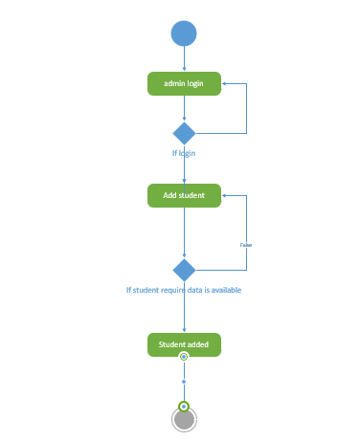

Figure 13 Activity Diagram: Add Student

### Add Teacher

Figure 14 Activity Diagram Add Teacher

### Attendance

Figure 15 Activity Diagram Attendance

### Chat

Figure 16 Activity Diagram Chat

### Create Class

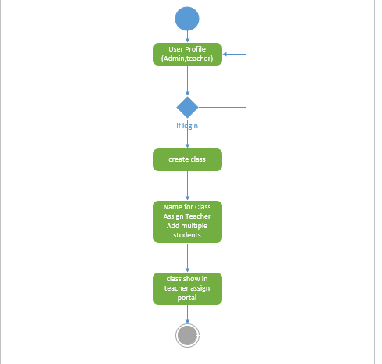

Figure 17 Activity Diagram Create Class

### Profile

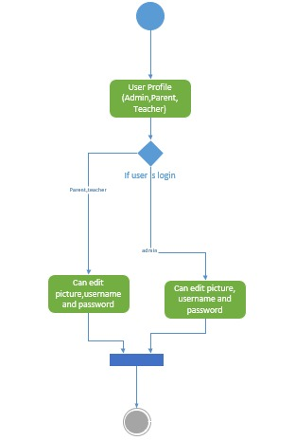

Figure 18 Activity Diagram Profile

### Progress Report

Figure 19 Activity Diagram Progress Report

### Today Activity

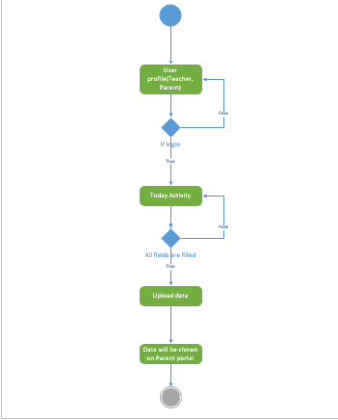

Figure 20 Activity Diagram Today Activity

### Recent Announcement

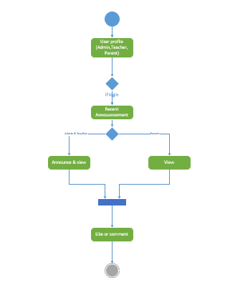

Figure 21 Activity Diagram Recent Announcement

### Logout

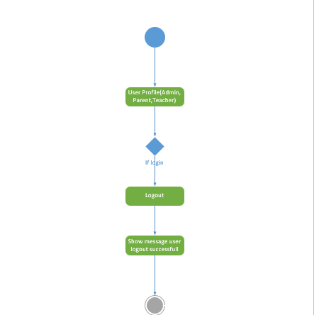

Figure 22 Activity Diagram Logout

## Sequence Diagram

### Log in

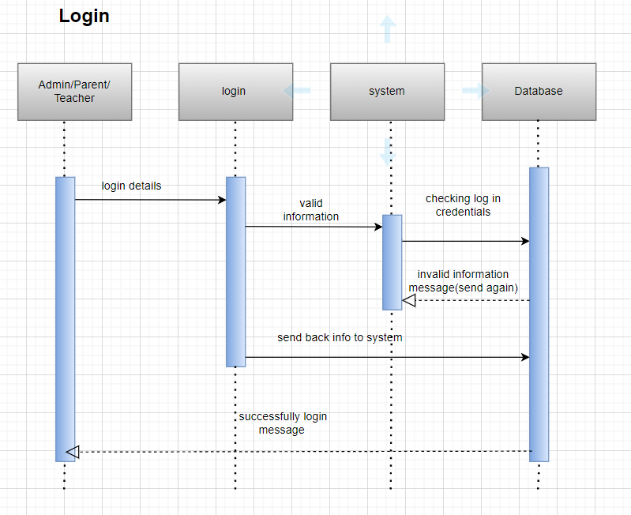

Figure 23 Sequence diagram login

### Today Activity

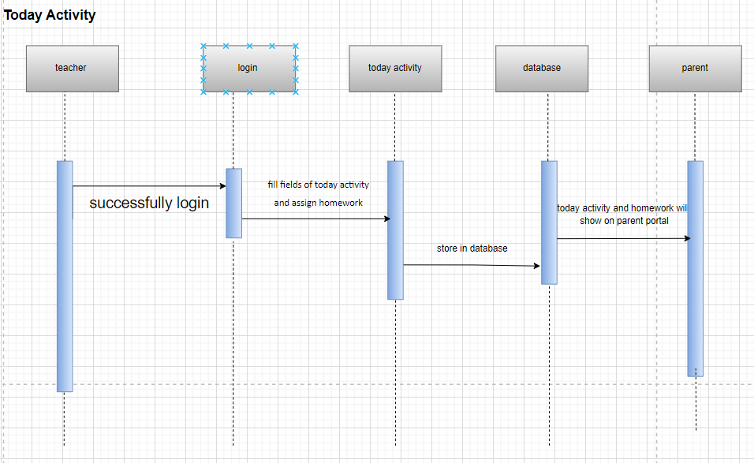

Figure 24 Sequence diagram Today Activity

### Profile

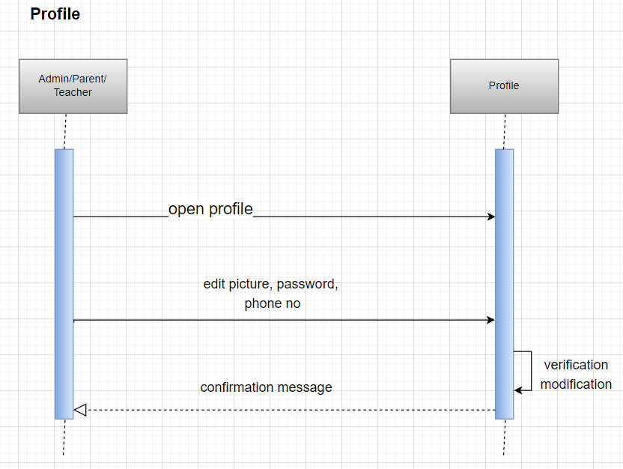

Figure 25 Sequence diagram Profile

### Attendance

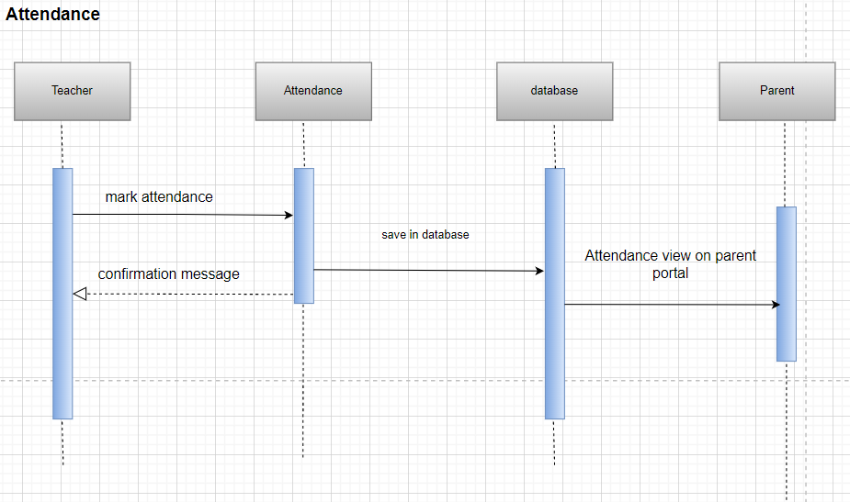

Figure 26 Sequence diagram Attendance

### Announcement

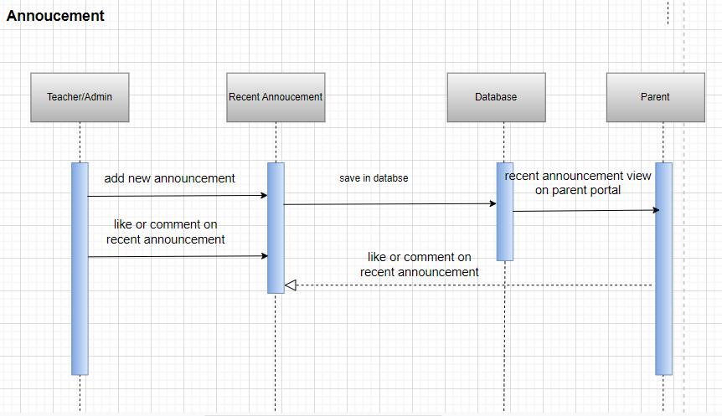

Figure 27 Sequence diagram Announcement

### Progress Report

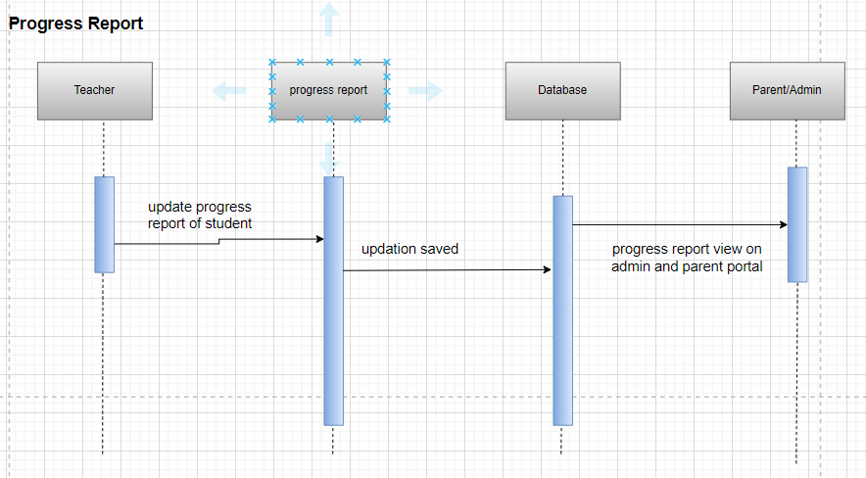

Figure 28 Sequence diagram Progress Report

### Chat

Figure 29 Sequence diagram Chat

### Register Student

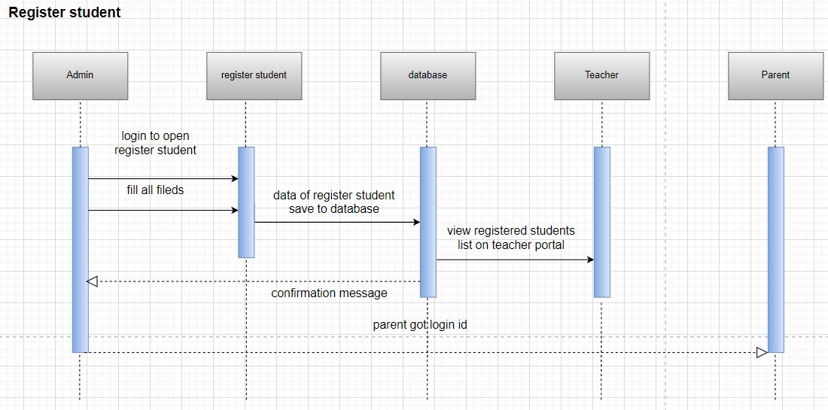

Figure 30 Sequence diagram Register student

### Register teacher

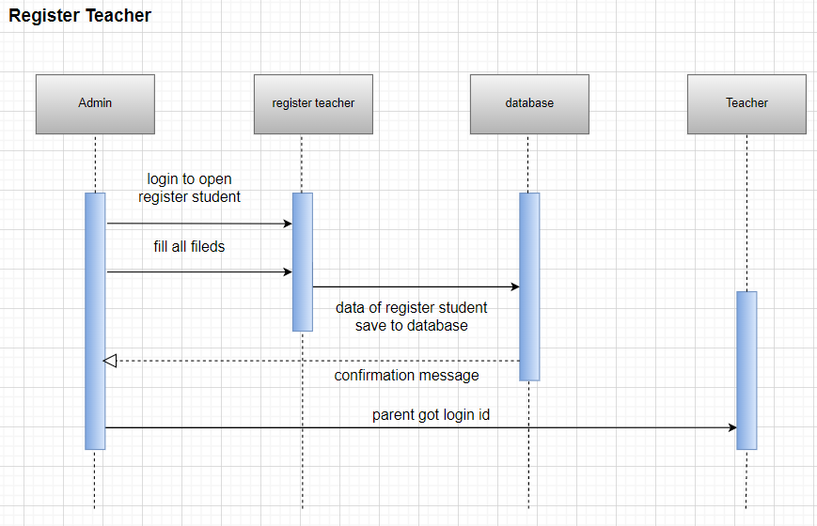

Figure 31 Sequence diagram register teacher

### Create class

Figure 32 Sequence diagram create class

## Software architecture

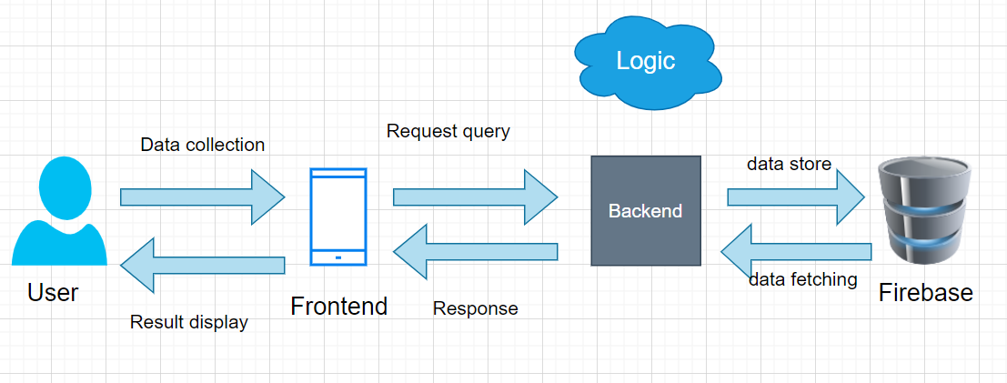

Figure 33 Software Architecture

## Class Diagram

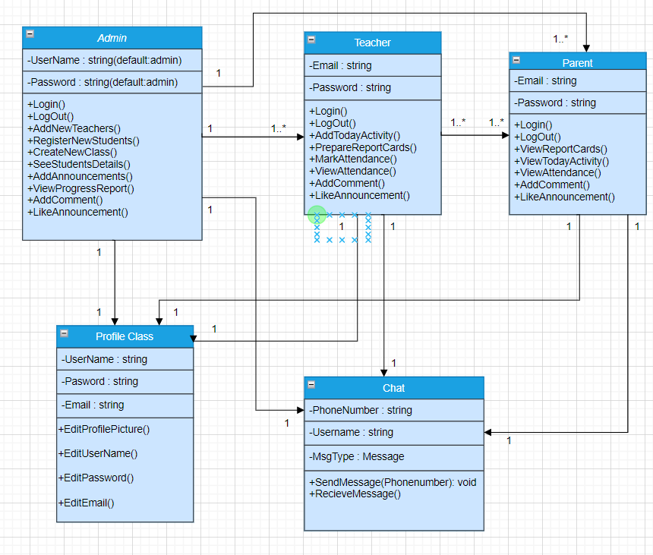

Figure 34 Class diagram

## ERD

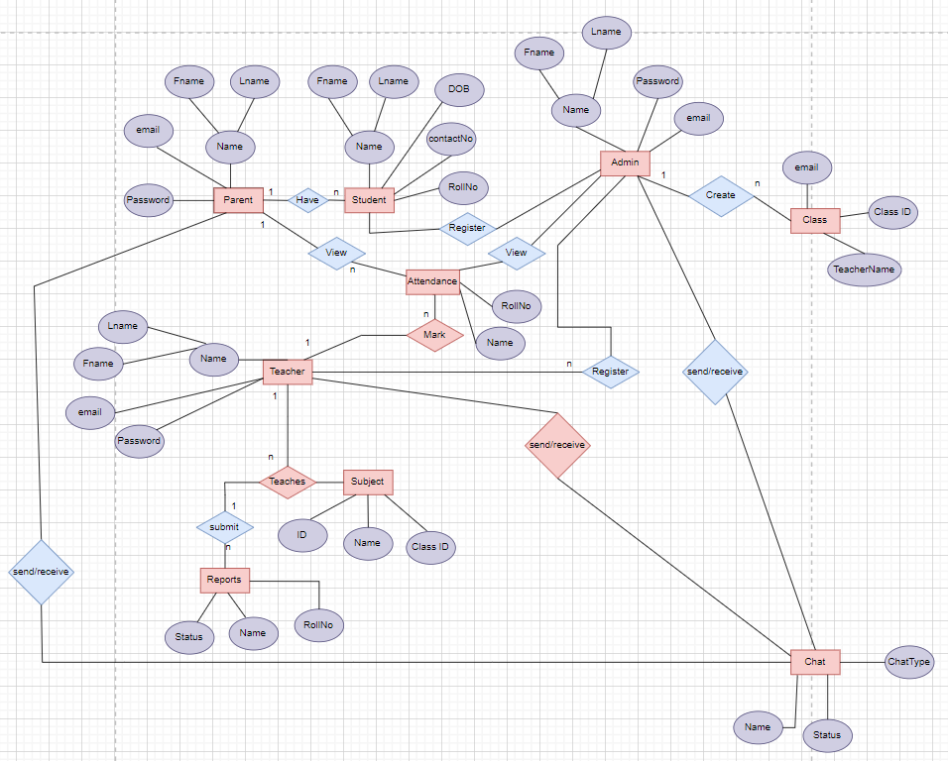

Figure 35 ERD

## Network Diagram/Gantt chart

Figure 36 Gantt chart

# Chapter 4: System Testing

## Test Cases

### Today Activity

|  |  |  |  |  |
| --- | --- | --- | --- | --- |
| **Id** | | TC001 | | |
| **Name** | | Today activity | | |
| **Tested By** | | Aqsa Nawaz | | |
| **Date** | | 12/27/2022 | | |
| **Description** | | Test functionality of filling all fields of today activity. | | |
| No | **Test Steps** | | Expected Result | **Actual** |
| 1 | Teacher select emoji for today mode | | Parent will view selected emoji on his/her portal. | - |
| 2 | Teacher selects if student has done lunch or not | | Parent will view lunch status either child done lunch or not in school. | - |
| 3 | Teacher selects activities which student done in school. | | Parent will view selective activities as marked one. | - |
| 4 | Teacher type home task for student. | | Home task will be viewed on parent portal. | - |
| 5 | Teacher clicks save button. | | Filled today activity page saved and uploaded on parent portal. | - |

Table 18 Test case Today Activity

### Sign In

|  |  |  |  |  |
| --- | --- | --- | --- | --- |
| **Id** | | TC002 | | |
| **Name** | | Sign In | | |
| **Tested by** | | Aqsa Nawaz | | |
| **Date** | | 12/27/2022 | | |
| **Description** | | Test Functionality of sign in. | | |
| **No** | **Steps** | | **Expected Result** | **Actual Result** |
| 1 | Users enter invalid email but valid password and click on login button | | Error message will be shown to user related to invalid email. | - |
| 2 | Users enter valid email but invalid password and click on login button | | Error message will be shown to user related to invalid password. | - |
| 3 | User enters valid email and password and click on login button. | | Login successful and redirected to dashboard. | - |
| 4 | User clicks on the forgot password link and gives his email and clicks on “send verification code” button. | | Code should be sent from server to user through email. | - |

Table 19 Test case – Sign In

### Attendance

|  |  |  |  |  |
| --- | --- | --- | --- | --- |
| **Id** | | TC002 | | |
| **Name** | | Attendance | | |
| **Tested by** | | Aqsa Nawaz | | |
| **Date** | | 12/27/2022 | | |
| **Descr**  **Iption** | | Test case for marking attendance. | | |
| No | **Steps** | | **Expected Result** | **Actual Result** |
| 1 | Teacher will click on the P or A button. | | It will mark the student present(P) or absent(A). | - |
| 2 | Teacher will click on the save button. | | Attendance will be uploaded and viewable in parent portal. | - |

Table 20 Test case –Attendance

### Logout

|  |  |  |  |  |
| --- | --- | --- | --- | --- |
| **Id** | | TC004 | | |
| **Name** | | Logout | | |
| **Test by** | | Huma Nadir | | |
| Date | | 12/27/2022 | | |
| **Description** | | Logout from portal. | | |
| **No** | **Steps** | | **Expected Result** | **Actual Result** |
| 1 | * After successfully logging into the account, user click on profile icon, Logout button will be visible to the user. | | * Logout button will be navigated to log in page. | - |
| 2 | User click on logout button, user is redirected to the login page. | | * Verify by clicking on log out button without internet connection. | - |

Table 21 Test case –Logout

### Chat

|  |  |  |  |  |
| --- | --- | --- | --- | --- |
| **Id** | | TC005 | | |
| **Name** | | Chat | | |
| **Test by** | | Huma Nadir | | |
| Date | | 12/27/2022 | | |
| **Description** | | Parent can chat with Admin and teacher | | |
| **No** | **Steps** | | **Expected Result** | **Actual Result** |
| 1 | * User clicks on chat icon, chat box will be opened and user will send message to admin. | | * Images or text message will be sent to receiver(admin/teacher) | - |
| 2 | Users can edit or deleted message. | | * Message will be deleted. | - |
| 3 | User can send up to 200 words of chat in one message. | | Message is sent to the end user. | - |

Table 22 Test case Chat

### Register Student

|  |  |  |  |  |
| --- | --- | --- | --- | --- |
| **Id** | | TC006 | | |
| **Name** | | Register student | | |
| **Test by** | | Huma Nadir | | |
| Date | | 12/27/2022 | | |
| **Description** | | Test functionality for registering student | | |
| **No** | **Steps** | | **Expected Result** | **Actual Result** |
| 1 | * Admin after login is redirected to the home page. | | * Admin can see home page. | - |
| 2 | Admin clicks on Register Student icon. | | * Register student page will be opened. | - |
| 3 | Admin fills the data of student. | | Suggestions will be shown which type of data is required. | - |
| 4 | Admin click on Register Button. | | * Added student will be shown on registered student list | - |

Table 23 test case Register Student

### Register Teacher

|  |  |  |  |  |
| --- | --- | --- | --- | --- |
| **Id** | | TC006 | | |
| **Name** | | Register teacher | | |
| **Test by** | | Durr e Sabeeh | | |
| Date | | 12/27/2022 | | |
| **Description** | | Test functionality for registering Teacher | | |
| **No** | **Steps** | | **Expected Result** | **Actual Result** |
| 1 | * Admin after login is redirected to the home page. | | * Admin can see home page. | - |
| 2 | Admin clicks on Register Teacher icon. | | * Register Teacher page will be opened. | - |
| 3 | Admin fills the data of Teacher. | | Suggestions will be shown which type of data is required. | - |
| 4 | Admin click on Register Button. | | * Added teacher will be shown on registered Teacher list. | - |

Table 24 test case Register teacher

### Create Class

|  |  |  |  |  |
| --- | --- | --- | --- | --- |
| **Id** | | TC007 | | |
| **Name** | | Create class | | |
| **Test by** | | Durr e Sabeeh | | |
| Date | | 12/27/2022 | | |
| **Description** | | Test functionality for creating class | | |
| **No** | **Steps** | | **Expected Result** | **Actual Result** |
| 1 | * Admin after login is redirected to home page. | | * Admin can see the home page and administrative options. | - |
| 2 | Admin clicks on the create class icon. | | * Admin redirected to the create class page. | - |
| 3 | Admin fills the data for creating class. | | Suggestions will be shown for filling data. | - |
| 4 | Admin click on the create button. | | * Created class will be shown in teacher portal. | - |

Table 25 test case Create class

### Progress Report

|  |  |  |  |  |
| --- | --- | --- | --- | --- |
| **Id** | | TC008 | | |
| **Name** | | Progress report | | |
| **Test by** | | Durr e Sabeeh | | |
| Date | | 12/27/2022 | | |
| **Description** | | Test functionality for uploading progress report | | |
| **No** | **Steps** | | **Expected Result** | **Actual Result** |
| 1 | * User after login is redirected to home page. | | * User can see the home page and other options. | - |
| 2 | Teacher clicks on the progress report icon. | | * Progress report page containing ABLLS will be shown. | - |
| 3 | Teacher fill the ABLLS chart for report of student. | | Three colors will be shown as a suggestion for filling. | - |
| 4 | Teacher can click on full screen or single column icon. | | * The screen will response accordingly. | - |
| 5 | Teacher clicks on upload button. | | * Progress report will be updated on admin and parent portal. |  |

Table 26 test case Progress report

### Recent Announcement

|  |  |  |  |  |
| --- | --- | --- | --- | --- |
| **Id** | | TC009 | | |
| **Name** | | Recent Announcement | | |
| **Test by** | | Durr e Sabeeh | | |
| Date | | 12/27/2022 | | |
| **Description** | | Test functionality for Recent announcement | | |
| **No** | **Steps** | | **Expected Result** | **Actual Result** |
| 1 | * User after login is redirected to home page. | | * User can see the home page and other options. | - |
| 2 | User (admin, teacher) view or add recent announcement. | | * Announcement will be shown and updated on parent portal. | - |
| 3 | Users click on like and comment button. | | Likes and comments will be added and updated on user portal. | - |

Table 27 test case Recent announcement

# Conclusion

## Problems faced and lessons learned

**Problems Faced**

* Changing requirements
* Difficulty in managing the scope of the project
* Lack of clear requirements
* Lack of skills and expertise to decide the architecture

**Lessons Learned**

* The need for regular review and updates
* The benefits of using appropriate tools and technologies
* Communication with faculty and supervisor
* Using project management tools such as MS Project
* The value of collaboration with team members

## Project summary

Step ahead an inclusive learning management system for children with autism will be a mobile app. It is a mutual platform for both parents and school administration where they can communicate easily. This app consists of three portals (parent, teacher, and admin) which cover these functionalities.

Admin can be able to

* Register students and teachers
* Assign valid ids to registered students and teachers.
* Add, like or comment on new announcements,
* Create class,
* Edit profile,
* Chat with teacher and parents
* View progress report of students.

Teacher can be able to

* Add, like or comment on new announcements,
* Edit profile,
* Update today activity,
* Chat with admin and parents
* Add attendance
* Add Progress report of students.

Parents can be able to

* View, like, and comment on recent announcement
* View attendance, today activity and progress report of their child
* Edit profile
* Chat with admin and teacher

## Future work

These modules will be added in our future work.

* Fee vouchers module will be added.
* Online fee submission
* Notification feature for fee with due date
* Web based admin portal.
* Module in which admin takes review from parents.

# References

* OASIS Unlock the potential (September 06,2022), ‘OASIS SCHOOL IS A DREAM’ <http://www.oasis.org.pk/> [1]
* Autism society of Pakistan (September 06,2022), ‘What is autism?’ <https://autismpak.com/> [2]
* ARCL Autism Resource Center Lahore (September 06,2022),’A School For Kids With Autism Disorder Spectrum’ <https://arcl.org.pk/> [3]
* Elemy (September 10,2022),’Life-changing care for autism’ <https://www.elemy.com/> [4]
* King’s InterHigh leading online school (September 10,2022),’Online schools for autistic Children’ <https://kingsinterhigh.co.uk/online-british-school/online-schools-autistic-children/> [5]
* Gemm learning (September 10,2022),’HomeSchool Autism Help’ <https://www.gemmlearning.com/can-help/homeschool/autistic-children/> [6]

# 

# Plagiarism Report

# 

# HFPs

# Teacher Portal

# 

# 

# 

# 

# Admin Portal

# 

# 

# Parent Portal

# 

