Table of Contents
1. Introduction 3
2. Problem Statement 3
3. Problem Solution/Objectives of the Proposed System 3
3.1 Objectives 3
4. Related System Analysis 4
5. Scope 4
6. System Limitations/Constraints 4
7. Data Gathering Approach 4
8. Tools and Technologies 5
9. Dataset Preprocessing 5
10. Model Pipeline Design 5
11. Model Performance Evaluation 5
12. Findings 6
13. Which Model Performed Better and Why? 6
14. Critical Analysis of the Project 6
15. Visual Results / Mockups 6

1. Introduction
This project aims to predict whether a bank customer will subscribe to a term deposit using machine learning classification techniques. The analysis uses the UCI Bank Marketing Dataset, implementing Decision Trees, Naïve Bayes, Random Forest, and SVM within Scikit-Learn pipelines for efficient preprocessing and model training.

2. Problem Statement
The marketing departments in banks often run term deposit campaigns that yield low subscription rates due to non-targeted outreach. These campaigns incur significant costs without yielding proportional results. One major issue is the inability to accurately identify which customers are most likely to subscribe. This project seeks to address this by building a machine learning-based solution that can analyze past campaign data to identify key indicators of customer interest. Accurate prediction of customer responses can optimize resource allocation and enhance campaign success.

3. Problem Solution/Objectives of the Proposed System
To tackle the inefficiency in traditional marketing campaigns, a data-driven machine learning model has been proposed. The solution involves automating the entire predictive modeling workflow using pipelines in Python. This ensures systematic preprocessing, robust model training, and consistent evaluation. The system is trained on a real-world dataset that captures customer demographics, behavior, and prior campaign outcomes. Our solution uses four classification algorithms—Decision Tree, SVM, Naïve Bayes, and Random Forest—and compares their performance to select the most effective approach. The insights generated from the model are intended to guide marketing strategies.

3.1 Objectives
- Build a predictive classification model for bank term deposit subscriptions.
- Automate data preprocessing, model training, and evaluation using Scikit-Learn pipelines.
- Compare performance of various classifiers using appropriate metrics.
- Extract key features influencing predictions to provide business insights.
- Assist banks in implementing cost-effective and successful marketing strategies.

4. Related System Analysis
Previous efforts in this domain often relied on standalone models, lacking an integrated approach to data preprocessing and training. In many cases, inconsistent data handling led to unreliable results. Traditional models also struggled to deal with class imbalance or to interpret feature importance effectively. With the introduction of pipelines, machine learning workflows can now be standardized, reducing manual intervention and increasing reproducibility. Our project builds on these advancements to ensure high performance and consistency.

5. Scope
The system is designed to assist financial institutions, particularly banks, in refining their term deposit marketing strategies. Its scope extends from academic and research domains to practical implementations in CRM systems. The model can be adapted for similar classification tasks in other industries where customer behavior prediction is essential. Limitations of the dataset, however, restrict the model's generalizability beyond the features provided, and updates may be needed to accommodate evolving trends in customer behavior.

6. System Limitations/Constraints
- The dataset is highly imbalanced, with only 11.7% of customers subscribing, which may bias the model.
- The analysis is limited to structured data; unstructured inputs such as customer feedback or emails are not considered.
- Performance is dependent on the quality of input data, and feature engineering is limited to the dataset's original attributes.
- While pipelines enhance consistency, they also limit flexibility in fine-tuning specific stages.

7. Data Gathering Approach
The data was collected from the UCI Machine Learning Repository. It contains 11,162 instances and 17 features, including both numerical and categorical data. Attributes such as age, job, marital status, education, balance, and contact method were used to train the model. The dataset reflects marketing campaigns run by a Portuguese banking institution. Data preprocessing and analysis were conducted using Jupyter Notebook with the help of Python libraries such as pandas, numpy, and scikit-learn. The dataset was explored thoroughly before applying preprocessing techniques.

8. Tools and Technologies
- Python: The primary programming language used for the project.
- Jupyter Notebook: For interactive data exploration, visualization, and development.
- Scikit-Learn: For implementing machine learning models and pipelines.
- Pandas and NumPy: For data manipulation and preprocessing.
- Matplotlib and Seaborn: For data visualization and exploratory analysis.

9. Dataset Preprocessing
The dataset underwent a series of preprocessing steps before model training. First, missing values were handled using median imputation for numerical features and the most frequent category for categorical ones. Next, categorical features were converted into numerical values using one-hot encoding, allowing the models to process them effectively. Numerical features were standardized using StandardScaler to ensure equal weighting. Finally, the data was split into training (80%) and testing (20%) sets to evaluate model performance. All preprocessing steps were embedded within the Scikit-Learn pipeline for efficiency and to prevent data leakage.

10. Model Pipeline Design
The pipeline design included both preprocessing and classification stages. It automated the process of transforming data and training models. The pipeline consisted of the following steps: imputation, encoding, scaling, and model fitting. This was implemented for each classifier—Decision Tree, SVM, Naïve Bayes, and Random Forest. Pipelines not only ensured reproducibility but also helped reduce manual coding errors and improved scalability. Once the pipeline was defined, it was trained and tested on the split dataset, allowing for rapid iteration and consistent evaluation.

11. Model Performance Evaluation
Each classifier's performance was assessed using a range of evaluation metrics: accuracy, precision, recall, F1-score, and ROC-AUC. Random Forest achieved the highest performance with an F1-score of 0.80 and ROC-AUC of 0.88, demonstrating its robustness. The SVM also performed well but required careful tuning of hyperparameters. Naïve Bayes was the least accurate but offered fast computation. Confusion matrices were generated for each model to visualize performance across classes, especially in identifying false positives and false negatives. ROC curves highlighted the trade-offs in model sensitivity and specificity.

Performance Comparison
Model | Accuracy | Precision | Recall | F1-Score | ROC-AUC
Random Forest | 0.91 | 0.82 | 0.78 | 0.80 | 0.88
Decision Tree | 0.89 | 0.76 | 0.72 | 0.74 | 0.75
SVM | 0.90 | 0.80 | 0.70 | 0.75 | 0.86
Naïve Bayes | 0.85 | 0.68 | 0.65 | 0.66 | 0.81

12. Findings
The top predictive features were identified as duration of call, contact type, month of contact, and previous campaign outcomes. Longer calls and successful past campaigns increased the likelihood of subscription. Cellular contact was more effective than landlines. These insights can be used by banks to target the right customers and optimize call strategies. Random Forest provided the best balance of sensitivity and specificity. The use of pipelines improved both accuracy and training efficiency. The model is ready for deployment in customer relationship systems to guide real-time decision-making.

13. Which Model Performed Better and Why?
Among the models tested, Random Forest outperformed the rest in nearly every metric. Its ability to handle feature interactions and its robustness against overfitting contributed to its superior performance. While SVM provided competitive results, it was computationally more intensive and sensitive to hyperparameter tuning. Decision Trees were interpretable but prone to overfitting. Naïve Bayes was the fastest but least accurate. Therefore, Random Forest is the most suitable model for this classification task due to its high accuracy, balanced precision and recall, and adaptability to different types of features.

14. Critical Analysis of the Project
The use of pipelines significantly enhanced the reliability and reusability of the machine learning workflow. It minimized human error in preprocessing and made the training process more efficient. However, the project also revealed the challenges of handling imbalanced datasets. Metrics like F1-score and ROC-AUC were more reliable than plain accuracy in evaluating model performance. The feature importance analysis revealed valuable insights that can guide business decisions. Overall, the project achieved its objectives, though future improvements could involve resampling techniques, additional features, or ensemble methods.

15. Visual Results / Mockups
Visuals played a crucial role in interpreting and validating model performance. These included:
- Confusion matrices for each model to assess true vs. predicted labels
- Feature importance bar charts to highlight the most influential variables
- ROC curves to compare classifier sensitivity and AUC values

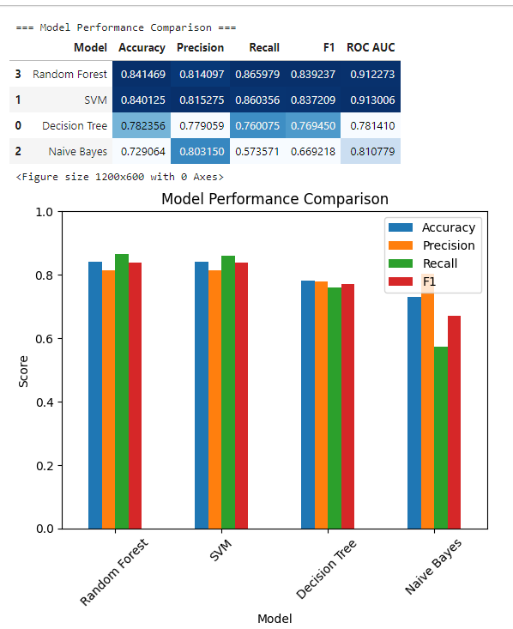

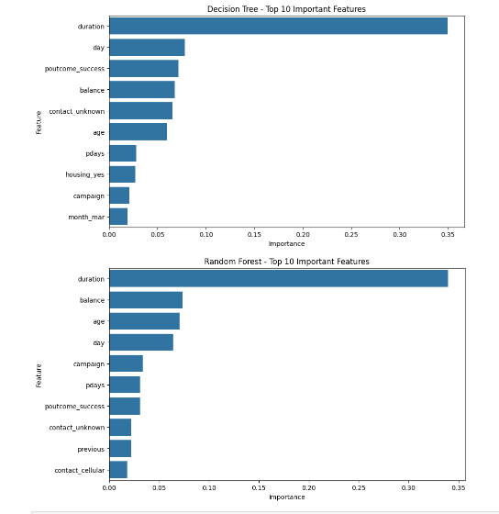
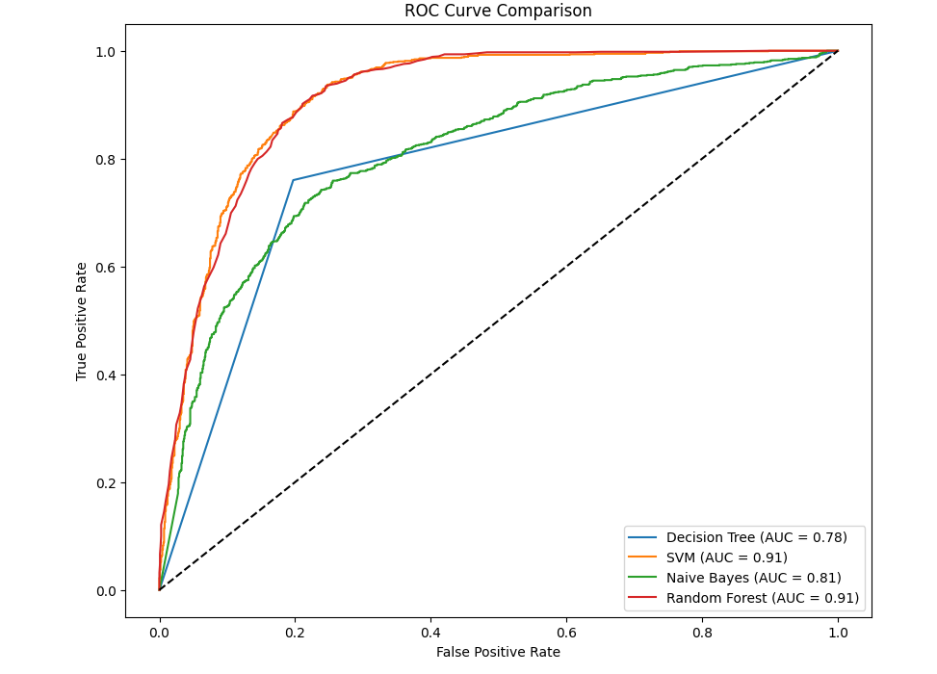
s

