Bahria University,

Karachi Campus

COURSE: CEN-409 ARTIFICIAL INTELLIGENCE

AND MACHINE LEARNING

TERM: FALL 2023, CLASS: BCE- 7A

Submitted By:

**DANIA SAMI**  **02-132202-025**

(Name) (Reg. No.)

Submitted To: **Engr. Qasim Hassan**

Signed Remarks: Score:

Bahria University,

Karachi Campus

LAB ASSIGMENT: 02

LIST OF TASKS

|  |  |
| --- | --- |
| TASK NO | OBJECTIVE |
| 1 | Given 3 int values, a b c, return their sum. However, if any of the values is a teen -- in the range 13..19 inclusive -- then that value counts as 0. |
| 2 | Given a string input Count all lower case, upper case, digits, and special symbols. |
| 3 | Given a string, return the sum and average of the digits that appear in the string, ignoring all other characters. |
| 4 | Given an array length 1 or more of ints, return the difference between the largest and smallest values in the array. Note: the built-in min(v1, v2) and max(v1, v2) functions return the smaller or larger of two values. |
| 5 | Return the number of times that the string "ant" appears anywhere in the given string, except we'll accept any letter for the 'n', so "art" and "abt" and other counts. |

Submitted On:

09 /10/2023

(Date: DD/MM/YY)

**TASK NO 01:**

**RETORT:**

**TASK NO 02:**

**RETORT:**

**TASK NO 03:**

**RETORT:**

**TASK NO 04:**

**RETORT:**

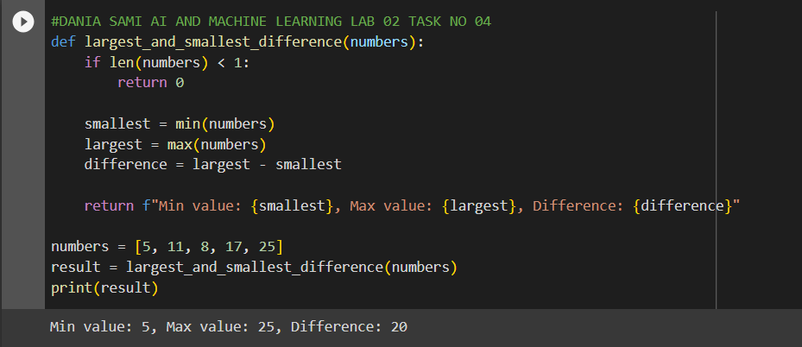

**TASK NO 05:**

**RETORT:**

