DIU CPC × upay AI Hackathon 2026 · Project Report
SalaryBridge
AI-powered earned-wage access for upay, repaid by the employer on payday
Track | 03 · Customer Innovation & Financial Independence (responsible credit readiness)
Team | NeuroVerse
Members | Md Abdul Quym Shanto — Leader, Frontend, AI Engineer, 241-15-053  Sajid Ahasan — AI/ML, 241-15-909  Sakibul Hasan Sakib — Backend Engineer, 241-15-048
Institution | Computer Science and Engineering, Daffodil International University
Live demo | https://salary-bridge-iota.vercel.app
Source code | https://github.com/aqshanto/SalaryBridge
Demo video | https://drive.google.com/drive/folders/18cgFP-ZswDTM1POsnOrVzhjxlWLzCTIX?usp=sharing
All data in this project is synthetic. No real customer, employer or upay data was used.

Contents
Abstract 3
1. Problem 3
1.1 Who has the problem 3
1.2 Why it is not solved today 3
1.3 Problem statement 3
1.4 Why upay, and why AI 3
2. Proposed idea 4
3. Implemented solution 4
3.1 Architecture 4
3.2 The four views 5
3.3 Settlement and simulation 6
4. Key features 6
5. AI approach 7
5.1 Data 7
5.2 Models 7
5.3 How a decision is made 7
5.4 Generative AI with guard-rails 7
6. Validation and results 8
6.1 The two misses 9
7. Responsible AI and security 9
8. Business and customer impact 9
8.1 Value for each party 9
8.2 Economics (one sandbox month, Profile A) 9
9. Real-life impact and path to production 10
10. Limitations 10
11. How to run and verify 10
Appendix A. Policy assumptions 11

Abstract
Monthly-paid workers in Bangladesh earn their wages every working day but receive them once a month, so a mid-month emergency often ends in costly informal credit. SalaryBridge is an AI-powered earned-wage access product for upay. A worker can draw up to 20% of salary from wages already earned, for a flat ৳25 fee with no interest, straight into the upay wallet. On payday the employer repays upay in one bulk transfer from a ready-made deduction list.
Published rules decide eligibility, while five models size each offer safely: employer late-payroll risk (M1), repayment-risk tiers (M2), risk of leaving before payday (M3), a P10–P90 capital forecast (M4) and a borrowing-pattern monitor (M5). Claude explains every decision in plain English or Bangla from an allow-listed fact sheet. Large, high-risk and unusual cases go to a human queue. On unseen months of a synthetic world, ML tiers cut the loss rate from 0.95% to 0.62% (1.55% to 1.31% in a harsher stress world). Eight of ten targets declared before the results pass, and the two misses are disclosed with their causes. The prototype is live with employee, employer, operations and validation views.

1. Problem

1.1 Who has the problem
Garment, factory, retail, school and hospital staff are typically paid once a month. Take Rahim, a garment worker earning ৳18,000 a month (a synthetic persona from the sandbox). By 20 October he has earned ৳11,612, yet he can reach none of it until 1 November. When a medicine bill or a school fee arrives in between, he borrows from a shopkeeper, a supervisor or a moneylender: costly, opaque and outside any wallet.

1.2 Why it is not solved today
- Lenders cannot see wages. Without payroll data nobody can size a safe advance, so the answer is usually no.
- Employers will not run it. Cash advances mean paperwork, recovery work and risk that HR does not want.
- A flat rule is either too tight or too loose. Treating every worker and employer the same either refuses people who are safe or loses money on people who leave or whose employer pays late.

1.3 Problem statement
For monthly-paid workers such as garment staff, the gap between earning wages and receiving them causes mid-month cash shortfalls that are filled with informal, costly credit. We will build SalaryBridge, an AI-powered earned-wage access product inside upay that uses payroll, tenure, employer reliability and repayment history to size a safe advance and recover it from the employer on payday, with success measured by the loss rate at an equal approval rate, coverage of the capital need and approval-rate gaps across groups.

1.4 Why upay, and why AI
An MFS already holds the wallet, the verified customer and the payment rails; what it lacks is a safe way to size credit against wages that are earned but not yet paid. AI adds value beyond a fixed rule because risk differs sharply between employers and between workers: the validation in Section 6 shows that ML tiers lose less than a flat cap in both synthetic worlds.

2. Proposed idea
Step | What happens | Who acts
1. Opt in | The employer joins and chooses a limit of up to 20% of salary. No cash and no paperwork. | Employer HR
2. Request | The worker opens SalaryBridge in upay, picks an amount and sees the fee, total deduction and date before confirming. | Worker
3. Decide | Rules check eligibility; models size the offer or send it to a person; every offer carries reasons. | SalaryBridge
4. Disburse | The money lands in the upay wallet; the flat ৳25 fee stays inside earned wages; no interest. | upay
5. Repay | On payday the employer sends one bulk transfer from the deduction list; wallet auto-debit, carry-over and write-off follow if needed. | Employer, upay

Design principle. Only published rules can decline a request (tenure, monthly count, cooling-off, employer status, kill switch). Models can only shrink an offer or send it to a human; the LLM only words the result. The hard cap is min(20% of salary, earned wages − amount already owed), so a worker can never owe more than they have earned.

3. Implemented solution

3.1 Architecture
The prototype follows the guideline's Input → Intelligence → Action reference architecture, with data preparation, model inference, business rules and LLM text kept in separate modules.
Synthetic world (payroll, staff, advances) | → | Point-in-time features | → | Rules + models M1–M5 | → | Offer, reasons, Claude wording | → | Wallet, ledger, payday settlement
Figure 1. Data flow from the synthetic world to the worker's wallet
Layer | Implementation
Data | Synthetic world generator (Python, pandas): 40 employers, about 6,000 positions, 24 months; seed database in SQLite
ML | LightGBM classifiers with calibration and SHAP reasons, quantile LightGBM with conformal intervals, IsolationForest
Generative AI | Anthropic Claude (claude-opus-5-5) for plain-language EN/BN explanations; deterministic templates as fallback
API | FastAPI with typed schemas; per-session simulation sandbox keyed by X-Session-Id; CORS allow-list; /health
Ledger | Double-entry ledger in integer paisa with a reconciliation check after every operation
Frontend | Next.js 16, React 19, Tailwind CSS, Recharts; mobile-first employee view; English/Bangla toggle
Hosting | API on Render, frontend on Vercel

3.2 The four views
Employee. A phone-sized screen with earned-to-date, the safe limit, one slider and an offer that shows the fee, total deduction and date with a reason before confirmation.
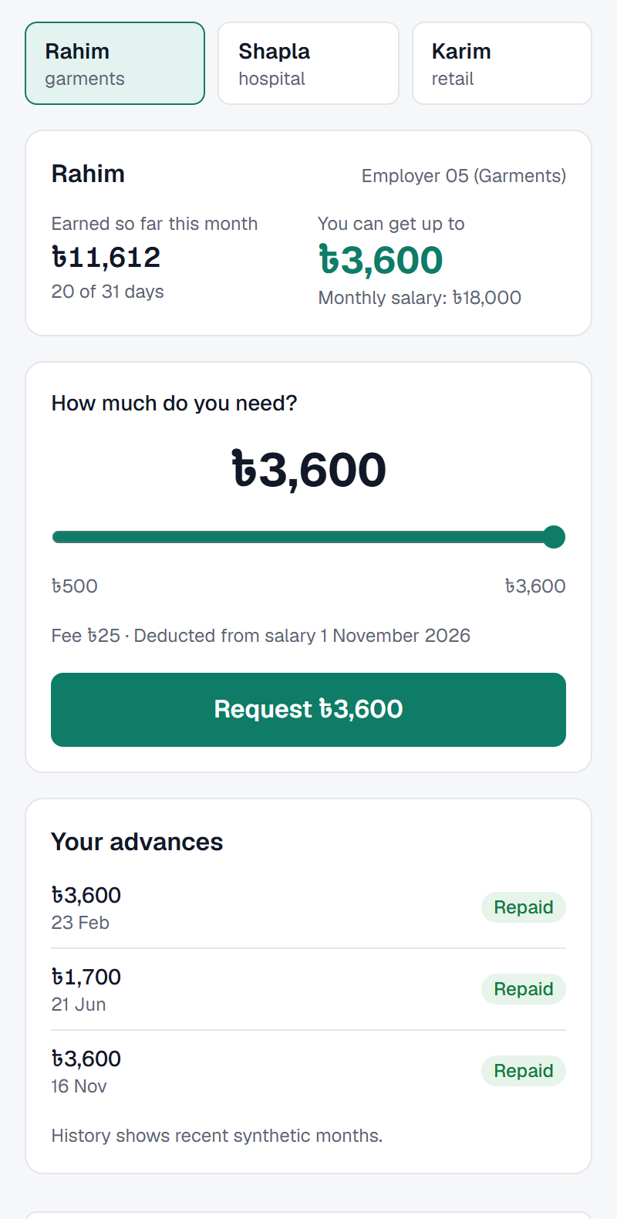 | 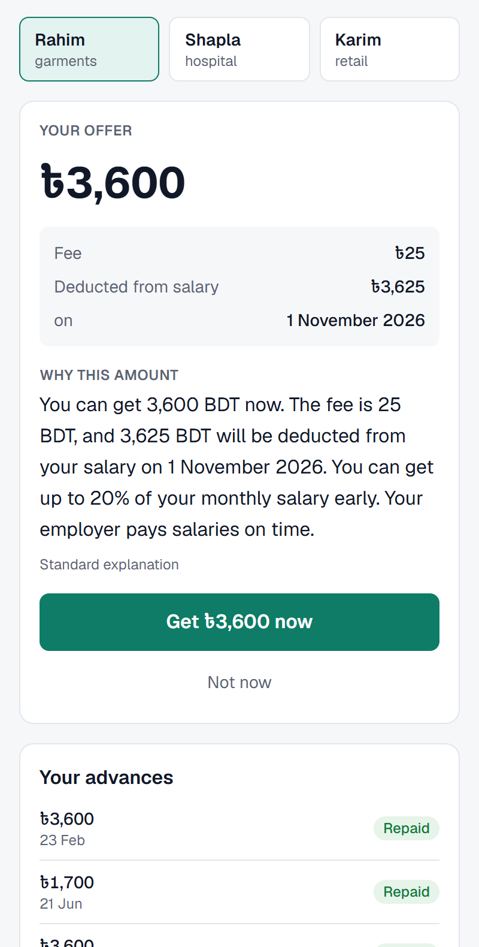 | 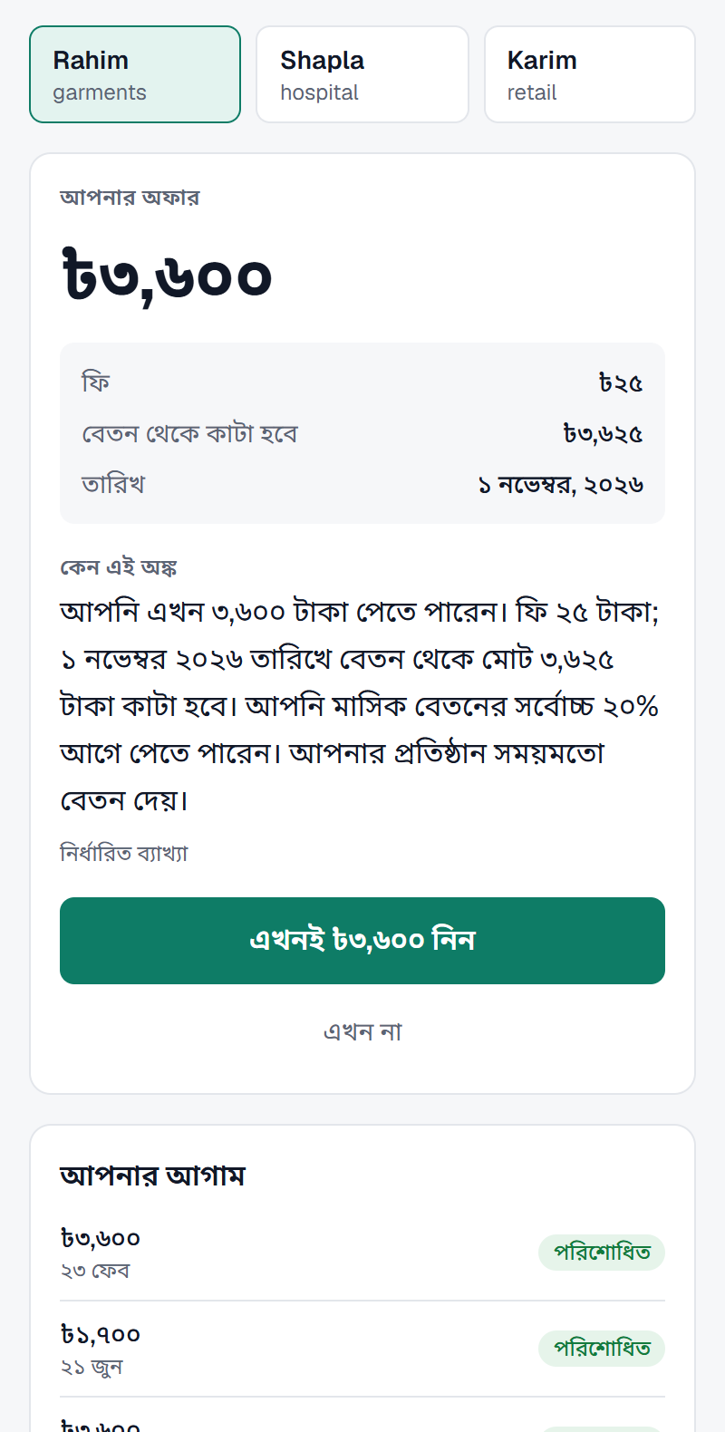
Earned to date and safe limit | Offer with fee, date and reason | The same offer in Bangla
Figure 2. Employee view (real screenshots of the running prototype, synthetic persona)
Employer HR and upay operations. HR gets a deduction notice and CSV and confirms one remittance. Operations sees outstanding advances, the capital forecast, the human approval queue, the kill switch, employer risk and the borrowing monitor.
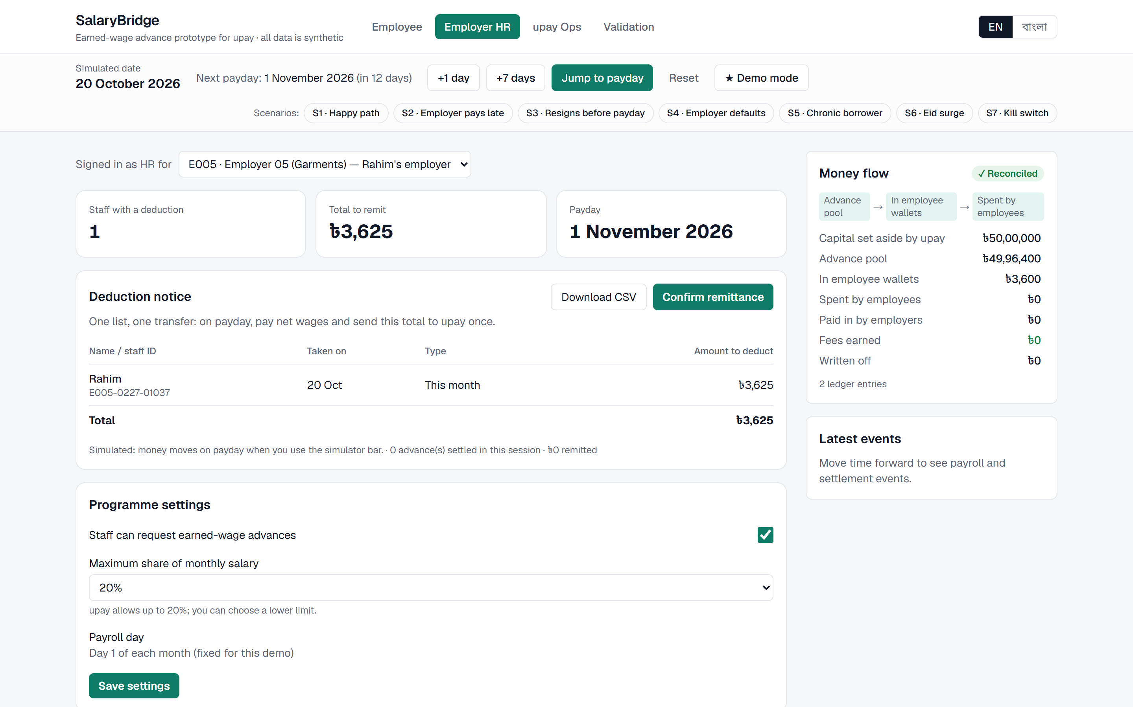
Figure 3. Employer HR: one deduction list and one remittance
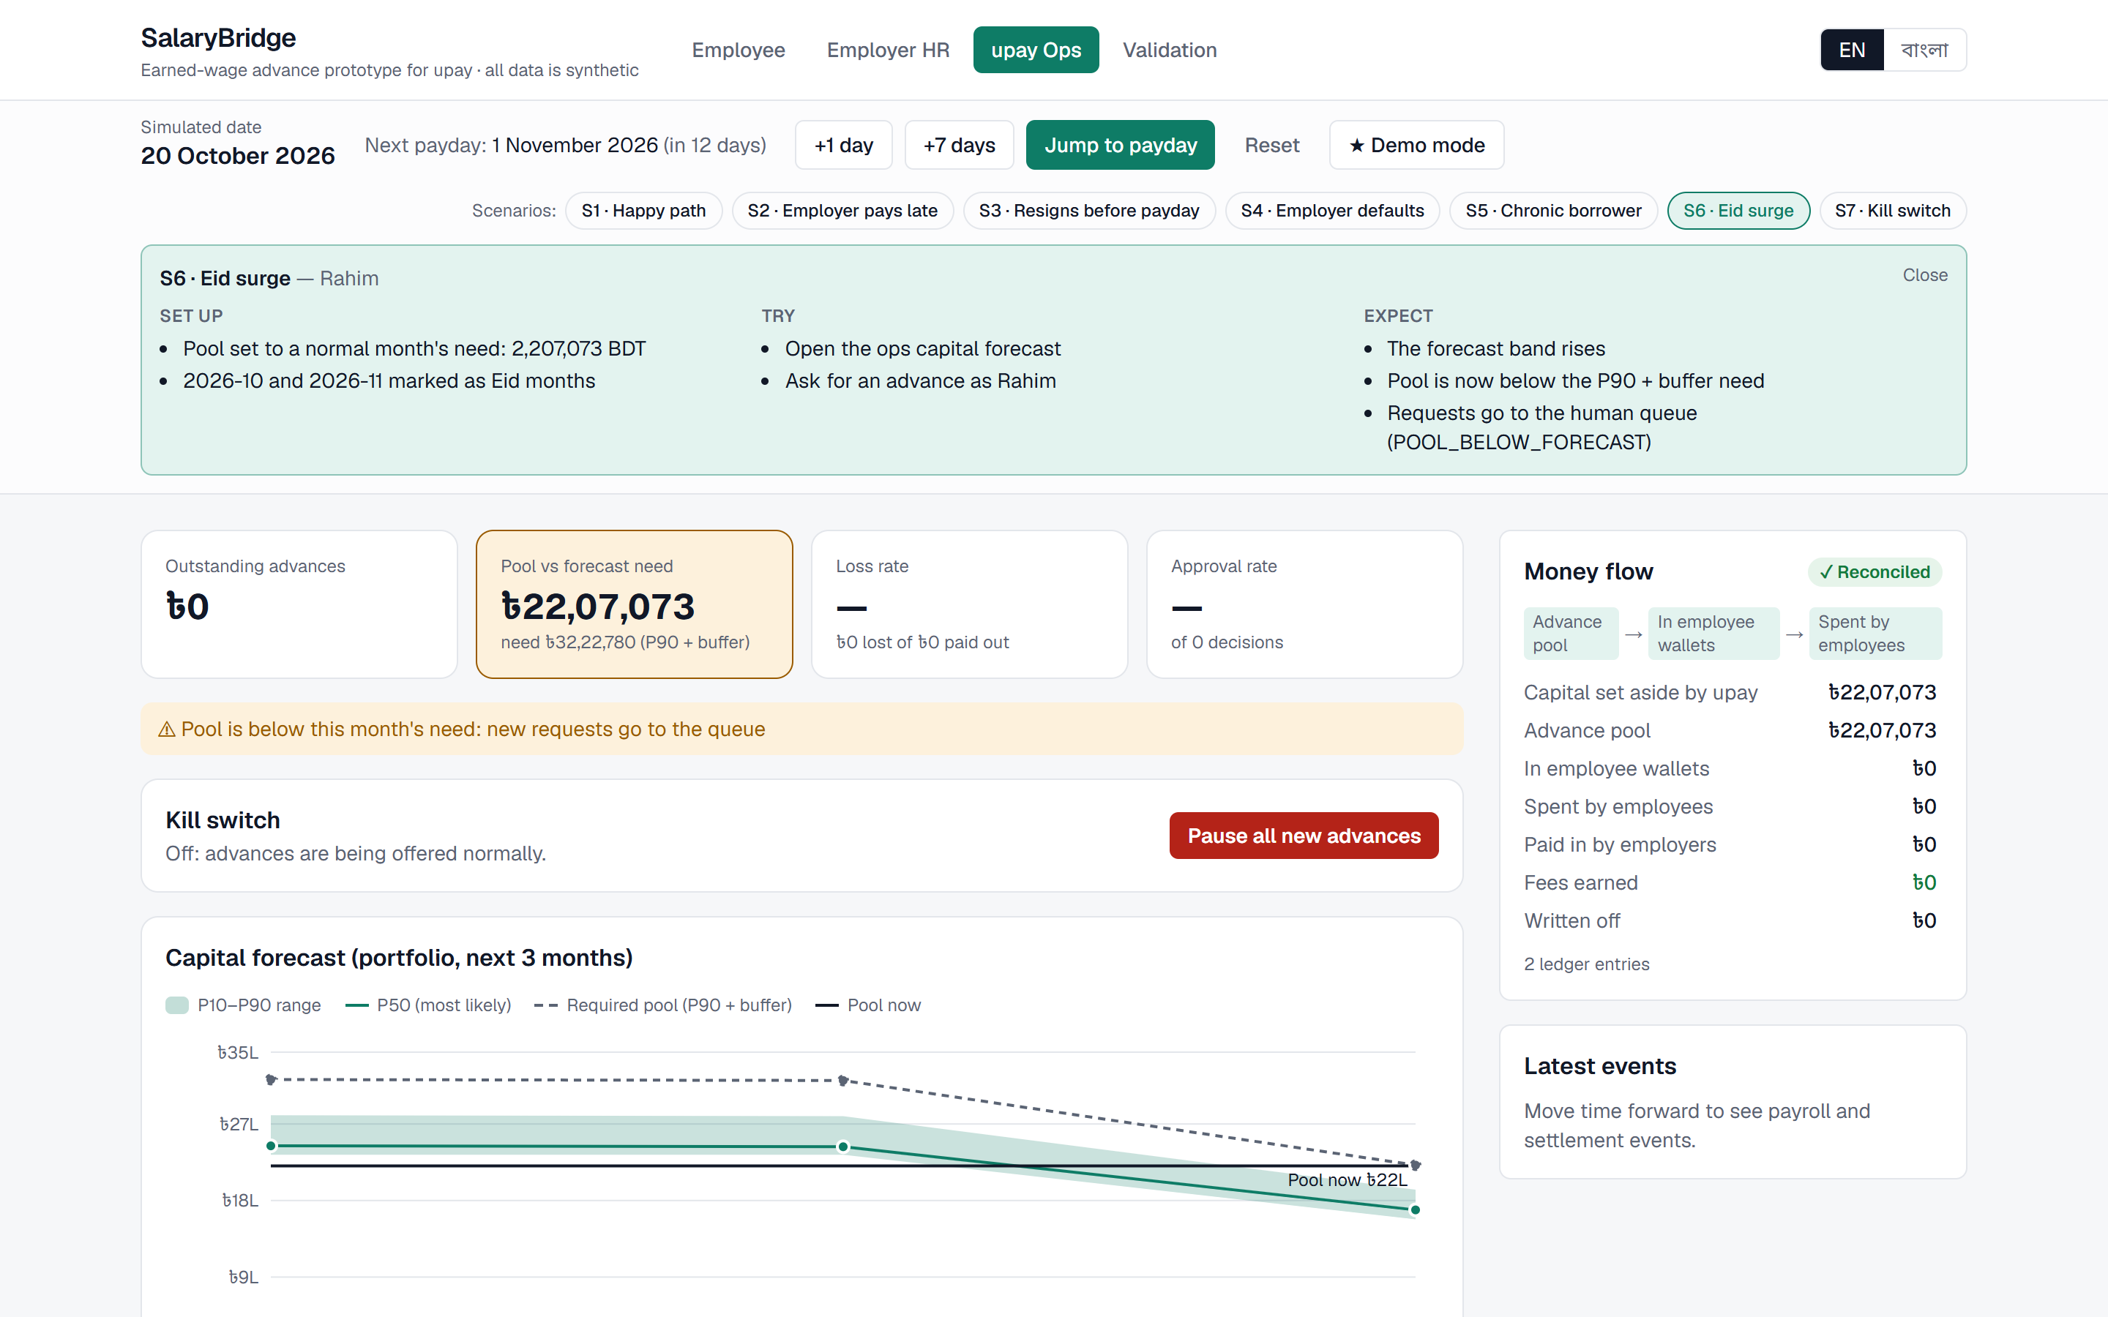
Figure 4. upay operations during scenario S6 (Eid surge): the required pool rises above the pool, so new requests queue

3.3 Settlement and simulation
A simulator bar moves time (+1 day, +7 days, jump to payday). On payday the settlement waterfall runs in a fixed order: employer remittance, then wallet auto-debit, then carry-over to the next payday with a smaller limit, then write-off after 60 days. Seven scenarios demonstrate the edge cases: S1 happy path, S2 employer pays late, S3 worker resigns before payday, S4 employer defaults, S5 chronic borrower, S6 Eid surge and S7 kill switch.

4. Key features
- Earned-wage advance with a hard cap of min(20% of salary, earned − owed), a minimum of ৳500 and at most two advances a month.
- Risk-sized offers: tier A/B/C keeps 100% / 70% / 40% of the cap; tier D goes to a person; a high risk of leaving steps the tier down.
- Explanations for every decision: a machine-readable rule trace and top SHAP reasons, worded in English or Bangla.
- Employer deduction notice with CSV export and one-click remittance confirmation; HR can lower the limit or switch the programme off.
- Capital forecast with a P10–P90 band; when the pool falls below P90 + 15%, new requests queue for a person.
- Human approval queue for amounts of ৳10,000 or more, tier D and anomaly-flagged requests; a kill switch pauses all new advances.
- Supportive cooling-off after three consecutive months of borrowing, worded as protection rather than punishment.
- Validation page with pre-declared targets, loss versus approval, calibration, fairness gaps and economics sliders, all read from generated files.
- Full Bangla mode with Bangla digits and lakh formatting, and a Demo mode that resets to a known starting point.

5. AI approach

5.1 Data
No production data is needed. A seeded generator builds a synthetic world (Profile A) with known patterns: employers that pay late or default, workers who resign, Eid surges in demand, chronic borrowers and abusers. A harsher Profile B is used only as a stress test. Every model is trained on Profile A and evaluated on the last three months, which are never used for training, across five seeds (42, 1042, 2042, 3042, 4042). Features are computed only from data strictly before each decision date, and leakage tests guard this. Gender and region are kept out of every model and used only for the fairness audit.

5.2 Models
Model | Question it answers | Method | Result on unseen months (Profile A)
M1 | Will this employer pay salaries late? | LightGBM + calibration, SHAP | ROC-AUC 0.91 vs 0.68 for a 'late last month' rule; Brier 0.067 vs 0.082
M2 | Will this advance fail to be repaid on time? | LightGBM + calibration, SHAP → tier A/B/C/D | ROC-AUC 0.88 vs 0.50 for a tenure rule
M3 | Will this worker leave before payday? | LightGBM + calibration | ROC-AUC 0.82 vs 0.65 for a tenure rule
M4 | How much money will be advanced next month? | Quantile LightGBM + split conformal | P10–P90 coverage 0.92 (A), 0.76 (B); target 0.75–0.85
M5 | Is this borrowing pattern unusual? | IsolationForest, top 2% to a person | Flagged precision 0.63–0.83 per seed (A); chronic rule 0.93–0.98

5.3 How a decision is made
- Eligibility rules: tenure of at least 90 days, at most two advances a month, cooling-off, employer open and kill switch off.
- Hard cap: min(20% of salary, earned − already owed).
- M2 sets the tier share of the cap; M3 steps the tier down when the leaving risk is 30% or more; M1 adds employer reasons.
- Capital check with M4: if the pool is below P90 + 15%, the request queues.
- Human queue: ৳10,000 or more, tier D or an M5 flag.
- Output: amount, fee, total deduction, date, rule trace and top SHAP reasons.

5.4 Generative AI with guard-rails
Claude receives only an allow-listed fact sheet (amounts, dates, reason codes), never free text from the user, and returns structured JSON. The reply is rejected if a number does not match the facts, the amount is missing or a banned word appears; the deterministic EN/BN template is used instead. The LLM never makes or changes a decision, and the product works fully without an API key.

6. Validation and results
All results below are generated by scripts/validate.py; none are typed by hand. The targets were declared before the results were seen.
ID | Target | Result | Status
T1-A | ML-tier loss rate < flat-cap loss rate at an equal approval rate | 0.62% vs 0.95% | Pass
T1-B | Same, in the harsher stress world | 1.31% vs 1.55% | Pass
T2-A | M4 P10–P90 coverage between 75% and 85% | 92.2% | Miss (explained)
T2-B | Same, in the stress world | 75.6% | Pass
T3-A-gender | Approval-rate gap across gender ≤ 5 pp | 1.6 pp | Pass
T3-A-region | Approval-rate gap across region ≤ 5 pp | 0.66 pp | Pass
T3-A-employer size | Approval-rate gap across employer size ≤ 5 pp | 3.97 pp | Pass
T3-B-gender | Gap across gender, stress world | 2.16 pp | Pass
T3-B-region | Gap across region, stress world | 0.33 pp | Pass
T3-B-employer size | Gap across employer size, stress world | 9.13 pp | Miss (explained)

Who to decline at an equal approval rate. Declining the same share of requests by different rankings shows where the gain comes from: random (= flat cap) 0.95% / 1.55% loss (A / B), tenure rule 0.82% / 1.25%, M2 0.69% / 1.45%, M3 leaving risk 0.62% / 1.15%, M2 + M3 0.66% / 1.43%. Leaving before payday is the strongest single signal.
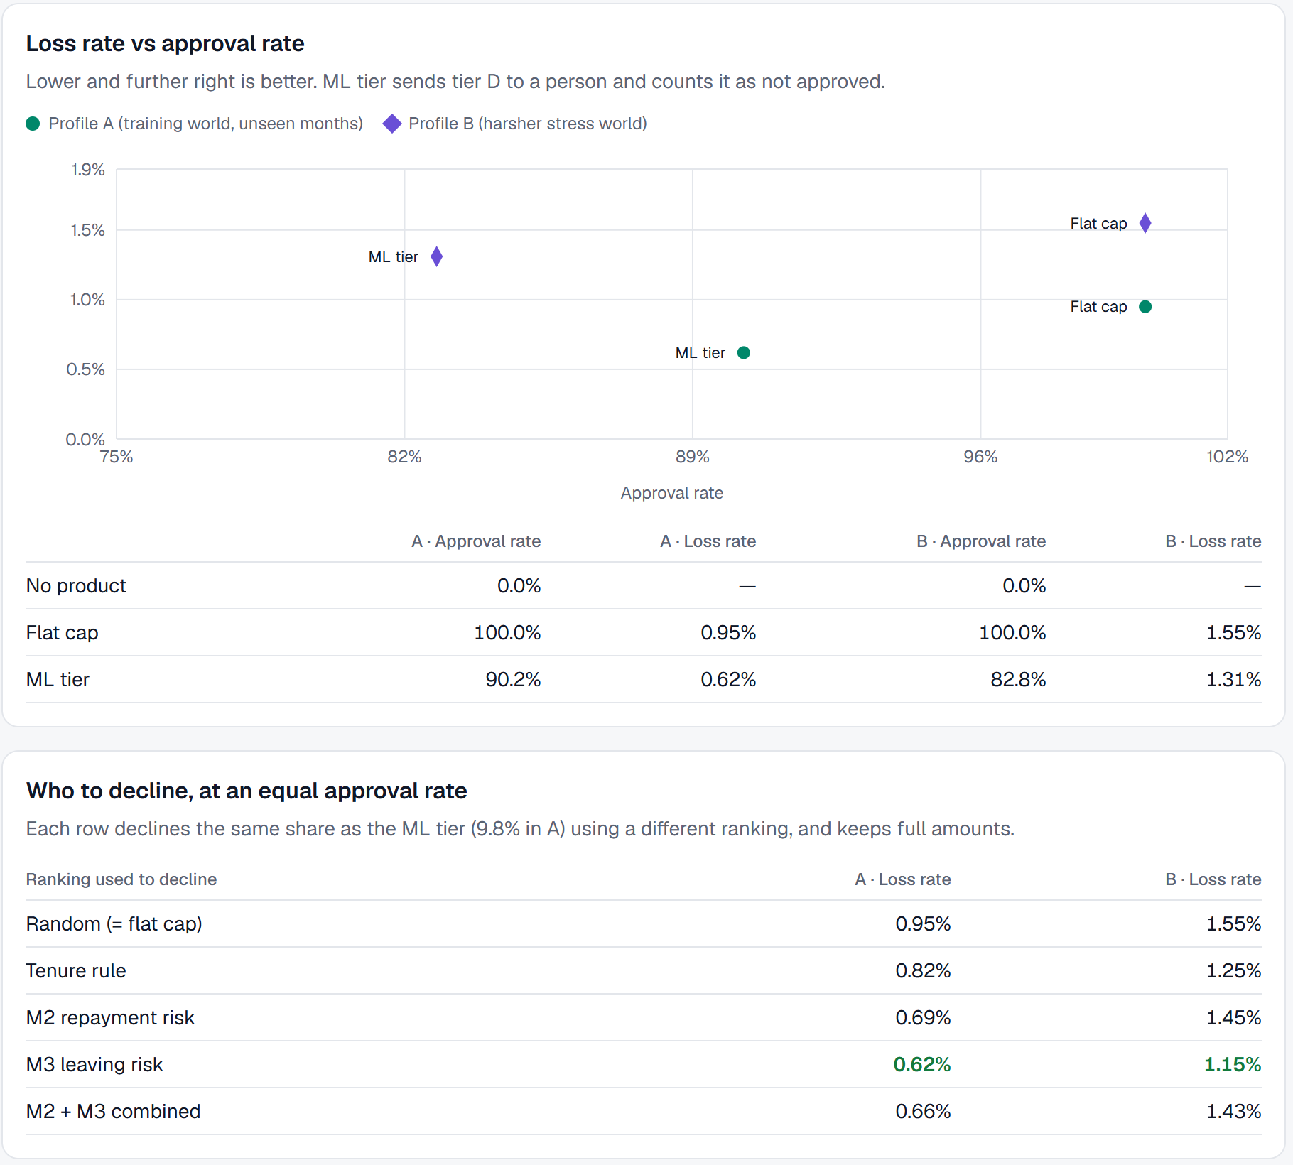
Figure 5. Validation page: loss rate against approval rate for both worlds

6.1 The two misses
T2-A (forecast band too wide). The calibration months include synthetic Eid months, so the band is sized for a surge the test months do not have. The error is on the safe side: upay would hold more capital than needed. It was not tuned on the test result, which would make the check meaningless.
T3-B employer size (9.13 pp gap). Most of the gap comes from how many advances sit in the highest employer-risk band, which differs by size in the stress world, but employer headcount is a model feature, so a direct size effect cannot be ruled out. Next step: retrain M2 and M3 without employer headcount and re-run the audit; until then a person reviews requests in the 10–30% employer-risk band.

7. Responsible AI and security
The project maps 32 controls to code and to the automated test that guards each one (docs/responsible_ai.md). The table follows the guideline's minimum expectations.
Principle | How SalaryBridge meets it
Privacy | Synthetic data only, from a seeded generator; no real names, phone numbers or IDs.
Explainability | Every offer carries a rule trace and top SHAP reasons, worded in English or Bangla.
Fairness | Gender and region are never model features; approval gaps by gender, region and employer size are audited against a 5 pp threshold, and misses are published.
Security | Isolated per-session sandboxes, CORS allow-list, no secrets in the repository, no user free text in LLM prompts (prompt-injection resistant), ledger reconciled to the paisa.
Human oversight | Amounts of ৳10,000 or more, tier D and anomaly-flagged requests go to a human queue; operations has a kill switch.
Transparency | Fee, total deduction and date are shown before confirmation; assumptions are labelled; LLM text is marked as such and checked against the facts.
No harmful automation | Models never decline; declines come only from published rules with the reason shown; cooling-off protects chronic borrowers; the cap keeps debt within earned wages.

8. Business and customer impact

8.1 Value for each party
- Workers: reach wages they have already earned, at a flat, visible fee instead of informal credit, in their own language.
- Employers: offer a staff benefit with no cash handling and one payday transfer.
- upay: a new reason for monthly-paid workers to keep money in the wallet, payroll-linked inflows and fee revenue, with measured risk.

8.2 Economics (one sandbox month, Profile A)
Item | Amount | Note
Advances | ≈ 455 | ML-tier policy
Fee revenue at ৳25 | ৳11,370
Credit loss | ৳10,248 | written-off amounts
Cost of capital | ৳7,284 | 12% a year on money outstanding
Idle buffer | ৳2,441 | 15% buffer held for a month
Operations | ৳2,274 | ৳5 per advance
Net | −৳10,876 | loss at the ৳25 fee
Break-even fee | ৳49 (A) · ৳60 (B) | 1.4% one-time fee on a ৳3,600 advance at ৳49

The flat ৳25 fee does not cover costs in the sandbox; we show this openly rather than tuning it away. Paths to viability are a fee near the break-even, an employer co-paying part of the fee as a staff benefit, and the indirect value of payroll inflow and active wallets. Every assumption can be changed on the Validation page.

9. Real-life impact and path to production
Stage | What we would do | Measure
Technical review | Retrain M2/M3 without employer headcount and re-run the fairness audit; security review of the API. | Gap ≤ 5 pp; review findings closed
Controlled validation | Retrain and re-validate on governed, anonymised payroll and repayment data. | Loss and coverage on real months
Pilot (3 months) | One garment employer, real payroll file, upay sandbox wallets, weekly reviews with HR and operations. | Loss rate, share repaid by remittance, worker satisfaction
Integration | Module inside the upay app, employer portal, upay KYC and ledger, regulatory review. | Adoption, fee viability, complaints

When real data arrives, only the data source changes: the API, rules engine and model interfaces were designed so the synthetic world can be swapped for governed data and SQLite for a production database.

10. Limitations
- All results come from synthetic worlds; real behaviour will differ and must be re-validated.
- Outcomes exist only for advances the pilot policy approved, so declined requests have no observed outcome.
- The employer-size fairness gap in the stress world is not yet resolved (Section 6.1).
- At the ৳25 fee the product loses money in the sandbox (Section 8.2).
- The free hosting plan sleeps when idle, so the first request after a pause can take about a minute.

11. How to run and verify
Live: https://salary-bridge-iota.vercel.app · Code: https://github.com/aqshanto/SalaryBridge
The README gives step-by-step setup, environment variables, run, build and test commands. In short: install backend/requirements-dev.txt on Python 3.11 and run uvicorn; run npm install and npm run dev in frontend; run pytest for the 229 automated tests. To verify by hand, press ★ Demo mode, request Rahim's ৳3,600 advance, open Employer HR and jump to payday, then run scenario S6 on the upay Ops page.

Appendix A. Policy assumptions
Every number is a labelled assumption in backend/app/config.py and docs/assumptions.md, and can be overridden by environment variable.
Policy | Value
Cap | 20% of monthly salary, and never more than earned − owed
Minimum advance / tenure / per month | ৳500 / 90 days / 2 advances
Fee | Flat ৳25, no interest
Grace / write-off | 5 days / 60 days after payday
Tiers (M2 risk) | A ≤ 5%, B ≤ 12%, C ≤ 25%, D above; shares 100% / 70% / 40% / person
Leaving-risk downgrade (M3) | 30% or more
Cooling-off | After 3 consecutive months, 1 month pause
Human review | ৳10,000 or more; top 2% of borrowing patterns
Fairness threshold | 5 percentage points
Capital | Initial pool ৳50,00,000; buffer 15%; cost of capital 12% a year; operations ৳5 per advance

