1a - python

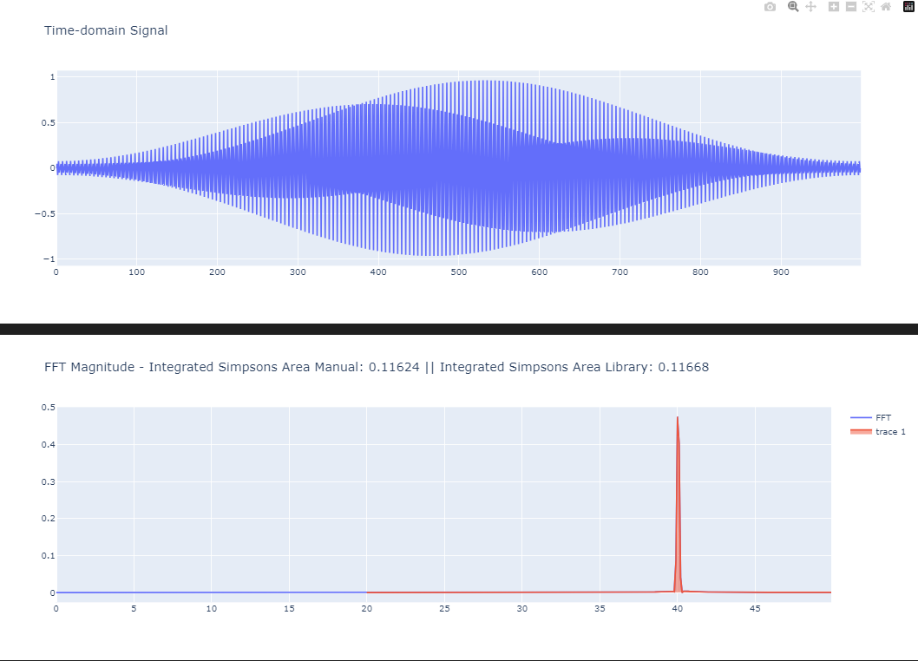

1a - matlab

1b - python

Figure : Maclaurin Series - checking validity of low N value hand calc

Figure : increasing N to compare to Simpson Rule

1b – matlab

1c – python

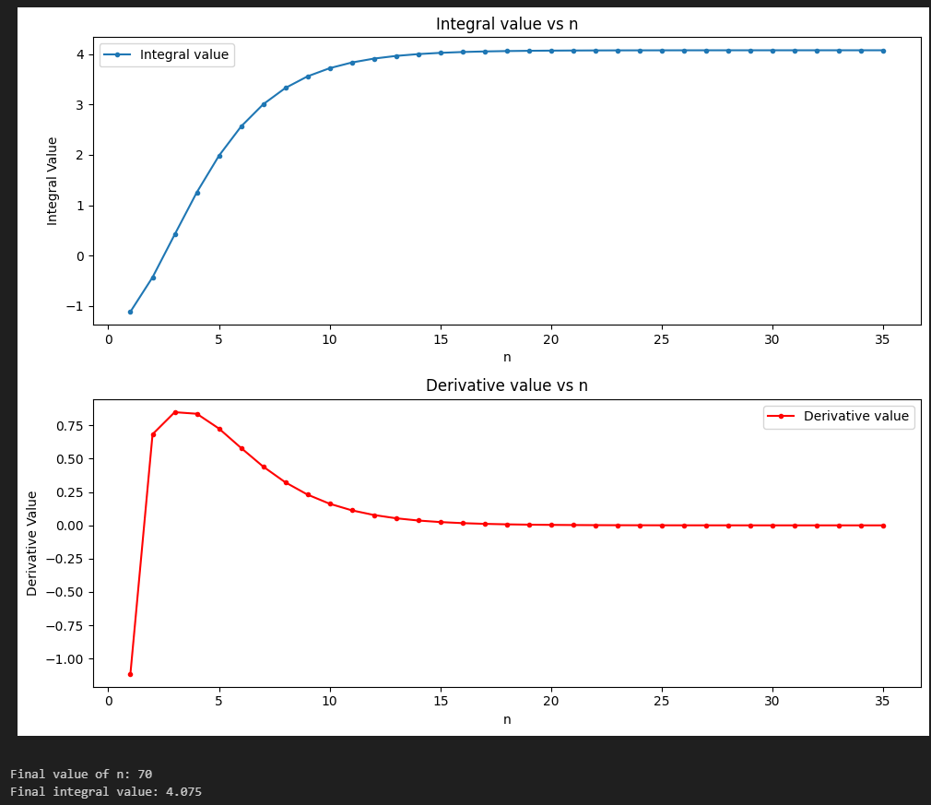

1c – matlab

\*\*\*\* <https://www.mathworks.com/help/matlab/ref/integral.html> - matlab uses the same approach!!

Output - Value of I from 0 to 5: 4.07500

2a – python

2a – matlab

2b – python

2b – matlab

3a – python

3a – matlab

3b – python

3b – python

