1. **MATLAB**

1. **MATLAB**

**3. MATLAB**

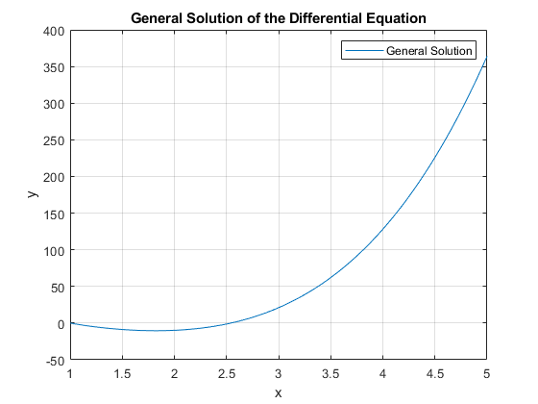

**4. MATLAB**

