Demo Report

Tim Foster

27 April, 2023

# Introduction

This is a demo report…

# Results

Some results…

## location_id question response date_taken  
## 1 666 WHPT ASPT Abund 7.13 23-Nov-2005  
## 2 666 WHPT ASPT Abund 7.73 20-May-2005  
## 3 666 WHPT ASPT Abund 7.42 08-May-2006  
## 4 666 WHPT ASPT Abund 6.96 14-Nov-2006  
## 5 666 WHPT ASPT Abund 7.95 01-May-2007  
## 6 666 WHPT ASPT Abund 6.96 12-Oct-2007

# Analysis

#### Determinand Summary

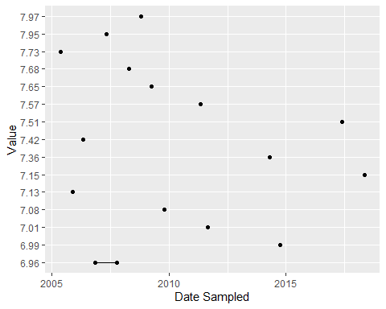

#### Sampling Location Map

# Conclusion

There are a total of 1 sampling locations within this dataset…