StayPulse
Data Flow Diagrams
Phase 3: Requirement Analysis
Item | Details
Project | StayPulse: Hotel Booking and Property Management Web Application (MERN stack)
Phase | Phase 3: Requirement Analysis
Document | Data Flow Diagrams
Version / date | 1.0, 28 October 2026
Basis | Inspection of the uploaded StayPulse source repository. Statements are tagged as implemented, partial, proposed, assumption, or not verified.

1. Introduction and Notation
This document models how data moves through StayPulse at three levels: a context diagram (Level 0), a Level 1 decomposition, and a Level 2 decomposition of the booking process. The diagrams follow Gane and Sarson notation and were derived from the routes, controllers and models in the repository.
Symbol | Meaning
Grey rectangle | External entity (a user role)
Blue box with ID | Process
Open-ended box with D-ID | Data store
Arrow | Data flow (labelled)
Dashed edge | Not used; all flows are shown solid

2. External Entities and Data Stores
Table 1: External entities
Entity | Description
Guest | Registered user with role GUEST
Property Owner | Registered user with role PROPERTY_OWNER
Platform Admin | User with role PLATFORM_ADMIN, created by a seed script, not by public registration

Table 2: Data stores
ID | Store | Implementation
D1 | Users | MongoDB collection users (Mongoose model User)
D2 | Image Files | Local folder backend/uploads (properties, rooms, profiles); not MongoDB
D3 | Properties | MongoDB collection properties
D4 | Rooms | MongoDB collection rooms
D5 | Room Reservation Slots | MongoDB collection roomreservationslots
D6 | Bookings | MongoDB collection bookings

3. Level 0: Context Diagram
The single process represents the React single-page application together with the Express API. The three roles are the only external entities; MongoDB and the file system are internal to the system boundary and therefore appear only at Level 1.
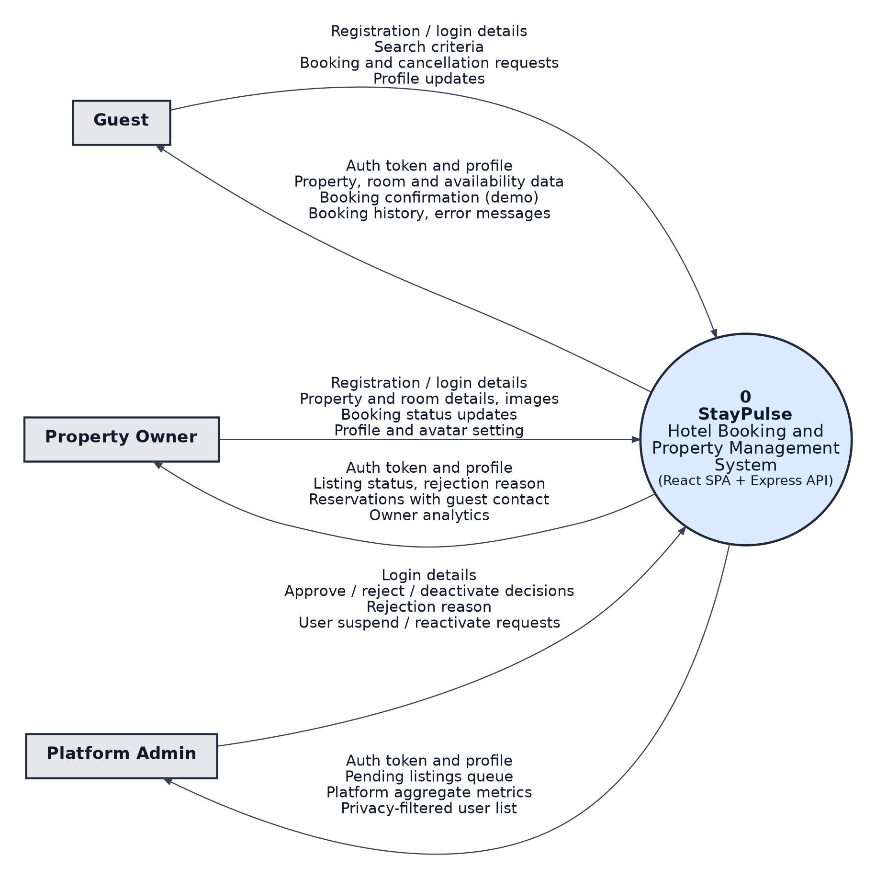
Figure 1: Level 0 context diagram of StayPulse

4. Level 1 DFD
Process 1.0 is the client interface. Each user interacts only with 1.0, which calls the REST API processes 2.0 to 9.0 using JSON over HTTP with a JWT bearer token. Read-only flows that would add clutter are listed in the flow table below instead of being drawn.
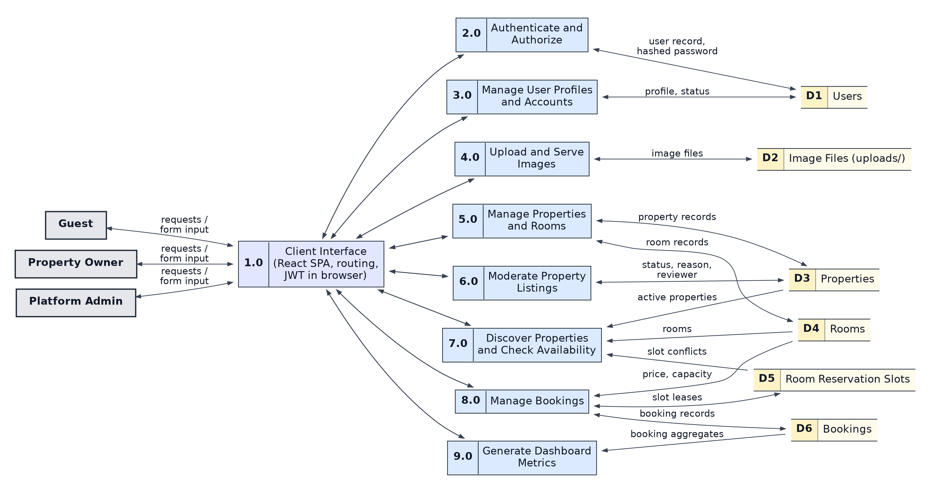
Figure 2: Level 1 data flow diagram
Table 3: Level 1 processes and implementation mapping
ID | Process | Backend module | Frontend module
1.0 | Client interface, routing, token handling | n/a (browser) | App.jsx, AuthContext, services/api.js
2.0 | Authenticate and authorize | authController (register, login, getMe), auth.js | LoginPage, RegisterPage
3.0 | Manage user profiles and accounts | authController.updateProfile; adminController user functions | Guest/OwnerProfile, AdminUsers
4.0 | Upload and serve images | uploadRoutes, fileUpload.js | CameraCaptureModal, profile and property forms
5.0 | Manage properties and rooms | propertyController, roomController | OwnerProperties, OwnerRooms
6.0 | Moderate property listings | adminController (getAdminProperties, updatePropertyStatus) | AdminProperties
7.0 | Discover properties and check availability | propertyController (public), roomController, checkRoomAvailability | HomePage, HotelListingPage, HotelDetailsPage
8.0 | Manage bookings | bookingController (create, cancel, owner status, get) | HotelDetailsPage, GuestBookings, OwnerBookings
9.0 | Generate dashboard metrics | bookingController.getOwnerAnalytics, adminController.getAdminOverview | OwnerOverview, AdminOverview

Table 4: Level 1 data flows
Flow | Data carried
Entity to 1.0 | Form input and navigation; 1.0 to entity: rendered pages, messages, errors
1.0 to 2.0 | Registration or login details; returns JWT and user profile
2.0 to D1 | Create user (password hashed with bcrypt); read user by email for login
1.0 to 3.0 | Profile fields (name, phone, avatar, avatar visibility); admin user status change
3.0 to D1 | Read and update user records
1.0 to 4.0 | Image file or camera data URL; returns a relative image URL
4.0 to D2 | Write and read image files. Also reads D1 for avatar privacy rules (not drawn)
1.0 to 5.0 | Property and room details; returns listing status and rejection reason
5.0 to D3 / D4 | Create, read, update and delete properties and rooms. Also reads D6 to block deletion with active bookings (not drawn)
1.0 to 6.0 | Admin decision: ACTIVE, REJECTED (with reason), INACTIVE, PENDING_APPROVAL
6.0 to D3 | Read properties; write status, rejection reason, reviewedAt, reviewedBy. Reads room counts from D4 (not drawn)
1.0 to 7.0 | Search text, city, price, amenities, dates; returns properties, rooms, availability result
7.0 to D3 / D4 / D5 | Read ACTIVE properties, rooms and slot conflicts. Also reads D6 for overlap (not drawn)
1.0 to 8.0 | Booking, cancellation or owner status request; returns booking and demo pricing notice
8.0 to D6 / D5 / D4 | Create and update bookings, create and delete slots, read price and capacity. Also reads D3 for property status and D1 for guest contact (not drawn)
1.0 to 9.0 | Metrics request; returns owner analytics or admin aggregates
9.0 to D6 | Read booking counts and totals. Also reads D1, D3, D4 for counts (not drawn)

5. Level 2 DFD: Process 8.0 Manage Bookings
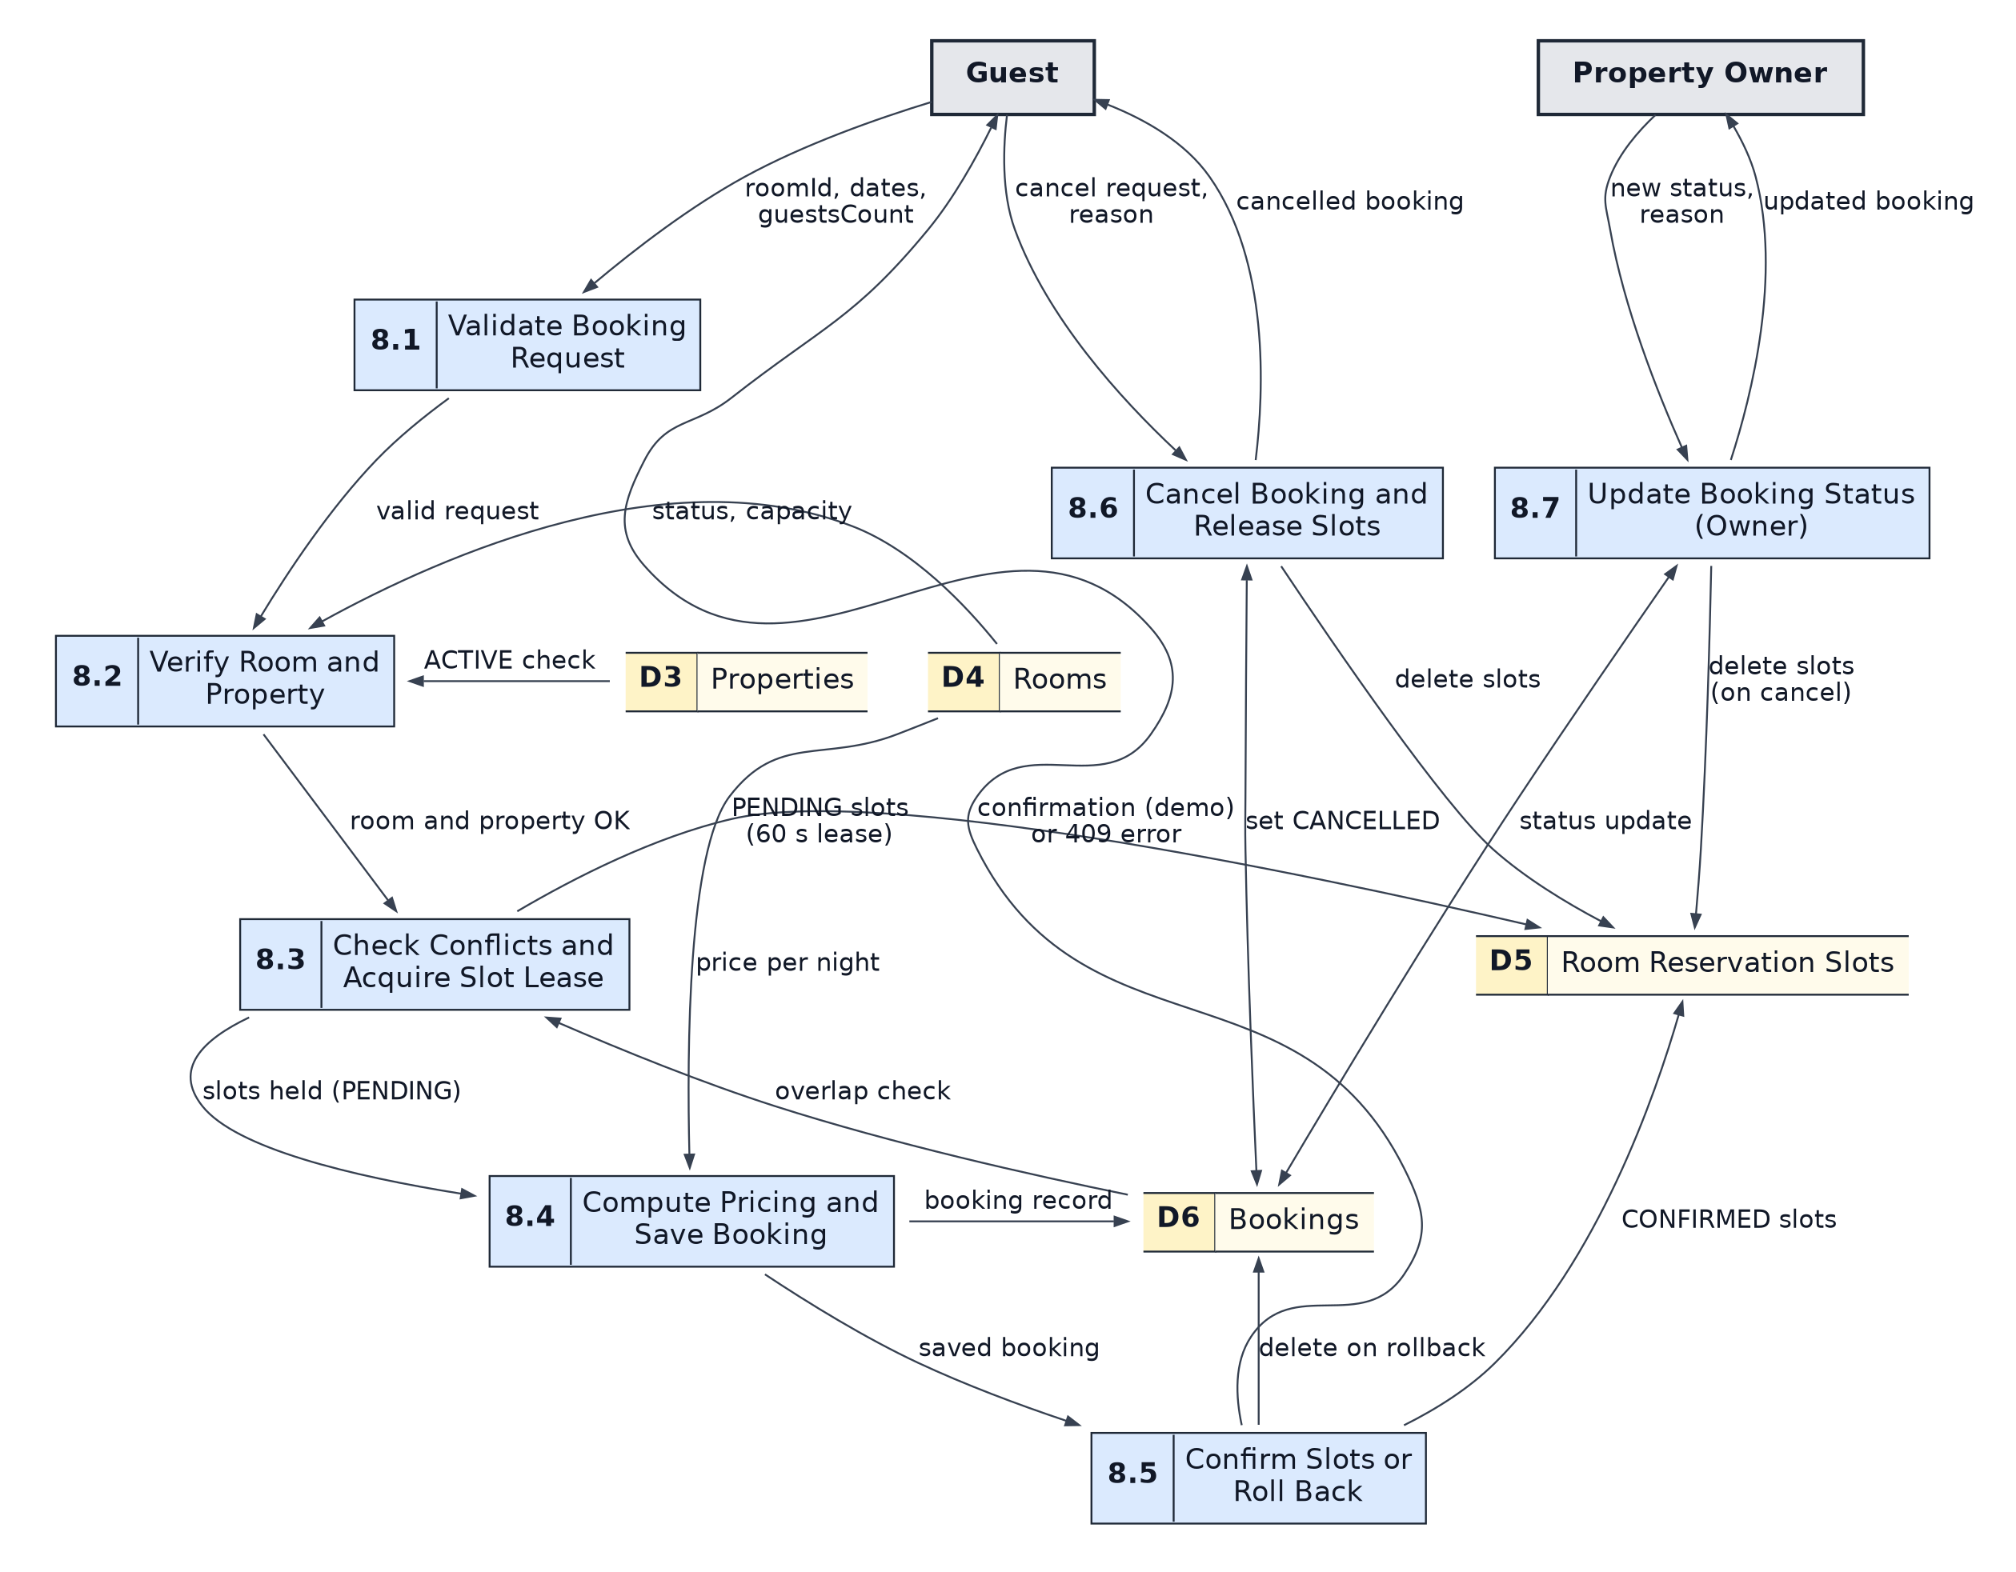
Figure 3: Level 2 decomposition of Process 8.0 Manage Bookings
Table 5: Level 2 sub-processes
ID | Sub-process | Behaviour verified in bookingController.js
8.1 | Validate booking request | roomId format, both dates, guest count of at least 1, valid dates, check-in not in the past, check-out after check-in
8.2 | Verify room and property | Room exists and is AVAILABLE, guests within capacity, property is ACTIVE
8.3 | Check conflicts and acquire slot lease | Overlap query on CONFIRMED or PENDING bookings; insert one PENDING slot per night with a lockToken and 60 second expiry; duplicate key returns 409
8.4 | Compute pricing and save booking | Nights times room price, tax at the configured GST rate (default 12 percent), total, booking reference SP-YYYY-XXXXXX, status CONFIRMED
8.5 | Confirm slots or roll back | Slots updated to CONFIRMED; if the count differs from nights, the booking and slots are deleted and 409 is returned
8.6 | Cancel booking and release slots | Guest only, own booking, not already cancelled or completed, before the check-in date; slots deleted; status CANCELLED
8.7 | Update booking status (owner) | CONFIRMED, COMPLETED or CANCELLED; terminal states locked; COMPLETED only on or after check-out; cancel releases slots

6. Consistency Notes
- Balancing: The six entity flows of Level 0 correspond to the entity flows through 1.0 at Level 1. Level 2 uses the same entities and stores as the parent process 8.0.
- Admin privacy: No flow lets the Platform Admin read individual guest bookings; admin metrics read aggregates only (implemented in adminController and the booking detail endpoint, which returns 403 to admins).
- Frontend note: The React SPA also holds a mock sandbox (default mock user and role switcher). It is a development aid and is not modelled as a data flow.
- Assumption: Process boundaries are logical groupings of controller functions; the code does not use these exact process names.

Status legend
Tag | Meaning
Implemented | Supported by code in the repository (verified by reading the source).
Partial | Present in code but incomplete, UI-only, or not wired end to end.
Proposed | Not in the repository; suggested for future work or planning.
Assumption | A reasonable statement not verifiable from the repository.
Not Verified | Could not be confirmed (for example, tests that were not executed).

