StayPulse
Proposed Solution
Phase 4: Project Design
Item | Details
Project | StayPulse: Hotel Booking and Property Management Web Application (MERN stack)
Phase | Phase 4: Project Design
Document | Proposed Solution
Version / date | 1.0, 28 October 2026
Basis | Inspection of the uploaded StayPulse source repository. Statements are tagged as implemented, partial, proposed, assumption, or not verified.

1. Proposed Application Overview
StayPulse is a single-page web application backed by a REST API and a MongoDB database. It supports three roles. Guests search and book rooms, owners publish and manage properties, and a platform administrator approves listings and oversees the platform. Bookings are demonstrations: no payment is collected and every booking is marked as an unpaid demo reservation.

2. Main Features
Feature | Description | Status
Registration and login | Guest and owner self-registration; JWT login | Implemented
Property discovery | Search and filter ACTIVE properties; property and room details | Implemented
Room and property management | Owner creates, edits and removes properties and rooms; sets prices and room status | Implemented
Listing approval | Admin approves or rejects with reason; owner resubmits | Implemented
Booking and cancellation | Conflict-free demo booking; guest cancels before check-in | Implemented
Dashboards | Owner analytics; admin aggregate metrics; guest history | Implemented
User moderation | Suspend and reactivate accounts | Implemented
Image upload | JPEG, PNG, WEBP up to 5 MB with signature check; camera capture in UI | Implemented
Platform settings | Fee, cancellation grace hours, maintenance mode | Partial (UI only, not saved)
Payments, notifications, reviews | Not part of the solution | Proposed (future)

3. Cross-Role Workflow Overview
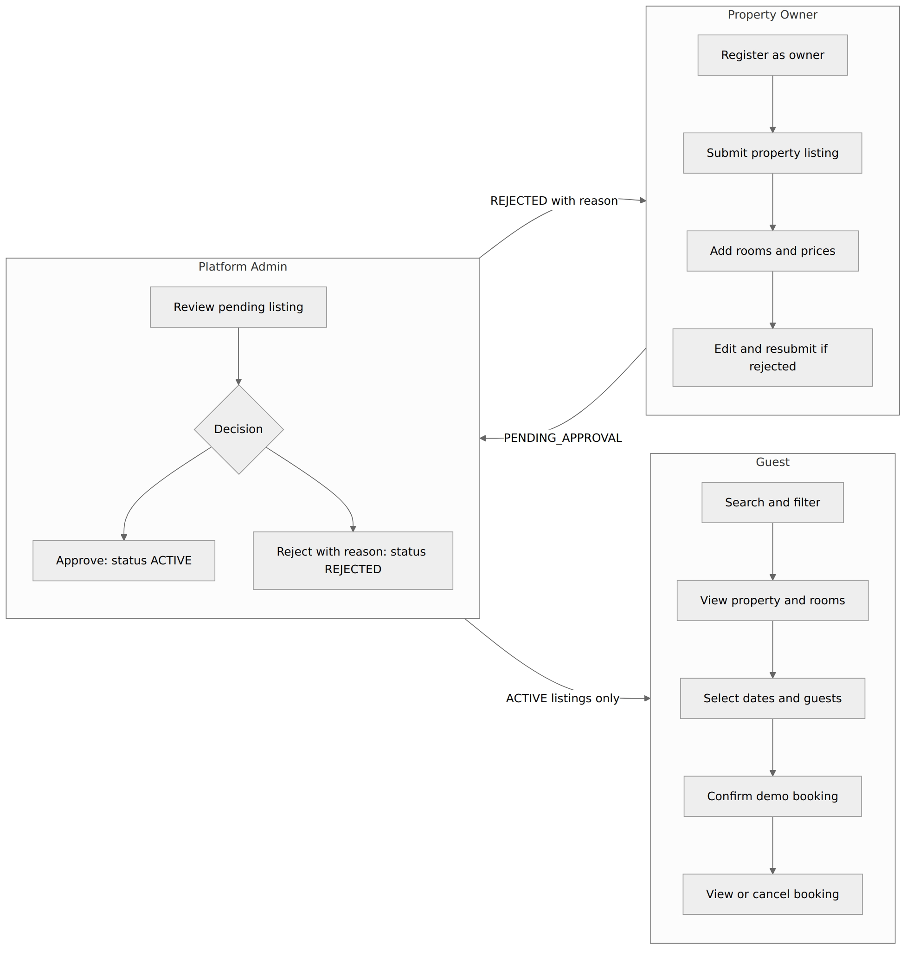
Figure 1: Workflow across Owner, Admin and Guest roles

4. Guest Workflow
- Register or log in as a guest.
- Search or filter properties on the listing page.
- Open a property and review rooms, capacity and nightly price.
- Select check-in, check-out and guest count; choose a room.
- Confirm the reservation. The server validates dates, room status, capacity and conflicts, then returns a booking reference and price breakdown with a demo notice.
- Open the guest dashboard to view bookings and cancel an eligible booking (before the check-in date).

5. Property Owner Workflow
- Register as a property owner and log in.
- Create a property with details and a cover image; it is saved as PENDING_APPROVAL.
- Add rooms with type, bed type, capacity and price.
- Wait for review. If rejected, read the reason, edit the property and save to resubmit.
- After approval, pause or resume the listing, view reservations with guest contact details, update booking status, and view analytics.

6. Platform Admin Workflow
- Log in with an account created by the seed script.
- Open the property list and filter by status (for example, pending).
- Approve, reject with a reason, or deactivate a listing.
- Review aggregate metrics on the overview page.
- Suspend or reactivate user accounts when needed.

7. Property Approval Workflow
Step | Actor | System result
Submit property | Owner | Status PENDING_APPROVAL; hidden from search, details, rooms and booking
Approve | Admin | Status ACTIVE; reviewer and time recorded; reason cleared; public and bookable
Reject | Admin | Status REJECTED with reason; still hidden
Edit rejected property | Owner | Status returns to PENDING_APPROVAL; reason cleared
Pause or deactivate | Owner or Admin | Status INACTIVE; hidden from public
A diagram of these status changes is in the Solution Architecture document.

8. Booking Workflow
The booking process checks input, room and property status, and overlapping bookings. It then reserves one slot per night using a short lease, calculates the price on the server, saves the booking as CONFIRMED and confirms the slots. If the lease is lost, the booking is removed and the guest is asked to retry. Cancellation by the guest or owner deletes the slots so the dates can be booked again. The detailed sequence is in the Solution Architecture document.

9. Role-Based Access
Capability | Guest | Owner | Admin | Visitor
Search properties, view details, check availability | Yes | Yes | Yes | Yes
Register and log in | Yes | Yes | Login only | Yes
Create booking, view own bookings, cancel own booking | Yes | No | No | No
View a single booking | Own only | Own properties only | No (403) | No
Create and manage properties and rooms | No | Own only | No | No
View reservations and analytics of own properties | No | Yes | No | No
Update booking status | No | Own properties | No | No
Approve, reject, deactivate listings | No | No | Yes | No
Platform overview and user suspension | No | No | Yes | No
Upload property or room images | No | Yes | No | No
Upload own profile photo | Yes | Yes | Yes | No

10. Expected Outcomes
- Guests can complete a demo booking end to end.
- Owners can manage listings and see reservations.
- Only reviewed listings are public.
- Role and privacy boundaries are enforced by the API.

11. Scope Limitations
- No real payments, refunds, notifications, reviews, password reset or booking modification.
- The listing page shows only the first 10 results because the UI does not use pagination.
- The frontend contains a development role sandbox and a mock login fallback that should be removed before real use.
- Admin settings are not saved.
- Images are stored on the local file system.
- Revenue figures are estimated booking values, not settled funds.

Status legend
Tag | Meaning
Implemented | Supported by code in the repository (verified by reading the source).
Partial | Present in code but incomplete, UI-only, or not wired end to end.
Proposed | Not in the repository; suggested for future work or planning.
Assumption | A reasonable statement not verifiable from the repository.
Not Verified | Could not be confirmed (for example, tests that were not executed).

