StayPulse
Solution Architecture
Phase 4: Project Design
Item | Details
Project | StayPulse: Hotel Booking and Property Management Web Application (MERN stack)
Phase | Phase 4: Project Design
Document | Solution Architecture
Version / date | 1.0, 28 October 2026
Basis | Inspection of the uploaded StayPulse source repository. Statements are tagged as implemented, partial, proposed, assumption, or not verified.

1. System Architecture
StayPulse uses a three-tier architecture: a React single-page application in the browser, a stateless Node.js and Express REST API, and a MongoDB database plus a local folder for images.
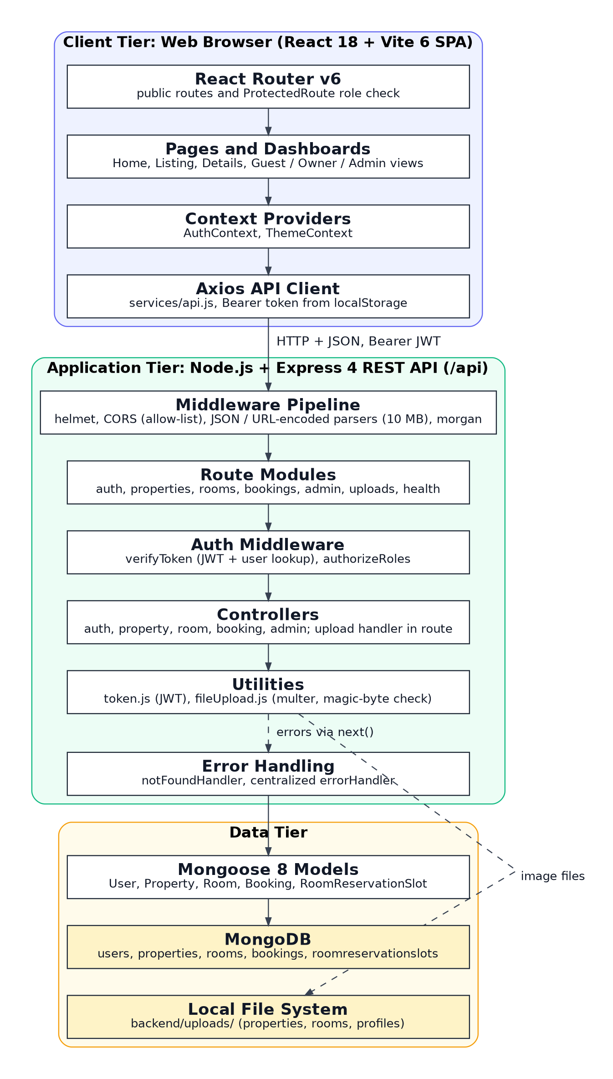
Figure 1: System architecture of StayPulse

2. Frontend Architecture
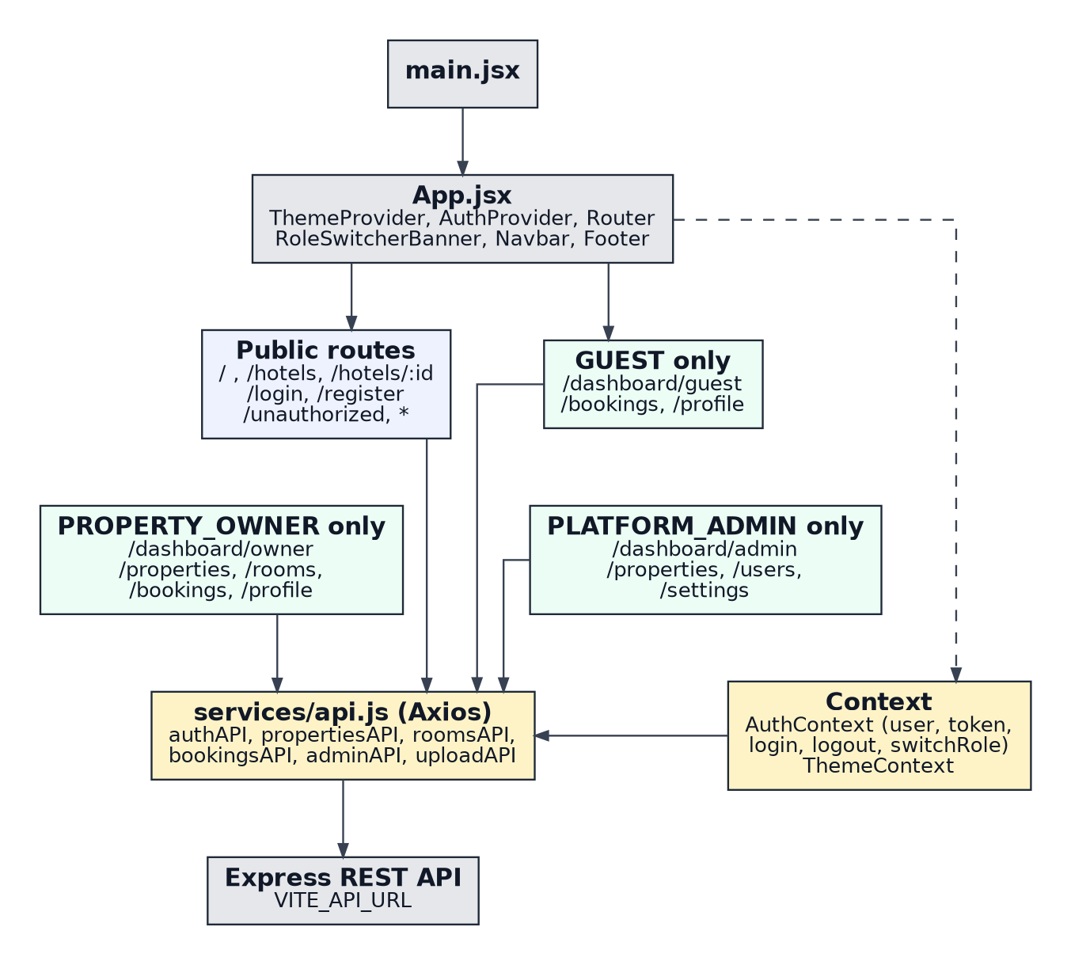
Figure 2: Frontend structure and routing
App.jsx wraps the application in ThemeProvider, AuthProvider and BrowserRouter. ProtectedRoute checks the user held in AuthContext against the allowed roles and redirects to /login or /unauthorized. All API calls go through services/api.js, which attaches the stored JWT as a bearer token and clears it on a 401 response. Styling uses Tailwind CSS with a dark mode toggle.
Limitation: AuthContext starts with a default mock guest user, and a "UI Dev Role Sandbox" banner changes the role in the browser without a token. A mock login is used when the backend is unreachable. The API still enforces roles, but these features should be removed or disabled for real deployments.

3. Backend Architecture
Layer | Modules | Responsibility
Entry | server.js, config/db.js | Load environment, connect to MongoDB, start server, graceful shutdown
Application | app.js | helmet, CORS allow-list, body parsers (10 MB), morgan, route mounting, 404 and error handlers
Routes | auth, property, room, booking, admin, upload routes | URL mapping and middleware per route
Middleware | auth.js, notFoundHandler.js, errorHandler.js | JWT verification, role checks, uniform error responses
Controllers | auth, property, room, booking, admin | Business rules and database access
Models | User, Property, Room, Booking, RoomReservationSlot | Schemas, validation, indexes
Utilities | token.js, fileUpload.js | JWT helpers; image validation and storage

4. API Communication
The frontend calls the API at the base URL given by VITE_API_URL (default http://localhost:5000/api) using JSON. Responses contain a success flag and either data (for example, property, properties, booking) or a message. Typical status codes are 200, 201, 400, 401, 403, 404 and 409. The main endpoints are listed below; the health endpoint GET /api/health and three test-role endpoints under /api/test-roles also exist.

Authentication and users
Method and path | Access | Controller function
POST /api/auth/register | Public | register
POST /api/auth/login | Public | login
GET /api/auth/me | Any logged-in user | getMe
PUT /api/auth/profile | Any logged-in user | updateProfile

Properties and rooms
Method and path | Access | Controller function
GET /api/properties | Public | getPublicProperties
GET /api/properties/:id | Public | getPublicPropertyById
GET /api/properties/:propertyId/rooms | Public | getRoomsByProperty
GET /api/properties/owner/my-properties | Owner | getMyProperties
POST /api/properties | Owner | createProperty
PUT, DELETE /api/properties/:id | Owner (own) | updateProperty, deleteProperty
POST /api/properties/:propertyId/rooms | Owner (own) | createRoom
GET /api/rooms/:id | Public | getRoomById
GET /api/rooms/owner/my-rooms | Owner | getMyRooms
PUT, DELETE /api/rooms/:id | Owner (own) | updateRoom, deleteOrDeactivateRoom

Bookings
Method and path | Access | Controller function
GET /api/bookings/rooms/:roomId/availability | Public | checkRoomAvailability
POST /api/bookings | Guest | createBooking
GET /api/bookings/my-bookings | Guest | getMyGuestBookings
PATCH /api/bookings/:id/cancel | Guest (own) | cancelBooking
GET /api/bookings/:id | Guest (own), Owner (own property); Admin denied | getBookingById
GET /api/bookings/owner/my-bookings | Owner | getOwnerBookings
GET /api/bookings/owner/analytics | Owner | getOwnerAnalytics
PATCH /api/bookings/owner/:id/status | Owner (own) | updateBookingStatusByOwner
GET /api/bookings/admin/stats | Admin | getAdminBookingStats

Administration and uploads
Method and path | Access | Controller function
GET /api/admin/overview | Admin | getAdminOverview
GET /api/admin/users | Admin | getAdminUsers
PATCH /api/admin/users/:id/status | Admin | updateUserStatus
GET /api/admin/properties | Admin | getAdminProperties
PATCH /api/admin/properties/:id/status | Admin | updatePropertyStatus
POST /api/uploads | Logged-in user; property and room images owner only | inline handler in uploadRoutes
GET /api/uploads/:category/:filename | Public, with privacy rules for profile photos | inline handler in uploadRoutes

5. Authentication and Authorization Flow
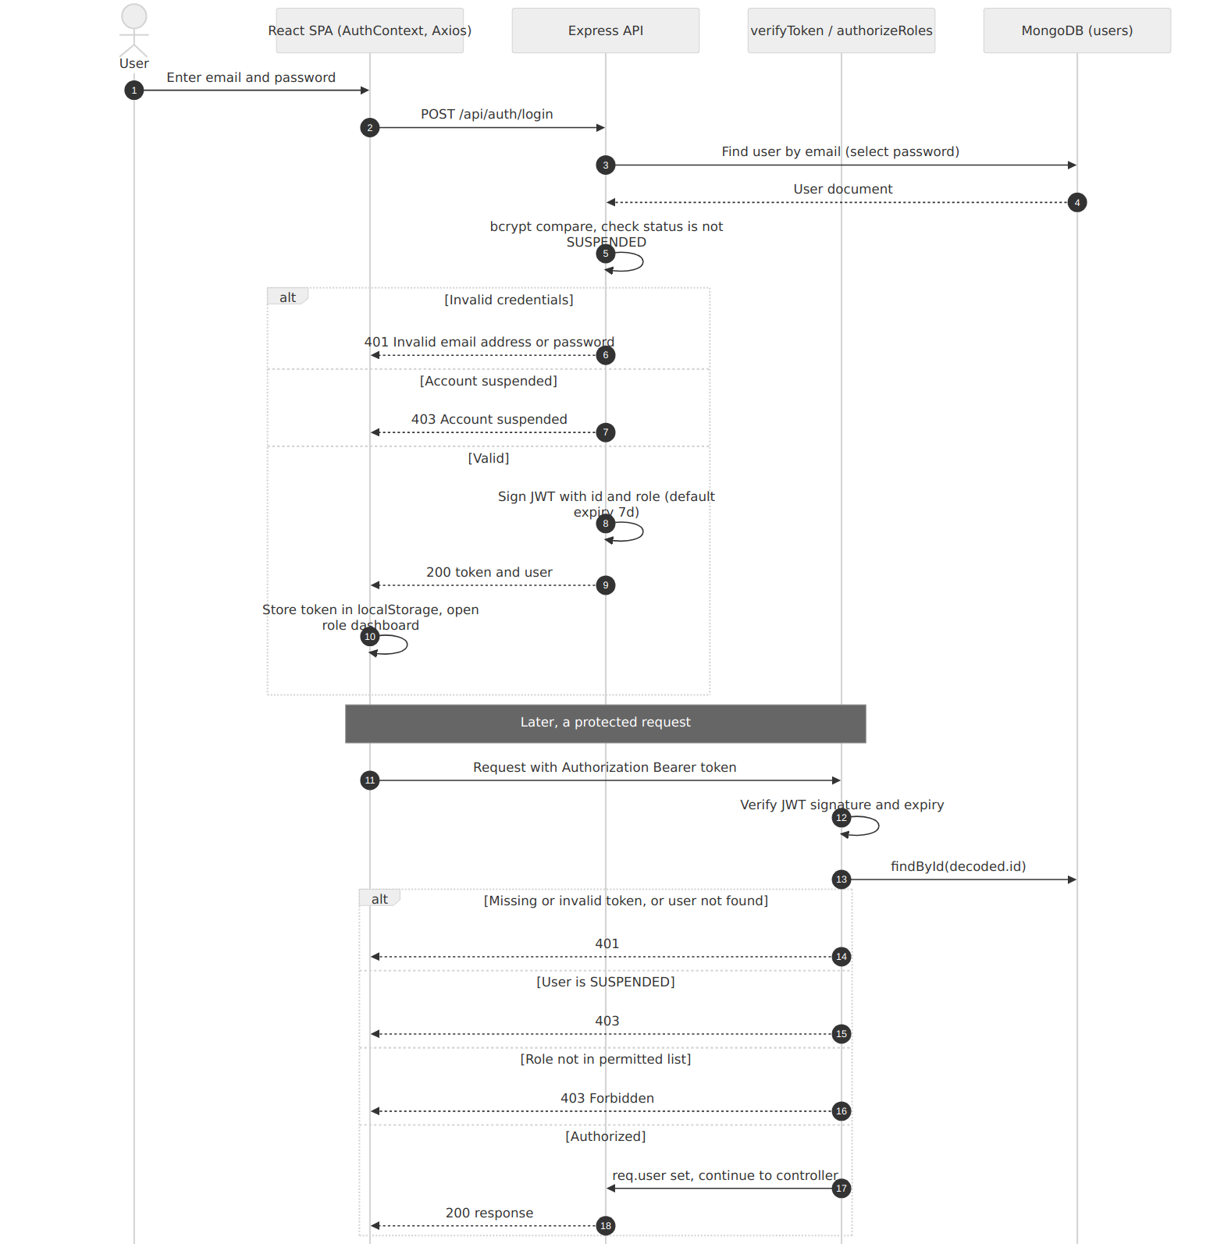
Figure 3: Login and protected request flow

6. Property Listing Approval Flow
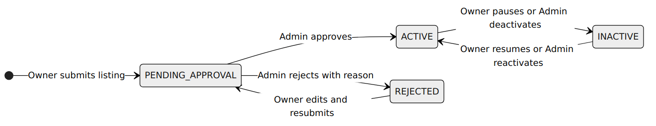
Figure 4: Property status lifecycle
The owner endpoint accepts only ACTIVE and INACTIVE toggles for approved properties and rejects self-approval. The admin endpoint accepts any of the four statuses without checking the previous status. Only ACTIVE properties appear in public search, details, room lists, availability checks and bookings.

7. Booking and Availability Flow
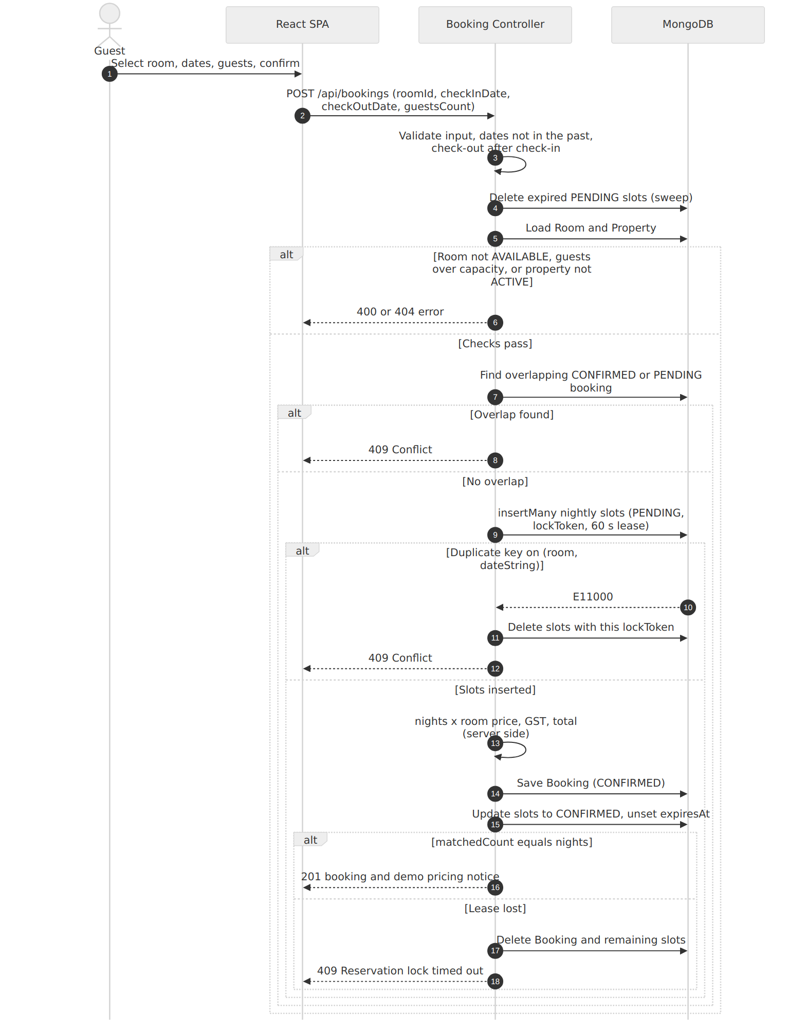
Figure 5: Booking creation sequence
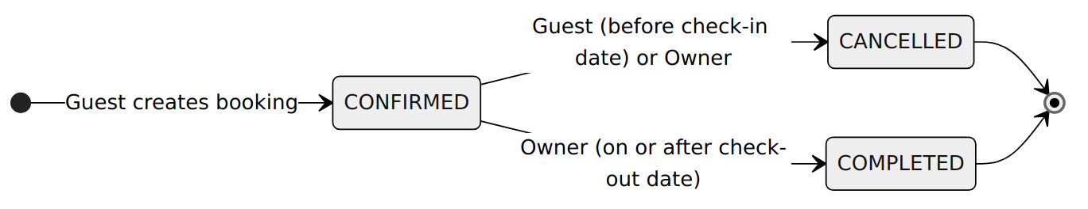
Figure 6: Booking status lifecycle
The schema also defines a PENDING booking status. The create flow does not set it, but conflict queries still include it.

8. Database Architecture and Entity Relationships
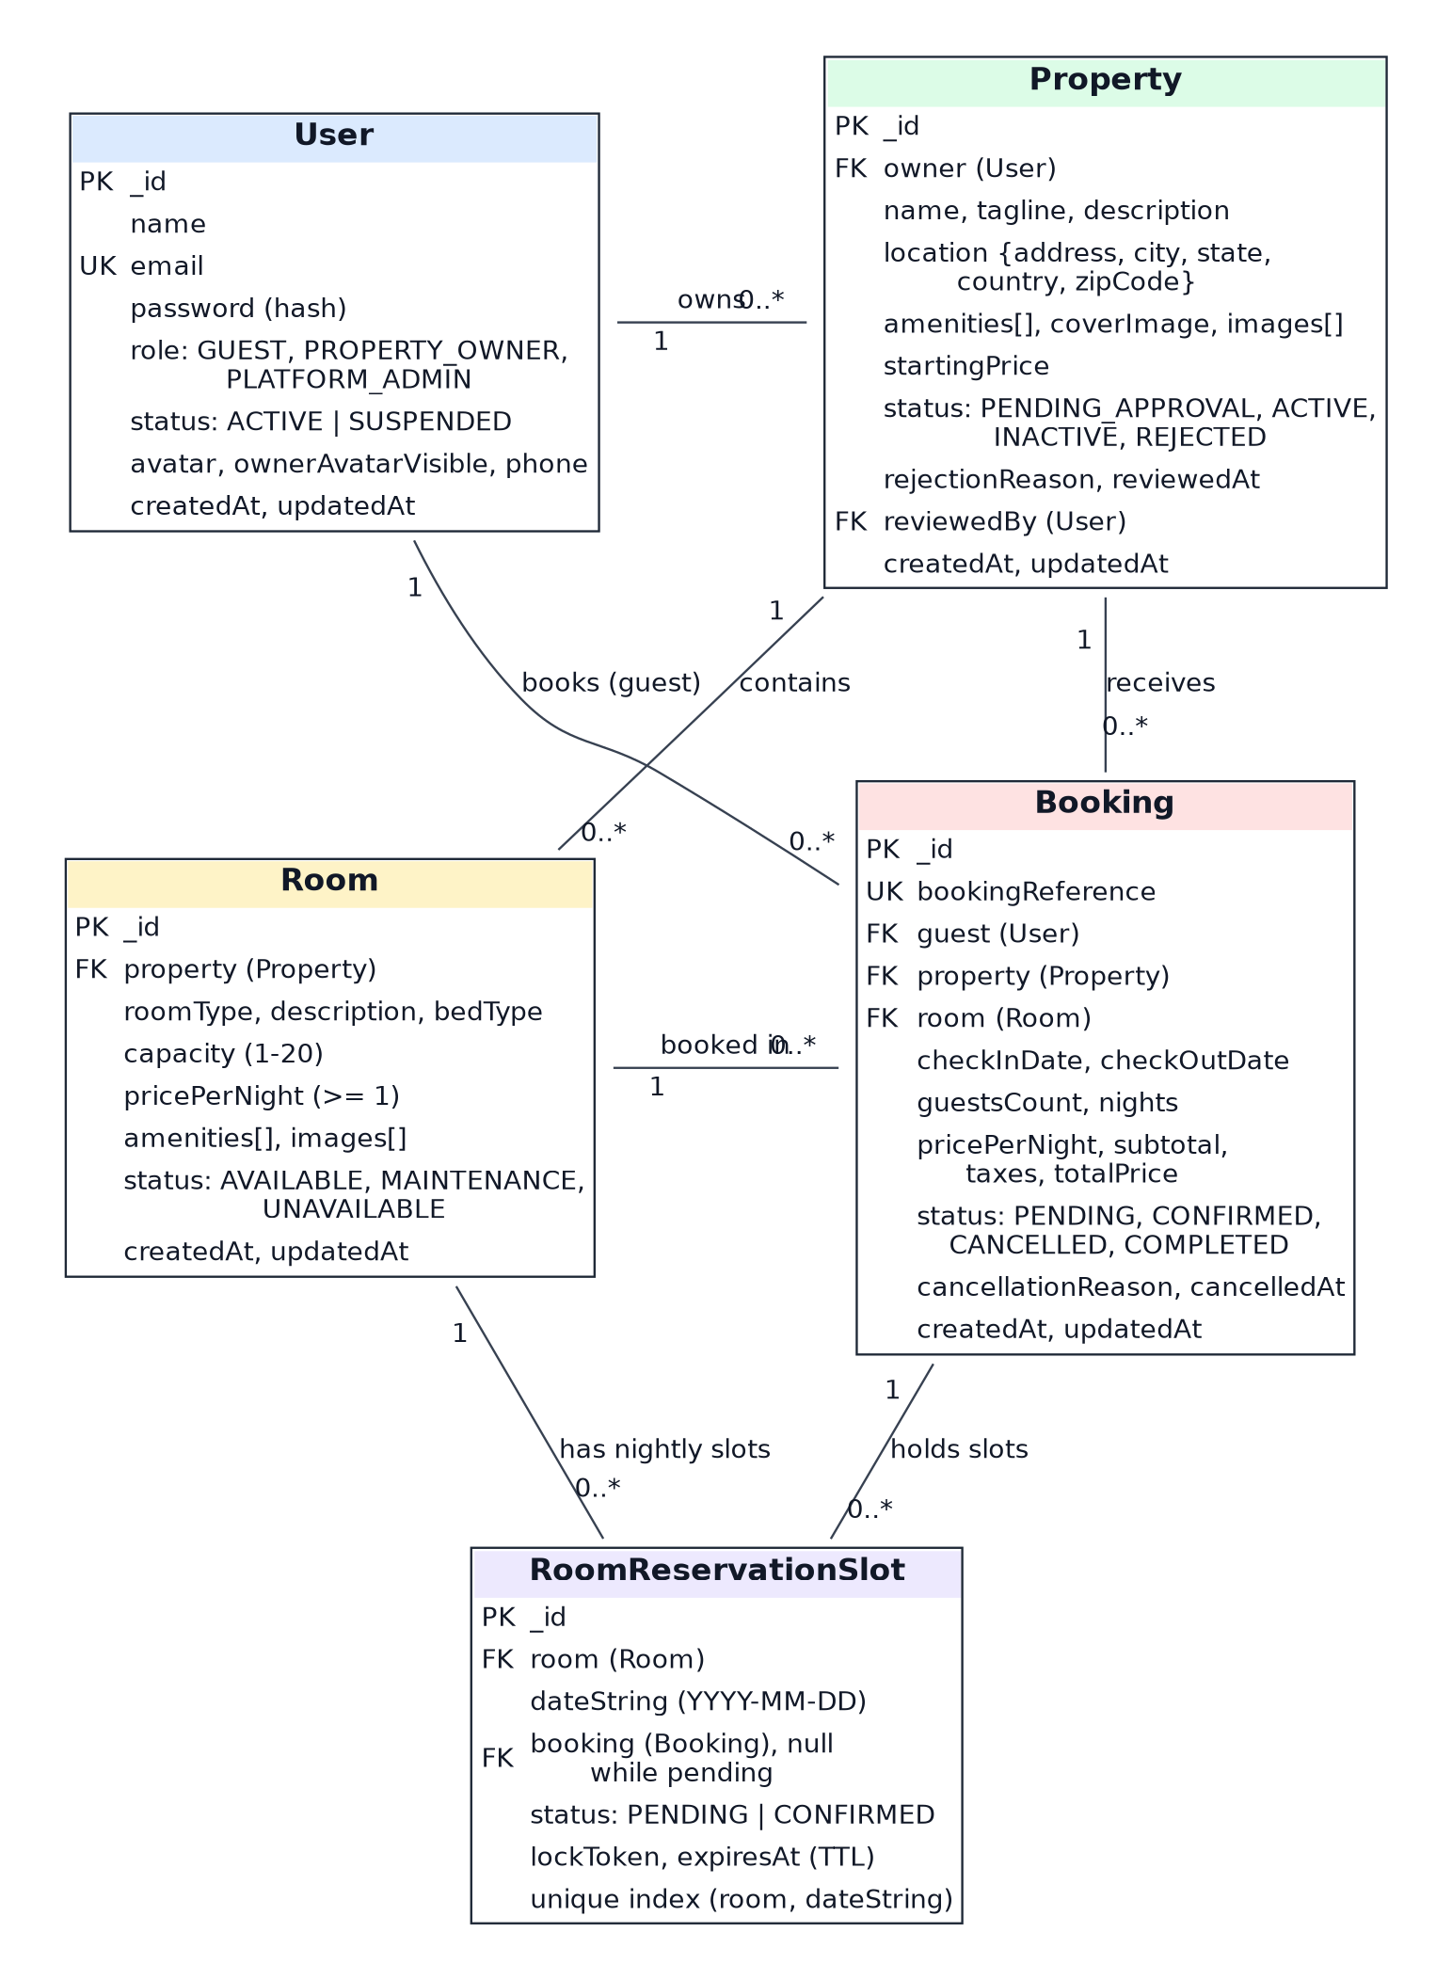
Figure 7: Entity relationship diagram (fields as defined in the Mongoose models)
Property also references a User through reviewedBy. Relationships are enforced by application code; MongoDB does not enforce foreign keys.
Index or constraint | Purpose
users.email unique | One account per email
bookings.bookingReference unique | Unique booking reference
roomreservationslots (room, dateString) unique | Only one reservation per room per night
roomreservationslots.expiresAt TTL (0 seconds) | Automatic removal of expired pending leases; confirmed slots have no expiry
properties (location.city, status); (owner, createdAt) | Search and owner lists
bookings (room, checkInDate, checkOutDate, status); (guest, createdAt); (property, createdAt) | Overlap and list queries

9. Error Handling and Security Considerations
Topic | Current design | Observation or recommendation
Errors | Controllers return JSON with success false and a message; errorHandler maps cast, duplicate key and validation errors | Stack traces are included unless NODE_ENV is production
Authentication | JWT with bcrypt-hashed passwords; suspended users blocked | JWT_SECRET has a code fallback; require it at start-up
Authorization | authorizeRoles plus ownership checks in controllers | Good tenant isolation; admin status changes are not transition-guarded
Input handling | Required-field checks and schema validation; image signature check; path traversal checks on file serving | Search builds RegExp from raw input; escape it
Transport and headers | helmet and CORS allow-list | HTTPS must be provided by deployment
Token storage | localStorage | Exposed to script injection; consider httpOnly cookies in future
Availability and abuse | Body size limit only | No rate limiting
Data consistency | Slots with leases and compensating rollback | No multi-document transactions on a standalone database
Privacy | Admin blocked from bookings and guest photos; guest phone and photo hidden in admin list | Owners see guest contact data of their own bookings by design

10. Architecture Limitations
- The ARCHITECTURE.md diagram includes a RateLimit box, but no rate limiter exists in the code.
- Local file storage prevents running multiple server instances without shared storage.
- The architecture was documented from source reading; it was not run or load tested here.

Status legend
Tag | Meaning
Implemented | Supported by code in the repository (verified by reading the source).
Partial | Present in code but incomplete, UI-only, or not wired end to end.
Proposed | Not in the repository; suggested for future work or planning.
Assumption | A reasonable statement not verifiable from the repository.
Not Verified | Could not be confirmed (for example, tests that were not executed).

