AI FOR KIDS
Revised 14-Video Teaching Course
Video audit, curriculum redesign, lesson plans, assessments and implementation guide

Completed videos | 14 animated micro-lessons
Total video time | 23 minutes 48 seconds
Recommended learner group | Ages 9–12; adaptable for 6–8 and 13–16
Revised learning time | Approximately 8–9 hours including activities and capstones

Core positioning
This is not a passive 24-minute video product. It is a four-course interactive program in which each completed video acts as a short mission briefing, followed by guided practice, a hands-on challenge, assessment and a badge.

Version 2.0 | Built around the 14 completed MP4 files

Contents
- 1. Executive findings from the 14-video review
- 2. Revised product promise and delivery model
- 3. Video-by-video audit
- 4. Course architecture
- 5. Detailed lesson plans for all 14 videos
- 6. Four capstone projects
- 7. Platform implementation and quality controls
- 8. Client-facing course description

1. Executive Findings from the 14-Video Review
The most important finding
The completed videos range from 0:59 to 3:08, with an average length of about 1:42. They work well as animated concept introductions, but they cannot independently provide the previously planned 30–45-minute lesson experience. The lesson plan must supply the practice, interaction, explanation and assessment around them.

Technical inventory
Files reviewed | 14 MP4 videos
Format | 1280 × 720, 30 fps, H.264 video with AAC audio
Total video duration | 23:48
Average video duration | 1:42
Shortest video | Mood Mixer — 0:59
Longest video | Picture Clue Patrol — 3:08

What the videos do well
- Use bright, child-friendly cartoon worlds, robots, missions, badges and playful mistakes.
- Introduce meaningful AI concepts through concrete examples rather than formal mathematics.
- Repeat a healthy learning routine: Check, Question, Improve.
- Present uncertainty as acceptable, especially in classification, language and online information.
- Cover a strong foundation across perception, data, reasoning, game logic, privacy and misinformation.

Risks visible in the current files
- Generated text inside several scenes is misspelled, fragmented or difficult to read. Important definitions must therefore be shown again as clean platform text after the video.
- Tutor, robot and supporting-character designs vary between clips. A consistent course shell, thumbnail style and badge system are needed to make the collection feel intentional.
- Some concepts move too quickly for a child to practise while watching. Do not rely on in-video countdowns; place interactive pauses and tasks in the platform.
- The original 20-video structure is incomplete. Six planned videos are absent, so the course must be restructured honestly around 14 completed video missions.
- The videos alone provide less than 24 minutes of content. Consumer value must come from activities, challenges, quizzes, capstones, feedback and progress tracking.

2. Revised Product Promise and Delivery Model
Recommended product description: Four interactive AI courses for children, containing 14 animated mission videos, 14 hands-on activities, 14 quizzes, four capstone projects, badges and a final certificate.

Standard lesson flow
Stage | Time | Purpose
1. Mission hook | 2–3 min | A question, picture, sound or scenario activates curiosity.
2. Watch the completed video | 1–3 min | The video introduces the story and key concept.
3. Clean concept card | 3–4 min | The platform repeats the correct definition and vocabulary in readable text.
4. Guided activity | 12–15 min | Children manipulate cards, choices, messages, maps or rules.
5. Independent challenge | 5–8 min | The learner creates or explains something without copying.
6. Quiz and reflection | 5–7 min | Five questions, answer explanations and one “tell someone” prompt.
Result
Each lesson becomes approximately 30–38 minutes even though the animated video is short. With four capstones, the complete program provides roughly 8–9 hours of meaningful learning.

How the six absent planned videos are handled
Do not pretend the missing videos exist. Their most important learning outcomes are incorporated into non-video capstones and guided activities:
- Teach Pip With Examples → included in the Robot Trainer Lab capstone.
- Interactive Story Studio and Final Mini-Game → combined into the Mini Adventure Blueprint capstone.
- Rescue Route, Fair Team Fixer and Humans in Charge → converted into discussion cards inside the Digital Safety Newsroom capstone.

3. Video-by-Video Audit
Picture Clue Patrol: How Does AI See? | 3:08
Observed content | A cat image changes form; learners see pet-shelter sorting, silhouettes, feature detection, cat/toy/fox comparisons, an uncertain rabbit case, and the Check–Question–Improve routine.
Curriculum use: Course 1, Lesson 1. The video functions as a short mission briefing and must be followed by the activity and quiz specified later in this document.
Sound Safari: How Does AI Hear? | 1:51
Observed content | The video uses a safari/scout theme, animated waveforms, sound features, source choices and replay/confirmation ideas to introduce audio recognition.
Curriculum use: Course 1, Lesson 2. The video functions as a short mission briefing and must be followed by the activity and quiz specified later in this document.
Creative Clues: Human or Machine? | 1:59
Observed content | The video presents Human/Machine doors, source-evaluation graphics, confidence choices and examples showing that appearance or style alone does not prove authorship.
Curriculum use: Course 1, Lesson 3. The video functions as a short mission briefing and must be followed by the activity and quiz specified later in this document.
Glitch Hunt: Why AI Makes Mistakes | 1:03
Observed content | The clip identifies poor examples, unclear input and wrong rules as possible causes, then shows an Observe–Hypothesize–Test improvement cycle with a simple classifier error.
Curriculum use: Course 1, Lesson 4. The video functions as a short mission briefing and must be followed by the activity and quiz specified later in this document.
AI Detective: Build and Test a Classifier | 1:29
Observed content | Imaginary creatures, feature comparisons, training cards, rule construction, test examples and uncertainty screens introduce a complete miniature classification workflow.
Curriculum use: Course 1, Lesson 5. The video functions as a short mission briefing and must be followed by the activity and quiz specified later in this document.
Feature Find: Choose the Right Clues | 1:41
Observed content | A toy-room mission introduces feature selection, changing sorting goals, and the ideas that useful features should be relevant, measurable and safe.
Curriculum use: Course 2, Lesson 1. The video functions as a short mission briefing and must be followed by the activity and quiz specified later in this document.
Data Kitchen: Better Ingredients, Better Results | 1:35
Observed content | The video uses a kitchen metaphor, data rows, clocks, fruit examples and quality checks to show missing labels, mistakes, imbalance and representation problems.
Curriculum use: Course 2, Lesson 2. The video functions as a short mission briefing and must be followed by the activity and quiz specified later in this document.
Mood Mixer: Words, Tone and Context | 0:59
Observed content | The shortest video uses ambiguous statements, positive/negative/unclear categories and context clues to introduce sentiment classification and sarcasm.
Curriculum use: Course 2, Lesson 3. The video functions as a short mission briefing and must be followed by the activity and quiz specified later in this document.
Robot Brain: Train, Tune, Test | 2:22
Observed content | A championship/final-test story shows training, tuning, testing, unseen cases, targeted changes and a final evaluation, making it a natural module finale.
Curriculum use: Course 2, Lesson 4. The video functions as a short mission briefing and must be followed by the activity and quiz specified later in this document.
Game Hero: Inputs, States and Actions | 1:28
Observed content | The clip shows a game hero, input/state/action diagrams, responsive behavior, safety checks and testable rules while correcting the idea that a character is “alive.”
Curriculum use: Course 3, Lesson 1. The video functions as a short mission briefing and must be followed by the activity and quiz specified later in this document.
Choice Engine: If–Then Decisions | 1:11
Observed content | A castle/adventure setting introduces choices, check-condition-action flow, permission, rule priority and conflicts between possible actions.
Curriculum use: Course 3, Lesson 2. The video functions as a short mission briefing and must be followed by the activity and quiz specified later in this document.
Maze Mission: Goals, Paths and Costs | 1:51
Observed content | The video uses maze maps, route markers, visited spaces, obstacles, uncertainty and a plan–test–improve rhythm to introduce pathfinding.
Curriculum use: Course 3, Lesson 3. The video functions as a short mission briefing and must be followed by the activity and quiz specified later in this document.
Privacy Mission: Collect Only What Is Needed | 1:04
Observed content | The video presents a data-request form, purpose and minimum-data steps, age-band versus exact-date choices, permission and a privacy-shield metaphor.
Curriculum use: Course 4, Lesson 1. The video functions as a short mission briefing and must be followed by the activity and quiz specified later in this document.
Truth Tracker: Check Before You Share | 2:07
Observed content | A viral-post story, source/date/evidence cards, maps, magnifying-glass checks, claim sorting and share decisions introduce online verification.
Curriculum use: Course 4, Lesson 2. The video functions as a short mission briefing and must be followed by the activity and quiz specified later in this document.

4. Revised Course Architecture
Course 1: AI Detective Academy
Five video missions move from visual and sound pattern recognition to source evaluation, error analysis and a complete classifier build.
Existing video time: 9:30 | Structure: 5 core lessons + Mystery Media Lab capstone
- 1. Picture Clue Patrol: How Does AI See? (3:08)
- 2. Sound Safari: How Does AI Hear? (1:51)
- 3. Creative Clues: Human or Machine? (1:59)
- 4. Glitch Hunt: Why AI Makes Mistakes (1:03)
- 5. AI Detective: Build and Test a Classifier (1:29)

Course 2: Train Your Robot Brain
Four missions develop feature selection, data quality, language context and the train–tune–test cycle.
Existing video time: 6:37 | Structure: 4 core lessons + Robot Trainer Lab capstone
- 1. Feature Find: Choose the Right Clues (1:41)
- 2. Data Kitchen: Better Ingredients, Better Results (1:35)
- 3. Mood Mixer: Words, Tone and Context (0:59)
- 4. Robot Brain: Train, Tune, Test (2:22)

Course 3: AI Game Creator Lab
Three missions teach responsive characters, conditional logic and pathfinding, then combine them in a playable design blueprint.
Existing video time: 4:30 | Structure: 3 core lessons + Mini Adventure capstone
- 1. Game Hero: Inputs, States and Actions (1:28)
- 2. Choice Engine: If–Then Decisions (1:11)
- 3. Maze Mission: Goals, Paths and Costs (1:51)

Course 4: Smart and Safe AI Heroes
Two focused missions teach privacy and truth-checking, followed by an integrated digital-safety challenge.
Existing video time: 3:11 | Structure: 2 core lessons + Digital Safety Newsroom capstone
- 1. Privacy Mission: Collect Only What Is Needed (1:04)
- 2. Truth Tracker: Check Before You Share (2:07)

5. Detailed Lesson Plans
Primary audience: ages 9–12. Every lesson is designed for a total of 30–38 minutes. The exact video duration is shown so the platform can display accurate expectations.

Course 1: AI Detective Academy
Course purpose
Five video missions move from visual and sound pattern recognition to source evaluation, error analysis and a complete classifier build.

Lesson 1: Picture Clue Patrol: How Does AI See?
Completed video | Picture Clue Patrol.mp4 (3:08)
Total lesson time | 30–38 minutes
Key vocabulary | image, feature, label, classification, prediction, unsure
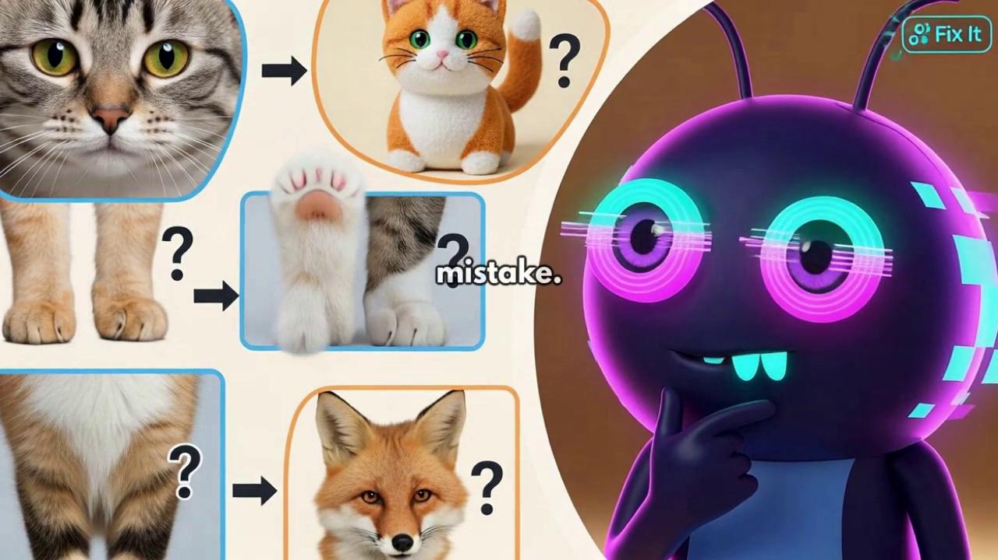
Representative frame from the completed video; generated in-frame text should not be treated as the authoritative lesson definition.

Learning objectives
- Define image classification in child-friendly language.
- Use at least two visible features to justify a category.
- Choose “Unsure” when evidence is incomplete and explain why.

Before the video: curiosity hook
Show one clear animal card and one cropped or shadowed version. Ask: “What clues stayed the same?” Do not define image classification yet.

Watch focus
Pause mentally whenever Pip makes a choice. Learners should look for the clue behind the choice, not only the answer.

Guided activity: Mystery Picture Sort
1. Place Cat, Dog and Unsure category cards on a table or screen.
2. Sort six clear animal cards and name one visible clue for each.
3. Sort six tricky cards containing shadows, costumes, partial views or unusual angles.
4. Move weak-evidence cases to Unsure rather than forcing a guess.
5. Write one rule that would help Pip avoid a repeated mistake.

Independent mission
Give the learner a new animal image. Require the sentence: “I chose ___ because I noticed ___ and ___.”

Five-question learning check
Question | Correct answer | Why it matters
What does image classification do? | It places a picture into a category. | This is the central concept of the lesson.
Why might a cat wearing a costume confuse a classifier? | The costume may create misleading visual features. | AI can focus on the wrong pattern.
When is “Unsure” the best answer? | When the picture does not provide enough reliable evidence. | Responsible systems should not invent certainty.
Is one feature always enough? | No. Several relevant clues are often needed. | Single-feature rules are fragile.
What should we do after an incorrect prediction? | Check the clues, question the rule and improve it. | Errors are evidence for improvement.

Age adaptation
Ages 6–8: use only picture cards and oral explanations. Ages 13–16: compare a hand-written rule with a real classifier and discuss confidence scores.

Parent or teacher takeaway
The learner practises evidence-based sorting and learns that computer vision can be useful without being perfect.
Release requirement
A human tutor must verify the captions, definitions, answer explanations and activity instructions. Correct any visible generated-text errors with platform overlays or post-production titles.

Lesson 2: Sound Safari: How Does AI Hear?
Completed video | Sound Safari.mp4 (1:51)
Total lesson time | 30–38 minutes
Key vocabulary | sound wave, pitch, rhythm, loudness, noise, speech recognition
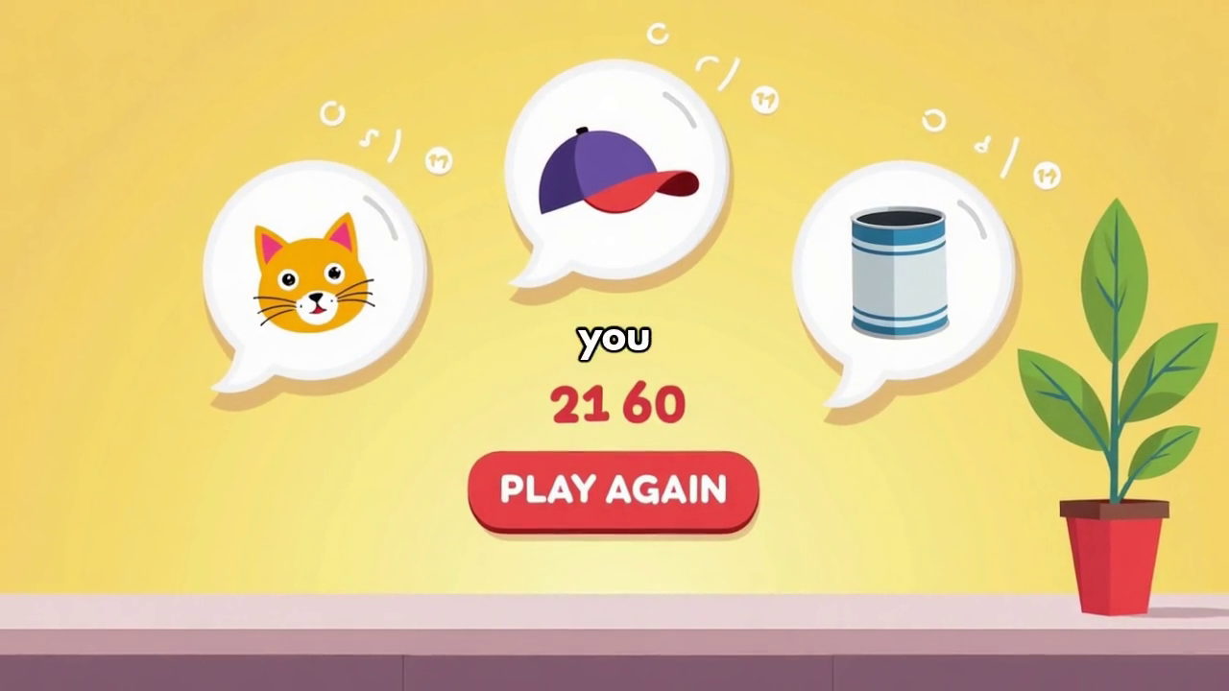
Representative frame from the completed video; generated in-frame text should not be treated as the authoritative lesson definition.

Learning objectives
- Name pitch, rhythm and loudness as useful sound features.
- Explain how background noise can change a prediction.
- Choose a safe confirmation response when speech is unclear.

Before the video: curiosity hook
Ask learners to close their eyes while the tutor makes a safe sound, such as tapping a pencil or shaking keys. Ask for two clues before revealing the source.

Watch focus
Listen for the difference between recognizing a pattern and understanding the real-world situation.

Guided activity: Eyes-Closed Sound Hunt
1. Play or make six safe sounds one at a time.
2. For each sound, record the guessed source and two clues.
3. Replay one sound with background noise added.
4. Compare which features remained useful and which became unclear.
5. Write a confirmation question a voice assistant should ask instead of guessing.

Independent mission
Create a three-clue “sound riddle” for a partner without naming the source.

Five-question learning check
Question | Correct answer | Why it matters
What is pitch? | How high or low a sound is. | Pitch is one measurable audio feature.
What can background noise do? | Hide or distort useful sound patterns. | Noise can lower reliability.
Should a voice assistant act when it is unsure? | It should ask for confirmation first. | Confirmation prevents harmful mistakes.
Name another useful sound feature. | Rhythm or loudness. | Multiple features improve comparison.
Does a waveform mean the computer understands the sound like a person? | No. It measures patterns in the signal. | Pattern recognition is not human understanding.

Age adaptation
Ages 6–8: use live sound guessing and picture choices. Ages 13–16: view simple waveforms and compare amplitude, frequency and noise.

Parent or teacher takeaway
The learner explores how machines recognize sounds and why uncertain voice systems should ask for confirmation.
Release requirement
A human tutor must verify the captions, definitions, answer explanations and activity instructions. Correct any visible generated-text errors with platform overlays or post-production titles.

Lesson 3: Creative Clues: Human or Machine?
Completed video | Creative Clues.mp4 (1:59)
Total lesson time | 30–38 minutes
Key vocabulary | source, evidence, metadata, process, confidence, generated
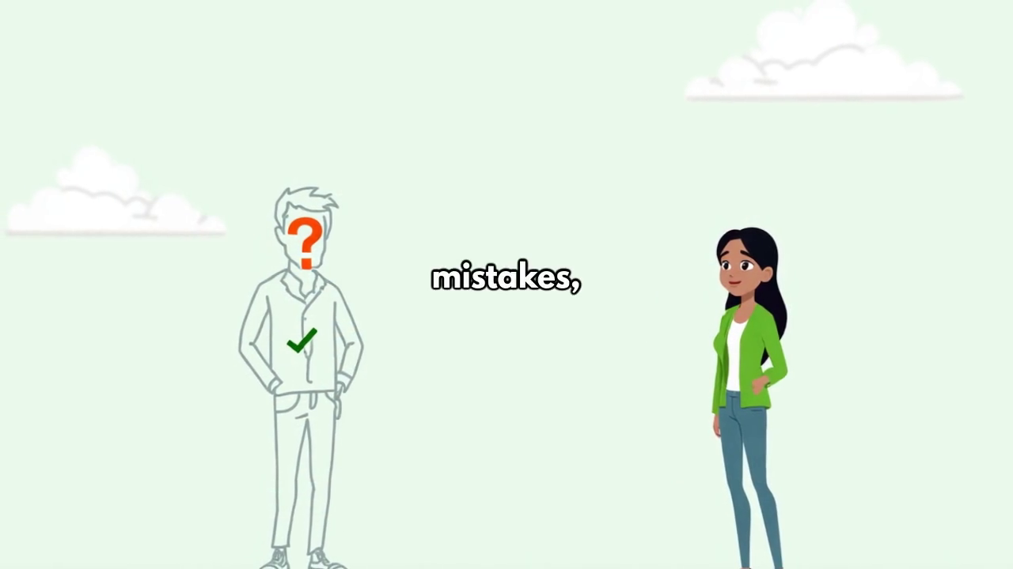
Representative frame from the completed video; generated in-frame text should not be treated as the authoritative lesson definition.

Learning objectives
- Distinguish weak style clues from stronger source evidence.
- Use Sure, Likely and Unsure honestly.
- Explain why accusing a creator without evidence can be harmful.

Before the video: curiosity hook
Show an unfamiliar picture and ask learners to guess who or what made it. Then ask: “What evidence do we actually have?”

Watch focus
Notice how conclusions change when source, process or metadata evidence is added.

Guided activity: Gallery Source Investigation
1. Inspect a teacher-prepared creation without source information.
2. Record a first guess and confidence level.
3. Reveal one style clue, then one process clue, then a source record.
4. Allow learners to update their conclusion after each clue.
5. Write a fair claim that separates evidence from guesswork.

Independent mission
Rewrite “AI definitely made this” as a careful evidence-based statement.

Five-question learning check
Question | Correct answer | Why it matters
Is visual style proof that AI made something? | No. Style alone is weak evidence. | Humans and tools can produce similar styles.
Which evidence is stronger: “it looks strange” or a verified creation record? | A verified creation record. | Source evidence is more reliable than appearance.
What should you say when evidence is incomplete? | Likely or Unsure, with a reason. | Confidence should match evidence.
Why can a false accusation cause harm? | It can unfairly damage a person’s work or reputation. | Responsible claims affect real people.
Can your conclusion change after new evidence? | Yes. Good investigators update their view. | Changing with evidence is a strength.

Age adaptation
Ages 6–8: use “guess” and “know” cards. Ages 13–16: discuss metadata limits, provenance and manipulated evidence.

Parent or teacher takeaway
The learner practises fair source evaluation and avoids claiming AI authorship from appearance alone.
Release requirement
A human tutor must verify the captions, definitions, answer explanations and activity instructions. Correct any visible generated-text errors with platform overlays or post-production titles.

Lesson 4: Glitch Hunt: Why AI Makes Mistakes
Completed video | Glitch Hunt.mp4 (1:03)
Total lesson time | 30–38 minutes
Key vocabulary | error, cause, hypothesis, test, fix, improve
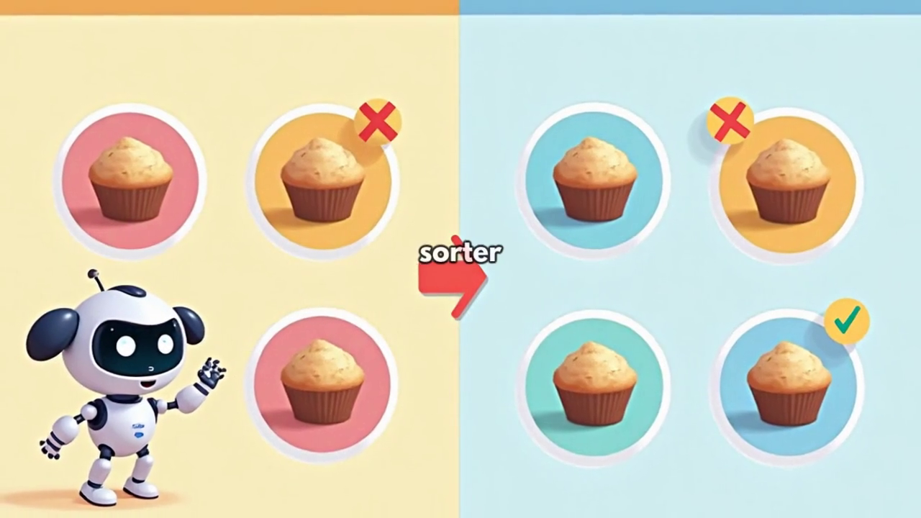
Representative frame from the completed video; generated in-frame text should not be treated as the authoritative lesson definition.

Learning objectives
- Use a calm error-analysis cycle.
- Match an error to a plausible cause.
- Test one change at a time using a new example.

Before the video: curiosity hook
Show a deliberately wrong sorting result. Ask: “What are three different reasons this could have happened?”

Watch focus
Watch for the difference between changing everything and testing one specific fix.

Guided activity: Glitch Case Files
1. Read one short case and circle the incorrect result.
2. Choose the most likely cause: poor examples, unclear input or wrong rule.
3. Select one fix only.
4. Predict what should improve if the hypothesis is correct.
5. Test with a fresh example and record whether the fix worked.

Independent mission
Explain a technology mistake without saying “the computer is stupid.” Use evidence and a possible cause.

Five-question learning check
Question | Correct answer | Why it matters
What is the first step after finding an error? | Observe and describe the error clearly. | A precise problem is easier to investigate.
What is a hypothesis? | A testable idea about the cause. | It guides the next experiment.
Why change one thing at a time? | So we can tell which change caused the improvement. | Controlled testing produces useful evidence.
Should the same examples be used for every test? | Use fresh examples as well. | New cases show whether the fix generalizes.
What does an error provide? | A clue about what may need improvement. | Mistakes are information, not just failure.

Age adaptation
Ages 6–8: use picture-based cause/fix cards. Ages 13–16: introduce validation data, confounding changes and error categories.

Parent or teacher takeaway
The learner uses a scientific routine to investigate mistakes instead of automatically trusting or rejecting technology.
Release requirement
A human tutor must verify the captions, definitions, answer explanations and activity instructions. Correct any visible generated-text errors with platform overlays or post-production titles.

Lesson 5: AI Detective: Build and Test a Classifier
Completed video | AI Detective.mp4 (1:29)
Total lesson time | 30–38 minutes
Key vocabulary | training data, test data, decision rule, classifier, unseen example
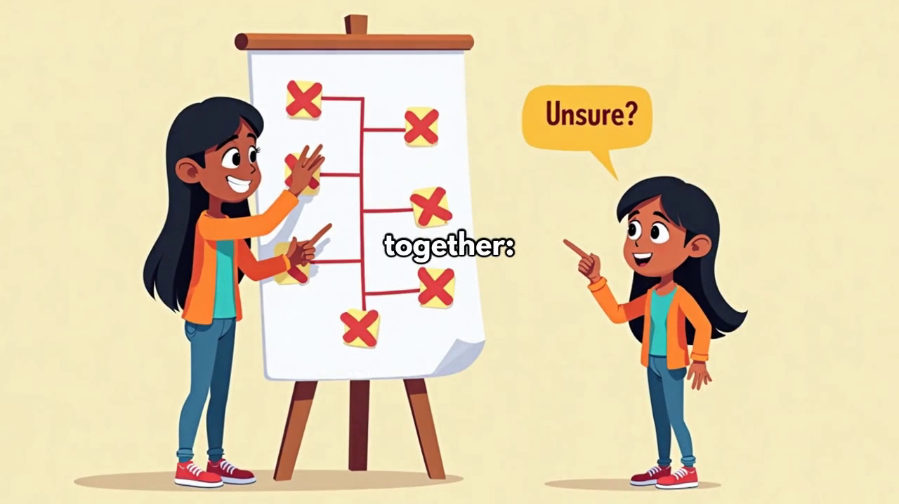
Representative frame from the completed video; generated in-frame text should not be treated as the authoritative lesson definition.

Learning objectives
- Create useful labels and features for a classification task.
- Build a simple decision rule with an Unsure outcome.
- Test the rule on unseen examples and improve one weakness.

Before the video: curiosity hook
Show three imaginary creatures. Let learners invent category names and identify one feature that separates them.

Watch focus
Notice that training examples teach the rule, while unseen test examples check whether the rule works beyond memorization.

Guided activity: Creature Classifier Lab
1. Place eight labelled creature cards in a Training envelope.
2. List the features that best separate the creature types.
3. Create a short decision tree, including Unsure.
4. Open four unseen Test cards and classify them without changing labels mid-test.
5. Record errors and improve one part of the decision tree.

Independent mission
Design one tricky creature card that exposes a weakness in the current rule.

Five-question learning check
Question | Correct answer | Why it matters
What is training data used for? | To build or learn the classification rule. | Training examples shape the classifier.
What is test data used for? | To check the rule on new examples. | Testing measures generalization.
Why keep test cards unseen? | To prevent memorizing the answers. | A fair test must be independent.
Why include an Unsure outcome? | Some cases do not contain enough clear evidence. | Uncertainty is safer than forced guessing.
What should be improved after a repeated error? | The relevant feature, example or decision rule. | Targeted improvement is more reliable.

Age adaptation
Ages 6–8: use two creature categories and a simple yes/no rule. Ages 13–16: calculate a confusion matrix and discuss overfitting.

Parent or teacher takeaway
The learner completes a miniature AI workflow: define, train, test and improve.
Release requirement
A human tutor must verify the captions, definitions, answer explanations and activity instructions. Correct any visible generated-text errors with platform overlays or post-production titles.

Course 2: Train Your Robot Brain
Course purpose
Four missions develop feature selection, data quality, language context and the train–tune–test cycle.

Lesson 1: Feature Find: Choose the Right Clues
Completed video | Feature Find.mp4 (1:41)
Total lesson time | 30–38 minutes
Key vocabulary | feature, goal, relevant, measurable, safe, sensitive information
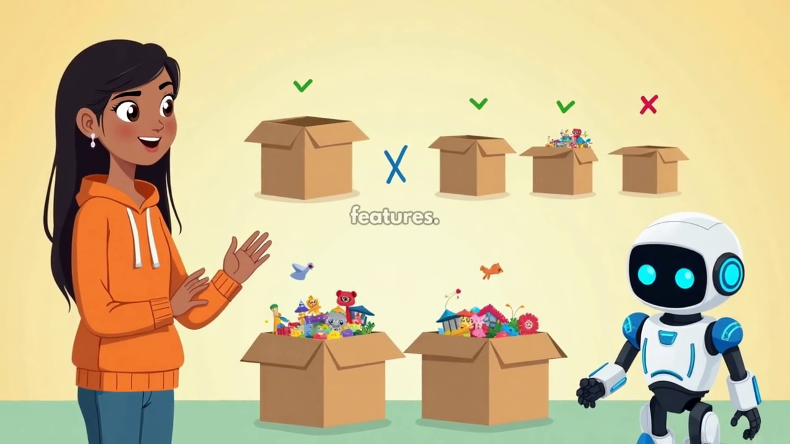
Representative frame from the completed video; generated in-frame text should not be treated as the authoritative lesson definition.

Learning objectives
- Define a feature as information used for a decision.
- Choose features that match a stated goal.
- Reject irrelevant or sensitive information.

Before the video: curiosity hook
Show the same set of toys and ask learners to sort them first by storage size, then by cleaning method. Compare which clues changed.

Watch focus
The best feature depends on the goal. More information is not automatically better.

Guided activity: Three-Way Toy Sort
1. Sort toys by storage size using size and shape.
2. Reset and sort for indoor versus outdoor play.
3. Reset and sort by material for cleaning.
4. Circle the most useful feature for each goal.
5. Identify one feature that should never be used for an unrelated child decision.

Independent mission
Give a goal and ask the learner to choose three useful features and one feature to exclude.

Five-question learning check
Question | Correct answer | Why it matters
What is a feature? | A piece of information used to make a decision. | Features are the clues a system measures.
Is color useful for every toy-sorting goal? | No. It depends on the goal. | Relevance changes with the task.
Why avoid unnecessary personal information? | It can be irrelevant and create privacy or fairness risks. | Safe systems collect only what they need.
What makes a feature measurable? | It can be observed or recorded consistently. | Vague features produce inconsistent decisions.
Is using more features always better? | No. Extra features can add noise or risk. | Good selection is purposeful.

Age adaptation
Ages 6–8: sort physical toys with picture goal cards. Ages 13–16: discuss proxy variables and feature leakage.

Parent or teacher takeaway
The learner discovers that useful AI decisions begin with a clear goal and carefully chosen information.
Release requirement
A human tutor must verify the captions, definitions, answer explanations and activity instructions. Correct any visible generated-text errors with platform overlays or post-production titles.

Lesson 2: Data Kitchen: Better Ingredients, Better Results
Completed video | Data Kitchen.mp4 (1:35)
Total lesson time | 30–38 minutes
Key vocabulary | dataset, duplicate, missing value, label, balance, representative
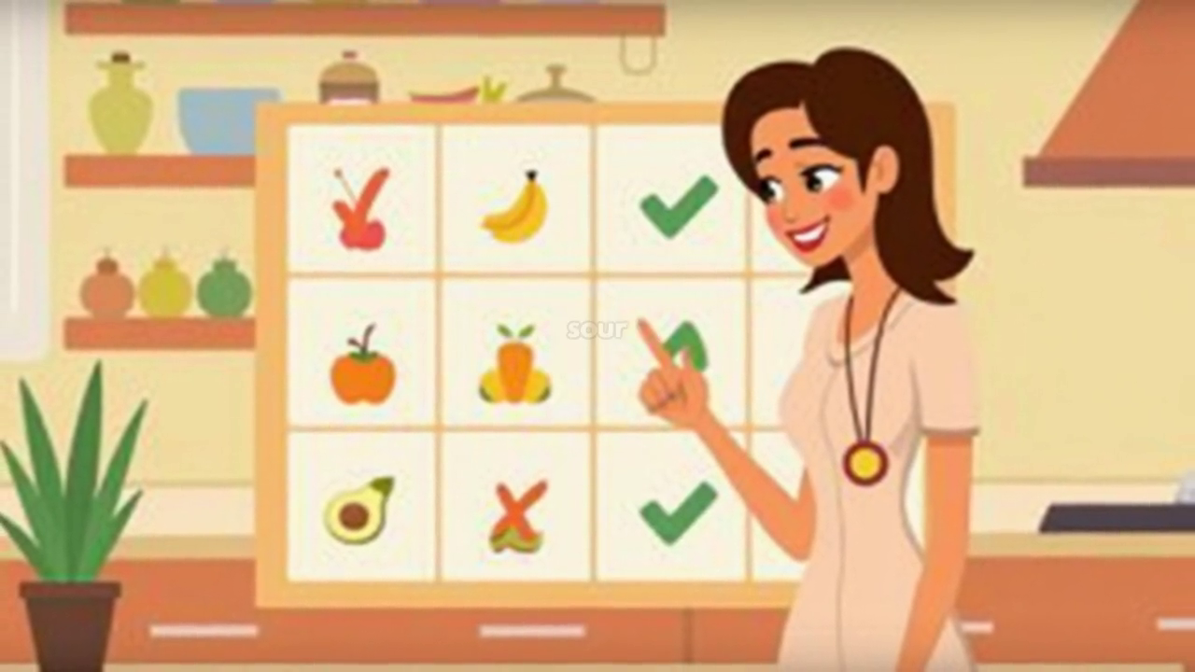
Representative frame from the completed video; generated in-frame text should not be treated as the authoritative lesson definition.

Learning objectives
- Identify duplicates, missing labels and impossible values.
- Explain imbalance with a simple category example.
- Propose a specific data improvement.

Before the video: curiosity hook
Present a pretend fruit recipe containing repeated, missing and impossible items. Ask what must be fixed before cooking.

Watch focus
Good data is not only “more data.” It must be accurate, labelled, varied and fit for the people or cases affected.

Guided activity: Clean the Recipe Data
1. Circle duplicates, missing labels and impossible values in a small dataset.
2. Choose which rows to correct, remove or investigate.
3. Count examples in each category.
4. Add examples to reduce a clear imbalance.
5. Write a one-sentence data note explaining the changes.

Independent mission
Create one “bad data ingredient” and explain the error it might cause.

Five-question learning check
Question | Correct answer | Why it matters
What is a duplicate? | The same example appearing more than once unintentionally. | Duplicates can distort patterns.
Why are missing labels a problem? | The system may not know the correct category. | Supervised learning needs reliable labels.
What is imbalance? | Some groups or categories have far more examples than others. | Underrepresented cases may perform poorly.
Does a larger dataset guarantee better results? | No. Quality and representation also matter. | Quantity cannot repair systematic errors.
What should a data note record? | What was changed and why. | Documentation supports responsible review.

Age adaptation
Ages 6–8: clean a picture-based fruit table. Ages 13–16: discuss sampling bias, label noise and class imbalance metrics.

Parent or teacher takeaway
The learner sees that reliable AI begins with careful, representative and documented data.
Release requirement
A human tutor must verify the captions, definitions, answer explanations and activity instructions. Correct any visible generated-text errors with platform overlays or post-production titles.

Lesson 3: Mood Mixer: Words, Tone and Context
Completed video | Mood Mixer.mp4 (0:59)
Total lesson time | 30–38 minutes
Key vocabulary | sentiment, tone, context, sarcasm, positive, negative, unclear
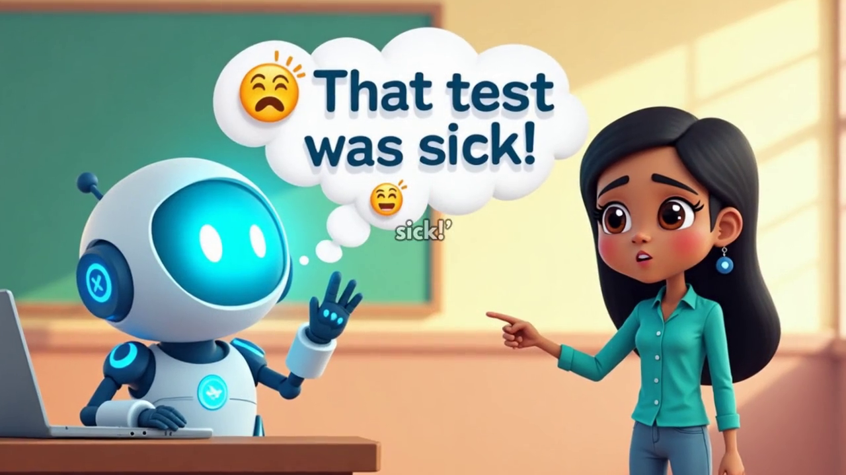
Representative frame from the completed video; generated in-frame text should not be treated as the authoritative lesson definition.

Learning objectives
- Explain sentiment classification as estimating tone from language.
- Recognize that context can change meaning.
- Use Unclear and a kind follow-up question instead of claiming to know a feeling.

Before the video: curiosity hook
Read “Great, another rainy day!” twice: once happily and once with frustration. Ask whether the words alone reveal the meaning.

Watch focus
A language system predicts from words and patterns; it cannot read a person’s mind.

Guided activity: Message Meaning Match
1. Sort four clear message cards into Positive, Negative or Unclear.
2. Add context cards to three ambiguous messages.
3. Update the first prediction when context changes.
4. Highlight the words that influenced the original choice.
5. Write one kind follow-up question for an unclear message.

Independent mission
Create a sentence that could sound positive or negative depending on context.

Five-question learning check
Question | Correct answer | Why it matters
What does sentiment classification estimate? | The likely tone of a message. | It predicts a category, not a private feeling.
What can make “Great!” negative? | Sarcasm or surrounding context. | The same words can carry different meanings.
Can AI know exactly how a person feels? | No. It can only estimate from available signals. | Emotion prediction has limits.
What is a safe response to an unclear message? | Ask a kind clarifying question. | Clarification is better than assumption.
Why include an Unclear category? | Some language is genuinely ambiguous. | Honest uncertainty reduces harm.

Age adaptation
Ages 6–8: use emoji and voice-tone demonstrations. Ages 13–16: discuss sentiment datasets, dialect and cultural context.

Parent or teacher takeaway
The learner understands that language tools estimate tone and should never be treated as mind readers.
Release requirement
A human tutor must verify the captions, definitions, answer explanations and activity instructions. Correct any visible generated-text errors with platform overlays or post-production titles.

Lesson 4: Robot Brain: Train, Tune, Test
Completed video | Robot Brain.mp4 (2:22)
Total lesson time | 30–38 minutes
Key vocabulary | train, tune, test, validation, final test, generalize
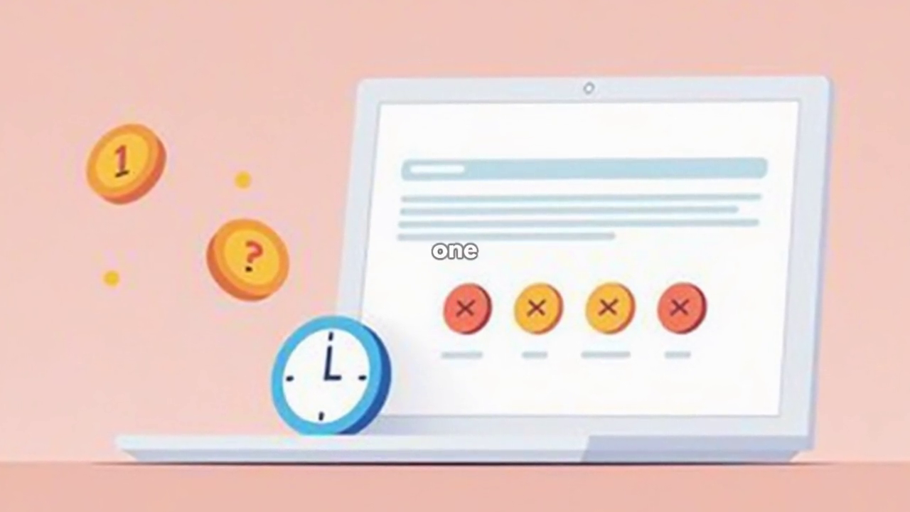
Representative frame from the completed video; generated in-frame text should not be treated as the authoritative lesson definition.

Learning objectives
- Describe the Train–Tune–Test cycle.
- Keep final test examples separate from improvement work.
- Make one targeted change and evaluate whether it generalizes.

Before the video: curiosity hook
Ask: “Would it be fair to practise with the exact questions from the final test?” Connect the answer to model evaluation.

Watch focus
The final test should measure performance honestly, not provide extra practice answers.

Guided activity: Robot Brain Championship
1. Use a small labelled training set to create an initial rule.
2. Try a tuning set and record repeated errors.
3. Change one feature, label or rule based on the evidence.
4. Seal the final test cards until tuning is complete.
5. Run the final test once and report both successes and remaining limits.

Independent mission
Write a fair “model card” with the goal, test result, one strength and one limitation.

Five-question learning check
Question | Correct answer | Why it matters
What happens during training? | The system learns or builds rules from labelled examples. | Training creates the initial model.
What is tuning for? | Improving choices using separate feedback examples. | Tuning refines without using the final test.
Why seal the final test? | To preserve an honest evaluation. | Repeated peeking makes the score unreliable.
What does generalize mean? | Work well on new examples, not only familiar ones. | Real usefulness requires transfer.
Should a final report hide errors? | No. It should report strengths and limits. | Transparent reporting supports safe use.

Age adaptation
Ages 6–8: use three envelopes and picture cards. Ages 13–16: separate training, validation and test metrics and discuss overfitting.

Parent or teacher takeaway
The learner completes a responsible train–tune–test cycle and reports limitations honestly.
Release requirement
A human tutor must verify the captions, definitions, answer explanations and activity instructions. Correct any visible generated-text errors with platform overlays or post-production titles.

Course 3: AI Game Creator Lab
Course purpose
Three missions teach responsive characters, conditional logic and pathfinding, then combine them in a playable design blueprint.

Lesson 1: Game Hero: Inputs, States and Actions
Completed video | Game Hero.mp4 (1:28)
Total lesson time | 30–38 minutes
Key vocabulary | input, state, action, behavior, feedback, rule
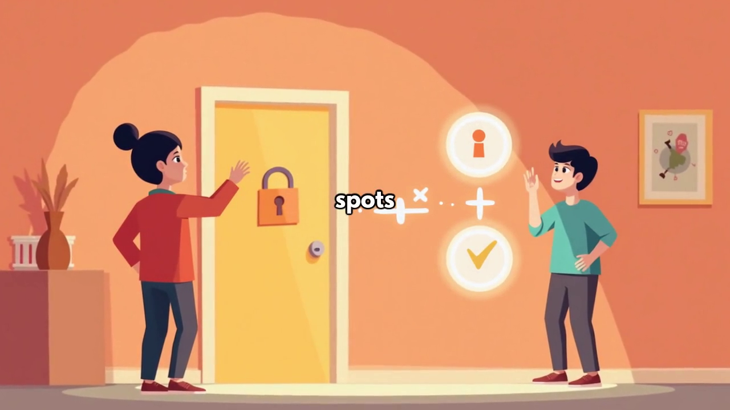
Representative frame from the completed video; generated in-frame text should not be treated as the authoritative lesson definition.

Learning objectives
- Identify an input, a remembered state and an action.
- Create different actions from the same input in different states.
- Test whether a character rule is clear and predictable.

Before the video: curiosity hook
Ask learners what should happen when the same jump button is pressed on the ground versus in mid-air.

Watch focus
The game character follows designed rules. It may appear clever without being alive or conscious.

Guided activity: Hero Behavior Builder
1. Choose a hero goal and three things the hero can notice.
2. Define two pieces of state the game remembers.
3. Write three Input–State–Action rules.
4. Act them out with a partner acting as the game engine.
5. Revise any rule that produces confusing behavior.

Independent mission
Create one rule that prevents an unsafe or unfair action in the game.

Five-question learning check
Question | Correct answer | Why it matters
What is an input? | A signal or event the game receives. | Inputs trigger decision rules.
What is state? | Information the game remembers about the current situation. | State changes how the same input is handled.
Can the same input cause different actions? | Yes, when the state is different. | Responsive behavior depends on context.
Is a game hero alive because it reacts? | No. It follows programmed or learned behavior. | Appearance of agency is not consciousness.
Why test rules with a partner? | To find unclear or unexpected behavior. | Testing improves design.

Age adaptation
Ages 6–8: act out rules physically. Ages 13–16: implement a finite-state machine or block-code prototype.

Parent or teacher takeaway
The learner understands the architecture behind responsive game characters.
Release requirement
A human tutor must verify the captions, definitions, answer explanations and activity instructions. Correct any visible generated-text errors with platform overlays or post-production titles.

Lesson 2: Choice Engine: If–Then Decisions
Completed video | Choice Engine.mp4 (1:11)
Total lesson time | 30–38 minutes
Key vocabulary | condition, if–then, branch, priority, conflict, feedback
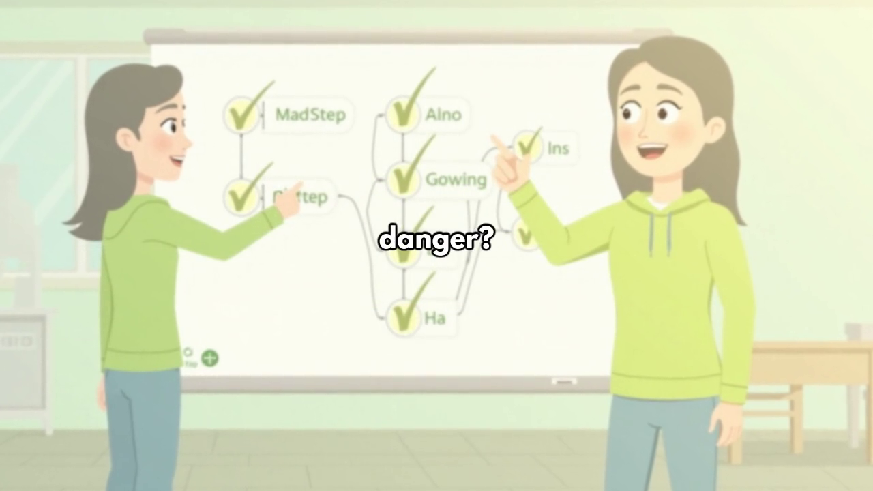
Representative frame from the completed video; generated in-frame text should not be treated as the authoritative lesson definition.

Learning objectives
- Write clear if–then rules.
- Order rules by priority when several conditions are true.
- Identify and repair a conflict between rules.

Before the video: curiosity hook
Give the rule “If the door is locked, use the key.” Then add “If there is a fire, leave immediately.” Ask which rule should have priority.

Watch focus
A decision engine needs both conditions and an order for resolving conflicts.

Guided activity: Guard Rule Workshop
1. Choose four facts a castle guard can observe.
2. Write three if–then rules.
3. Place the rules in priority order.
4. Role-play five player situations, including one conflict.
5. Repair the conflict and add clear feedback for the player.

Independent mission
Design a rule that asks permission before using a player’s personal information.

Five-question learning check
Question | Correct answer | Why it matters
What comes after “if” in a rule? | A condition to check. | The condition determines whether the rule applies.
What comes after “then”? | The action to perform. | The action is the response.
Why do rules need priority? | More than one condition may be true. | Priority resolves competing actions.
What is a conflict? | Two rules call for incompatible actions. | Conflicts can create unfair or broken behavior.
Why provide feedback? | So the player understands what happened and why. | Transparent systems are easier to trust and improve.

Age adaptation
Ages 6–8: use physical condition/action cards. Ages 13–16: create a flowchart and test edge cases.

Parent or teacher takeaway
The learner practises conditional logic, rule ordering and clear feedback.
Release requirement
A human tutor must verify the captions, definitions, answer explanations and activity instructions. Correct any visible generated-text errors with platform overlays or post-production titles.

Lesson 3: Maze Mission: Goals, Paths and Costs
Completed video | Maze Mission.mp4 (1:51)
Total lesson time | 30–38 minutes
Key vocabulary | path, goal, cost, visited, obstacle, uncertainty
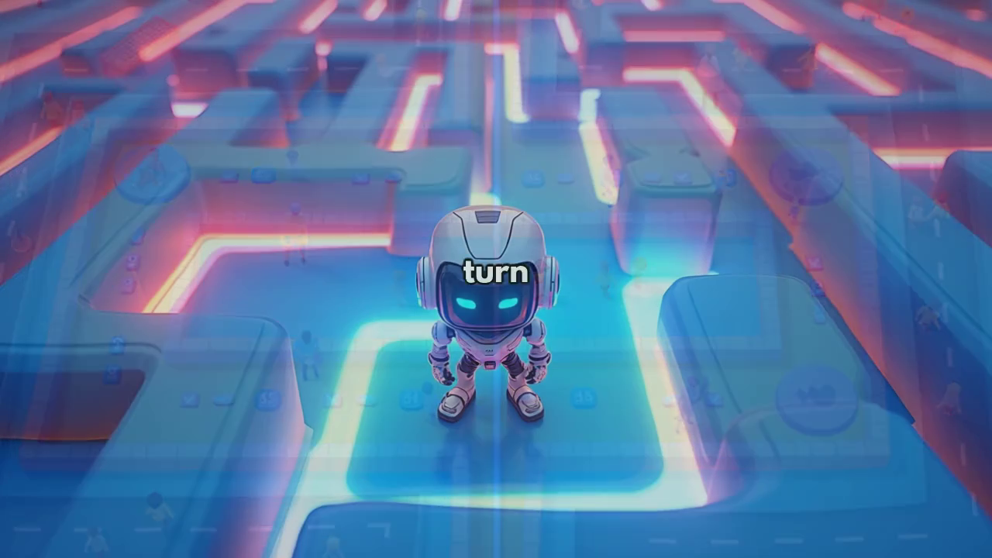
Representative frame from the completed video; generated in-frame text should not be treated as the authoritative lesson definition.

Learning objectives
- Compare routes using a stated cost.
- Track visited locations and obstacles.
- Explain why the “best” route depends on the goal.

Before the video: curiosity hook
Show two routes: one shorter but risky, one longer but safe. Ask which is best before revealing the mission goal.

Watch focus
Pathfinding is not only about distance; goals can include safety, time, energy or uncertainty.

Guided activity: Crystal Route Race
1. Read the movement and cost rules.
2. Mark the start, goal and known obstacles.
3. Explore one route while recording visited squares.
4. Calculate its total cost.
5. Find a second route and compare distance, safety and uncertainty.

Independent mission
Change one obstacle and explain how the best route should update.

Five-question learning check
Question | Correct answer | Why it matters
What is a path? | A sequence of moves from start to goal. | Paths are the object being compared.
Why mark visited squares? | To avoid unnecessary repetition and track exploration. | Memory improves search efficiency.
Is the shortest route always best? | No. The goal may include safety or another cost. | Optimization depends on the objective.
What should happen when a new obstacle appears? | Re-plan using the updated information. | Adaptive systems respond to change.
What does cost mean in pathfinding? | A value used to compare routes, such as time or risk. | Cost makes the goal measurable.

Age adaptation
Ages 6–8: walk a floor maze. Ages 13–16: compare breadth-first search, weighted costs and heuristic ideas.

Parent or teacher takeaway
The learner sees that intelligent route planning depends on goals, costs and changing information.
Release requirement
A human tutor must verify the captions, definitions, answer explanations and activity instructions. Correct any visible generated-text errors with platform overlays or post-production titles.

Course 4: Smart and Safe AI Heroes
Course purpose
Two focused missions teach privacy and truth-checking, followed by an integrated digital-safety challenge.

Lesson 1: Privacy Mission: Collect Only What Is Needed
Completed video | Privacy Mission.mp4 (1:04)
Total lesson time | 30–38 minutes
Key vocabulary | personal data, privacy, purpose, minimum, permission, delete
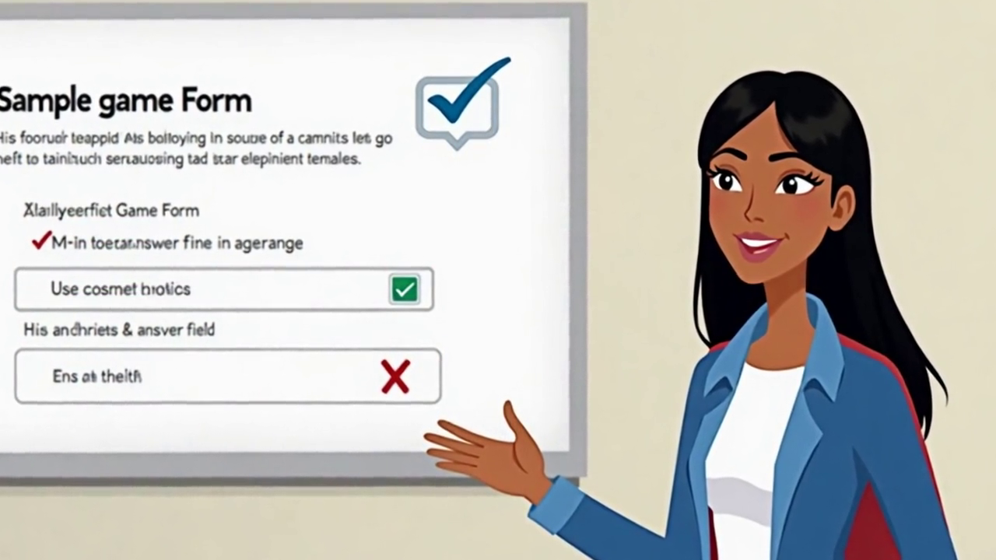
Representative frame from the completed video; generated in-frame text should not be treated as the authoritative lesson definition.

Learning objectives
- Distinguish necessary from unnecessary personal data.
- Apply data minimization to a child-facing app.
- Name a safe action before sharing information.

Before the video: curiosity hook
Ask: “A drawing app wants your home address. Does it need it to let you draw?” Require a reason.

Watch focus
Every requested data field should connect to a clear purpose. Less data can be safer and still achieve the goal.

Guided activity: App Privacy Makeover
1. Read the fictional app’s purpose.
2. Sort requested fields into Needed, Optional and Do Not Collect.
3. Replace exact information with a less specific option where possible.
4. Add a child-friendly explanation and trusted-adult permission step.
5. Choose when stored data should be deleted.

Independent mission
Redesign one sign-up form so it asks for the minimum information needed.

Five-question learning check
Question | Correct answer | Why it matters
What is data minimization? | Collecting only the information needed for a clear purpose. | It reduces unnecessary exposure.
Which is often safer: exact birth date or age band? | Age band, when an exact date is not needed. | Less precise data can meet the same goal.
Should an app explain why it wants data? | Yes. The purpose should be clear. | Informed choices require understandable reasons.
Who should a child involve before sharing sensitive data? | A trusted adult. | Adult support strengthens safety.
Should data be kept forever by default? | No. Delete it when the purpose is finished. | Retention should be limited.

Age adaptation
Ages 6–8: use simple safe/not-safe cards with an adult. Ages 13–16: discuss consent, retention, access control and privacy by design.

Parent or teacher takeaway
The learner practises deciding what an app genuinely needs and when to involve a trusted adult.
Release requirement
A human tutor must verify the captions, definitions, answer explanations and activity instructions. Correct any visible generated-text errors with platform overlays or post-production titles.

Lesson 2: Truth Tracker: Check Before You Share
Completed video | Truth Tracker.mp4 (2:07)
Total lesson time | 30–38 minutes
Key vocabulary | claim, source, evidence, date, context, misinformation, verify
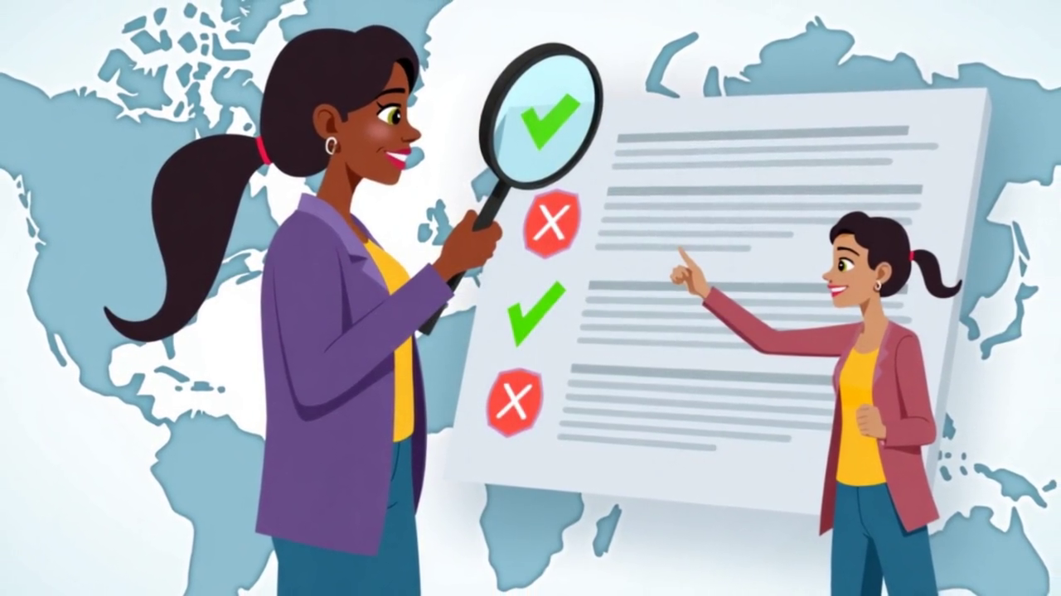
Representative frame from the completed video; generated in-frame text should not be treated as the authoritative lesson definition.

Learning objectives
- Apply a simple source–date–evidence–context checklist.
- Explain how real media can be paired with false context.
- Choose Do Not Share or Need More Information when evidence is insufficient.

Before the video: curiosity hook
Show a dramatic fictional headline. Ask learners to pause, breathe and identify what information is missing before reacting.

Watch focus
Likes and confident language are not evidence. Verification happens before sharing.

Guided activity: Newsroom Verification Desk
1. Read a fictional claim without reacting to the headline.
2. Find the named source and publication date.
3. Identify the evidence actually provided.
4. Compare the claim with two tutor-supplied reliable sources.
5. Choose Share, Do Not Share or Need More Information and explain the decision.

Independent mission
Write a calm response to a friend who shared an unverified claim.

Five-question learning check
Question | Correct answer | Why it matters
What should you check first about a claim? | Its source and what the source actually says. | A claim without a traceable source is weak.
Why does the date matter? | Old information may be presented as current. | Context can change over time.
Are many likes proof that a post is true? | No. Popularity is not evidence. | False claims can spread widely.
Can a real photo support a false claim? | Yes, if the context is changed. | Authentic media can be misused.
What should you do when evidence is insufficient? | Do not share, or mark Need More Information. | Pausing prevents further spread.

Age adaptation
Ages 6–8: use simple “Who said it? When? How do they know?” cards. Ages 13–16: compare primary and secondary sources and reverse-context scenarios.

Parent or teacher takeaway
The learner develops a practical routine for checking online claims before believing or sharing them.
Release requirement
A human tutor must verify the captions, definitions, answer explanations and activity instructions. Correct any visible generated-text errors with platform overlays or post-production titles.

6. Four Capstone Projects
The capstones replace the educational depth that would otherwise have been carried by the six absent videos. They also give parents and schools something concrete to assess and display.

Course 1 Capstone: Mystery Media Lab
Time | 30–40 min
Completion badge | Chief AI Detective
Evidence produced | Worksheet, explanation and final design or decision
Learners investigate one image, one sound and one creative work; classify with evidence, state confidence, diagnose one glitch and improve a rule.
1. Classify one tricky image and one noisy sound using evidence.
2. Evaluate the source of one creative work using confidence language.
3. Diagnose one incorrect AI result and test a targeted fix.
4. Build a simple decision rule and explain one limitation.
Success standard
The learner must explain the reasoning behind the result, not only submit a final answer.

Course 2 Capstone: Robot Trainer Lab
Time | 35–45 min
Completion badge | Robot Brain Champion
Evidence produced | Worksheet, explanation and final design or decision
Learners choose features, clean a small dataset, train a simple rule, test ambiguous cases and publish a one-page model card.
1. Choose relevant, measurable and safe features for a goal.
2. Clean a small dataset containing duplicates, missing labels and imbalance.
3. Train and tune a simple classifier.
4. Open a sealed test set and publish a short model card.
Success standard
The learner must explain the reasoning behind the result, not only submit a final answer.

Course 3 Capstone: Mini Adventure Blueprint
Time | 40–50 min
Completion badge | Junior Game Architect
Evidence produced | Worksheet, explanation and final design or decision
Learners design a hero, write prioritized if–then rules and create a maze with at least two routes and a measurable cost.
1. Design a game hero with inputs, states and actions.
2. Write prioritized if–then rules, including one safety rule.
3. Create a maze with two routes and a measurable cost.
4. Present the complete game blueprint and test one edge case.
Success standard
The learner must explain the reasoning behind the result, not only submit a final answer.

Course 4 Capstone: Digital Safety Newsroom
Time | 35–45 min
Completion badge | Smart and Safe AI Hero
Evidence produced | Worksheet, explanation and final design or decision
Learners audit an app form, verify a viral claim and decide when a human or trusted adult must take control.
1. Redesign an app form using data minimization.
2. Verify a fictional viral post using source, date, evidence and context.
3. Discuss three bonus cases: safe rescue route, fair team selection and when a human must take control.
4. Create a personal “Pause Before You Share” checklist.
Success standard
The learner must explain the reasoning behind the result, not only submit a final answer.

7. Platform Implementation and Quality Controls

Required lesson components
- Accurate lesson title and exact video runtime.
- Clean text definition outside the video.
- Downloadable or interactive activity materials.
- Five-question quiz with explanations, not only scores.
- An “Unsure” or “Need More Information” option where appropriate.
- Badge and progress indicator.
- Parent/teacher summary.
- Captions checked by a human tutor.

How to compensate for current visual inconsistencies
- Use the same course cover, lesson thumbnail frame, typography and color system across all 14 lessons.
- Display character names in the platform shell rather than relying on generated text inside scenes.
- Add a clean summary card immediately after every video.
- Place countdowns and answer pauses in the interactive platform, not inside the short video.
- Where an in-video label is unreadable, overlay a corrected title in the player or edit the video before release.
- Use the same badge shape and progress map even when the character artwork changes between videos.

Tutor release checklist
Check | Release question
Concept accuracy | Does the lesson distinguish prediction from understanding?
Child suitability | Are sentences, examples and actions appropriate for the target age?
Safety | Does the activity avoid collecting children’s personal data or exposing them to open web searches?
Assessment validity | Does each wrong answer reveal a real misconception?
Visual clarity | Are all essential words readable outside the generated artwork?
Accessibility | Are captions accurate, contrast sufficient and instructions available without audio?
Consistency | Do title, badge, lesson number and course order match the platform?

Recommended learner progress rules
- Allow replay without penalty.
- Require completion of the activity before unlocking the quiz.
- Require at least 80% on the quiz, with unlimited supported retries.
- Always show answer explanations after submission.
- Award the course badge only after the capstone, not after passive video viewing.
- Provide a final certificate after all four capstones are approved.

8. Client-Facing Course Description
Suggested wording
AI for Kids is a four-course interactive learning adventure for ages 9–12. Children complete 14 animated AI missions covering how machines recognise pictures and sounds, learn from data, make decisions, power game characters, protect privacy and check online information. Every short video is followed by a hands-on activity, challenge, quiz and badge. Four capstone projects turn the ideas into practical skills, providing approximately 8–9 hours of guided learning.

What customers receive
- 4 structured courses
- 14 animated mission videos
- 14 guided activities
- 14 independent challenges
- 70 quiz questions with answer explanations
- 4 capstone projects
- Course badges and one completion certificate
- Parent or teacher summaries

Final professional recommendation
Do not market the product as “twenty 10-minute video lessons.” The files do not support that claim. Market it accurately as a four-course interactive program with 14 animated mission videos and substantial guided activities. This positioning is both more honest and more educationally valuable.
Approval status
This revised curriculum is ready for client review as a structured plan. Before children use it, a qualified human tutor should complete a final review of captions, quiz wording, safety, cultural suitability and age-level adaptations.

