6. Running Analysis

The purpose of performing NPAIRS or PLS analysis on neuroimaging data is to obtain result data that can better interpret brain activity and other brain statistical information through data-driven analysis model generation. Results include statistical parametric images (SPIs) and measures of significance and reliability of results.

6.1 NPAIRS

The internal procedures of an NPAIRS analysis include the following steps:

- Arrange data in a 2D matrix, one image volume (scan) per row. Each 3D image volume is represented as a 1D array of voxel intensity data, hence dimensions of data are Number of Scans X Number of voxels in each scan.
- Optionally: Reduce data dimensions via PCA or (coming soon) some other initial feature-selection technique.
- Run analysis (e.g. CVA) on full data matrix (i.e., all input scans).
- Split data repeatedly into random disjoint training and test sets (i.e., subsets containing only some rows of full data matrix).
- Run analysis on each training split data set.
- Test results of each analysis on corresponding test set and generate
analysis model test statistics for current data split, e.g. prediction metrics.
- Depending on resampling (i.e., data splitting) technique, possibly switch
roles of training and test sets (i.e., run analyses on previously designated
test sets and test results on corresponding training sets).
- Calculate average analysis results over resampling results, first bringing all
results into comparable space using original full-data analysis as reference.
- Compute other summary results, e.g. (in case training/test sets switched) reproducibility metric.

6.1.1 Analysis Window

In the start window, select NPAIRS/Blocked fMRI module and then click Run Analysis button to open Analysis window (Figure 11).

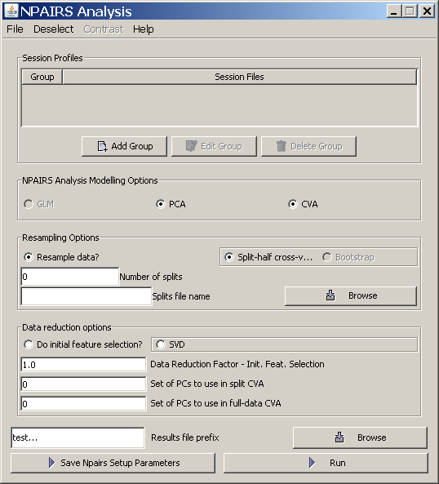

Figure 11

Note that, unlike the PLS Analysis window, the information given by the user in the NPAIRS Analysis window must be saved in an ‘NPAIRS Setup Parameters’ file before running an NPAIRS analysis. The default suffix is ‘_NPAIRSSetupParams.mat’. A previously saved NPAIRS Setup Parameters file can also be loaded via the File menu and run.

Session Files

In the Analysis window, add data via session files by clicking Add Group and choosing which session files you want to include in the first group. You can edit or delete a group of session files by highlighting the line in the Analysis window containing the group to be changed and clicking Edit Group or Delete Group.

If you want to add another group, click Add Group again to choose session files for the next group. Note that dividing the input data into groups means that any split data subset will contain session files from each group in the same proportion as they exist in the full data set. For example, if the input data consists in equal measures of young and old subjects, grouping them will ensure that each split sample contains an equal number of old and young subjects.

NPAIRS Analysis Modelling Options

When you have finished adding session files, choose the type of NPAIRS analysis technique you would like to use. (Note that the default choice of PCA and CVA, i.e., PCA followed by CVA, is the only currently implemented analysis option.)

Resampling Options

The only resampling option currently implemented is split-half cross-validation, wherein data is randomly split into 2 equal disjoint halves (or almost equal, if input data has odd number of session files), and each split half is used as a ‘training’ set to generate a model that is then tested on the remaining ‘test’ data set (i.e., each split half plays both ‘training’ and ‘test’ roles). The number you enter in Number of splits is an upper bound on the number of times the data is resampled, i.e., if the total possible number of splits is 15 and you enter 20, then 15 splits will be generated.

Note that the default split unit is session file (~ subject).

If you do not choose the Resample data? option, then only a full-data analysis will be run.

If you do not enter a file name into the Splits file name text field, then splits information will be saved by default in a new file named Results file prefix + ‘.NPAIRS.vols’. If you enter the name of an existing file, then splits information (i.e., which rows (scans) of input data are included in each split) will be loaded from the file instead of generated anew for this analysis. This allows you to run multiple analyses on exactly the same resampled data. You can also click Browse to find an existing file. If you enter the name of a file that doesn’t exist, then splits information will be generated and saved in a new file with the supplied name. (Note: if you supply a file name with no suffix, then the new file will have ‘.vols’ added as a suffix.)

Data reduction options

If you want to reduce the dimensionality of the data before analyzing it (recommended), click Do initial feature selection. By default, an initial SVD will be run (other feature selection techniques will be implemented later). Enter a number n (0.0 < n <= 1.0) in Data Reduction Factor field to indicate proportion of original data dimensions to keep. (Note orig. data dims == no. masked voxels.)
If running PCA followed by CVA, enter PC dimensions of data to pass into CVA analysis for full data and (if resampling done) split data. PC dimensions can be comma separated with or without spaces and/or given as a range, e.g. 1-5, 7 , 10 – 15,22, 25- 30

If running CVA, specify classes (conditions) to include in analysis by choosing Deselect
from the menu bar and unchecking the classes to exclude (Figure 12).

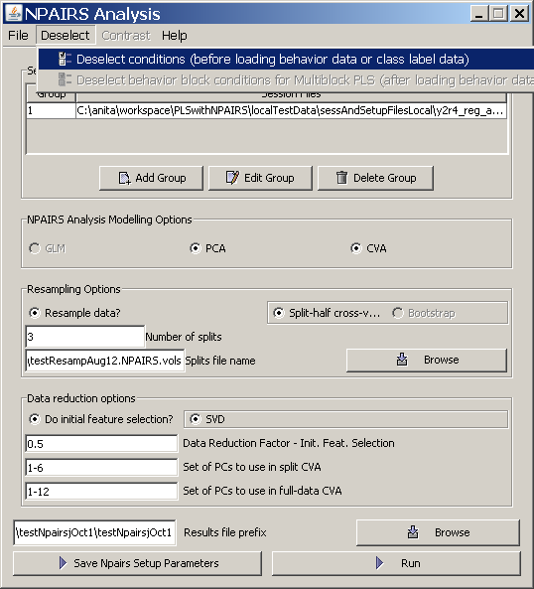

Figure 12

Results

Enter or Browse for a Results file prefix; include path name (otherwise results will be saved in current working directory).

Running Analysis

* NOTE: You must save Analysis window info in NPAIRS Setup Params file (click Save Npairs Setup Parameters or choose Save/Save As in File menu) before running analysis!

Click Run button to run NPAIRS analysis and save results.

6.2 PLS

The internal procedures of a PLS analysis include the following steps:

- Stack the datamat in the format of subject within condition within group. For Behaviour PLS and Multiblock PLS, behaviour data should also be stacked in this way.
- Generate a covariance or correlation matrix from the stacked datamat (and stacked behaviour data).
- Decompose the covariance or correlation matrix to compute the singular vectors.
- Run permutation for significance test (optional).
- Run bootstrap for reliability test (optional).

6.2.1 Analysis Window

In the start window, select PLS and desired Experiment Type and then click Run Analysis button to open Analysis window (Figure 13). The Analysis window is almost identical for all experiment types; there are some key differences, however, in input data:

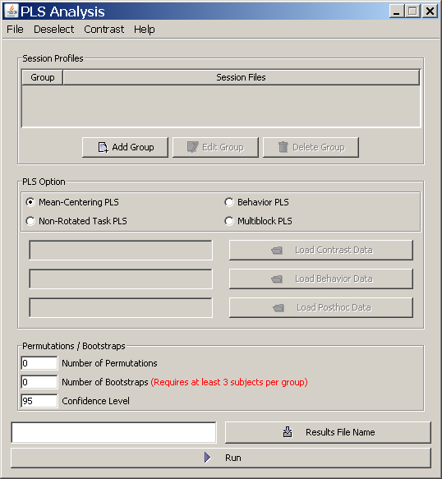

Figure 13

Session Profiles

For PET data analysis, input files are not actually session files; each group of input data consists of a single datamat file. For event-related and blocked fMRI analyses, each group consists of one or more session files.

Add data for each group by clicking Add Group. You can also optionally remove some conditions from analysis by clicking Deselect conditions under Deselect menu.

PLS Option

Choose which type of PLS to perform:
If you choose Mean-Centering PLS, the grand mean across tasks is calculated and this value is subtracted from all individual data points. The newly generated matrix is subjected to singular value decomposition (SVD) to obtain singular values, singular vectors, etc.

If you choose Non-Rotated Task PLS, a priori contrasts are used to restrict the patterns derived from PLS. You will need to provide a contrast file (in plain text) in order to run this analysis. Select Open Contrast Window from Contrast menu to open New Contrasts (Figure 15). Load existing contrast file by clicking Load in File menu of New Contrasts window, or create one and save it by using Save/Save As.

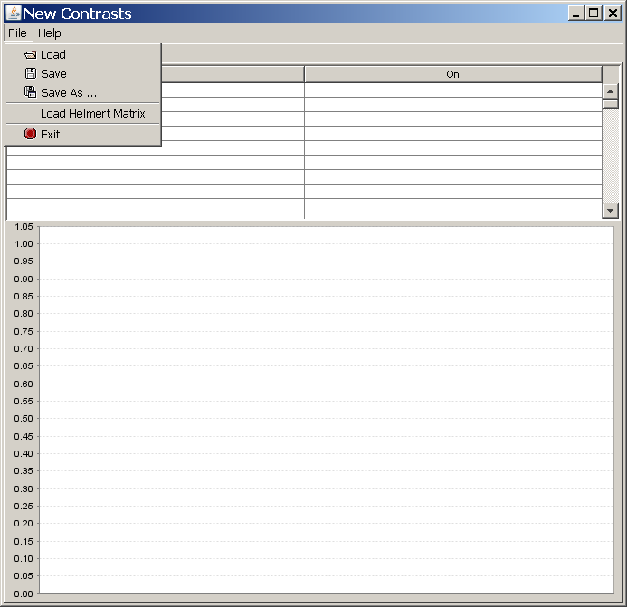

Figure 15

For Behavior PLS and Multiblock PLS, you must have at least 3 subjects in order to generate a correlation matrix on which PLS can run properly.

If you choose the Behavior PLS option, behaviour measures that correspond to each scan image are used to compute the correlation matrix between the measures and the datamat. Hence you also need to provide a behaviour file (in plain text) in order to run this analysis. Each column in the behaviour file stands for one measure, and is separated by a space. The rows should be arranged in the order of “subjects in selected conditions in groups”.

For example, let's say you have group1 and group2 with condition1 and condition2. In group1, you have 2 subjects, and in group2 you have 3 subjects. Here is the order of the behaviour file:

group1 condition1 subject1
group1 condition1 subject2
group1 condition2 subject1
group1 condition2 subject2
group2 condition1 subject1
group2 condition1 subject2
group2 condition1 subject3
group2 condition2 subject1
group2 condition2 subject2
group2 condition2 subject3

To input behaviour data, click Load behavior data button and a file browser will open up. Note that if you deselect any condition after loading behaviour data, your behaviour data file should only contain information about the final set of included conditions, i.e. the behaviour data should correspond to the selected conditions only.

If you choose the Multiblock PLS option, the program will apply both Mean-Centering Task PLS and Behavior PLS to the same datamat. Hence a behaviour file must be input the same way as for Behavior PLS. Optionally, you can also choose to select only some of the conditions for the behaviour block of Multiblock PLS. To do this, you need to click Deselect behaviorblock conditions for Multiblock PLS under Deselect menu.

Permutations/Bootstraps

To test the significance of the singular vectors, you can enter the Number of Permutations to perform. To test the reliability of the activity area, enter the Number of Bootstraps to do. Note that you must have at least 3 subjects (session files) in order to perform a bootstrap test. If you choose to do a bootstrap test, the bootstrap result will also contain the upper and lower percentile of correlations. It is determined by the value entered in the Confidence Level field, which is 95 percent by default.

Results

Enter or Browse for a Results file name; include path name (otherwise results will be saved in current working directory). If you do not include a suffix, the name you enter will be appended with ‘_fMRIresult.mat’ (event-related fMRI), ‘_BfMRIresult.mat’ (blocked fMRI) or ‘_PETresult.mat’ (PET).

Running Analysis

Click Run button to run PLS analysis and save results.

