


实 验 报 告

学 院 国际学院
专 业 软工
学 号 20242605031
姓 名 石一泽
指导教师 湛燕

2025年 12月15日

国际学院汇编程序设计实验报告

- 实验目的：
1、熟悉汇编程序的格式；
2、了解汇编语言的执行过程；

- 实验要求：
学习掌握汇编语言的基本指令，以及各种结构程序设计、变量的使用，字符串的输入输出。

- 实验内容：（题目及实现代码）
1、编写程序，在一行上依次显示26个大写英文字母。
2、已知字符串“ABCDEFGH”位于数据段开始的区域中，编程序将该字符串转换成小写后，存于其后。

INCLUDE io32.inc
INCLUDELIB io32.lib

.data
string DB "ABCDEFGH"
var_a DW 0BD61h, 0FF46h
var_b DW 2 DUP(?)

.code
PrintAllCharacters PROC
MOV AX, 'A'
MOV CX, 26
@Loop:
CALL dispc
INC AX
DEC CX
JNZ @Loop
RET
PrintAllCharacters ENDP

DataStringToLowerCase PROC
LEA ESI, string
MOV ECX, LENGTHOF string
LEA EDI, [string + ECX]
XOR EBX, EBX
@ConvertLoop:
MOV AL, [ESI]
ADD AL, 20h
MOV [EDI], AL
INC ESI
INC EDI
DEC ECX
JNZ @ConvertLoop

LEA EAX, string
CALL dispmsg
RET
DataStringToLowerCase ENDP
- 实验结果及分析：
Experiment Report on Assembler Program Design of International College

1、 Purpose:
1. Familiar with the format of assembler;
2. Understand the execution process of assembly language;

2、 Experimental requirements:
Learn and master the basic instructions of assembly language, as well as the design of various structural programs, the use of variables, and the input and output of strings.

3、 Experiment content: (topic and implementation code)
1. Write a program that displays 26 uppercase English letters on one line.
2. The known string "ABCDEFGH" is located in the area at the beginning of the data segment. The program converts the string to lowercase and stores it later.

INCLUDE io32.inc
INCLUDELIB io32.lib

.data
string DB "ABCDEFGH"
var_a DW 0BD61h, 0FF46h
var_b DW 2 DUP(?)

.code
PrintAllCharacters PROC
MOV AX, 'A'
MOV CX, 26
@Loop:
CALL dispc
INC AX
DEC CX
JNZ @Loop
RET
PrintAllCharacters ENDP

DataStringToLowerCase PROC
LEA ESI, string
MOV ECX, LENGTHOF string
LEA EDI, [string + ECX]
XOR EBX, EBX
@ConvertLoop:
MOV AL, [ESI]
ADD AL, 20h
MOV [EDI], AL
INC ESI
INC EDI
DEC ECX
JNZ @ConvertLoop

LEA EAX, string
CALL dispmsg
RET
DataStringToLowerCase ENDP
4、 Experimental results and analysis:
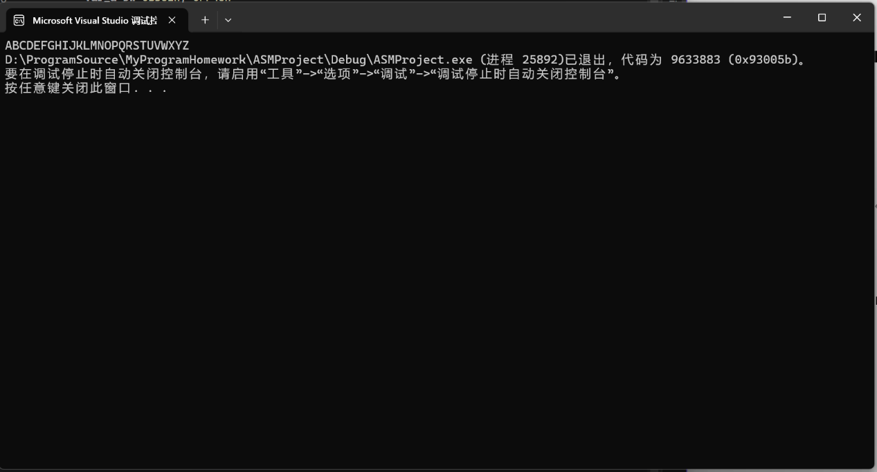

PrintAllCharacters PROC
MOV AX, 'A'
MOV CX, 26

In the procedure of PrintAllCharacters, the program set the AX to the character “A” and set the CX to 26 as the length of all characters.

@Loop:
CALL dispc
INC AX
DEC CX
JNZ @Loop

Then the program executed CALL dispc to display each character, also increasing the AX as ASCII to the next character and decreasing the CX, the program will stop if the CX turns to 0.

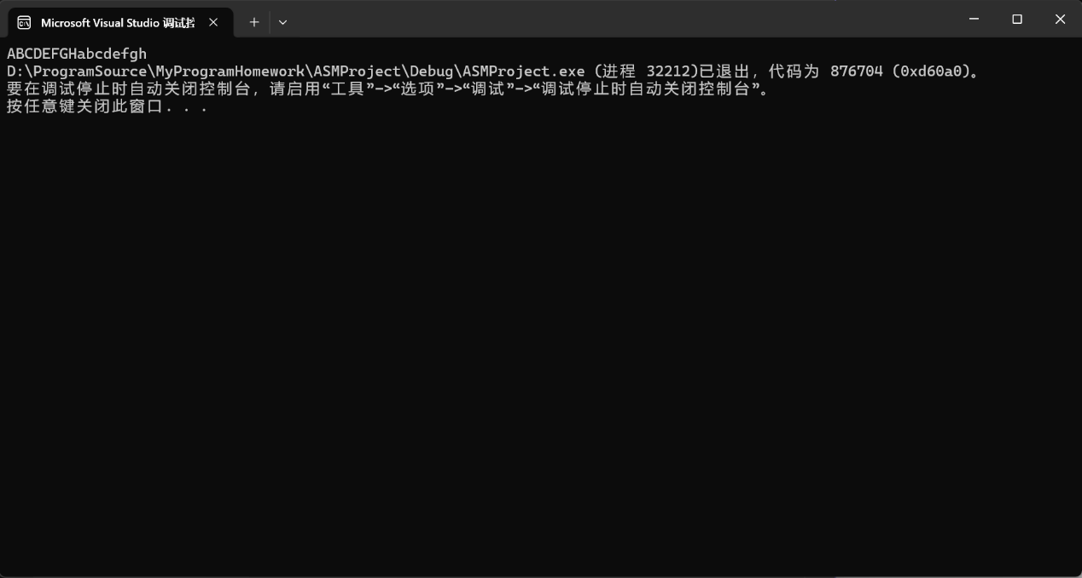

DataStringToLowerCase PROC
LEA ESI, string
MOV ECX, LENGTHOF string
LEA EDI, [string + ECX]
XOR EBX, EBX

In the procedure of DataStringToLowerCase, the program will get the address of string by LEA operator and get the length of the string to ECX.
@ConvertLoop:
MOV AL, [ESI]
ADD AL, 20h
MOV [EDI], AL
INC ESI
INC EDI
DEC ECX
JNZ @ConvertLoop

In the @ConvertLoop, each character will add 20h because the ASCII table to switch to the lowercase, then use MOV [EDI], AL to insert the converted character at the end.

LEA EAX, string
CALL dispmsg
RET

In the end, the CALL dispmsg will be executed to print the result.
国际学院汇编程序设计实验报告

- 实验目的：
1、熟悉汇编程序的格式；
2、了解汇编语言的执行过程；
3、熟练使用OD进行调试。

- 实验要求：
学习掌握汇编语言的基本指令，以及各种结构程序设计、变量的使用，字符串的输入输出。

- 实验内容：（题目及实现代码）
1.试编写一程序求出双字长数的绝对值。双字长数在A和A+2单元中，结果存放在B和B+2单元中。
INCLUDE io32.inc
INCLUDELIB io32.lib

.data
string DB "ABCDEFGH"
var_a DW 0BD61h, 0FF46h
var_b DW 2 DUP(?)

.code
CalculateAbsNumber PROC
MOV AX, [var_a]
MOV BX, [var_a+2]
TEST BX, 8000h
JZ @IsPositive
NEG BX
NEG AX
SBB BX, 0

@IsPositive:
MOV [var_b], AX
MOV [var_b+2], BX
SHL EBX, 16
MOV BX, AX
MOV EAX, EBX
CALL dispuid
RET

CalculateAbsNumber ENDP

2.试分析下面的程序段完成什么功能？
MOV CL, 04
SHL DX, CL
MOV BL, AH
SHL AX, CL
SHR BL, CL
OR DL, BL

- 实验结果及分析：
Experiment Report on Assembler Program Design of International College

1、 Purpose:
1. Familiar with the format of assembler;
2. Understand the execution process of assembly language;
3. Proficiently use OD for debugging.

2、 Experimental requirements:
Learn and master the basic instructions of assembly language, as well as the design of various structural programs, the use of variables, and the input and output of strings.

3、 Experiment content: (topic and implementation code)
1. Try to write a program to calculate the absolute value of double word length. Double word length is stored in cells A and A+2, and the results are stored in cells B and B+2.

INCLUDE io32.inc
INCLUDELIB io32.lib

.data
string DB "ABCDEFGH"
var_a DW 0BD61h, 0FF46h
var_b DW 2 DUP(?)

.code
CalculateAbsNumber PROC
MOV AX, [var_a]
MOV BX, [var_a+2]
TEST BX, 8000h
JZ @IsPositive
NEG BX
NEG AX
SBB BX, 0
@IsPositive:
MOV [var_b], AX
MOV [var_b+2], BX
SHL EBX, 16
MOV BX, AX
MOV EAX, EBX
CALL dispuid
RET

CalculateAbsNumber ENDP

2. Try to analyze what functions are completed by the following program segments?
MOV CL, 04
SHL DX, CL
MOV BL, AH
SHL AX, CL
SHR BL, CL
OR DL, BL

4、 Experimental results and analysis:
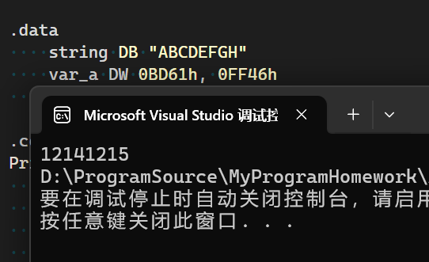

CalculateAbsNumber PROC
MOV AX, [var_a]
MOV BX, [var_a+2]
TEST BX, 8000h

First, we use TEST BX, 8000h to check the symbol digit, the 16 digit of a signed int (SWORD) is the symbol digit, also TEST BX, 1000000000000000b is also correct.

JZ @IsPositive

With the JZ operator to jump @IsPositive if the number is positive.

NEG BX
NEG AX
SBB BX, 0

Otherwise, use NEG BX and NEG AX to get its absolute number, also use SBB BX,0 to correctly handled the CF (Carry Flag) if the carry happened.

MOV [var_b], AX
MOV [var_b+2], BX
SHL EBX, 16
MOV BX, AX
MOV EAX, EBX
CALL dispuid

And CALL dispuid (display unsigned integer number) to print the result.

MOV CL, 04
把4移动到CL寄存器中，用于指定移位的次数
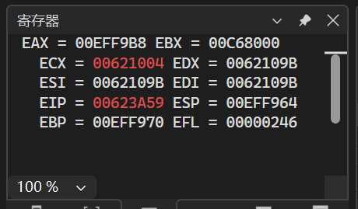
SHL DX, CL
把DX的内容左移四位（CL寄存器为4）
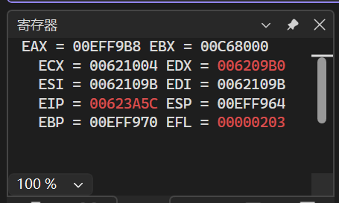
MOV BL, AH
把AH寄存器的内容复制到BL寄存器中（BX的低8位）
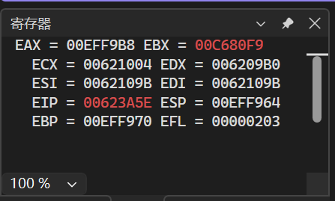
SHL AX, CL
把AX寄存器的内容左移四位
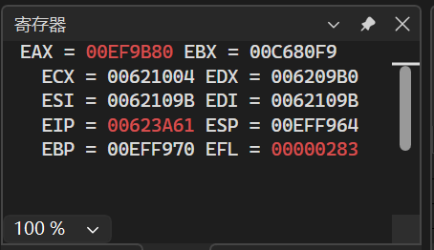
SHR BL, CL
把BL寄存器的内容右移四位
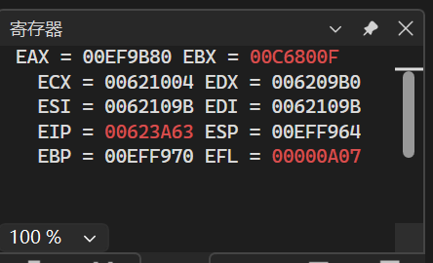
OR DL, BL

对DL和BL进去按位或运算，把BL的低四位填充到DL的低四位空缺处
代码等同于
SHL EAX, 4（如果DX:AX这个32位数直接存在EAX这个32-bit寄存器内）
