


实 验 报 告

学 院 国际学院
专 业 软工
学 号 20242605031
姓 名 石一泽
指导教师 湛燕

2025年 12月15日

国际学院汇编程序设计实验报告

- 实验目的：
1、熟悉汇编程序的格式；
2、了解汇编语言的执行过程；

- 实验要求：
学习掌握汇编语言的基本指令，以及各种结构程序设计、变量的使用，字符串的输入输出。

- 实验内容：（题目及实现代码）
1、有两个32位无符号整数存放在变量buffer1和buffer2中，定义数据并编写代码完成EDX.EAX<--buffer1-buffer2功能。（数据可以自己设定）
INCLUDE io32.inc
INCLUDELIB io32.lib
.data
buffer1 DWORD 1214
buffer2 DWORD 1215
buf DWORD 1214h, 1215h
result DWORD ?
string DB "How are # you ?",13,10,0
.code

Subtract PROC
MOV EAX, buffer1
SUB EAX, buffer2
MOV EDX, 0
SBB EDX, EDX
RET
Subtract ENDP
2、编程将一个32位数据逻辑左移3位，假设这个数据已经保存在DX.AX寄存器对中。（数据可以自己设定）
LogicalLeftShift3Digits PROC
MOV DX, 1214h
MOV AX, 1215h
MOV EAX, EDX
SHL EAX, 16
MOV AX, AX
SHL EAX, 3
RET
LogicalLeftShift3Digits ENDP

3.给出下列各条指令执行后al的结果
mov al,1fh
and al,al
or al,al
xor al,al
not al
test al,0fh

- 实验结果及分析：
Experiment Report on Assembler Program Design of International College

1、 Purpose:
1. Familiar with the format of assembler;
2. Understand the execution process of assembly language;

2、 Experimental requirements:
Learn and master the basic instructions of assembly language, as well as the design of various structural programs, the use of variables, and the input and output of strings.

3、 Experiment content: (topic and implementation code)
1. There are two 32-bit unsigned integers stored in the variables buffer1 and buffer2. Define data and write code to complete the EDX. EAX<-- buffer1-buffer2 function. (The data can be set by yourself)
INCLUDE io32.inc
INCLUDELIB io32.lib
.data
buffer1 DWORD 1214
buffer2 DWORD 1215
.code
Subtract PROC
MOV EAX, buffer1
SUB EAX, buffer2
MOV EDX, 0
SBB EDX, EDX
RET
Subtract ENDP
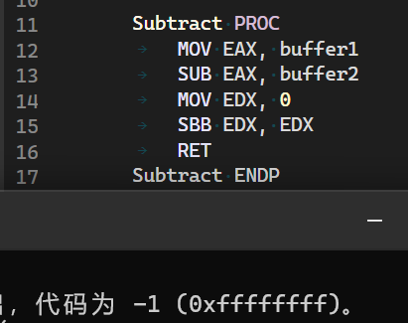
2. A 32-bit data is logically shifted 3 bits to the left by programming, assuming that the data has been saved in the DX.AX register pair. (The data can be set by yourself)
LogicalLeftShift3Digits PROC
MOV DX, 1214h
MOV AX, 1215h
MOV EAX, EDX
SHL EAX, 16
MOV AX, AX
SHL EAX, 3
RET
LogicalLeftShift3Digits ENDP
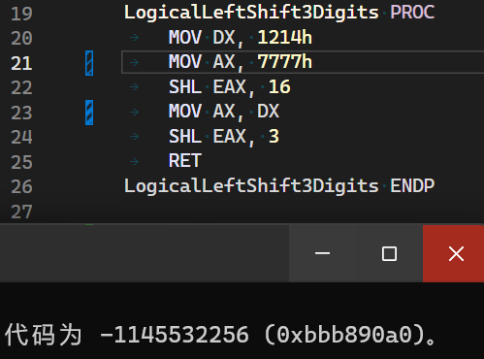
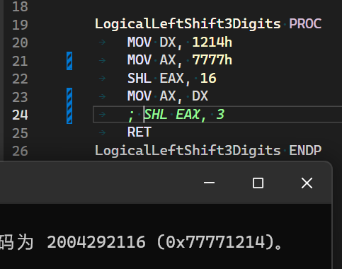
First, we SHL 4*4 (means the size of AX * the size of a DWORD) bits and MOV AX, DX to move the DX-AX to the uniformed EAX register, and later SHL EAX, 3 to shift 3 bits.

3. Give the results of al after executing the following instructions

mov al,1fh
and al,al
or al,al
xor al,al
not al
test al,0fh

MOV AX, 1Fh
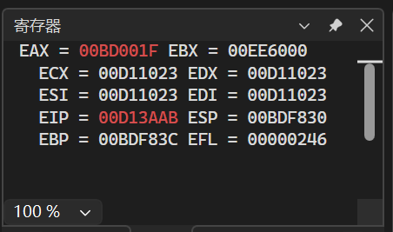

AND AX, AX
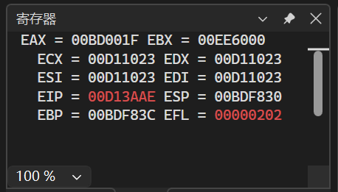
OR AX, AX
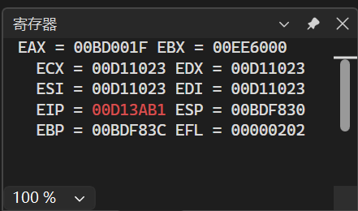
XOR AX, AX
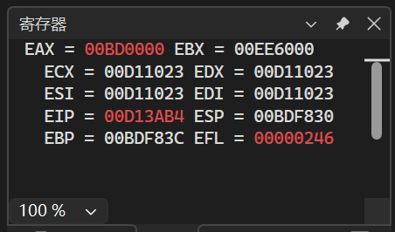

NOT AX
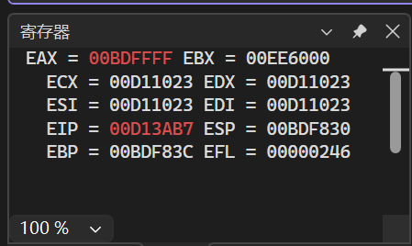
TEST AX, 0Fh
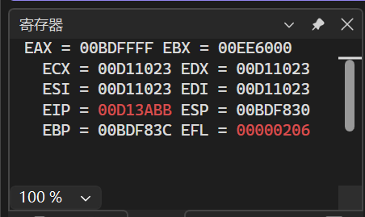

When executed the commands of AND and or, the AX (expanded AL, since AL as a 8-digit register is not allowed in modern Visual Studio) didn’t modified, and the XOR AX, AX usually meant to set the AX to 0, it was a common action and it was faster than MOV AX, 0. NOT AX will modified the register from 0x00 to 0xFF.

4、 Experimental results and analysis:
1. There are two 32-bit unsigned integers stored in the variables buffer1 and buffer2. Define data and write code to complete the EDX. EAX<-- buffer1-buffer2 function. (The data can be set by yourself)

.data
buffer1 DWORD 1214
buffer2 DWORD 1215

Subtract PROC
MOV EAX, buffer1
SUB EAX, buffer2

This operation affects the CPU's flags register. Because a borrow is required (1214 < 1215), the Carry Flag (CF) is set to 1.

MOV EDX, 0

This instruction clears the EDX register by setting its value to 0. EDX is intended to hold the upper 32 bits of the 64-bit result.

SBB EDX, EDX

SBB stands for "Subtract with Borrow". It performs the operation destination = destination - (source + CF). Here, it executes EDX = EDX - (EDX + CF). • This is a common technique to sign-extend a value. If there had been no borrow (CF=0), EDX would have become 0. Because there was a borrow (CF=1), EDX becomes -1, correctly propagating the sign to the higher-order bits.

2. A 32-bit data is logically shifted 3 bits to the left by programming, assuming that the data has been saved in the DX.AX register pair. (The data can be set by yourself)
LogicalLeftShift3Digits PROC
MOV DX, 1214h
MOV AX, 7777h
SHL EAX, 16

SHL stands for "Shift Logical Left". This instruction shifts all bits in the EAX register 16 positions to the left. The value 7777h from the lower 16 bits (AX) is moved to the upper 16 bits of EAX. The lower 16 bits are filled with zeros. After this instruction, EAX holds the value 77770000h.

MOV AX, DX

This instruction copies the value from the DX register (1214h) into the AX register (the lower 16 bits of EAX). The upper 16 bits of EAX remain unchanged. After this instruction, EAX holds 77771214h. This step effectively combines the two 16-bit values into one 32-bit value.

SHL EAX, 3

This instruction again performs a logical left shift on EAX, this time by 3 bit positions.
国际学院汇编程序设计实验报告

- 实验目的：
1、熟悉汇编程序的指令；
2、了解汇编语言的执行过程；

- 实验要求：
学习掌握汇编语言的基本指令，以及各种结构程序设计、变量的使用，字符串的输入输出。

- 实验内容：（题目及实现代码）
- 使用串指令编写程序，查找字符串‘How are # you ?’中是否含有字符‘#‘,若有，将字符‘#’用空格字符代替。
StringReplacePoundToWhitespace PROC
LEA EDI, string
MOV EBX, LENGTHOF string
MOV ECX, 0
@ScanLoop:
CMP BYTE PTR [EDI], '#'
JNE @ScanLoopItor
MOV BYTE PTR [EDI], ' '
@ScanLoopItor:
INC EDI
INC ECX
CMP ECX, EBX
JB @ScanLoop

MOV EAX, OFFSET string
CALL dispmsg
RET
StringReplacePoundToWhitespace ENDP

- 已知两个带符号的数据BUF在开始的地址单元，如果两个数的符号相同，则求其差，否则求其和，结果放在RESULT单元。提示：数据段 BUF dword 1100H，8203H RESULT dword ？
使用XOR指令来判断两个数的符号是否相同，根据符号标志位SF，来判断是做差还是和。
SumIfEqualSignAndSubtractOtherwise PROC
MOV EAX, [buf]
MOV EDX, [buf+4]
XOR EDX, EAX
JNS @IsEqual
MOV EAX, [buf]
ADD EAX, [buf+4]
JMP @Result
@IsEqual:
MOV EAX, [buf]
SUB EAX, [buf+4]
@Result:
MOV result, EAX
RET
SumIfEqualSignAndSubtractOtherwise ENDP

- 实验结果及分析：
Experiment Report on Assembler Program Design of International College

- Purpose:
1. Familiar with assembler instructions;
2. Understand the execution process of assembly language;

2、 Experimental requirements:
Learn and master the basic instructions of assembly language, as well as the design of various structural programs, the use of variables, and the input and output of strings.

3、 Experiment content: (topic and implementation code)
1. Use string instructions to write programs and find the string 'How are # you?' Whether the character '#' is included in the. If so, replace the character '#' with a space character.

StringReplacePoundToWhitespace PROC
LEA EDI, string
MOV EBX, LENGTHOF string
MOV ECX, 0
@ScanLoop:
CMP BYTE PTR [EDI], '#'
JNE @ScanLoopItor
MOV BYTE PTR [EDI], ' '
@ScanLoopItor:
INC EDI
INC ECX
CMP ECX, EBX
JB @ScanLoop

MOV EAX, OFFSET string
CALL dispmsg
RET
StringReplacePoundToWhitespace ENDP
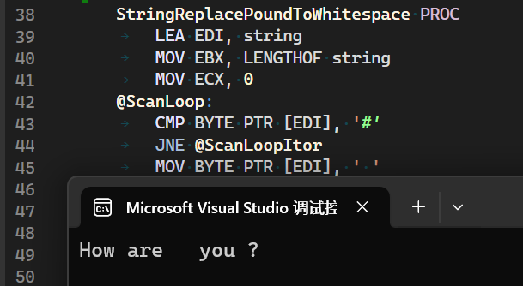
LEA EDI, string
MOV EBX, LENGTHOF string
MOV ECX, 0
@ScanLoop:
CMP BYTE PTR [EDI], '#'
JNE @ScanLoopItor
MOV BYTE PTR [EDI], ' '

First, we store the length of string to EBX, and loop to execute the action of
CMP BYTE PTR [EDI] , ‘#’, then the program will jump to @ScanLoopItor if is not matched, or MOV BYTE PTR [EDI], ‘ ‘ otherwise.

@ScanLoopItor:
INC EDI
INC ECX
CMP ECX, EBX
JB @ScanLoop

The @ScanLoopItor will increase the ECX and the EDI like the general for loop in C program as i++. In the end, the program will compare the ECX as the current index and the EBX as the whole length of the string, and jump out the loop if the whole string was scanned.

MOV EAX, OFFSET string
CALL dispmsg
RET

And called the dispmsg (from Irvine32.lib) to display the string after replacement.
2. The address cell at the beginning of two signed data BUFs is known. If the symbols of the two numbers are the same, the difference is calculated; otherwise, the sum is calculated and the result is placed in the RESULT cell. Prompt: data segments BUF dword 1100H, 8203H
RESULT dword ?

The XOR instruction is used to determine whether the symbols of two numbers are the same, and the difference or sum is determined according to the symbol flag SF.

SumIfEqualSignAndSubtractOtherwise PROC
MOV EAX, [buf]
MOV EDX, [buf+4]
XOR EDX, EAX
JNS @IsEqual
MOV EAX, [buf]
ADD EAX, [buf+4]
JMP @Result
@IsEqual:
MOV EAX, [buf]
SUB EAX, [buf+4]
@Result:
MOV result, EAX
RET
SumIfEqualSignAndSubtractOtherwise ENDP
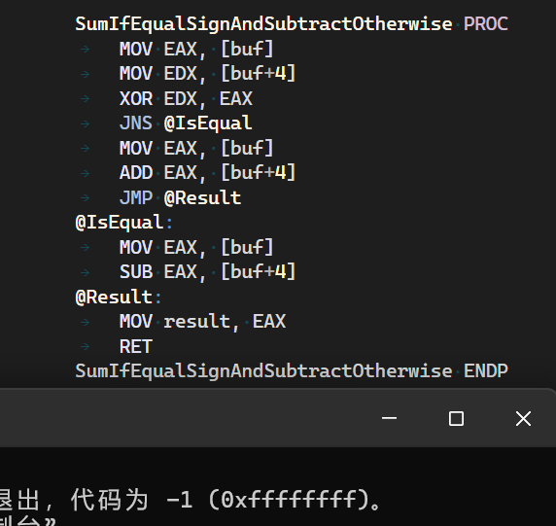

MOV EAX, [buf]
MOV EDX, [buf+4]
XOR EDX, EAX
JNS @IsEqual

The program will compare EAX (as the buf+0) and the EDX (as the buf+4).

MOV EAX, [buf]
ADD EAX, [buf+4]
JMP @Result
@IsEqual:
MOV EAX, [buf]
SUB EAX, [buf+4]

And then use JNS to check the symbol flag SF, and executed ADD or SUB after the comparison, then stored the result to EAX.
@Result:
MOV result, EAX
RET

