


实 验 报 告

学 院 国际学院
专 业 软工
学 号 20242605031
姓 名 石一泽
指导教师 湛燕

2025年 12月15日

国际学院汇编程序设计实验报告

- 实验目的：
1、熟悉汇编程序的指令；
2、了解汇编语言的执行过程；

- 实验要求：
学习掌握汇编语言的基本指令，以及各种结构程序设计、变量的使用，串操作指令的使用和字符串的输入输出。

- 实验内容：（题目及实现代码）
- 在一个已知长度的字符串中查找是否包含“BUG”子字符串。如果存在，显示“Y”，否则显示“N”。
INCLUDE io32.inc
INCLUDELIB io32.lib

.data
pattern DB "BUG"
string DB "Fix a BUG, and birth more BUGs."
success DB "Y",0
failure DB "N",0
result DB 100 DUP(?)
.code
FindStringContainPattern PROC
XOR EAX, EAX
XOR EBX, EBX
MOV EDX, LENGTHOF string
LEA ESI, string
LEA EDI, pattern
SUB EDX, ECX
@CheckingLoop:
CMP EAX, EDX
JAE @Failure
CMP EBX, 3
JAE @Success
MOV EBP, EAX
ADD EBP, EBX
MOV CH, [ESI+EBP]
MOV CL, [EDI+EBX]
CMP CH, CL
JNE @Mismatch
INC EBX
JMP @CheckingLoop
@Mismatch:
INC EAX
MOV EBX, 0
JMP @CheckingLoop

@Success:
LEA EAX, success
CALL dispmsg
JMP @Return
@Failure:
LEA EAX, failure
CALL dispmsg
@Return:
RET
FindStringContainPattern ENDP

- 已知一个字符串的长度，剔除其中所有的空格字符。请从字符串最后一个字符开始逐个向前判断、并进行处理。

EraseAllWhitespace PROC
XOR EAX, EAX
XOR EBX, EBX
MOV EDX, LENGTHOF string
LEA ESI, string
@CheckingLoop:
CMP EAX, EDX
JAE @Return
MOV CL, [ESI+EAX]
INC EAX
CMP CL, ' '
JE @CheckingLoop
LEA EDI, [result+EBX]
MOV [EDI], CL
INC EBX
JMP @CheckingLoop

@Return:
LEA EAX, result
CALL dispmsg
RET
EraseAllWhitespace ENDP
- 实验结果及分析：
Experiment Report on Assembler Program Design of International College

1、 Purpose:
1. Familiar with the format of assembler;
2. Understand the execution process of assembly language;

2、 Experimental requirements:
Learn and master the basic instructions of assembly language, as well as the design of various structural programs, the use of variables, and the input and output of strings.

3、 Experiment content: (topic and implementation code)
1. Find whether a string of known length contains a "BUG" substring. If it exists, "Y" is displayed, otherwise "N" is displayed.

INCLUDE io32.inc
INCLUDELIB io32.lib

.data
pattern DB "BUG"
string DB "Fix a BUG, and birth more BUGs."
success DB "Y",0
failure DB "N",0
result DB 100 DUP(?)
.code
FindStringContainPattern PROC
XOR EAX, EAX
XOR EBX, EBX
MOV EDX, LENGTHOF string
LEA ESI, string
LEA EDI, pattern
@CheckingLoop:
CMP EAX, EDX
JAE @Failure
CMP EBX, 3
JAE @Success
MOV EBP, EAX
ADD EBP, EBX
MOV CH, [ESI+EBP]
MOV CL, [EDI+EBX]
CMP CH, CL
JNE @Mismatch
INC EBX
JMP @CheckingLoop
@Mismatch:
INC EAX
MOV EBX, 0
JMP @CheckingLoop

@Success:
LEA EAX, success
CALL dispmsg
JMP @Return
@Failure:
LEA EAX, failure
CALL dispmsg
@Return:
RET
FindStringContainPattern ENDP

2. Given the length of a string, remove all white space characters. Please judge one by one from the last character of the string and process it.
EraseAllWhitespace PROC
XOR EAX, EAX
XOR EBX, EBX
MOV EDX, LENGTHOF string
LEA ESI, string
@CheckingLoop:
CMP EAX, EDX
JAE @Return
MOV CL, [ESI+EAX]
INC EAX
CMP CL, ' '
JE @CheckingLoop
LEA EDI, [result+EBX]
MOV [EDI], CL
INC EBX
JMP @CheckingLoop

@Return:
LEA EAX, result
CALL dispmsg
RET
EraseAllWhitespace ENDP

4、 Experimental results and analysis:
1. Find whether a string of known length contains a "BUG" substring. If it exists, "Y" is displayed, otherwise "N" is displayed.

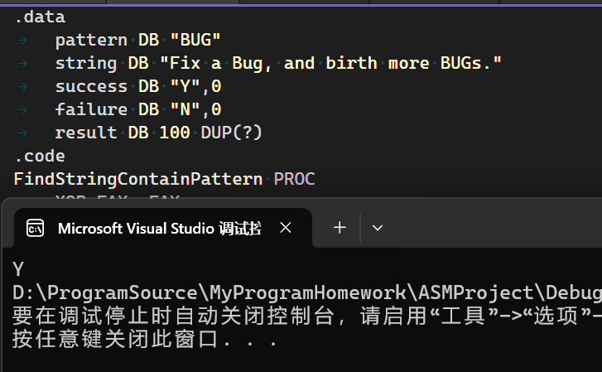
When the pattern is “BUG” and the string is “Fix a Bug, and birth more BUGs.”, the program successfully matched.
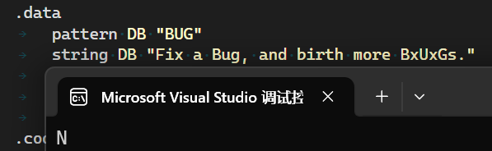
When the pattern is “BUG” but the string is “Fix a Bug, and birth more BxUxGs.”, the program was not matched.

XOR EAX, EAX
XOR EBX, EBX
MOV EDX, LENGTHOF string
LEA ESI, string
LEA EDI, pattern
First, we clear the EAX and the EBX registers, and let the EDX to the length of the string. Also, we saved the address of string into ESI and the address of pattern into EDI.
CMP EAX, EDX
JAE @Failure
CMP EBX, 3 ; the length of pattern
JAE @Success
MOV EBP, EAX
ADD EBP, EBX
MOV CH, [ESI+EBP] ; CH firstly, could not use AH or BH
MOV CL, [EDI+EBX] ; CL lastly
CMP CH, CL
JNE @Mismatch
INC EBX
JMP @CheckingLoop

In the procedure of FindStringContainPattern, the program will keep two index of the string and the pattern, and loop the whole string to check the equality of the char of current position of string and the first char of the pattern. We use the registers CH and CL to save the character, because other registers like EAX, EBX and EDX were all saved the data and the data will be broken if we use AL or AH.Also, we must MOV CH firstly because the CH is higher than CL in digits. Then the index of pattern will be increased if matched and ready to compare the second char by JNE and JMP operators.

@Mismatch:
INC EAX
MOV EBX, 0
JMP @CheckingLoop

If any character mismatched, let the EBX to 0 to label the program should match again. And then back to the loop @CheckingLoop.

@Success:
LEA EAX, success ; “Y”
CALL dispmsg
JMP @Return
@Failure:
LEA EAX, failure ; “N”
CALL dispmsg
@Return:
RET

When the all pattern was matched by checking the index of pattern reached the length of pattern, the program will jump to @Success to display the “Y” as successfully. Otherwise, the index of pattern will set to 0 to prepare the next comparison. If the whole string is checked but the index of pattern always haven’t reached the length of the pattern, the program will jump to @Failure to display the “N” as failure.
2. Given the length of a string, remove all white space characters. Please judge one by one from the last character of the string and process it.

EraseAllWhitespace PROC
XOR EAX, EAX
XOR EBX, EBX
MOV EDX, LENGTHOF string
LEA ESI, string

First, we clear the data of EAX and EBX registers

@CheckingLoop:
CMP EAX, EDX
JAE @Return
MOV CL, [ESI+EAX]
INC EAX
CMP CL, ' '
JE @CheckingLoop
LEA EDI, [result+EBX]
MOV [EDI], CL
INC EBX
JMP @CheckingLoop

@Return:
LEA EAX, result
CALL dispmsg
RET
EraseAllWhitespace ENDP

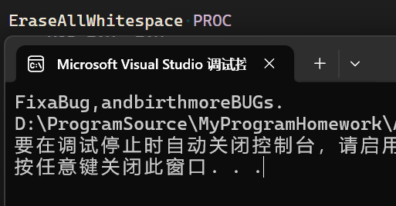
In the procedure of EraseAllWhitespace, the program will loop all characters and compare the character and the ‘ ‘ whitespace, the index will be increased to skip the whitespace if matched. Finally, print the result by CALL dispmsg (from the function of Irvine32.lib)

