


装

订

线

本科生实验报告

《Java编程入门实验》

学 院 国际学院
专 业 软件工程
学 号 20242605031
姓 名 石一泽

实验一 简单Java程序
一、实验目的
（1）掌握开发Java应用程序的三个步骤：编写源文件，编译源文件和运行应用程序。
- 实验内容和步骤
（1）编写一个简单的Java应用程序。
package org.aquamarine5.brainspark.exp1;
public class Main {
public static void main(String[] args) {
if(args.length==0)
System.out.println("Hello!");
else
for (String arg : args) System.out.println(arg);
}
}
三、实验结果
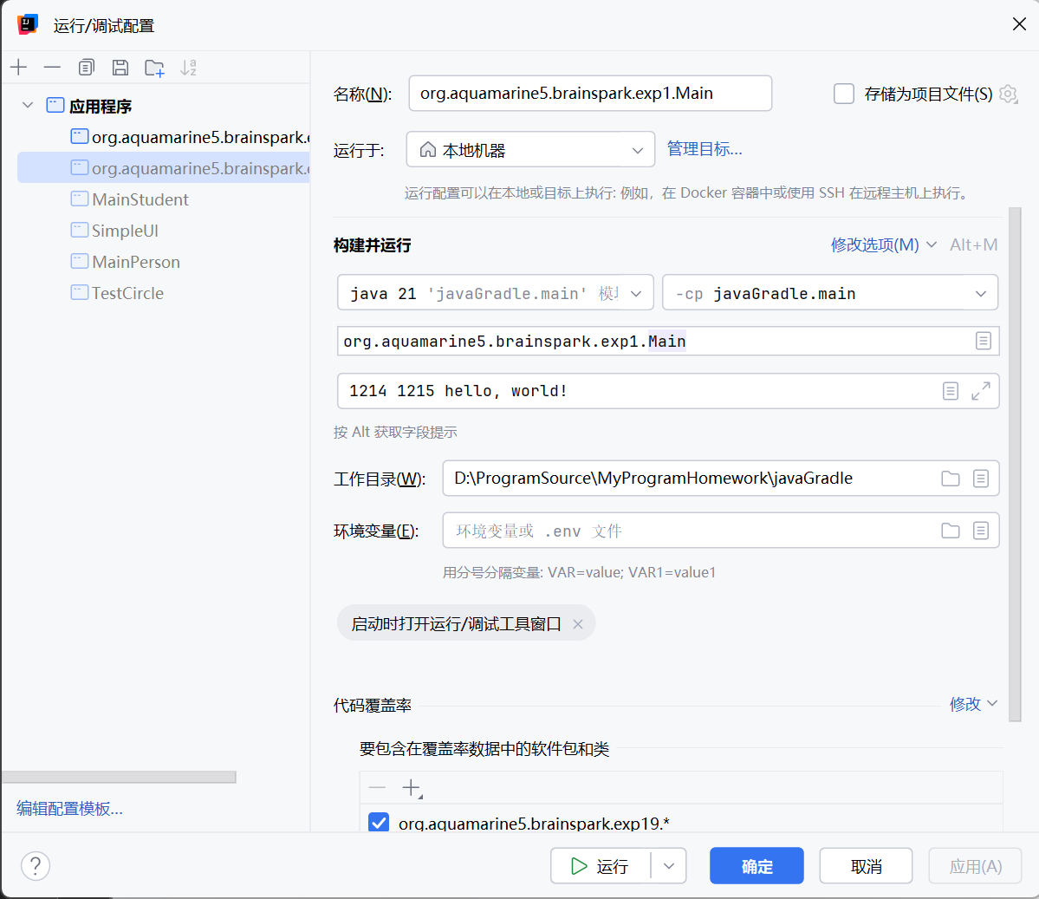
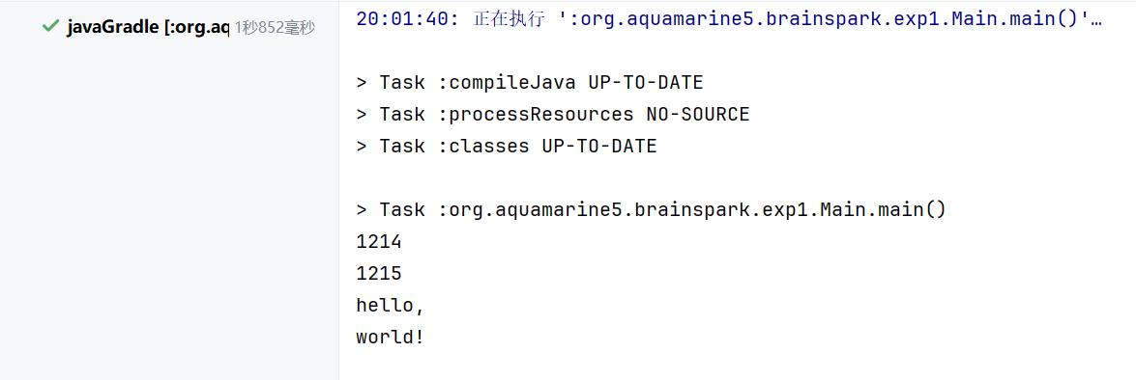

实验二 多类Java程序和包
一、实验目的
- 掌握开发Java应用程序的包
二、实验内容和步骤
（1）编写多类Java应用程序。
package org.aquamarine5.brainspark.exp2.mypackage;
public class Line {
public Point point1, point2;
public Line(Point point1, Point point2)
{
this.point1 = point1;
this.point2 = point2;
}
public double length()
{
int a = point1.x - point2.x, b = point1.y - point2.y;
return Math.sqrt(a * a + b * b);
}
public String toString()
{
return "一条直线，起点" + point1.toString() + "，终点" + point2.toString() + "，长度" + String.format("%1.2f", length());
}
}
package org.aquamarine5.brainspark.exp2.mypackage;
public class Point
{
public int x, y;
public Point(int x,int y)
{
this.x=x;
this.y=y;
}
public Point()
{
this(0,0);
}
public Point(Point p)
{
this(p.x,p.y);
}
public String toString()
{
return"("+this.x+","+this.y+")";
}
}
package org.aquamarine5.brainspark.exp2;
import org.aquamarine5.brainspark.exp2.mypackage.Point;
import org.aquamarine5.brainspark.exp2.mypackage.Line;
public class Main {
public static void main(String[] args) {
var point1 = new Point(0,0);
var point2=new Point(40,30);
System.out.println(new Line(point1,point2).toString());
}
}

三、实验结果
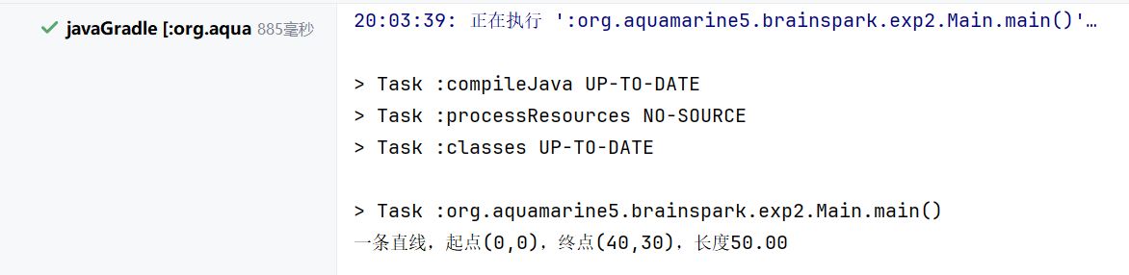

实验三 Java程序的输入和包的导入
一、实验目的
（1）掌握开发Java应用程序的输入和包的使用；
二、实验内容和步骤
（1）实现Test类，完成Java程序的输入和输入。
package org.aquamarine5.brainspark.exp3;
import java.util.Scanner;
public class Main {
public static void main(String[] args) {
var input = new Scanner(System.in);
System.out.print(
"Enter the investment amount, for example 120000.95: ");
double investmentAmount = input.nextDouble();
System.out.print("Enter annual interest rate, for example 8.25: ");
double annualInterestRate = input.nextDouble();
double monthlyInterestRate = annualInterestRate / 1200;
System.out.print(
"Enter number of years as an integer, \nfor example 5: ");
int numOfYears = input.nextInt();
double futureValue =
investmentAmount * Math.pow(1 + monthlyInterestRate,
numOfYears * 12);
System.out.print("Future value is " +
(int) (futureValue * 100) / 100.0);
}
}
三、实验结果
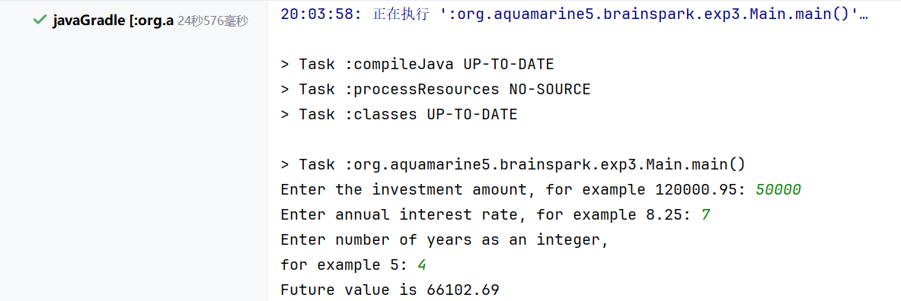
实验四 Java程序分支语句
一、实验目的
（1）掌握开发Java应用程序的分支语句；
二、实验内容和步骤
（1）
package org.aquamarine5.brainspark.exp4;
import java.util.Scanner;
public class Main {
public static void main(String[] args) {
var input = new Scanner(System.in);
System.out.print("Enter a point with two coordinates: ");
double x = input.nextDouble();
double y = input.nextDouble();
double hDistance = Math.abs(x);
double vDistance = Math.abs(y);
System.out.println("Point (%.2f, %.2f) is ".formatted(x, y) + ((hDistance <= 5 && vDistance <= 2.5) ? "in" : "not in" + " the rectangle."));
}
}
（2）
package org.aquamarine5.brainspark.exp4;
public record MyDate(int year,int month,int day){
private static int thisYear=2000;
static {
thisYear=3000;
}
@Override
public String toString() {
return "%d/%d/%d".formatted(year,month,day);
}
public static int getThisYear(){
return thisYear;
}
}
package org.aquamarine5.brainspark.exp4;
import java.util.Scanner;
public class MainMyDate {
public static void main(String[] args) {
MyDate date=new MyDate(2024,10,15);
System.out.println(date);
System.out.println(MyDate.getThisYear());
System.out.println(date.getThisYear());
}
}

三、实验结果
（1）
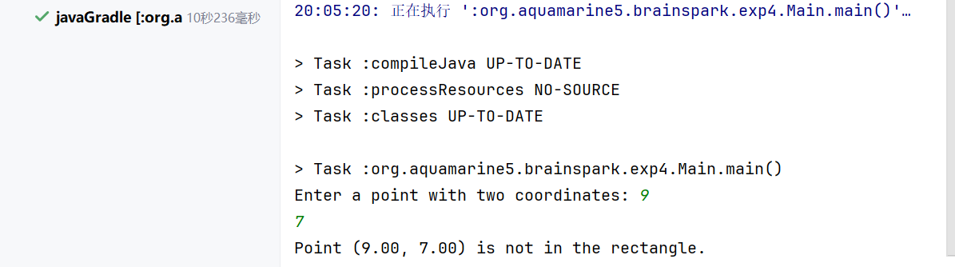
（2）
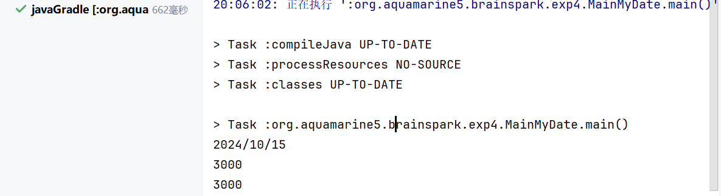

实验五 Java程序Switch语句与格式化控制台输出
一、实验目的
（1）掌握开发Java应用程序的分支语句和格式化输出；
二、实验内容和步骤
（1）
package org.aquamarine5.brainspark.exp5;
import java.util.Scanner;
public class Main {
public static void main(String[] args) {
var input = new Scanner(System.in);
System.out.print("Enter an uppercase letter:");
char ch = input.next().charAt(0);
int number = 0;
switch (Character.toUpperCase(ch)) {
case 'A':
case 'B':
case 'C':
number = 2;
break;
case 'D':
case 'E':
case 'F':
number = 3;
break;
case 'G':
case 'H':
case 'I':
number = 4;
break;
case 'J':
case 'K':
case 'L':
number = 5;
break;
case 'M':
case 'N':
case 'O':
number = 6;
break;
case 'P':
case 'Q':
case 'R':
case 'S':
number = 7;
break;
case 'T':
case 'U':
case 'V':
number = 8;
break;
case 'W':
case 'X':
case 'Y':
case 'Z':
number = 9;
break;
default:
System.out.println(ch + "is an invalid input ");
System.exit(1);
}
System.out.println("The corresponding number is " + number);
}
}

三、实验结果
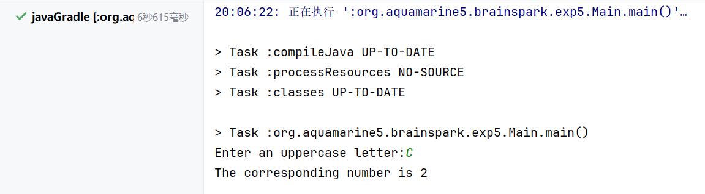
实验六 Java程序循环语句与输入输出重定向
一、实验目的
（1）掌握开发Java应用程序的循环语句和输入输出重定向；
二、实验内容和步骤
（1）
package org.aquamarine5.brainspark.exp6;
import java.util.Scanner;
public class Main {
public static void main(String[] args) {
var input = new Scanner(System.in);
System.out.print("Enter numbers: ");
int number = input.nextInt();
int max = number;
int count = 1;
while (number != 0) {
number = input.nextInt();
if (number > max) {
max = number;
count = 1;
} else if (number == max)
count++;
}
System.out.printf("The largest number is %d, The occurrence count of the largest number is %d%n", max, count);
}
}
三、实验结果
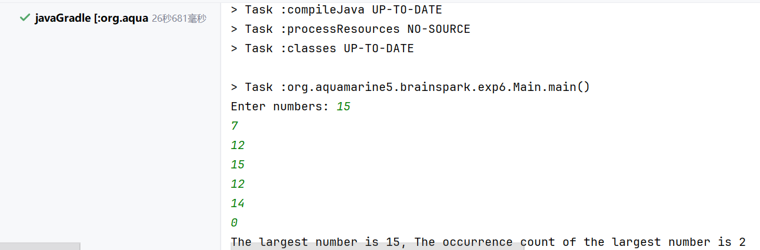
实验七 Java程序一维数组和循环语句
一、实验目的
（1）掌握开发Java应用程序的一维数组；
二、实验内容和步骤
（1）
package org.aquamarine5.brainspark.exp7;
public class Main {
public static void main(String[] args) {
final int NUMBER_OF_STUDENTS = 100;
boolean[] lockers = new boolean[NUMBER_OF_STUDENTS];
for (int student = 1; student <= NUMBER_OF_STUDENTS; student++) {
for (int locker = student - 1; locker < NUMBER_OF_STUDENTS; locker += student) {
lockers[locker] = !lockers[locker];
}
}
for (int i = 0; i < lockers.length; i++) {
if (lockers[i]) {
System.out.printf("Locker %d is open\n", i);
}
}
}
}
三、实验结果
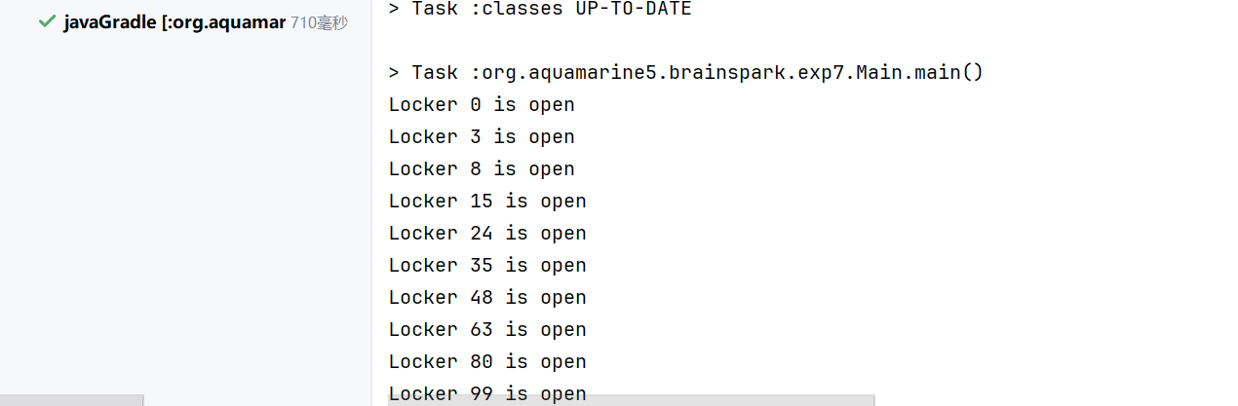

实验八 Java程序--类和对象
一、实验目的
（1）掌握开发Java应用程序的一类和对象；
二、实验内容和步骤
（1）
package org.aquamarine5.brainspark.exp8;
import lombok.AllArgsConstructor;
import lombok.Getter;
import lombok.Setter;
import java.util.Date;
@AllArgsConstructor
@Getter
@Setter
public class Account {
@Setter
private static double annualInterestRate;
private final Date dateCreated = new Date();
private int id;
private double balance;
public double getMonthlyInterest() {
return balance * annualInterestRate / 1200;
}
public void withdraw(double amount) {
balance -= amount;
}
public void deposit(double amount) {
balance += amount;
}
}
package org.aquamarine5.brainspark.exp8;
public class Main {
public static void main(String[] args){
Account account=new Account(1122,20000);
Account.setAnnualInterestRate(4.5);
account.withdraw(2500);
account.deposit(3000);
System.out.printf("Balance is %.2f\n",account.getBalance());
System.out.printf("Monthly interest is %.2f\n",account.getMonthlyInterest());
System.out.println("This account was created at "+account.getDateCreated());
}
}

三、实验结果
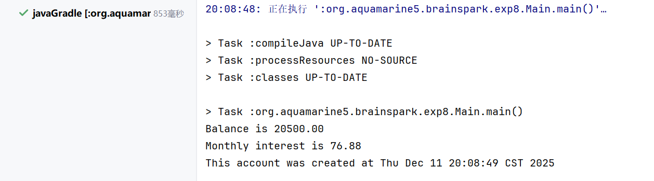

实验九 类和对象
一、实验目的
（1）掌握开发Java应用程序的一类和对象；
二、实验内容和步骤
（1）
package org.aquamarine5.brainspark.exp9;
import lombok.AllArgsConstructor;
import lombok.Getter;
import lombok.NoArgsConstructor;
@AllArgsConstructor
@NoArgsConstructor
public class MyRectangle {
@Getter
double height=1;
double width=1;
public double getPerimeter(){
return 2*(height+width);
}
public double getArea(){
return height*width;
}
}
package org.aquamarine5.brainspark.exp9;
public class Main {
public static void main(String[] args) {
var myRectangle = new MyRectangle(4d, 40d);
System.out.printf("The area of a rectangle with width %.2f and height %.2f is %.2f",
myRectangle.width, myRectangle.height, myRectangle.getArea());
System.out.printf("\nThe perimeter of a rectangle is %.2f",myRectangle.getPerimeter());
var yourRectangle = new MyRectangle(3.5d, 35.9d);
System.out.printf("The area of a rectangle with width %.2f and height %.2f is %.2f",
yourRectangle.width, yourRectangle.height, yourRectangle.getArea());
System.out.printf("\nThe perimeter of a rectangle is %.2f", yourRectangle.getPerimeter());
}
}
（2）
package org.aquamarine5.brainspark.exp9;
import lombok.AllArgsConstructor;
import lombok.EqualsAndHashCode;
import lombok.Getter;
import lombok.Setter;
@Setter
@Getter
@EqualsAndHashCode
@AllArgsConstructor
public class MyDate {
private static final int thisYear;
static{
thisYear=2025;
}
private int year = 1970;
private int month = 1;
private int day = 1;
public void set(int year, int month, int day) {
this.year = year;
this.month = (month >= 1 && month <= 12) ? month : 1;
this.day = (day >= 1 && day <= 31) ? day : 1;
}
public void set(MyDate date){
this.year = date.year;
this.month = date.month;
this.day = date.day;
}
public String toString() {
return String.format("%04d年%02d月%02d日", year, month, day);
}
public static boolean isLeapYear(int year) {
return (year % 4 == 0 && year % 100 != 0) || (year % 400 == 0);
}
public boolean isLeapYear() {
return isLeapYear(this.year);
}
public static int daysOfMonth(int year,int month){
return switch (month) {
case 1, 3, 5, 7, 8, 10, 12 -> 31;
case 4, 6, 9, 11 -> 30;
case 2 -> isLeapYear(year) ? 29 : 28;
default -> 0;
};
}
public int daysOfMonth(){
return daysOfMonth(this.year,this.month);
}
public void tomorrow(){
if(this.day<daysOfMonth()){
this.day++;
}else{
this.day=1;
if(this.month<12){
this.month++;
}else{
this.month=1;
this.year++;
}
}
}
public void yesterday(){
if(this.day>1){
this.day--;
}else{
if(this.month>1){
this.month--;
}else{
this.month=12;
this.year--;
}
this.day=daysOfMonth();
}
}
}

三、实验结果
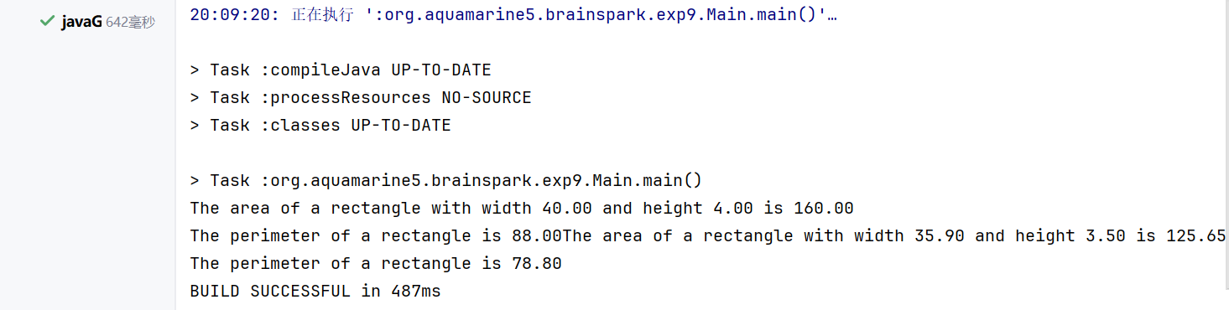

实验十 Java程序--面向对象编程
一、实验目的
（1）掌握开发Java应用程序的一类和对象；
二、实验内容和步骤
（1）
package org.aquamarine5.brainspark.exp10;
import lombok.*;
import java.util.Date;
@Getter
@NoArgsConstructor
@AllArgsConstructor
public class Loan {
private final Date loanDate = new Date();
@Setter
private double annualInterestRate = 2.5;
@Setter
private int numberOfYears = 1;
@Setter
private double loanAmount = 1000;
public double getMonthlyPayment() {
double monthlyInterestRate = annualInterestRate / 1200;
return loanAmount * monthlyInterestRate /
(1 - 1 / Math.pow(1 + monthlyInterestRate, numberOfYears * 12));
}
public double getTotalPayment() {
return getMonthlyPayment() * numberOfYears * 12;
}
}
（2）
package org.aquamarine5.brainspark.exp10;
import lombok.AllArgsConstructor;
import lombok.Getter;
import lombok.NoArgsConstructor;
@AllArgsConstructor
@NoArgsConstructor
public class MyRectangle {
@Getter
double height=1;
double width=1;
public MyRectangle(double w){
this.width=w;
this.height=w;
}
public double getPerimeter(){
return 2*(height+width);
}
public double getArea(){
return height*width;
}
public void draw(){
for (int i = 0; i < this.width; i++)
System.out.print("*");
System.out.println();
for (int i = 0; i < this.height - 2; i++) {
System.out.print("*");
for (int j = 0; j < this.width-2; j++)
System.out.print(" ");
System.out.print("*");
System.out.println();
}
for (int i = 0; i < this.width; i++)
System.out.print("*");
}
}
package org.aquamarine5.brainspark.exp10;
import lombok.AllArgsConstructor;
@AllArgsConstructor
public class Person {
public String name;
public int age;
public void getInfo(){
System.out.println("Name: " + name + ", Age: " + age);
}
}
package org.aquamarine5.brainspark.exp10;
public class Teacher extends Person{
public String teacherID;
public Teacher(String name,int age,String id){
super(name,age);
this.teacherID=id;
}
public void getInfo(){
System.out.println("Name: " + name + ", Age: " + age + ", Teacher ID: " + teacherID);
}
}
package org.aquamarine5.brainspark.exp10;
import java.util.Scanner;
public class MainMyRectangle {
public static void main(String[] args){
var scanner=new Scanner(System.in);
System.out.print("Enter width:");
double width=scanner.nextDouble();
System.out.print("Enter height:");
double height=scanner.nextDouble();
var myRectangle=new MyRectangle(height,width);
System.out.printf("The area of a rectangle with width %.2f and height %.2f is %.2f",
myRectangle.width, myRectangle.height, myRectangle.getArea());
System.out.printf("\nThe perimeter of a rectangle is %.2f\n",myRectangle.getPerimeter());
myRectangle.draw();
}
}
（3）
package org.aquamarine5.brainspark.exp10;
public class MainString {
public static void main(String[] args){
String str1 = "Hello";
String str2 = "Hello";
String str3 = new String("Hello");
String str4 = new String("Hello");
System.out.println(str1 == str2); // true
System.out.println(str1.equals(str2)); // true
System.out.println(str1 == str3); // false
System.out.println(str1.equals(str3)); // true
System.out.println(str3 == str4); // false
}
}

三、实验结果
（2）
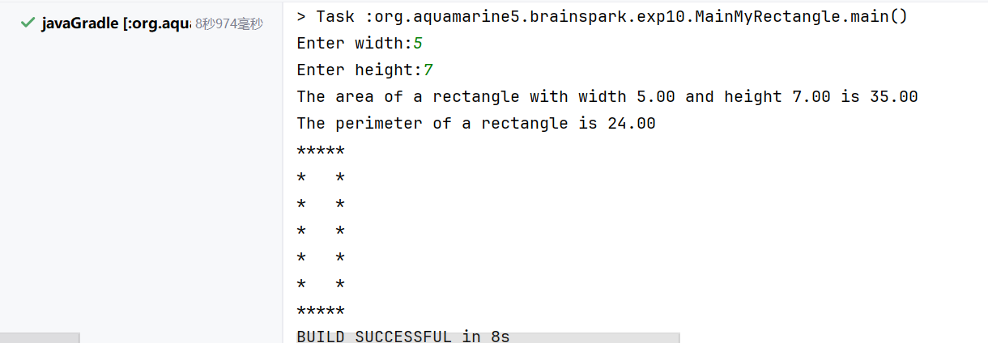
（3）
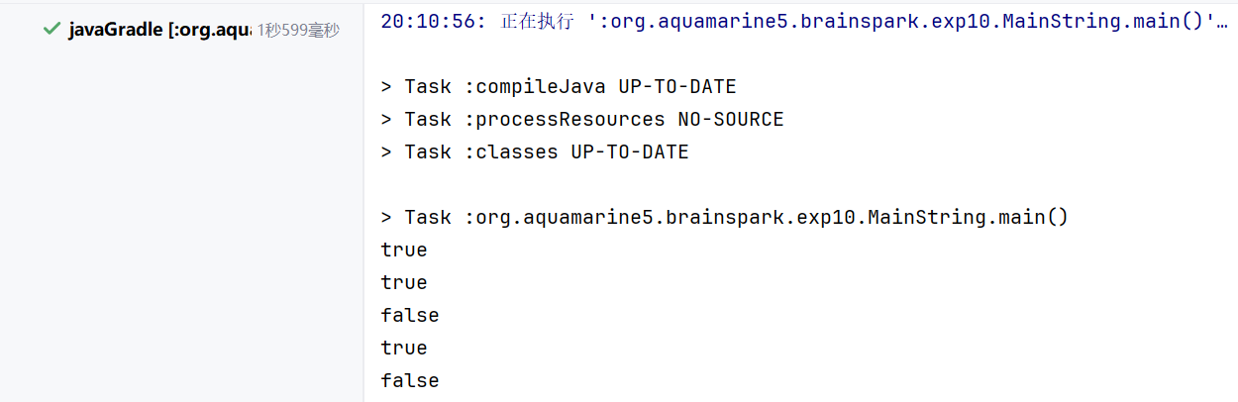

实验十一 Java程序--面向对象编程
一、实验目的
（1）掌握开发Java应用程序的一继承和多态；
二、实验内容和步骤
（1）
package org.aquamarine5.brainspark.exp11;
import java.util.Date;
public abstract class GeometricObject {
private final Date dateCreated;
private String color = "white";
private boolean filled;
protected GeometricObject() {
dateCreated = new Date();
}
protected GeometricObject(String color, boolean filled) {
this.color = color;
this.filled = filled;
dateCreated = new Date();
}
public String getColor() {
return color;
}
public void setColor(String color) {
this.color = color;
}
public boolean isFilled() {
return filled;
}
public void setFilled(boolean filled) {
this.filled = filled;
}
public Date getDateCreated() {
return dateCreated;
}
@Override
public String toString() {
return "GeometricObject{" +
"color='" + color + '\'' +
", filled=" + filled +
", dateCreated=" + dateCreated +
'}';
}
public abstract double getArea();
public abstract double getPerimeter();
}
package org.aquamarine5.brainspark.exp11;
public class Rectangle extends GeometricObject {
private double width, height;
public Rectangle() {
}
public Rectangle(double width, double height) {
this.width = width;
this.height = height;
}
public Rectangle(double width, double height, String color, boolean filled) {
super(color, filled);
this.width = width;
this.height = height;
}
public double getWidth() {
return width;
}
public void setWidth(double width) {
this.width = width;
}
public double getHeight() {
return height;
}
public void setHeight(double height) {
this.height = height;
}
@Override
public double getArea() {
return width * height;
}
@Override
public double getPerimeter() {
return 2 * (width + height);
}
}
package org.aquamarine5.brainspark.exp11;
public class Circle extends GeometricObject {
private double radius;
public Circle() {
}
public Circle(double radius) {
this.radius = radius;
}
public Circle(double radius, String color, boolean filled) {
super(color, filled);
this.radius = radius;
}
public double getRadius() {
return radius;
}
public void setRadius(double radius) {
this.radius = radius;
}
@Override
public double getArea() {
return radius * radius * Math.PI;
}
@Override
public double getPerimeter() {
return 2 * radius * Math.PI;
}
public double getDiameter() {
return 2 * radius;
}
public void printCircle() {
System.out.println("The circle is created " + getDateCreated() + " and the radius is " + radius);
}
}
package org.aquamarine5.brainspark.exp11;
import lombok.AllArgsConstructor;
import lombok.Getter;
import lombok.NoArgsConstructor;
import lombok.Setter;
@Getter
@Setter
@NoArgsConstructor
@AllArgsConstructor
public class Triangle extends GeometricObject {
private double side1 = 1.0, side2 = 1.0, side3 = 1.0;
@Override
public double getArea() {
double s = (side1 + side2 + side3) / 2;
return Math.sqrt(s * (s - side1) * (s - side2) * (s - side3));
}
@Override
public double getPerimeter() {
return side1 + side2 + side3;
}
@Override
public String toString() {
return "Triangle{" +
"side1=" + side1 +
", side2=" + side2 +
", side3=" + side3 +
"} ";
}
}
package org.aquamarine5.brainspark.exp11;
public class TestGeometricObject {
public static void main(String[] args) {
GeometricObject geoObject1=new Circle(5);
GeometricObject geoObject2=new Rectangle(5,3);
System.out.println("The two objects have the same area? "+equalArea(geoObject1,geoObject2));
displayGeometricObject(geoObject1);
displayGeometricObject(geoObject2);
}
public static boolean equalArea(GeometricObject object1, GeometricObject object2){
return object1.getArea()==object2.getArea();
}
public static void displayGeometricObject(GeometricObject object){
System.out.println();
System.out.println("The area is "+object.getArea());
System.out.println("The perimeter is "+object.getPerimeter());
}
}
（2）
package org.aquamarine5.brainspark.exp11;
public class MainPerson {
public static void main(String[] args) {
A b = new B();
b.m(5);
System.out.println(b.i);
}
}
class A {
int i = 1;
public void m(int i) {
this.i = i;
}
}
class B extends A {
// int i = 4;
int j = 2;
public void m(int i) {
this.i = i;
}
}

三、实验结果
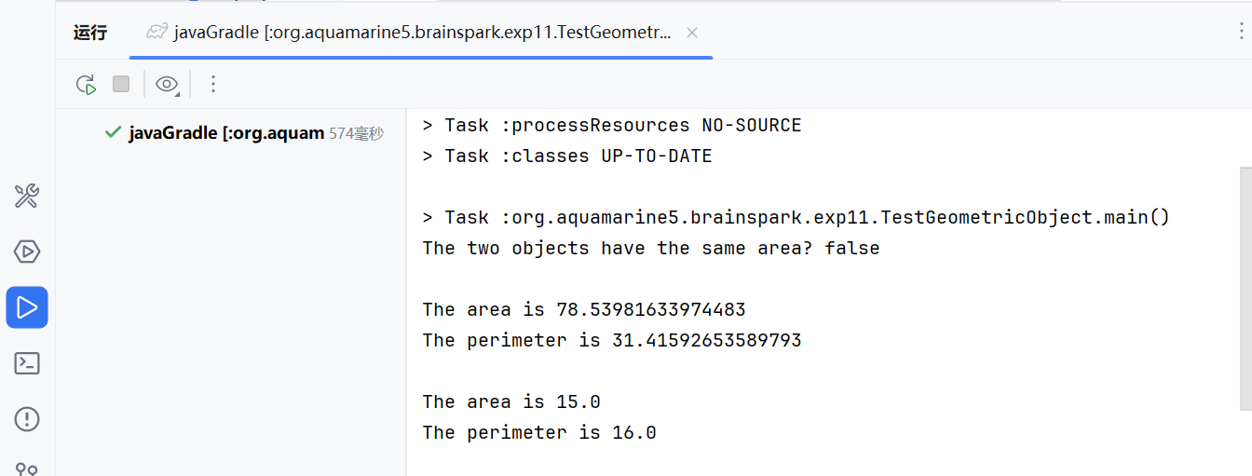

实验十二 Java程序--面向对象编程
一、实验目的
（1）掌握开发Java应用程序的一继承和多态；
二、实验内容和步骤
（1）
package org.aquamarine5.brainspark.exp12;
import lombok.AllArgsConstructor;
import lombok.Getter;
import lombok.Setter;
@AllArgsConstructor
@Getter
@Setter
public class Person {
private String name;
@Override
public String toString() {
return "Person{" +
"name='" + name + "'}";
}
}
package org.aquamarine5.brainspark.exp12;
public class Employee extends Person{
public Employee(String name) {
super(name);
}
@Override
public String toString() {
return "Employee{" +
"name='" + getName() + "'}";
}
}
package org.aquamarine5.brainspark.exp12;
public class Student extends Person{
public Student(String name) {
super(name);
}
@Override
public String toString() {
return "Student{" +
"name='" + getName() + "'}";
}
}
package org.aquamarine5.brainspark.exp12;
public class Staff extends Employee{
public Staff(String name) {
super(name);
}
@Override
public String toString() {
return "Staff(Employee){" +
"name='" + getName() + "'}";
}
}
package org.aquamarine5.brainspark.exp12;
public class Faculty extends Employee{
public Faculty(String name) {
super(name);
}
public String toString() {
return "Faculty(Employee){" +
"name='" + getName() + "'}";
}
}
package org.aquamarine5.brainspark.exp12;
public class MainTest {
public static void main(String[] args) {
Person person = new Person("Peter");
Student student = new Student("Susan");
Employee employee = new Employee("Eva");
Faculty faculty = new Faculty("Frank");
Staff staff = new Staff("Shane");
System.out.println(person);
System.out.println(employee);
System.out.println(student);
System.out.println((Person)faculty);
System.out.println((Employee)staff);
}
}

三、实验结果
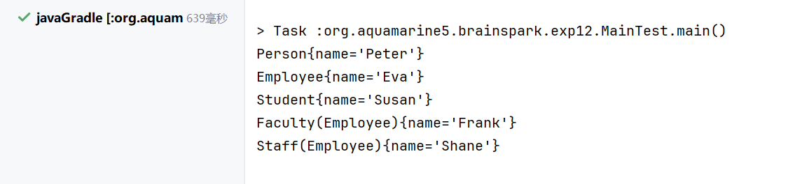

实验十三 Java程序--面向对象编程
一、实验目的
（1）掌握开发Java应用程序的一继承和多态；
二、实验内容和步骤
（1）
package org.aquamarine5.brainspark.exp13;
import java.util.ArrayList;
public class Classroom {
private final ArrayList<Person> people = new ArrayList<>();
public void Main() {
Person p = new Student("John", 150, 1);
Student s = new Student("Alice", 200, 2);
Student ps = (Student) p;
if(s instanceof Person){
System.out.println("s is a Person");
}
}
}
package org.aquamarine5.brainspark.exp13;
import lombok.AllArgsConstructor;
import lombok.Getter;
import lombok.Setter;
@AllArgsConstructor
@Setter
@Getter
public class Person extends Object{
private String name;
protected int money;
public void earnMoney(int amount) {
this.money += amount;
}
protected final void spendMoney(int amount){
this.money -= amount;
}
public static int getBasicMoney(){
return 100;
}
}
package org.aquamarine5.brainspark.exp13;
import lombok.Getter;
public class Student extends Person {
@Getter
private final int id;
public Student(String name,int money, int id) {
super(name,money);
this.id = id;
}
// @Override
// public void spendMoney(int amount) {
// super.spendMoney(amount - 5);
// }
public void earnMoney(int amount) {
var basic=getBasicMoney();
super.earnMoney(amount + 10);
}
@Override
public String toString() {
return "Student{" +
"name='" + getName() + "'}";
}
}

三、实验结果
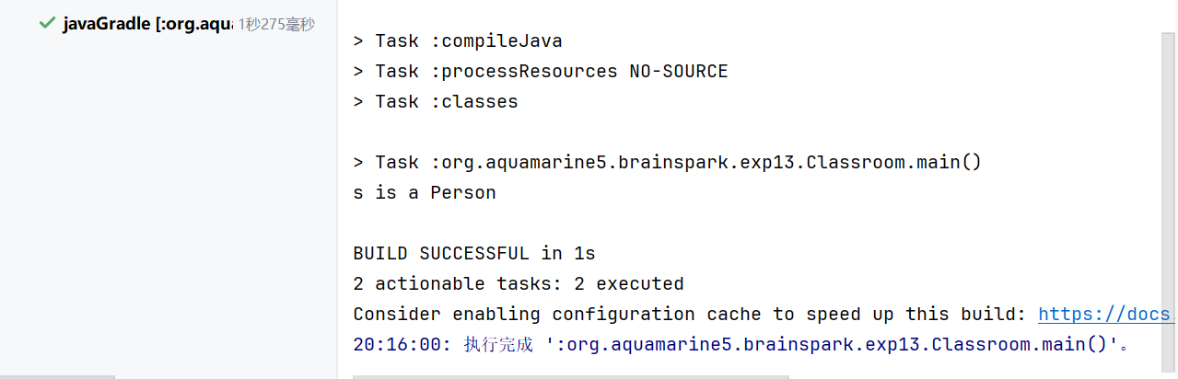

实验十四 Java程序--面向对象编程
一、实验目的
（1）掌握开发Java应用程序异常处理；
二、实验内容和步骤
（1）
package org.aquamarine5.brainspark.exp14;
import java.util.Scanner;
public class Quotient {
public static void quotient(double a, double b) {
System.out.println("The quotient is " + (a / b));
}
public static void quotientIf(double a, double b) {
if (b == 0)
System.out.println("Division by zero is not allowed.");
else System.out.println("The quotient is " + (a / b));
}
public static void quotientWithException(double a, double b)
throws ArithmeticException {
if (b == 0)
throw new ArithmeticException("Division by zero is not allowed.");
else System.out.println("The quotient is " + (a / b));
}
public static void main(String[] args) {
Scanner scan = new Scanner(System.in);
System.out.print("Enter two numbers: ");
int a = scan.nextInt();
int b = scan.nextInt();
quotient(a, b);
quotientIf(a, b);
try {
quotientWithException(a, b);
} catch (ArithmeticException e) {
System.out.println(e.getMessage());
}
}
}

三、实验结果
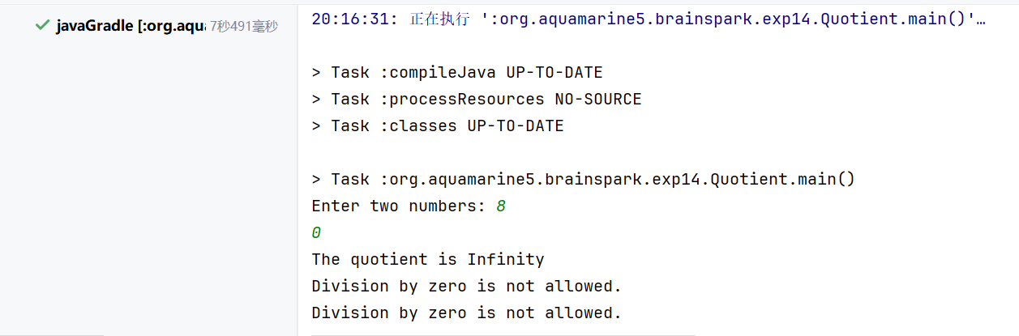

实验十五 Java程序--面向对象编程
一、实验目的
（1）掌握开发Java应用程序异常处理；
二、实验内容和步骤
（1）
package org.aquamarine5.brainspark.exp15;
public class Rectangle {
private double weight;
private double height;
private boolean square;
public double getWeight() {
return weight;
}
public void setWeight(double weight) {
this.weight = weight;
}
public double getHeight() {
return height;
}
public boolean isSquare() {
return square;
}
}
package org.aquamarine5.brainspark.exp15;
import lombok.Getter;
public class Circle {
@Getter
private double radius;
@Getter
private static int numberOfObjects = 0;
public Circle(){
this(1.0);
}
public Circle(double radius){
try{
setRadius(radius);
numberOfObjects++;
} catch (InvalidRadiusException e){
System.out.println(e.getMessage());
}
}
public void setRadius(double radius)
throws InvalidRadiusException{
if(radius < 0)
throw new InvalidRadiusException(radius);
this.radius = radius;
}
public double findArea(){
return radius * radius * Math.PI;
}
}
package org.aquamarine5.brainspark.exp15;
import lombok.Getter;
public class InvalidRadiusException extends Exception {
@Getter
private double radius;
public InvalidRadiusException(double radius) {
super("Invalid radius: " + radius);
this.radius = radius;
}
}
package org.aquamarine5.brainspark.exp15;
public class TestCircle {
public static void main(String[] args){
try{
Circle c1 = new Circle(5);
c1.setRadius(-5);
Circle c2 = new Circle(0);
} catch (InvalidRadiusException e) {
System.out.println(e.getMessage());
}
System.out.println(Circle.getNumberOfObjects());
}
}

三、实验结果
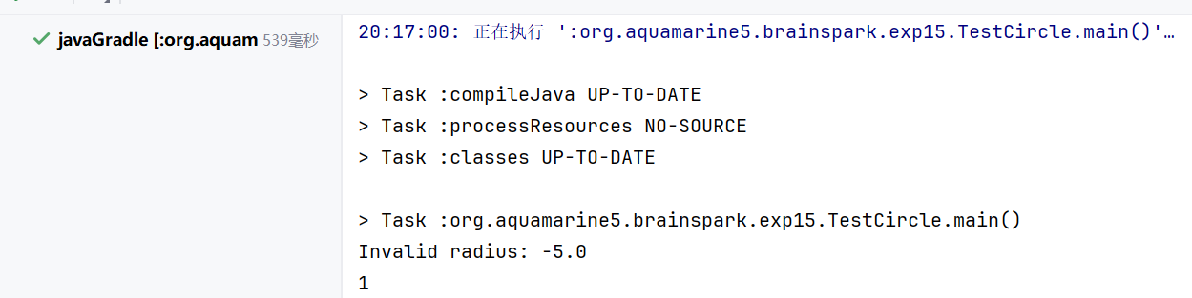

实验十六 Java程序--面向对象编程
一、实验目的
（1）掌握开发Java应用程序--抽象类和接口；
二、实验内容和步骤
（1）
package org.aquamarine5.brainspark.exp16;
import lombok.Getter;
import lombok.Setter;
@Getter
@Setter
public abstract class Animal {
private double weight;
public abstract String sound();
}
package org.aquamarine5.brainspark.exp16;
public class Apple extends Fruit{
@Override
public String howToEat() {
return "Apple: Make apple cider";
}
}
package org.aquamarine5.brainspark.exp16;
public class Chicken extends Animal implements Edible{
@Override
public String sound() {
return "Chicken: cock-a-doodle-doo";
}
@Override
public String howToEat() {
return "Chicken: Fry it";
}
}
package org.aquamarine5.brainspark.exp16;
public interface Edible {
public abstract String howToEat();
}
package org.aquamarine5.brainspark.exp16;
public abstract class Fruit implements Edible {
}
package org.aquamarine5.brainspark.exp16;
public class MainEdible {
public static void main(String[] args){
Object[] objects=
{new Tiger(),new Chicken(),new Apple()};
for(Object obj:objects){
if(obj instanceof Edible edible){
System.out.println(edible.howToEat());
}
if(obj instanceof Animal animal){
System.out.println(animal.sound());
}
}
}
}
package org.aquamarine5.brainspark.exp16;
public class Orange extends Fruit{
@Override
public String howToEat() {
return "Orange: Make orange juice";
}
}
package org.aquamarine5.brainspark.exp16;
public class Tiger extends Animal{
@Override
public String sound() {
return "Tiger: RROOAARR";
}
}

三、实验结果
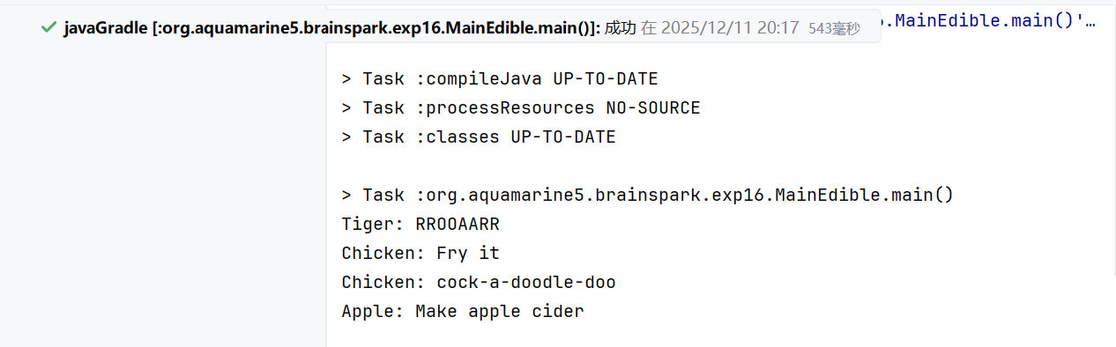

实验十七 Java程序--面向对象编程
一、实验目的
（1）编写程序，对常用的两个接口Comparable，Cloneable进行实现，并给出演示样例。
二、实验内容和步骤
（1）
package org.aquamarine5.brainspark.exp17;
public class People {
private String major;
private String name;
private long id;
public People(String major, String name, long id) {
this.major = major;
this.name = name;
this.id = id;
}
public int love(){
return 1;
}
public boolean love(int a){
return true;
}
public String getName() {
return name;
}
public void setName(String name) {
this.name = name;
}
}
package org.aquamarine5.brainspark.exp17;
import lombok.AllArgsConstructor;
import lombok.Getter;
import lombok.Setter;
@AllArgsConstructor
@Getter
@Setter
public class Student implements Cloneable, Comparable<Student> {
private String name;
private int age;
@Override
public int compareTo(Student o) {
return Integer.compare(this.age, o.age);
}
@Override
public Student clone() {
try {
return (Student) super.clone();
} catch (CloneNotSupportedException e) {
throw new RuntimeException(e);
}
}
@Override
public String toString() {
return "Student{" +
"name='" + name + '\'' +
", age=" + age +
'}';
}
}
package org.aquamarine5.brainspark.exp17;
public class MainStudent {
public static void main(String[] args) {
Student s1 = new Student("Alice", 20);
Student s2 = new Student("Bob", 22);
Student s3 = s1.clone();
Student s4 = s2;
s1.setAge(1215);
s4.setAge(1214);
System.out.println(s1);
System.out.println(s2);
System.out.println(s3);
System.out.println(s4);
}
}

三、实验结果
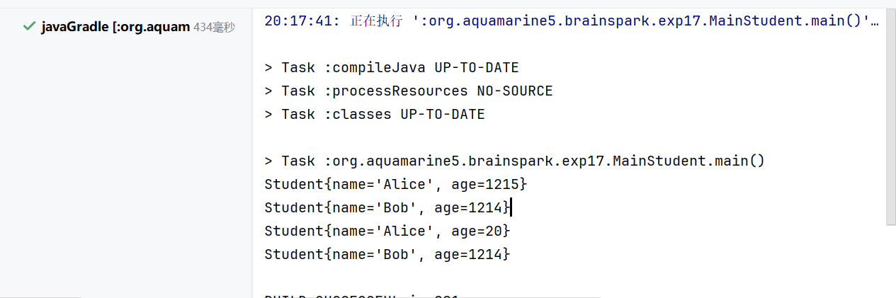

实验十八 Java程序--面向对象编程
一、实验目的
（1）编写一个简单的GUI程序，完成"Hello world"的显示。
二、实验内容和步骤
（1）
package org.aquamarine5.brainspark.exp18;
import java.awt.*;
import java.awt.event.WindowAdapter;
import java.awt.event.WindowEvent;
public class SimpleUI extends Frame {
public SimpleUI() {
super("Hello World Frame");
Label label = new Label("Hello World");
add(label);
setSize(300, 200);
addWindowListener(new WindowAdapter() {
public void windowClosing(WindowEvent we) {
System.exit(0);
}
});
}
public static void main(String[] args) {
SimpleUI frame = new SimpleUI();
frame.setVisible(true);
}
}

三、实验结果
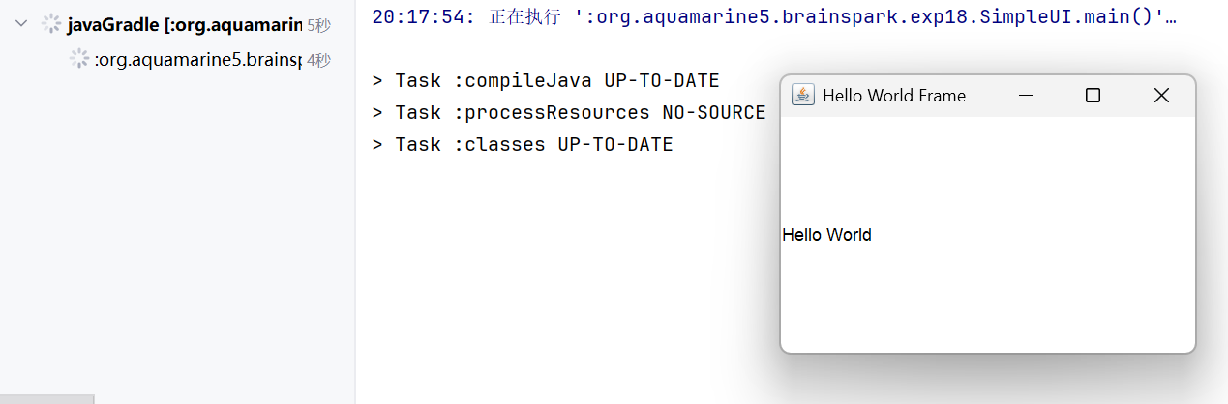

实验十九 Java程序--面向对象编程
一、实验目的
（1）Binary I/O 与Java对象序列化
二、实验内容和步骤
（1）
package org.aquamarine5.brainspark.exp19;
import lombok.AllArgsConstructor;
import lombok.Getter;
import lombok.Setter;
@AllArgsConstructor
@Getter
@Setter
public class Student implements java.io.Serializable {
private String name;
private long id;
private String major;
public Student() {
this.name = "石一泽";
this.id = 20242605031L;
this.major = "Software Engineering";
}
@Override
public String toString() {
return "Student{" +
"name='" + name + '\'' +
", id=" + id +
", major='" + major + '\'' +
'}';
}
}
package org.aquamarine5.brainspark.exp19;
import java.io.*;
import java.util.Date;
public class Main {
public static void main(String[] args) {
Student student = new Student();
try (FileOutputStream fos = new FileOutputStream("student.dat");
ObjectOutputStream oos = new ObjectOutputStream(fos)) {
oos.writeObject(student);
} catch (IOException e) {
e.printStackTrace();
}
Student diskStudent = null;
try (var fis = new FileInputStream("student.dat");
var ois = new ObjectInputStream(fis)) {
diskStudent = (Student) ois.readObject();
} catch (IOException | ClassNotFoundException e) {
e.printStackTrace();
}finally {
if (diskStudent != null) {
System.out.println(diskStudent);
}
}
System.out.println("程序运行时间："+new Date());
}
}

三、实验结果
