国际学院汇编程序设计实验报告

- 实验目的：
1、熟悉汇编程序的格式；
2、了解汇编语言的执行过程；

- 实验要求：
学习掌握汇编语言的基本指令，以及各种结构程序设计、变量的使用，字符串的输入输出。

- 实验内容：（题目及实现代码）
1、编写程序，在一行上依次显示26个大写英文字母。
2、已知字符串“ABCDEFGH”位于数据段开始的区域中，编程序将该字符串转换成小写后，存于其后。

INCLUDE io32.inc
INCLUDELIB io32.lib

.data
string DB "ABCDEFGH"
var_a DW 0BD61h, 0FF46h
var_b DW 2 DUP(?)

.code
PrintAllCharacters PROC
MOV AX, 'A'
MOV CX, 26
@Loop:
CALL dispc
INC AX
DEC CX
JNZ @Loop
RET
PrintAllCharacters ENDP

DataStringToLowerCase PROC
LEA ESI, string
MOV ECX, LENGTHOF string
LEA EDI, [string + ECX]
XOR EBX, EBX
@ConvertLoop:
MOV AL, [ESI]
ADD AL, 20h
MOV [EDI], AL
INC ESI
INC EDI
DEC ECX
JNZ @ConvertLoop

LEA EAX, string
CALL dispmsg
RET
DataStringToLowerCase ENDP
- 实验结果及分析：
Experiment Report on Assembler Program Design of International College

1、 Purpose:
1. Familiar with the format of assembler;
2. Understand the execution process of assembly language;

2、 Experimental requirements:
Learn and master the basic instructions of assembly language, as well as the design of various structural programs, the use of variables, and the input and output of strings.

3、 Experiment content: (topic and implementation code)
1. Write a program that displays 26 uppercase English letters on one line.
2. The known string "ABCDEFGH" is located in the area at the beginning of the data segment. The program converts the string to lowercase and stores it later.

INCLUDE io32.inc
INCLUDELIB io32.lib

.data
string DB "ABCDEFGH"
var_a DW 0BD61h, 0FF46h
var_b DW 2 DUP(?)

.code
PrintAllCharacters PROC
MOV AX, 'A'
MOV CX, 26
@Loop:
CALL dispc
INC AX
DEC CX
JNZ @Loop
RET
PrintAllCharacters ENDP

DataStringToLowerCase PROC
LEA ESI, string
MOV ECX, LENGTHOF string
LEA EDI, [string + ECX]
XOR EBX, EBX
@ConvertLoop:
MOV AL, [ESI]
ADD AL, 20h
MOV [EDI], AL
INC ESI
INC EDI
DEC ECX
JNZ @ConvertLoop

LEA EAX, string
CALL dispmsg
RET
DataStringToLowerCase ENDP
4、 Experimental results and analysis:
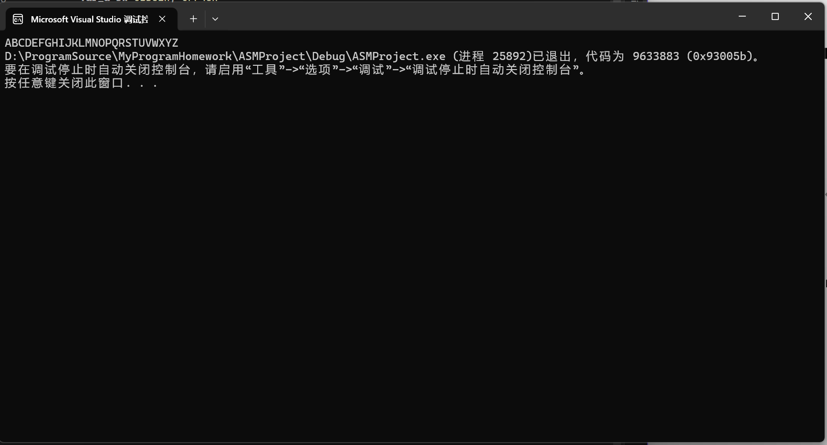

PrintAllCharacters PROC
MOV AX, 'A'
MOV CX, 26

In the procedure of PrintAllCharacters, the program set the AX to the character “A” and set the CX to 26 as the length of all characters.

@Loop:
CALL dispc
INC AX
DEC CX
JNZ @Loop

Then the program executed CALL dispc to display each character, also increasing the AX as ASCII to the next character and decreasing the CX, the program will stop if the CX turns to 0.

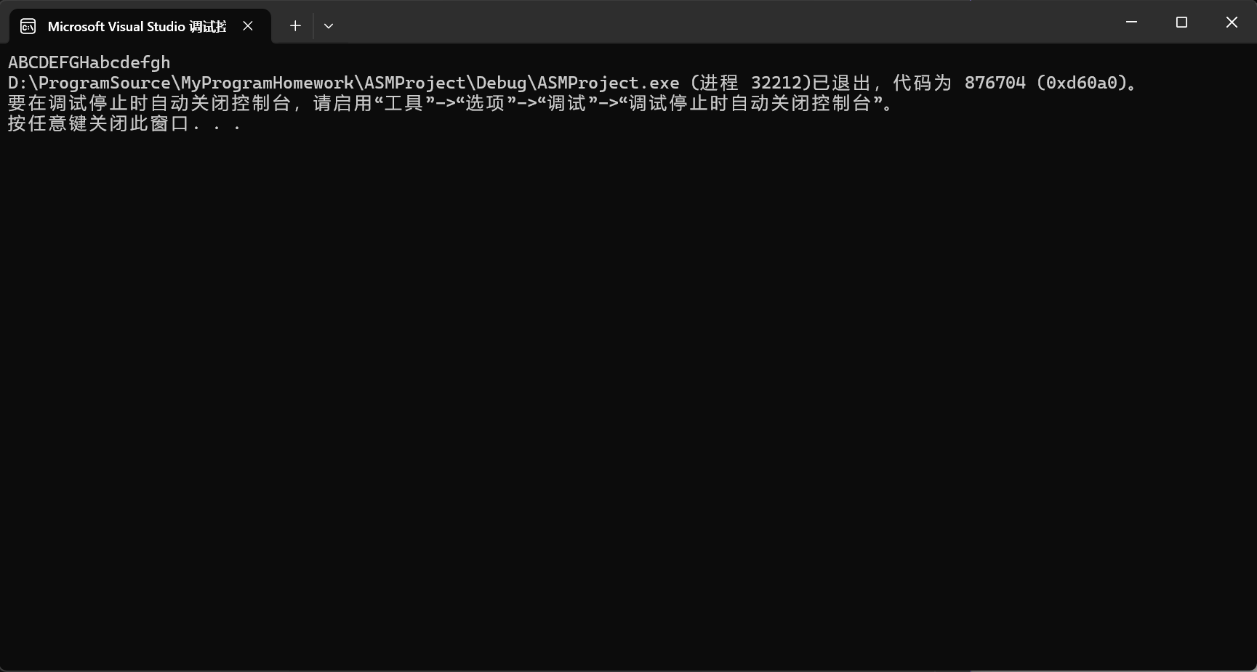

DataStringToLowerCase PROC
LEA ESI, string
MOV ECX, LENGTHOF string
LEA EDI, [string + ECX]
XOR EBX, EBX

In the procedure of DataStringToLowerCase, the program will get the address of string by LEA operator and get the length of the string to ECX.
@ConvertLoop:
MOV AL, [ESI]
ADD AL, 20h
MOV [EDI], AL
INC ESI
INC EDI
DEC ECX
JNZ @ConvertLoop

In the @ConvertLoop, each character will add 20h because the ASCII table to switch to the lowercase, then use MOV [EDI], AL to insert the converted character at the end.

LEA EAX, string
CALL dispmsg
RET

In the end, the CALL dispmsg will be executed to print the result.

