国际学院汇编程序设计实验报告

- 实验目的：
1、熟悉汇编程序的指令；
2、了解汇编语言的执行过程；

- 实验要求：
学习掌握汇编语言的基本指令，以及各种结构程序设计、变量的使用，字符串的输入输出。

- 实验内容：（题目及实现代码）
- 使用串指令编写程序，查找字符串‘How are # you ?’中是否含有字符‘#‘,若有，将字符‘#’用空格字符代替。
StringReplacePoundToWhitespace PROC
LEA EDI, string
MOV EBX, LENGTHOF string
MOV ECX, 0
@ScanLoop:
CMP BYTE PTR [EDI], '#'
JNE @ScanLoopItor
MOV BYTE PTR [EDI], ' '
@ScanLoopItor:
INC EDI
INC ECX
CMP ECX, EBX
JB @ScanLoop

MOV EAX, OFFSET string
CALL dispmsg
RET
StringReplacePoundToWhitespace ENDP

- 已知两个带符号的数据BUF在开始的地址单元，如果两个数的符号相同，则求其差，否则求其和，结果放在RESULT单元。提示：数据段 BUF dword 1100H，8203H RESULT dword ？
使用XOR指令来判断两个数的符号是否相同，根据符号标志位SF，来判断是做差还是和。
SumIfEqualSignAndSubtractOtherwise PROC
MOV EAX, [buf]
MOV EDX, [buf+4]
XOR EDX, EAX
JNS @IsEqual
MOV EAX, [buf]
ADD EAX, [buf+4]
JMP @Result
@IsEqual:
MOV EAX, [buf]
SUB EAX, [buf+4]
@Result:
MOV result, EAX
RET
SumIfEqualSignAndSubtractOtherwise ENDP

- 实验结果及分析：
Experiment Report on Assembler Program Design of International College

- Purpose:
1. Familiar with assembler instructions;
2. Understand the execution process of assembly language;

2、 Experimental requirements:
Learn and master the basic instructions of assembly language, as well as the design of various structural programs, the use of variables, and the input and output of strings.

3、 Experiment content: (topic and implementation code)
1. Use string instructions to write programs and find the string 'How are # you?' Whether the character '#' is included in the. If so, replace the character '#' with a space character.

StringReplacePoundToWhitespace PROC
LEA EDI, string
MOV EBX, LENGTHOF string
MOV ECX, 0
@ScanLoop:
CMP BYTE PTR [EDI], '#'
JNE @ScanLoopItor
MOV BYTE PTR [EDI], ' '
@ScanLoopItor:
INC EDI
INC ECX
CMP ECX, EBX
JB @ScanLoop

MOV EAX, OFFSET string
CALL dispmsg
RET
StringReplacePoundToWhitespace ENDP
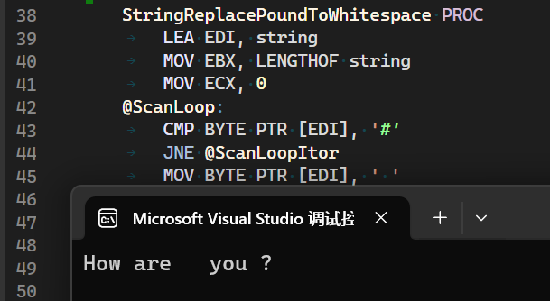
LEA EDI, string
MOV EBX, LENGTHOF string
MOV ECX, 0
@ScanLoop:
CMP BYTE PTR [EDI], '#'
JNE @ScanLoopItor
MOV BYTE PTR [EDI], ' '

First, we store the length of string to EBX, and loop to execute the action of
CMP BYTE PTR [EDI] , ‘#’, then the program will jump to @ScanLoopItor if is not matched, or MOV BYTE PTR [EDI], ‘ ‘ otherwise.

@ScanLoopItor:
INC EDI
INC ECX
CMP ECX, EBX
JB @ScanLoop

The @ScanLoopItor will increase the ECX and the EDI like the general for loop in C program as i++. In the end, the program will compare the ECX as the current index and the EBX as the whole length of the string, and jump out the loop if the whole string was scanned.

MOV EAX, OFFSET string
CALL dispmsg
RET

And called the dispmsg (from Irvine32.lib) to display the string after replacement.
2. The address cell at the beginning of two signed data BUFs is known. If the symbols of the two numbers are the same, the difference is calculated; otherwise, the sum is calculated and the result is placed in the RESULT cell. Prompt: data segments BUF dword 1100H, 8203H
RESULT dword ?

The XOR instruction is used to determine whether the symbols of two numbers are the same, and the difference or sum is determined according to the symbol flag SF.

SumIfEqualSignAndSubtractOtherwise PROC
MOV EAX, [buf]
MOV EDX, [buf+4]
XOR EDX, EAX
JNS @IsEqual
MOV EAX, [buf]
ADD EAX, [buf+4]
JMP @Result
@IsEqual:
MOV EAX, [buf]
SUB EAX, [buf+4]
@Result:
MOV result, EAX
RET
SumIfEqualSignAndSubtractOtherwise ENDP
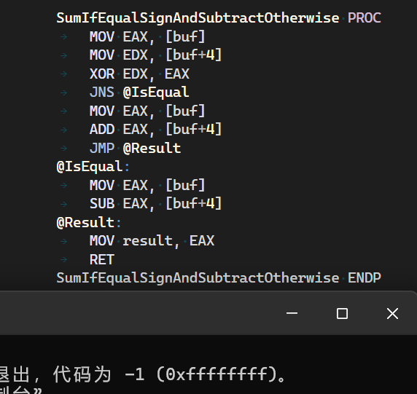

MOV EAX, [buf]
MOV EDX, [buf+4]
XOR EDX, EAX
JNS @IsEqual

The program will compare EAX (as the buf+0) and the EDX (as the buf+4).

MOV EAX, [buf]
ADD EAX, [buf+4]
JMP @Result
@IsEqual:
MOV EAX, [buf]
SUB EAX, [buf+4]

And then use JNS to check the symbol flag SF, and executed ADD or SUB after the comparison, then stored the result to EAX.
@Result:
MOV result, EAX
RET

