1 The average rate of change of any function is simply the change in outputs, divided by the change in inputs. For any function f(x), write an algebraic fraction for the average rate of change from *c* to d:

2 Next, suppose we want to find the average rate of change near point *c*. Write out in correct notation, “the limit as x approaches c of the average rate of change of f(x) from x to c”

3 Coming out of the abstract, let us find the rate of change of a physical object, say a thrown ball. A mathematical model for this situation might be f(x)=-x2+4x+5. Begin by graphing the function in the first quadrant:

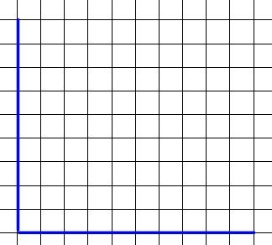

4 If we try to calculate directly the average rate of change at 0, we get an indeterminate form. Write the limit and solve it, for x approaching 0 of the average rate of change of f(x) from x to 0.

5 Looking at the graph, what do you estimate the rate of change is at x=2? Use limits to find the answer.

6 When we are able to construct a function that answers the rate of change, it is said to be the derivative function of the original. Try to find the derivative of f(x) by moving some distance h to the right of x, setting up the average rate of change and taking the limit at h approaches zero.

7 Describe in your own words what you think the point of this problem set is, using complete sentences.