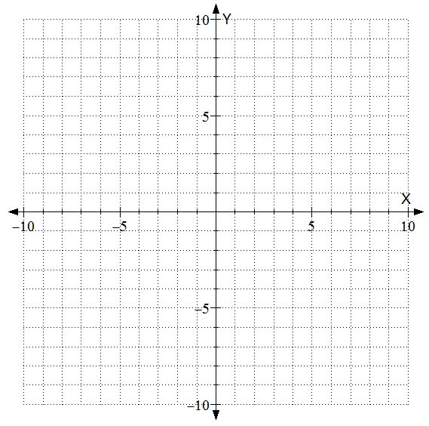

1 On the grid above, graph f(x)= ¼ x2.

2 Applying transformational thinking, graph f(x)-1.

3 Absolute values “flip” some numbers and leave others untouched. If we applied absolute values to the output (y), what part of the graph would be effected? Circle or highlight that portion of your second graph.



4 On the grid above, graph |f(x)-1|

5 What are the coordinates of the two cusps we have made?

6 Transform the previous graph by shifting it down 3 units. What is the equation of this new function?

7 Name the three lattice points that will be effected if we applied absolute values to **this** equation.

8 Graph $x^3-3x-2$ as $Y_1$. Draw it below.



9 What do you anticipate $Y_2=Y_1(|X|)$ will look like?

10. Verify in your TI-8*. Describe what the absolute value did to the graph.

11 How are absolute values differ if applied before vs after?