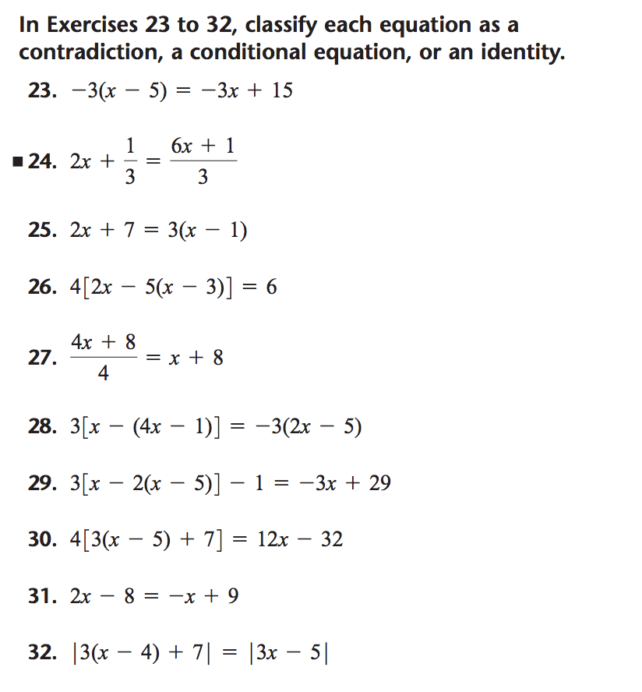

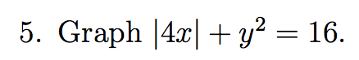

Graph |y|=9-x2

Graph ½ |x|x. Find its derivative.

Graph x2|x|. Find its derivative

What kind of symmetry does g(x)=f(|x|) force?

Graph |y|=|x|

Why should you be applying to the chain rule when differentiating sqrt(x2)?