1 We want to be able to transform any graph into its reciprocal. Graph y=x and y=4/x, either in different colors or in different line styles below.

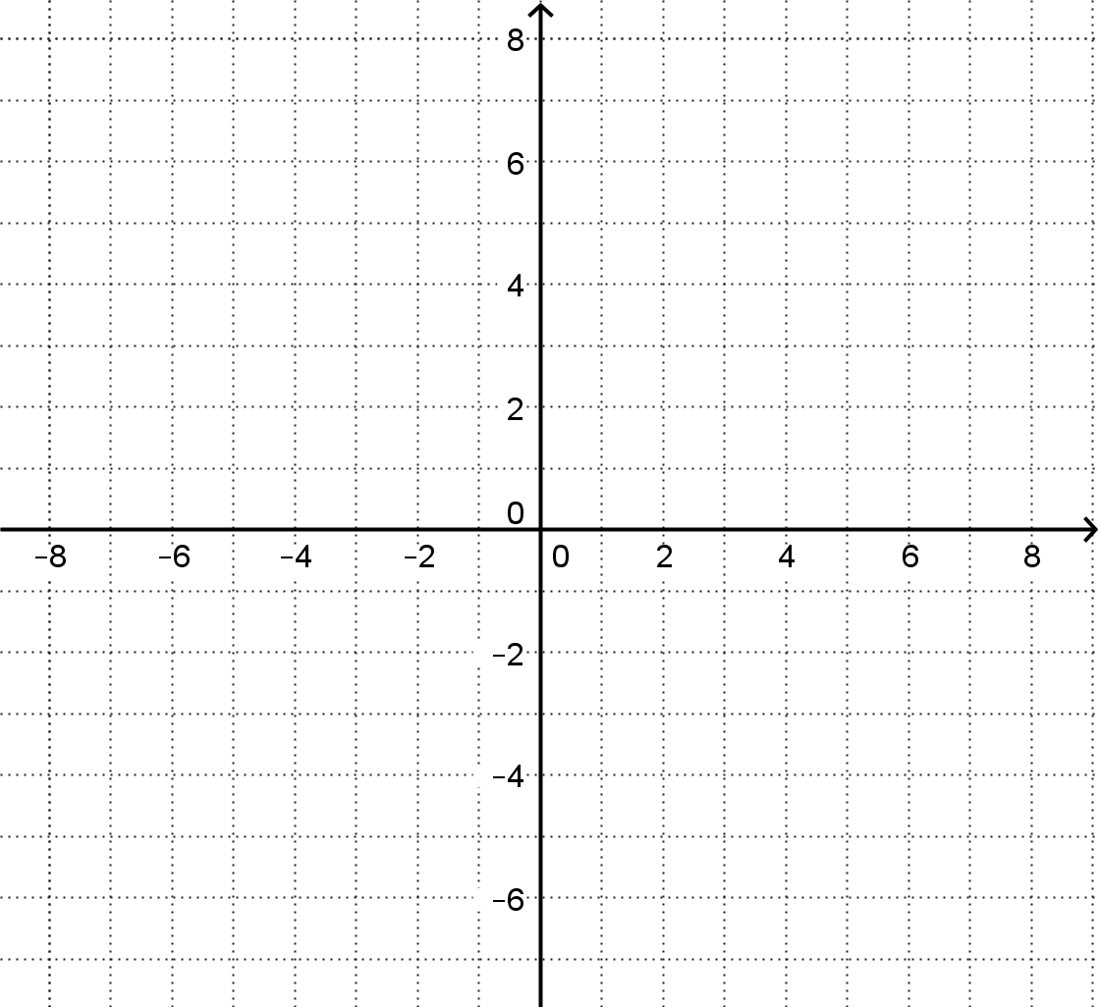

2 What points are in common between the two graphs? How is this the same question as “What numbers are their own reciprocals?”

3 What number is the reciprocal of 2? Find the ***eight*** points that illustrate that fact.

4. What number is the reciprocal of 0? Why is this a trick question? What behavior do graphs exhibit close to a “divide by 0”?

5. Construct a set of rules to help you graph reciprocals. What happens to positives and negatives? 1s? 2s? 0s?

6. Graph f(x)=x2-6x+5 and its reciprocal by hand

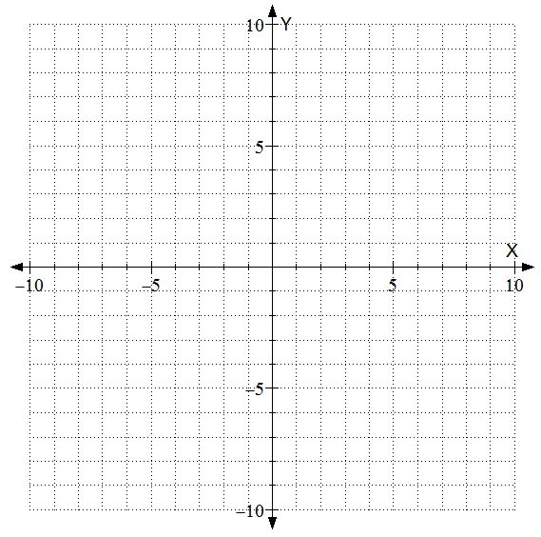

7. Describe a hypothetical situation where someone might graph one ratio on accident, and actually want the reciprocal.