Complete the table of numerical reciprocals for the following functions:

1.

|  |  |  |  |  |  |
| --- | --- | --- | --- | --- | --- |
| **X** | -2 | -1 | 0 | 1 | 2 |
| **f(x)** | -8 | -1 | 0 | 1 | 8 |
| **1/f(x)** |  |  |  |  |  |

2.

|  |  |  |  |  |
| --- | --- | --- | --- | --- |
| **X** | -2 | -1 | 1 | 2 |
| **f(x)** | ½ | 0 | 2 | 3/2 |
| **1/f(x)** |  |  |  |  |

3.

|  |  |  |  |  |
| --- | --- | --- | --- | --- |
| **x** | ¼ | ½ | 2 | 4 |
| **f(x)** | 0 | 6 | 63 | 255 |
| **1/(f(x))** |  |  |  |  |
| **f(1/x)** |  |  |  |  |

4.

|  |  |  |  |  |
| --- | --- | --- | --- | --- |
| **X** | -1 | ½ | 1 | 2 |
| **f(x)** | 1 | 4 | 5 | 7 |
| **1/(f(x))** |  |  |  |  |
| **f(1/x)** |  |  |  |  |

Freehand sketch the reciprocal of the given functions:

5.

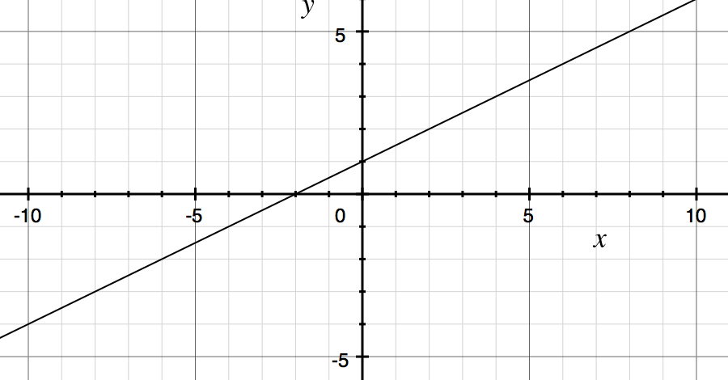

6.

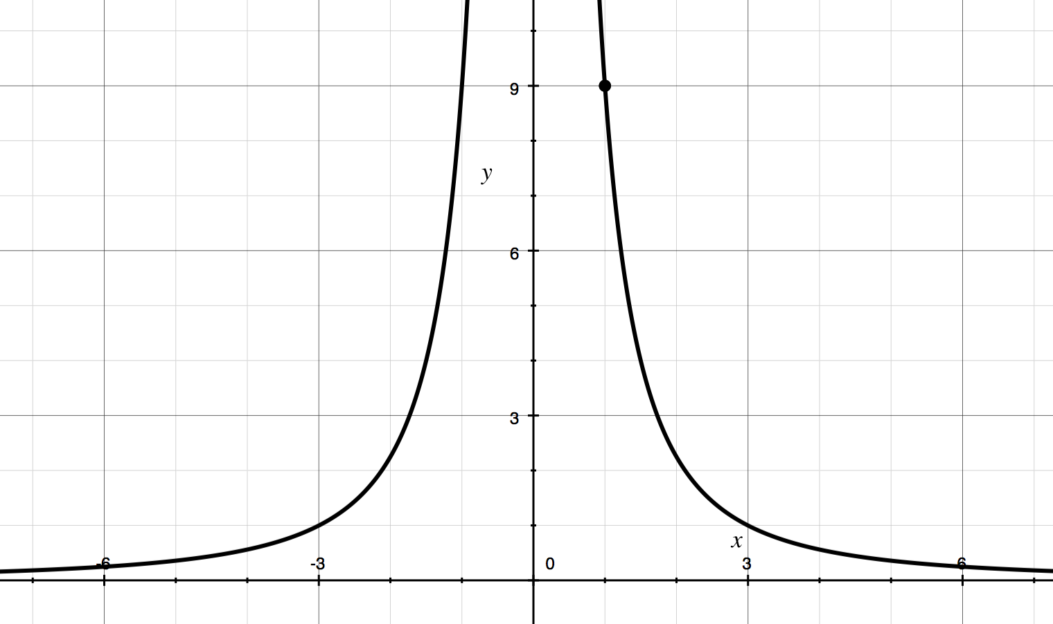

7.

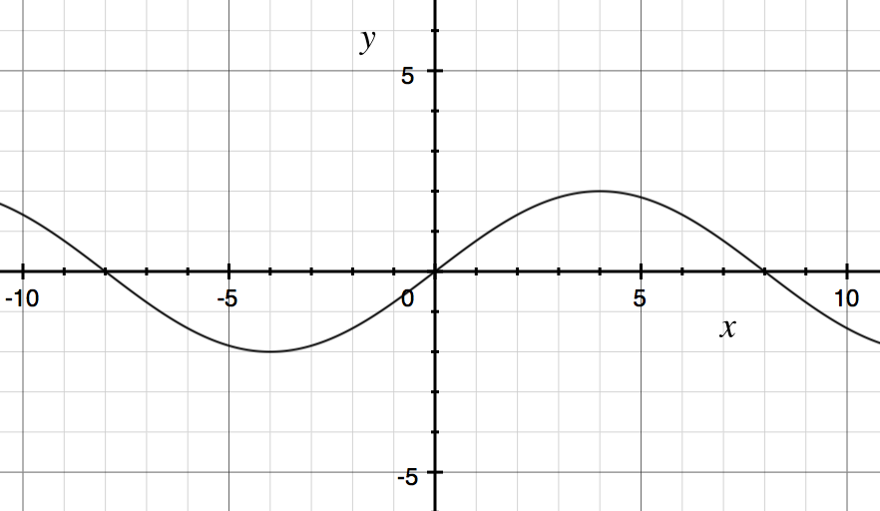

8.

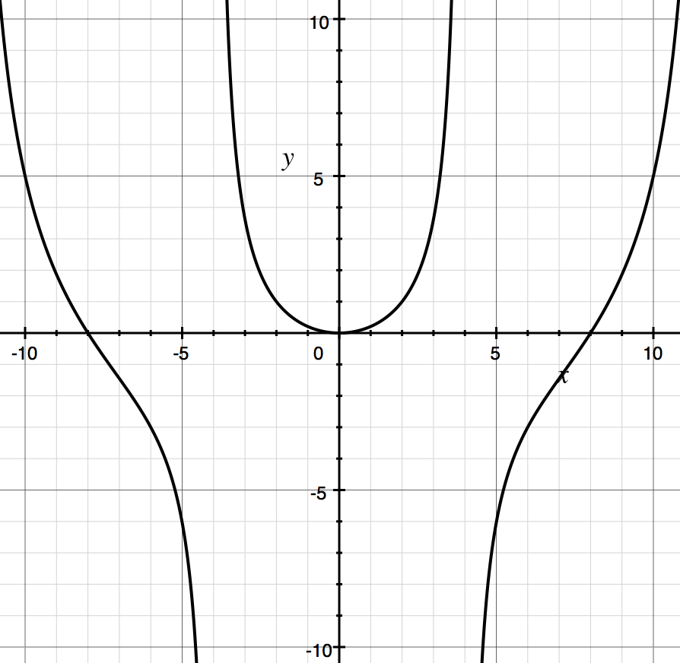

9.

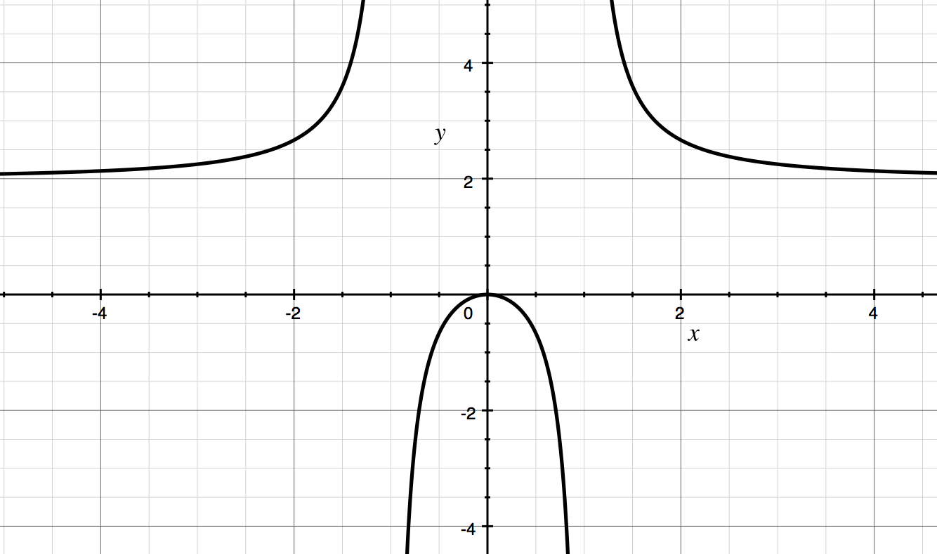

10.

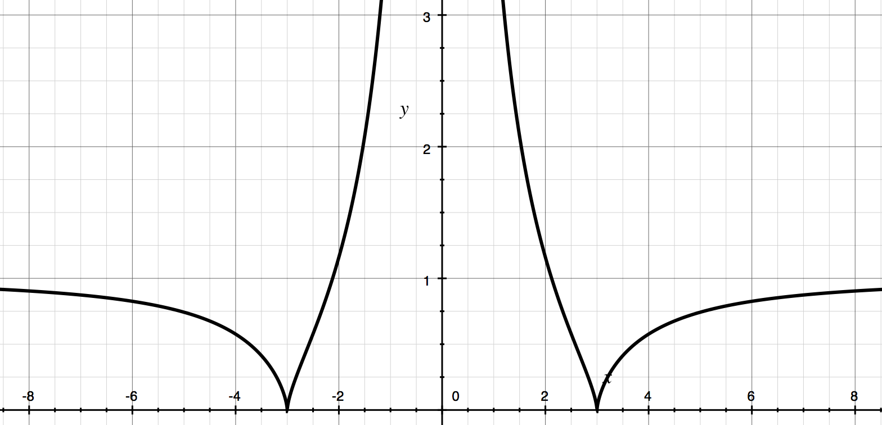

Find the derivative of the reciprocal of the given function:

11. f(x) = 2x + 3

12. g(x) = -5x - 1

13. h(x) = 3x2 -5x + 1

14. j(x) = -6x3 -2x

15 How can you use the function variables of your TI-8* to graph Y1’s reciprocal, without having to retype the entire function? Use your method to graph

Y1=(x^4-2x^3-52x^2+8x+256)/(32x+64) and its reciprocal.

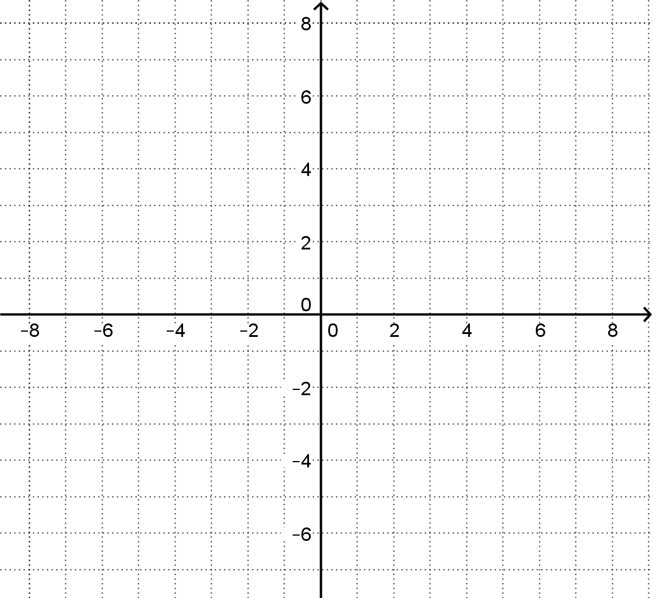

16 Come up with a formula for finding the derivative of the reciprocal of any function.

17 When is the derivative of a function equal to the derivative of its reciprocal? Give two examples.

18 Find the local minimum or maximum of the given function, using the (easier) derivative of the reciprocal.

A f(x) = 1/(x^2+x-6)

B g(x) = 1/(x^2+1)

C h(x) = 1/(x^3-x)

19 Suppose we have two functions, f and g.

A What is the derivative of f(g(x))?

B What is the derivative of 1/(f(g(x)))?

C What is the derivative of f(1/(g(x)))?

D What is the derivative of 1/(f(1/(g(x))))?

20 How would 19 A-D change if every x was replaced with 1/x?

21 One way to recast what we have been doing, is to image we are reflecting over the lines y^2=1, which keeps any point (x,pm 1) the same, but --- not speaking carefully --- reflects (x, pm infty) to (x,0). Another system which might vie for the name “reciprocal” is to reflect over the circle x^2+y^2=1.

A Find where (0.5,-0.5) and (0.25,0.25) reflect to

B Find where (2/3,-2/5) and (-1/7,2/9) reflect to

C Describe what happens to a line drawn on the inside once reflected.

D Watch the Numberphile video on inversion geometry (30 minutes)