1 Making every box equal to 0.5, graph of f(x)=x^(1/3) below. Also graph g(x)=x^1. One what intervals is the first greater than the second?

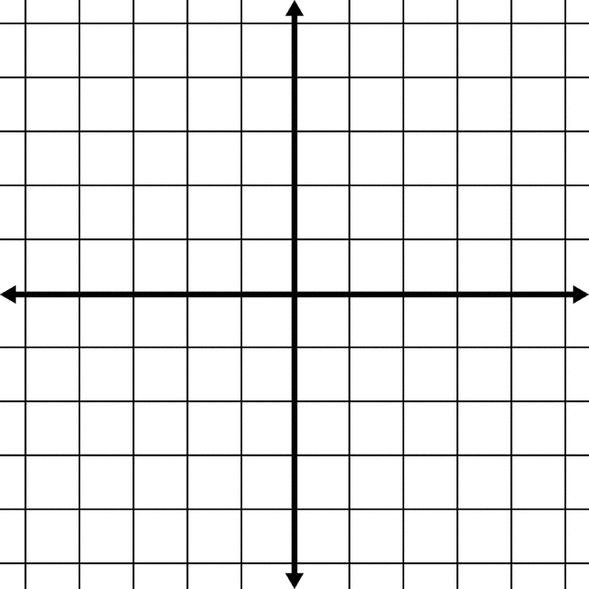

2 On the same graph, also graph h(x)=x^(5/3). On what intervals is this greater than g(x)?

3 When are the functions increasing and decreasing?

f(x)

g(x)

h(x)

3 Record the derivative of all three functions.

4 When are the derivatives positive and negative?

f’(x)

g’(x)

h’(x)

5 Find the derivatives of the derivatives, the second derivatives of each function. Record them here.

6 When are the function concave and convex? Concave is ‘U’ shaped, while convex is hill-shaped.

f(x)

g(x)

h(x)

7 When are the second derivatives positive and negative?

f’’(x)

g’’(x)

h’’(x)

8 In technical language, describe what you think the point of this problem set is.