1 Why are we able to predict the long-run behavior of any polynomial, simply by looking at the highest degree and leading coefficient?

2 Complete the table below for any f(x) with the given quality of degree and given sign of leading coefficient.

|  |  |  |
| --- | --- | --- |
|  | Positive | Negative |
| Even | $\lim_{x→∞}{f\left(x\right)= }$ $$\lim_{x→-∞}{f\left(x\right)}=$$ | $\lim_{x→∞}{f\left(x\right)= }$ $$\lim_{x→-∞}{f(x)}=$$ |
| Odd | $\lim_{x→∞}{f\left(x\right)= }$ $\lim_{x→-∞}{f(x)}=$ | $\lim_{x→∞}{f\left(x\right)= }$ $\lim_{x→-∞}{f(x)}=$ |

3 Recall that y-intercepts all have the form (0,c), where c is a number. How can you easily look at any polynomial and tell what the y-intercept will be?

4 Recall that x-intercepts all have the form (c,0), where c is a number. If we have a polynomial in factored form, where are the x-intercepts? For example, what are the intercepts of f(x) = (x-3)(x+2)(2x-1)(x-5) ?

5 What does it mean when a factor is repeated? For example, what does (x-1)2 look like? What does (x-1)2(x+2) look like near x=1?

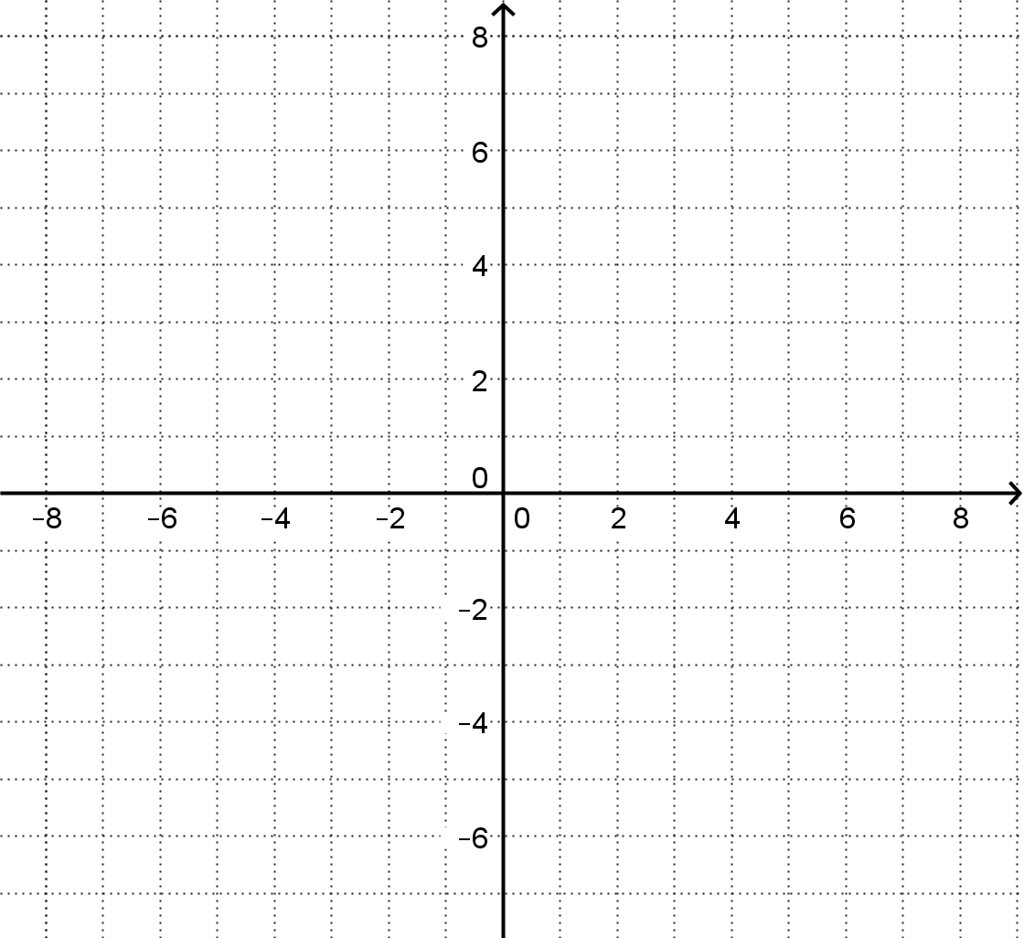

6 With all this information, we can sketch a graph of any polynomial. Let us graph (without a grapher) the following function

f(x) = -(x+1)2(x-4)2(3x+17)

Begin by calculating what the leading term will be. Do not multiply the entire equation out, only the x’s!

7 This will allow you so determine the end-behavior. Draw arrow beyond the left and right edges to indicate how the graph should finish.

8 Calculate the constant-term. Do not multiply the enture equation out, only the constants. Mark the y-intercept, using a scale of 100:1.

9 Mark the x-intercepts, noting whether they “bounce” or “go through”. Starting at the left edge of the graph and working write, sketch the function.

10. In technical language, describe what you think the point of this problem set it.