1. **Magic number**  We posit that there is at least one simple exponential function whose height at any given point is also equal to its derivative at that point. Sketch a graph of an un-translated exponential function, without a grapher, of the form f(x)=Ax. Label the y-intercept all such graphs have in common.

2. Rather than dealing within further math, let us choose the easiest point for the algebra. Work out the derivative formula for f(x) at 0. Rather than taking the limit, leave h in the equation. Record it below.

3. Calculate the approximate derivative for several values of A, using an h of 10^-8 or smaller. Guess-and-check until you get a derivative of 1.000. What must A be?

4. Graph your f(x)=Ax and its tangent line through (0,1).

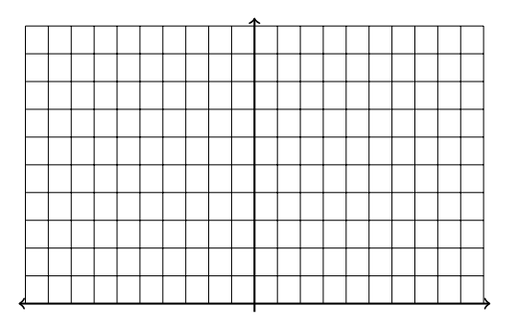

5. **Another Magic Number** What is the most amount of money you could get out of a bank in a year? Suppose you invested a $1.00 and got 100% interest. How much would you have at the end of the year?

6. Now suppose you asked them instead to compound your interest twice in a year. (This means they give you 50% interest each time.) How much would you have at the end of such a year?

7. That went so well, you decide to see how far you take this. How much does 100%÷4, compounded 4 times a year get you?

8. Write a formula and take the limit as the number of time interest is compound goes to infinity. What is the theoretical maximum you could make from a bank willing to compound continuously?

9. The magic number you found twice is called e, and is as important in calculus as π is geometry. Search the internet and find another definition of e.

10. Describe in your own word what you think the point of this problem set is.