1 Plot the graph of y = ex = y’

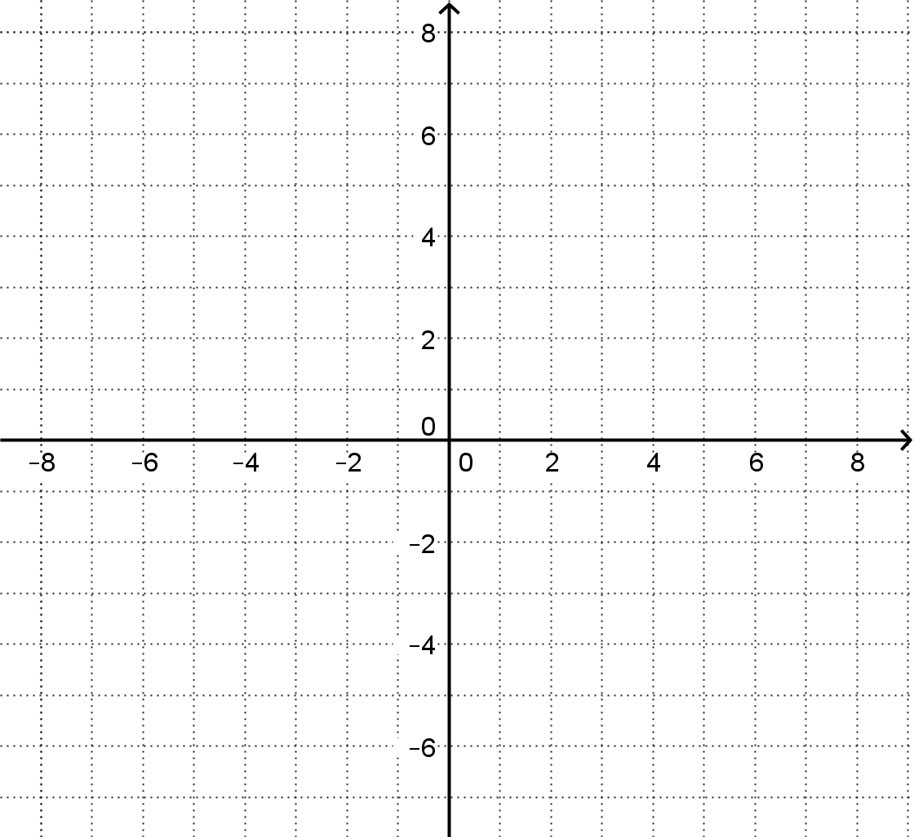

2 Record the value of 1/e and check your graphs accuracy.

3 We know that ln(x) [a.k.a. loge(x)] is the inverse function. How can we graph an inverse from an original numerically?

4 State the property relating the derivative of an inverse to the derivative of the original.

5 ex is special, because the height of the function is its derivative at every point. Use the above properties to find the derivative of ln(x) verbally.

6 Suppose y is equal to a product of functions, f·g. How can we find y’? Take the ln of both sides, and then the derivative, together called the logarithmic derivative.

7 How can we find the derivative of y = xx? The exponent is not a constant, so we may not use the Power Rule. The base is not a constant, so we may not use the derivative of ex. Find a way to find the derivative and use it to find the absolute minimum of the function.

8 Describe in technical vocabulary what you think the point of this problem set is.