1 It is not always easy to tell what a limit at infinity will be, especially with unfamiliar functions. Consider f(x) = (4(ex-e))/(x11-1). Sketch a graph below.

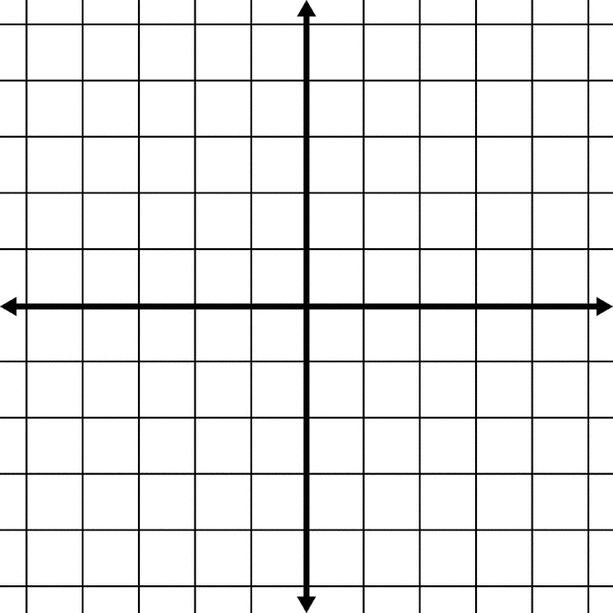

2 Based off the graph, how would you answer lim x🡪∞ f(x)?

3 Press 2nd-WINDOW and go to TABLE SETUP. Start at 0 and skip by 10’s. Now press 2nd-GRAPH and look at the TABLE itself. Describe the progression of f(x) for all positive arguments.

4 Before we tackle infinity, we should find the limit at 1. TRACE along the graph and ZOOM-IN several time to find a numerical approximation, accurate to 3 decimal places.

5 For every tiny step along f(x), the numerator is changing some small amount, and the denominator by a different amount. Implicitly differentiate the numerator and the denominator separately, but write them in a fraction.

6 Evaluate the function you made in #5 at 1.

7 To use this method (called L’Hopital’s Rule) at infinity, repeated applications are necessary. Differentiate the numerate and denominator separately, but write in fraction, several times until you obtain a function that is not indeterminate but infinite at infinity, confirming the TABLE.

8 Explain in your own words what you think the point of this problem set is.