1. Solve 2 cos (θ -17º) = 1, θ is in [0º,720º]. Begin by substituting u = θ – 17º.

2. Solve tan2θ – 2 tanθ = 3, θ is in [-τ, τ]. Begin by substituting u = tanθ.

3. The figure below shows the graphs of

y1 = -1 – 5sinθ and y2 = 2cos2θ

Find all the answers in [-τ/2, 2τ]

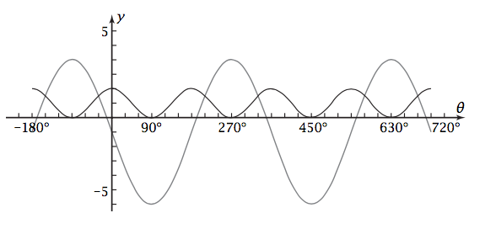

4. Consider the reference triangle formed within the unit circle. What are the length of its sides and how would Pythagoras relate them to each other?

5. Solve algebraic by substituting an equivalent expression for cos2θ:

-1 - 5sinθ = 2 cos2θ in [-τ/2, 2τ]

6. In your own words, using whole sentences, describe what you think the point of this problem set is.