Nottingham Trent University

School of Science and Technology

Simulating Visual Impairments in a Virtual Reality Environment

by

Dominic Peter Reynolds

in

2020

Project report in part fulfilment

of the requirements for the degree of

Bachelor of Science with Honours

in

Computer Science with Games Technology

I hereby declare that I am the sole author of this report. I authorize the Nottingham Trent University to lend this report to other institutions or individuals for the purpose of scholarly research.

I also authorize the Nottingham Trent University to reproduce this report by photocopying or by other means, in total or in part, at the request of other institutions or individuals for the purpose of scholarly research.

Signature

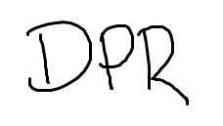

Dominic Peter Reynolds

Abstract

Visual Impairments are a hard topic for unaffected people to visualise, and as a result, they are not talked about very often, and the severity and range of visual impairments are not widely understood or known. This led to the investigation of the production of an environment in which Visual Impairments could be Simulated to allow for people to experience the effects of Impairments first-hand, to raise awareness and understanding of the nature of Visual Impairments.

Virtual Reality is a strong medium for building immersion and a sense of being inside of the Virtual World, this makes it the ideal medium to produce a Visual Impairment Simulator as the user will be able to experience the Impairments rather than just see them. This would make the Simulator provide more of an impression and result in a greater understanding of the nature of Visual Impairments.

To produce the environment, Unreal Engine will be utilised as it provides many pre-made utilities for creating projects within a game-style world, especially for Virtual Reality. Unreal Engine also has many built in features to assist with the production of Post-Process Materials, which will be used to simulate the Visual Impairments.

Unfortunately, part of the development process and the testing process was interfered with because of the COVID-19 pandemic, however, I did the best in the situation I was in, and worked around it.

This project concludes that Producing a Visual Impairment Simulator is very viable within a Virtual Reality Environment and that Virtual Reality is a significantly stronger tool for this use than other methods, due to the first-hand immersive experience of the Impairments. The participants who tested the Simulator also reported a greater appreciation for Visual Impairments and those afflicted with them.

Acknowledgements

I would like to extend a large amount of thanks to James Lewis, whose insightful overview of my project was most useful, and whose hints and help made this project a lot more possible to complete.

I would also like to thank the School of Computer Science at Nottingham Trent University for their support and supply of Technology that was crucial to this project.

Finally, I would like to thank my friends and family, who supported me during the COVID pandemic and helped me get through the hardest parts of this project, and also took part in my testing process, even though it was not ideal to provide me with results to evaluate.

Table of Contents

Abstract ii

Acknowledgements iii

Table of Contents iv

List of Figures vii

List of Tables ix

CHAPTER 1 1

Introduction 1

1.1 Introduction 1

CHAPTER 2 3

CONTEXT 3

2.1 Introduction 3

2.2 Literature Review 3

2.2.1 Virtual Reality 3

2.2.2 Developing for Virtual Reality 5

2.2.3 Visual Impairments 5

2.3 Conclusion 6

CHAPTER 3 7

New Ideas 7

3.1 Introduction 7

3.2 Software Development 8

3.2.1 Requirements 8

3.3 Time Management and Development Process 9

CHAPTER 4 12

IMPLEMENTATION 12

4.1 Introduction 12

4.2 Software Development 12

4.2.1 Analysis 12

4.2.2 Design 13

4.2.3 Testing 14

4.2.4 Getting Results 14

4.3 Project Progress Diary 14

CHAPTER 5 22

RESULTS and DISCUSSION 22

5.1 Pre-Simulation Results 22

CHAPTER 6 28

CONCLUSIONS and FUTURE WORK 28

6.1 Conclusions 28

6.2 Future work 29

6.3 Legal, Social, Ethical and Professional Issues 30

6.4 Synoptic Reflections 31

ReferenceS 33

Bibliography 36

Appendix A – GANTT CHART 39

Appendix B – PRE-SImulator Questionnaire 40

Appendix C – POst-SImulator Questionnaire 41

Appendix D – testing table 42

List of Figures

Figure 1 : Oculus Rift DK1 4

Figure 2 : HTC VIVE PRO EYE 4

Figure 3: Neutral Look Up Table 15

Figure 4: Protanopia Look Up Table 15

Figure 5: Deuteranopia Look Up Table 15

Figure 6: Tritanopia Look Up Table 15

Figure 7: Achromatopsia Look Up Table 15

Figure 8: Standard Scene View 16

Figure 9: Protanopia Scene View 17

Figure 10: Deuteranopia Scene View 17

Figure 11: Tritanopia Scene View 18

Figure 12: Achromatopsia Scene View 18

Figure 13: COBLIS Simulation of Protanomaly 19

Figure 14: COBLIS Simulation of Protanopia 19

Figure 15: A simple approximation of Cataracts 21

Figure 16: Question 1 Response 22

Figure 17: Question 2 Response 22

Figure 18: Question 3 Response 23

Figure 19: Question 4 Response 23

Figure 20: Question 5 Response 24

Figure 21: Question 6 Response 24

Figure 22: Question 7 Response 25

Figure 23: Question 8 Response 25

Figure 24: Question 9 Response 26

Figure 25: Question 10 Response 26

Figure 26: Question 11 Response 27

List of Tables

Table 1: Unreal Engine 4 Recommended Requirements 8

Table 2: Unreal Engine 4 Minimum Requirements 8

Table 3: Unreal Engine 4 Development Requirements 8

Table 4: Risk Assessment 11



Introduction

Introduction

Virtual Reality immerses the user inside of a different world outside of our own, in which they can be whatever they want to be or what the designer wants them to be, I can use this to my advantage. I can use this medium to instead of showing them how Visual Impairments can affect you but let them experience and feel how Visual Impairments can affect you. I believe this would be a significantly better method of conducting this project, as it will lead to more successful results of people being more aware of the difficulties of living with a Visual Impairment.

Visual Impairments are a very common yet hard to understand disability. There are many different forms, which tend to be bundled into groups and people do not know the differences between them and how they affect you differently. I will be building a simulator inside of a virtual reality environment which will let me simulate as many symptoms of Visual Impairments as I can so that the effects and complications of each can be demonstrated.

People in the care or design industry without visual impairments may struggle to incorporate consideration for people with visual impairments (Goodman-Deane, et al., 2007) into their job and routine, which can cause issues for their clientele. For example, if a designer does not take into account people with colour-blindness and uses the wrong colour scheme, then their product may be completely unusable to people with that type of colour-blindness, or if text is too small or hard to read, it may cause issues for people with poor eyesight. Also, if people in the care industry do not consider their patients’ eyesight there may be risks of the patients not knowing of a danger or not being able to live their life properly.

Modern Virtual Reality Headsets also contain eye-tracking capabilities, which I will be able to use to more accurately simulate Visual Impairments such as Diabetic Retinopathy, in which, areas of vision may be completely lost, or Floaters appear in the vision. Using the eye tracking, I can make these follow the user’s eyesight instead of being stationary, which would allow for the user to simply look around them and not provide a strong simulation of those Visual Impairments.

The goal of this project is to provide a strong tool for people to use to see how Visual Impairments can affect the Quality of Life for individuals afflicted, and to raise awareness and consideration for the Visually Impaired. The simulator could also be used by people in the Design or Care industries for them to be able to more accurately work with people with Visual Impairments as to not exclude them from their services and help them more.

## Aims and Objectives

AIMS:

* Produce a Virtual Reality Simulator of Visual Impairments.
* To raise awareness and understanding for the nature of Visual Impairments.

OBJECTIVES:

* Create a piece of Software which emulates an Environment.
* Produce simulations of Visual Impairments.
* Question Testers on their understanding of the nature of Visual Impairments, before and after experiencing the simulation.



CONTEXT

## Introduction

This chapter will contain a Literature Review, in which similar and adjacent projects will be analysed to discover if there were any shortcomings or gaps which could be touched upon with this project. The methods used within the reviewed projects will also be used to ensure that the methods used by this project provides a different view and to reduce, as much as possible, overlap between projects.

## Literature Review

### Virtual Reality

Virtual Reality is a very powerful Human-Computer Interface (Burdea & Coiffet, 2003), and has been used for a variety of objectives, from Neuroplasticity to Motor Rehabilitation to Virtual Training and Practice (Weiss, et al., 2014). It has also been proved to work very well with Simulations for education, especially for positions that require no mistakes, for example, medicine and surgery (Tsoulfas, 2018).

Since the initial release of the Oculus Rift DK1 in 2013, the amount of companies investing and upgrading consumer-grade Virtual Reality Systems has dramatically increased (Mealy, 2018). As more companies have started producing Virtual Reality Devices, their general availability and power increased, in 2018, the release of the Oculus Quest (Zuckerberg, 2018), marked the first full-strength, completely self-sufficient Virtual Reality Headset, increasing the availability of Virtual Reality to even more people than before.

Figure : Oculus Rift DK1

However, immersion in Virtual Reality is done by simulating as many human senses as possible (Altobelli, 2019), and this was increased recently with the release of the HTC VIVE PRO EYE, which is a Virtual Reality Headset with Eye Tracking Capabilities (HTC, 2019). Eye tracking allows for the Virtual Environment to be interacted with more, allowing for more immersion.

Figure : HTC VIVE PRO EYE

### Developing for Virtual Reality

To develop for Virtual Reality, I could either write code from scratch, or I could utilize a game engine and the components within it to ease my workload, and to speed up the development time. For this project, I believe that the speed and ease of an engine would be valued over the personalisation of a custom written program. The two most used engines currently are the Unreal Engine 4 and Unity. Both engines have their benefits, however, for my purposes, I believe that Unreal Engine would provide better utility.

### Visual Impairments

#### Visual Impairments

There are a vastly large amount of types of Visual Impairment and there is an even greater number of causes (FightForSight, 2019). The population of people with Visual Impairments is diverse; anybody can be affected, and most will be during their lifetime (Huebner, 2000). Although all people who have Visual Impairments are grouped together, the nature and severity of their individual impairments are very different and can affect them in different ways (Huebner, 2000).

#### Simulating Visual Impairments

There have been many projects where Visual Impairments have been simulated for various reasons and in various ways. In an 1983 study by [Dr Christof C. Krischer](https://journals.sagepub.com/action/doSearch?target=default&ContribAuthorStored=Krischer%2C+Christof+C), in which he simulated visual impairments and asked people to follow a reading speed test, and concluded that Simulated Visual Impairments resulted in similar reading speed results as People afflicted by the Impairments (Krischer, 1983).

Visual Impairments can be simulated using different methods, a basic method is to simulate a static image, this works for the purpose of simulating that single image however, for education, it does not provide much benefit. They can also be simulated using tinted lenses on goggles as done by J. Wood et. al.’s “Effect of Simulated Visual Impairment on Night-time Driving Performance”, where the researchers gave able sighted testers goggles that provided a cataract-style impairment and a pair that simulated a general blur effect and tested to see how the testers’ abilities to drive were affected (Wood, et al., 2010)

## Conclusion

In Conclusion, I found that Virtual Reality is a Powerful and Available Medium in which to Simulate a Visual Impairment. I also found that Simulating Visual Impairments is proven to be a possible goal and that Visual Impairments can be simulated to a high degree of similarity and relative strength.

Utilising Eye-Tracking inside of a Virtual Reality Visual Impairment Simulator is something that has not been done before, and therefore I shall be trying to include it within my project and recording if doing so increased the perceived level of immersion and if it resulted in the participants appreciating the nature of visual impairments more.



New Ideas

## Introduction

In the last chapter, I learnt that Virtual Reality is a powerful medium that could be used to Simulate Visual Impairments and that there has yet to be a in depth search into simulating them with a greater degree of accuracy by utilising the Eye-Tracking Capabilities of Modern Headsets. Therefore, the aim of this Project is to produce a Visual Impairment Simulator that makes use of the Eye-Tracking Technology in modern Headsets to increase accuracy and immersion to allow for a greater consideration and understanding of the nature of various Visual Impairments.

I shall be producing the aforementioned Simulator inside of the Unreal Engine 4, utilising its various built-in features to allow for the Simulator to be viewed inside of a Virtual Reality Headset. I shall also be adding in the ability for the user to change the visual Impairment that they are simulating whilst inside of the Simulation, to reduce down-time between experiments, and will be adding multiple environments where the user will be able to experience the Impairments.

My project is focused on the understanding and knowledge of Visual Impairments, so I will be providing a questionnaire to the testers about their knowledge of various Visual Impairments, testing how much they know about a Visual Impairment before and after the Simulation, as well as how much their view of Visual Impairments has been affected.

## Software Development

### Requirements

Since Unreal Engine 4 will be used to produce the Simulator, Unreal Engine 4 will be required, and therefore a Computer with sufficient specifications will be needed to run Unreal Engine 4. (Epic Games Inc, 2020)

|  |  |
| --- | --- |
| Operating System | Windows 10 64-bit |
| Processor | Quad-Core Intel or AMD, 2.5GHz or faster |
| Memory | 8GB RAM |
| Video Card/DirectX Version | DirectX11 or DirectX12 Compatible Graphics Card |

Table : Unreal Engine 4 Recommended Requirements

|  |  |
| --- | --- |
| Operating System | Windows 7 |
| DirectX Runtime | DirectX End-User Runtimes (June 2010) |

Table : Unreal Engine 4 Minimum Requirements

|  |  |
| --- | --- |
| All Minimum Requirements |  |
| Visual Studio | Visual Studio 2017 v15.6 or later |

Table : Unreal Engine 4 Development Requirements

For this project, a Virtual Reality Headset will also be needed to both develop and test the Simulation. Since this project aims to include Eye-Tracking, a Headset with built-in Eye-Tracking will need to be used, and currently, the only available Headset with Eye-Tracking is the HTC VIVE PRO EYE. Therefore, for this project, an HTC VIVE PRO EYE will be required.

To build the environments for the Simulator, 3DS Max will be used for custom models, however, if time is better spent on other parts of the project, the Unreal Marketplace or Independent Model Creators will be used to provide high-quality models for use in the Simulator. This is because an empty environment would not be a very immersive experience and therefore would not have the desired effect on the User.

## Time Management and Development Process

The simulation code shall be produced first as it has the greatest chance of having issues that could cause delays and will most likely take the most time to fully implement. I shall be working with prototypes for my project, with separate projects in which I test various simulation techniques and effects, then I shall implement them all together into one final project, which shall include everything.

The project report will be updated at various stages throughout the project, to ensure that the report is up to date and will be ready on time. A Gantt Chart has been produced for this project and will be included in the Appendices. In the Gantt chart, the deadlines for other projects have been included because in the time around those deadlines, less work on this specific project shall occur and that needs to be accounted for.

|  |  |  |  |  |
| --- | --- | --- | --- | --- |
| Risk | Possible Causes | Chance | Severity | Solutions |
| **Files Lost** | Hardware Failure or Destruction.  Human Error. | Low | High | Keep multiple backups, on separate Hardware and Cloud Services. |
| **Major Issues in Project Development** | Complex, High-tier coding or mathematical requirements.  Lack of Experience / Knowledge. | Medium | Medium | Keep ahead of schedule and ask for help if needed. |
| **Project Behind Schedule** | Illness / inability to work  Lack of ability to continue or uncertainty of how to continue. | High | Medium | Keep ahead of schedule and ask for help if needed. |
| **Depression, Anxiety, Stress or Similar Mental Issues** | Being behind schedule, not looking after your health or not having enough free time | High | High | Look after health, stay on track, ask for help if needed and take plenty of time to yourself. |
| **User experiences Epileptic seizures** | User prone to Epileptic seizures.  Exposure to flashing lights or patterns. | Low | Medium | Reduce exposure to flashing lights and patterns. Ask about Epilepsy before subjecting to Virtual Reality. |
| **User at physical risk during simulation** | Not enough care when setting up test area.  User not being cautious of their surroundings. | Low | Low | Ensure the user has an abundance of space, without hazards, while they are in the Simulation. |
| **Simulation does not provide real-world understanding** | Users struggle to translate the simulation into the real world, not increasing understand of Visual Impairments. | Low | High | Add a real-world element to the simulation, such as a front-facing camera throughput to simulate the room the user is in. |
| **Project Impossible** | Simulating Visual Impairments does not provide an accurate representation of being Impaired. | Low | High | Provide evidence of this and use to plan an improved project with more attainable goals. |
| **Incorrect Outcome** | Simulation does not provide users with a greater knowledge or appreciation of Visual Impairments. | Medium | High | Rework simulation to help. Construct conclusion stating incorrect hypothesis. |

Table : Risk Assessment



IMPLEMENTATION

## Introduction

In this section I shall be explaining, how and why I plan to carry out this Project. It shall start with the general theory and method that I shall follow and will end with a Diary of the route that I took to complete this project.

## Software Development

I shall be doing a Prototyping method to complete this project, in which I create a prototype, test and examine it, decide what needs to be produced in addition to what I have already included, as well as what needs changing or isn’t working as well as I had hoped it would. I would then take these notes, and update the project to ensure that the project is as good as I can make it, and that it has all of the features that I would like to include within it.

### Analysis

The project that I am producing must be able to Simulate a Virtual World within a Virtual Reality Headset to immerse the user inside of this world. This will allow for the Simulation to carry more weight once the Simulations are enabled, since experience is a stronger learning tool than viewing for most people.

The Simulation must also be able to simulate many various forms of Visual Impairment, the total number is not as important as the accuracy, however, as in my opinion it is better to teach people about fewer things correctly than more things incorrectly, as this could lead to confusion.

The project should also contain a system to enable Eye-Tracking so that the effects for Conditions such as Diabetic Retinopathy and Eye Floaters can be simulated to follow the eye’s movement, how they would in a person afflicted by the conditions, instead of being static in-front of the user.

The project could also be entirely self-contained, and able to be shipped as a product for people to obtain to simulate Visual Impairments in their own time. This would mean that the Simulator would need a way to enable and disable the Visual Impairments during the Simulation. Multiple Environments that the user could switch between could also be added as this would give the users more to look at, and finally, tasks could be added within these environments to show how “simple” tasks can be affected by having a visual impairment.

### Design

The user is going to be placed inside of an Environment without any Visual Impairment Simulation occurring. The user will have a menu attached to their left hand from which they will be able to select which impairment they want to simulate. From the same menu on the left, they would be able to change simulation, as well as disable the current simulation. There could also be a separate tab on the Menu that the user can use to change environment.

A consideration that would need to be made is that some headsets to not have Eye-Tracking, so a built-in backup would be needed for if the headset doesn’t support eye-tracking, that would just enable a static overlay to show visual impairments. Also, some people only have one controller for their headset, either because one of the controllers broke, or the headset does not support a second one, so a one controller mode would need to be considered, this would be low priority, however should be added since not adding it would mean some people would be unable to use the Simulator.

### Testing

For my project, I will need to test that the simulations work, and that they show up correctly within the Virtual Reality Headset.

I will also need to ensure that the menu that the user has access to works correctly and that they can switch between Visual Impairment and Environment Easily and Quickly.

The Updated Testing Table for during the Quarantine is included in Appendix D.

### Getting Results

To get results, I shall be providing my testers with a questionnaire about their knowledge and understanding of the nature and affects of various Visual Impairments. I shall create a Questionnaire that the users will have to fill in before and after their experience within the Simulator. I will then be able to evaluate the effect that experiencing the simulator.

The questionnaires can be found in Appendices B and C.

## Project Progress Diary

To be able to accurately simulate Colour-Blindness, Code needed to be produced that could convert RGB Values into Long, Medium and Short Wavelength Values, which can be converted more accurately to a colour-blind equivalent. Using Values from (ixora, 2019);

to get from RGB to wavelength values, called LMS (Long, Medium, Short) Colour space. This followed the path of:

* Get RBG Value
* Turn to Linear RGB
* Remove gamma correction from RGB value (uses formula)
* convert to XYZ colour space (uses transformation matrix)
* convert to LMS colour space (uses transformation matrix)
* adjust LMS to correctly simulate colour blindness (uses various transformation matrices depending on impairment)
* convert back through the chain to RGB again and now you have the adjusted colour value.

The code for this converter has been included as an external file, in the folder named: “Colour_Blindnes_Sim_2_Photo”

Initially, code to convert the values in the user’s active view was being constructed, however, due to intervention by my Supervisor, I looked into Look Up Tables. Look Up Tables (LUTs) are a feature inside of Unreal Engine 4, where an image is used to look up RGB values, and the image found at that value on the LUT is used as the value instead of the initial RGB value.



Figure : Neutral Look Up Table



Figure : Protanopia Look Up Table



Figure : Deuteranopia Look Up Table



Figure : Tritanopia Look Up Table



Figure : Achromatopsia Look Up Table

I could then apply these LUTs to a scene in Unreal Engine using a Post Process Volume object within the scene. I then built a scene using resources acquired from https://syntystore.com/, as this would allow for a quick scene to be setup from which I could test the LUTs.

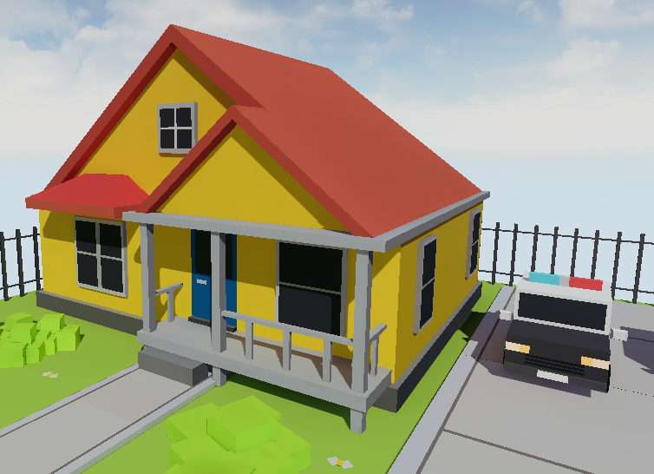

Figure : Standard Scene View

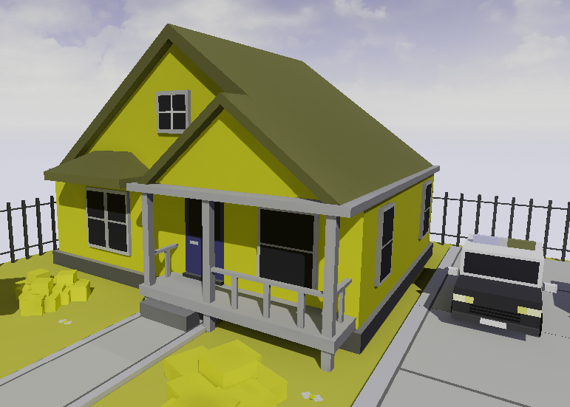

Figure : Protanopia Scene View

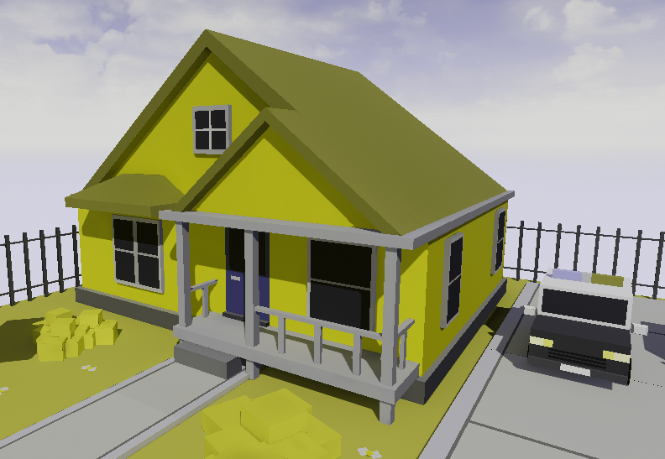

Figure : Deuteranopia Scene View

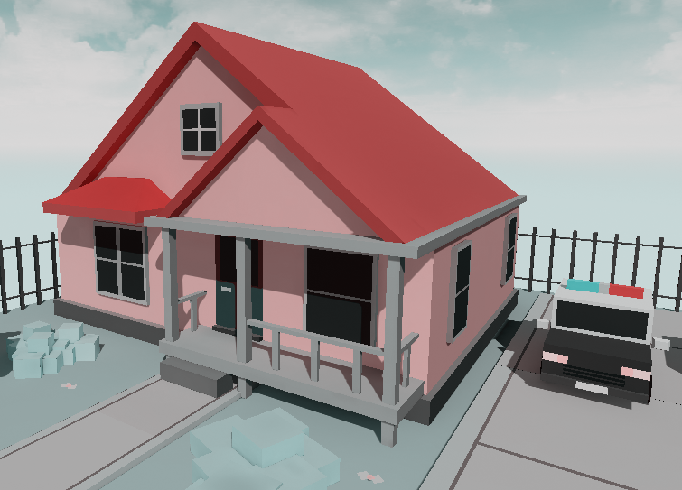

Figure : Tritanopia Scene View

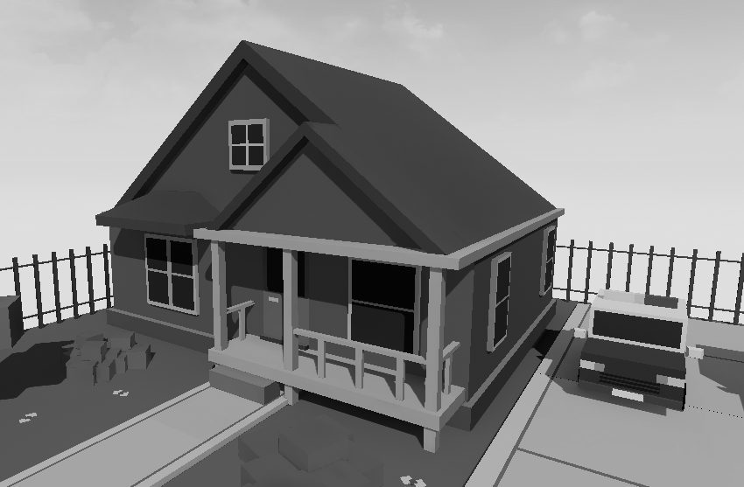

Figure : Achromatopsia Scene View

After implementing these Look Up Tables, I continued to search for more, as these only simulate Complete Colour-Blindness, however having a weakness of vision of a certain colour is up to 5 times more common than complete lack of vision of that colour (Colour Blind Awareness, 2019). Weakness of Colour detection is called -anomaly instead of -opia. For example, protanopia means that you cannot detect red colour, whereas Protanomaly means that you cannot detect a large amount of red. (Colblindor, 2001)



Figure : COBLIS Simulation of Protanomaly

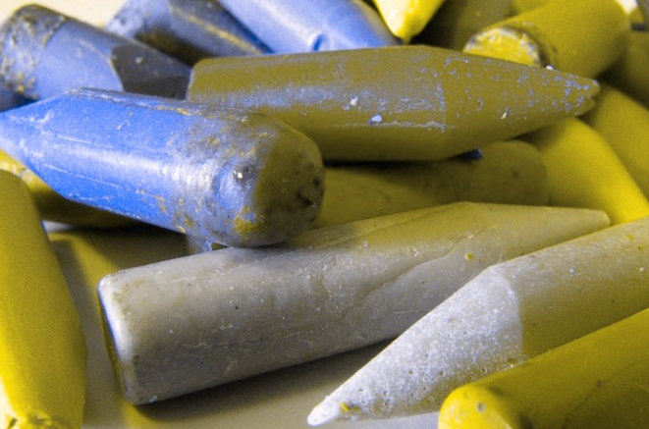

Figure : COBLIS Simulation of Protanopia

This led me to try and find LMS conversion matrices for the anomaly variants of Colour Blindness, however I was unable to find any that converted LMS, which I required for increased accuracy. However, from some matrices I found at (Lokno, 2014), I attempted to make some LUTs from RGB value, however, these were noticeably different to the ones that I had made from LMS values, and therefore I decided that I should keep to the LMS LUTs that I had previously made.

Unfortunately, after this the University got closed down due to the COVID-19 Pandemic, and I have since not had access to a Virtual Reality Headset. This has caused a multitude of issues, for example, I have been unable to properly test my Project and I am unable to evaluate my Project in the same way as before.

Since I have not had access to a Virtual Reality Headset with Eye-Tracking, I have been unable to implement the feature. I have also been unable to first-hand test some other features, such as the menu attached to the hand of the user. I have tested it in as many ways as possible but cannot be fully sure that the interaction with the menu will work completely.

I also looked into how to use “Stereo Layers” to produce an overlay for the user to simulate Visual Impairments such as Floaters and Diabetic Retinopathy, since these would be best simulated by having an image template with an example of the impairment in front of the camera. This would mean that the impairment would follow the user’s face, instead of being static in front of the user themselves. However, I followed many tutorials on how to add these, and as much as I did, they would not show up in the Simulate option inside of the Unreal Engine, so I cannot provide evidence that they did work, and I would not be able to test my users with those filters.

However, I did look into post process effects that I could make to simulate other impairments, these are materials that take in the information that the user is looking at and convert it. These are similar to how I intended to do the Colour-Blindness simulation at the start of the project. I added a simple Blur Post Process, since this loosely simulated Cataracts, which is a clouding of the retinas, causing a blur and slight white or yellow tint. The blur I made does not seem very strong from a third person perspective, but from the view of the user, it would be very noticeable.

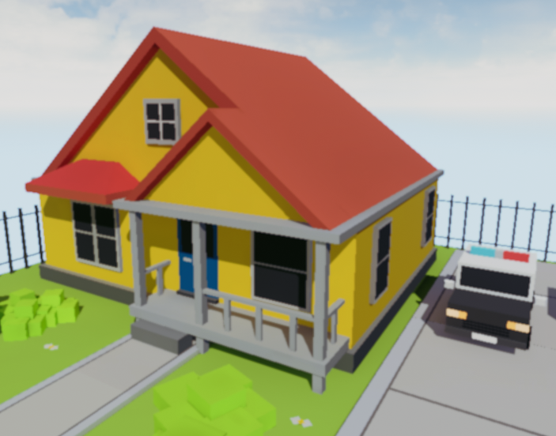

Figure : A simple approximation of Cataracts

I am also unable to give my simulation to any testers since I do not have a Virtual Reality Headset through which to show them the Simulation, nor can I get people to test it, if I did have a headset. This means I will be required to develop a new way of acquiring results for my Simulation.



RESULTS and DISCUSSION

Pre-Simulation Results

Figure : Question 1 Response

Figure : Question 2 Response

Figure : Question 3 Response

Figure : Question 4 Response

Figure : Question 5 Response

Figure : Question 6 Response

## Post-Simulation Results

Figure : Question 7 Response

Figure : Question 8 Response

Figure : Question 9 Response

Figure : Question 10 Response

Figure : Question 11 Response

## Analysis of Aims and Objectives

The aims for this project were to produce a Virtual Reality Simulator that could be used to increase the awareness and appreciation of users about Visual Impairments and the nature of them. I believe that I have achieved this, since I have created a Virtual Reality Simulator, and from my results, the testers understood the simulated Visual Impairments after the simulation, and most of the testers reported a stronger view on the nature of Visual Impairments.

I did also achieve all of my Objectives, however I did not simulate as many Visual Impairments as I would have hoped to, and I was unable to fully subject my testers into the virtual reality environment, so although I have mostly achieved my objectives, I do not personally believe that I achieved them strongly.



CONCLUSIONS and FUTURE WORK

## Conclusions

What the results conclude is that Visual Impairments are not very widely understood by the general populace and that it is an area that people could be educated more about. The results also show that a Virtual Reality Simulator, like the one I produced, is a valuable tool to educate people about the nature of Visual Impairments. Although my project was not as complete as I would have preferred, it works as a proof of concept that an application like this is very possible to create and could prove very useful in educating the population about Visual Impairments.

I do believe that throughout the Project, I have achieved everything that I set out to do. I managed to produce a Simulator, which when people viewed the simulation of Visual Impairments, their knowledge of Visual Impairments and their appreciation for the nature of them increased, which is what the project was meant to do, however I do believe that more Impairments are very possible to be simulated, and would only increase the effectiveness of the Visual Impairment Simulator.

I do consider this project a success, however I do believe that there is a lot more that was possible to add on that would make the project a lot better. Overall, I am pleased with my project but wish I was able to add more to it, as I know that doing so is very doable and would vastly increase the quality of the project.

## In Retrospect

If I were to redo this project, using the knowledge I now have, excluding situations that are out of my control, I would ensure that I would start the project sooner, and get through the initial stages faster, to allow me more time to gather and analyse results. This would let me draw a more accurate result. I would also spend more time per week on the project, to get a significant amount of the project done before the deadlines for my other projects, which caused significant delay in the progress of my project.

I would also produce backup video footage of Visual Impairments from my simulation in preparation for an event where I would not be able to demonstrate the Simulator to a tester with a Virtual Reality Headset.

## Future work

If I were to continue this project, I would attempt to acquire a Virtual Reality Headset so that I could develop more Simulated Visual Impairments, I would also invest time into learning how to utilise the Eye-Tracking features as it is a very new and interesting asset for programming for Virtual Reality and I believe that knowledge of using it would be a great asset for my future endeavours.

I would also add multiple environments for the user to experience, and attempt to make them realistic and recognisable, so that the user can instantly notice how things are different instead of having to learn and environment and then try and see how things are different whilst inside of the Simulation.

I would also like to add Aural Impairments to the Simulator, as they are also very possible to Simulate, they were not part of the original plan for this Project, however, I believe that they could also require more awareness, similar to Visual Impairments, and would benefit from an increase in awareness and understanding.

As a result of my Project, it is clear that the general populace are not very educated about Visual Impairments and their effects, which I believe should be more well known so that they can be more easily accounted for in the fields where accounting for people’s vision is important.

## Legal, Social, Ethical and Professional Issues

Any issues that may arise during my project should be monitored, as I should follow the British Computer Society (BCS) Code of Conduct (British Computer Society, 2015). However, BCS is not the only institute in the field of computing, so it would be advisable to also follow the Association for Computing Machinery Code of Ethics and Professional Conduct (Association for Computing Machinery, 2018)as well as the Institute of Electrical and Electronics Engineers’ Code of Conduct (Institute of Electrical and Electronic Engineers, 2014). The reason I should follow all of these, is due to the fact that if one society may have missed a certain topic, it is still an issue and should be addressed to as such.

“Have due regard for the legitimate rights of Third Parties” (British Computer Society, 2015), also “Ensure that you have the knowledge and understanding of the Legislation and you comply with such” (British Computer Society, 2015). The biggest issue would be the gathering and storing of user’s information, and specifically to follow the regulations of the Data Protection Act, 2018. Under the Data Protection Act, any person whose data I possess, has the right to know what it is being used for, the right to know what I hold, have incorrect data updated and to have data erased if wanted. I will follow this by explaining what the project is about and what conclusions I will be drawing, and what information shall be getting used in that. I will also provide any user with ways of contacting me if they require information updated or erased.

“Avoid harm … examples of harm include unjustified physical or mental injury” (Association for Computing Machinery, 2018). Since I am working in Virtual Reality there is a slight inherent risk for the user of the Simulation. Not being able to see and having greatly reduced other senses and awareness of the surroundings can result in risk to the user. I will ensure, with the user, that they are aware of the risk and that the area is as safe and with the lowest risk of harm possible. The risk cannot be removed; however, the user will be aware of it and is fully within their rights to not take part if they are not happy with the precautions.

An ethical issue would revolve around whether or not I should use stock assets or make my own, since if I were to use the assets that are for educational use, I would not be able to continue work on the system, unless I paid for the licenses, or took them out and made my own. Making my own would mean there would be none of those issues, however, it would take more time. I consider this project a proof of concept and would be willing to use premade assets as they would allow for more time to be spent on more time-consuming components.

## Synoptic Reflections

Throughout this Project, my ability and fluency with the Unreal Engine 4 has dramatically increased, as before this I had not used the Unreal Engine for very much. I also have gained a lot more experience with the process of how to produce products for Virtual Reality, which I expect to become a massive medium within the following years.

My planning and time management skills were also tested during this project, and I believe that they proved decent, however I could have managed my time better, with regards to my deadlines for other projects.

I also learnt that asking for assistance is important to do sooner rather than later. Most people will be willing to give some of their time to assist you, and it is important to get yourself out of a position where you don’t know how to continue as quick as possible, and delaying asking for help just means that its even harder to ask for assistance. This is something I will always remember with every other project I do in the future.

ReferenceS

Vogt, C. 1999. Creating Long Documents using Microsoft Word. Published on the Web at the Nottingham Trent University.

Altobelli, F., 2019. *ElectroOculoGraphy (EOG) Eye-Tracking for Virtual Reality.* Delft: Delft University of Technology.

Association for Computing Machinery, 2018. *Association for Computing Machinery Code of Ethics and Professional Conduct.* [Online]   
Available at: https://www.acm.org/code-of-ethics  
[Accessed 30 October 2019].

Brettel, H., Vienot, F. & Mollon, J. D., 1997. Computerized simulation of color appearance for dichromats. *Journal of the Optical Society of America A,* 14(10), pp. 2647-2655.

British Computer Society, 2015. *British Computer Society Code of Conduct.* [Online]   
Available at: https://cdn.bcs.org/bcs-org-media/2211/bcs-code-of-conduct.pdf  
[Accessed 30 October 2019].

Burdea, G. & Coiffet, P., 2003. *Virtual Reality Technology.* 2 ed. s.l.:John Wiley & Sons.

Colblindor, 2001. *Coblis — Colour Blindness Simulator.* [Online]   
Available at: https://www.color-blindness.com/Coblis-color-blindness-simulator/  
[Accessed 10 2019].

Colour Blind Awareness, 2019. *Types of Colour Blindness.* [Online]   
Available at: http://www.colourblindawareness.org/colour-blindness/types-of-colour-blindness/  
[Accessed 2019].

Epic Games Inc, 2020. *Hardware and Software Specifications.* [Online]   
Available at: https://docs.unrealengine.com/en-US/GettingStarted/RecommendedSpecifications/index.html  
[Accessed 20 3 2020].

FightForSight, 2019. *A-Z Eye Conditions.* [Online]   
Available at: https://www.fightforsight.org.uk/about-the-eye/a-z-eye-conditions/  
[Accessed 24 3 2020].

Goodman-Deane, J. et al., 2007. *Equipping Designers by Simulating the effects of Visual and Hearing Impairments.* Tempe, Proceedings of the 9th international ACM SIGACCESS conference of Computers and accessibility.

HTC, 2019. *HTC VIVE PRO EYE Product Page.* [Online]   
Available at: https://www.vive.com/uk/product/vive-pro-eye/  
[Accessed 26 3 2020].

Huebner, K. M., 2000. Chapter 2: Visual Impairments. In: M. Holbrook & A. Koenig, eds. *Foundations of Education: History and theory of teaching children and youths with visual impairments.* s.l.:American Foundation for the Blind, pp. 55-77.

Institute of Electrical and Electronic Engineers, 2014. *IEEE Code of Conduct.* [Online]   
Available at: https://www.ieee.org/content/dam/ieee-org/ieee/web/org/about/ieee_code_of_conduct.pdf  
[Accessed 30 October 2019].

ixora, 2019. *Colour Blindness Simulation Research.* [Online]   
Available at: https://ixora.io/projects/colorblindness/color-blindness-simulation-research/  
[Accessed 30 10 2019].

Korolov, M., 2014. The Real Risks of Virtual Reality. *Risk Management,* 61(8).

Krischer, D. C. C., 1983. Reading Speed under Real and Simulated Visual Impairment. *Journal of Visual Impairment and Blindness,* 77(8).

Lewis, J., Brown, D., Cranton, W. & Mason, R., 2011. *Simulating Visual Impairments using the Unreal Engine 3 game engine.* Braga, IEEE, pp. 1-8.

Lofti, A. & Garibaldi, J., 2004. *Applications and Science in Soft Computing.* 1 ed. s.l.:Springer-Verlag Berlin Heidelberg.

Lokno, 2014. *Colour Blindness Matrices.* [Online]   
Available at: https://gist.github.com/Lokno/df7c3bfdc9ad32558bb7  
[Accessed 11 2019].

Mealy, P., 2018. *Virtual & Augmented Reality For Dummies.* s.l.:John Wiley & Sons.

Tsoulfas, G., 2018. *Medical and Surgical Education: Past, Present and Future.* s.l.:InTech.

Weiss, P., Keshner, E. & Levin, M., 2014. *Virtual Reality for Physical and Motor Rehabilitation.* 1 ed. s.l.:Springer.

Wood, J., Chapparo, A., Carberry, T. & Chu, B. S., 2010. Effect of Simulated Visual Impairment on Nighttime Driving Performance. *Optometry and Vision Science,* 87(6), pp. 379-386.

Zuckerberg, M., 2018. Announcing Oculus Quest.

Bibliography

Vogt, C. 1999. Creating Long Documents using Microsoft Word. Published on the Web at the Nottingham Trent University.

Altobelli, F., 2019. *ElectroOculoGraphy (EOG) Eye-Tracking for Virtual Reality.* Delft: Delft University of Technology.

Association for Computing Machinery, 2018. *Association for Computing Machinery Code of Ethics and Professional Conduct.* [Online]   
Available at: https://www.acm.org/code-of-ethics  
[Accessed 30 October 2019].

Brettel, H., Vienot, F. & Mollon, J. D., 1997. Computerized simulation of color appearance for dichromats. *Journal of the Optical Society of America A,* 14(10), pp. 2647-2655.

British Computer Society, 2015. *British Computer Society Code of Conduct.* [Online]   
Available at: https://cdn.bcs.org/bcs-org-media/2211/bcs-code-of-conduct.pdf  
[Accessed 30 October 2019].

Burdea, G. & Coiffet, P., 2003. *Virtual Reality Technology.* 2 ed. s.l.:John Wiley & Sons.

Colblindor, 2001. *Coblis — Colour Blindness Simulator.* [Online]   
Available at: https://www.color-blindness.com/Coblis-color-blindness-simulator/  
[Accessed 10 2019].

Colour Blind Awareness, 2019. *Types of Colour Blindness.* [Online]   
Available at: http://www.colourblindawareness.org/colour-blindness/types-of-colour-blindness/  
[Accessed 2019].

Epic Games Inc, 2020. *Hardware and Software Specifications.* [Online]   
Available at: https://docs.unrealengine.com/en-US/GettingStarted/RecommendedSpecifications/index.html  
[Accessed 20 3 2020].

FightForSight, 2019. *A-Z Eye Conditions.* [Online]   
Available at: https://www.fightforsight.org.uk/about-the-eye/a-z-eye-conditions/  
[Accessed 24 3 2020].

Goodman-Deane, J. et al., 2007. *Equipping Designers by Simulating the effects of Visual and Hearing Impairments.* Tempe, Proceedings of the 9th international ACM SIGACCESS conference of Computers and accessibility.

HTC, 2019. *HTC VIVE PRO EYE Product Page.* [Online]   
Available at: https://www.vive.com/uk/product/vive-pro-eye/  
[Accessed 26 3 2020].

Huebner, K. M., 2000. Chapter 2: Visual Impairments. In: M. Holbrook & A. Koenig, eds. *Foundations of Education: History and theory of teaching children and youths with visual impairments.* s.l.:American Foundation for the Blind, pp. 55-77.

Institute of Electrical and Electronic Engineers, 2014. *IEEE Code of Conduct.* [Online]   
Available at: https://www.ieee.org/content/dam/ieee-org/ieee/web/org/about/ieee_code_of_conduct.pdf  
[Accessed 30 October 2019].

ixora, 2019. *Colour Blindness Simulation Research.* [Online]   
Available at: https://ixora.io/projects/colorblindness/color-blindness-simulation-research/  
[Accessed 30 10 2019].

Korolov, M., 2014. The Real Risks of Virtual Reality. *Risk Management,* 61(8).

Krischer, D. C. C., 1983. Reading Speed under Real and Simulated Visual Impairment. *Journal of Visual Impairment and Blindness,* 77(8).

Lewis, J., Brown, D., Cranton, W. & Mason, R., 2011. *Simulating Visual Impairments using the Unreal Engine 3 game engine.* Braga, IEEE, pp. 1-8.

Lofti, A. & Garibaldi, J., 2004. *Applications and Science in Soft Computing.* 1 ed. s.l.:Springer-Verlag Berlin Heidelberg.

Lokno, 2014. *Colour Blindness Matrices.* [Online]   
Available at: https://gist.github.com/Lokno/df7c3bfdc9ad32558bb7  
[Accessed 11 2019].

Mealy, P., 2018. *Virtual & Augmented Reality For Dummies.* s.l.:John Wiley & Sons.

Tsoulfas, G., 2018. *Medical and Surgical Education: Past, Present and Future.* s.l.:InTech.

Weiss, P., Keshner, E. & Levin, M., 2014. *Virtual Reality for Physical and Motor Rehabilitation.* 1 ed. s.l.:Springer.

Wood, J., Chapparo, A., Carberry, T. & Chu, B. S., 2010. Effect of Simulated Visual Impairment on Nighttime Driving Performance. *Optometry and Vision Science,* 87(6), pp. 379-386.

Zuckerberg, M., 2018. Announcing Oculus Quest.

Appendix A – GANTT CHART

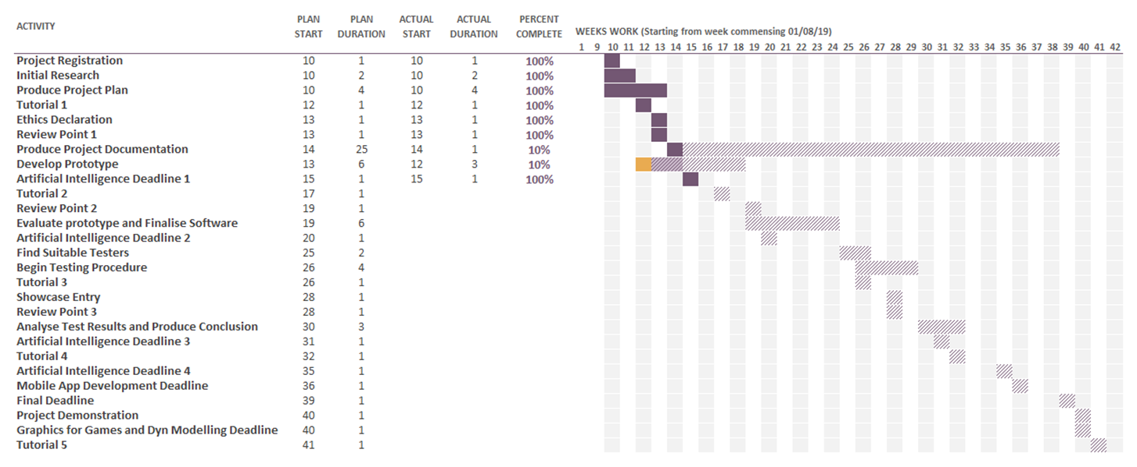

Appendix B – PRE-SImulator Questionnaire

1. Do you know of the following Visual Impairments?
   1. Colour-Blindness
   2. Glaucoma
   3. Cataracts
   4. Diabetic Retinopathy
   5. Age-related Macular Degeneration
   6. Myopia
   7. Retinitis Pigmentosa
   8. Eye Floaters, or Myodesopsias
2. On a scale of 1 to 5, How well do you believe you could explain the symptoms of the following Visual Impairments?
   1. Colour-Blindness
   2. Glaucoma
   3. Cataracts
   4. Diabetic Retinopathy
   5. Age-related Macular Degeneration
   6. Myopia
   7. Retinitis Pigmentosa
   8. Eye Floaters, or Myodesopsias
3. How often do you hear about the following Visual Impairments?
   1. Colour-Blindness
   2. Glaucoma
   3. Cataracts
   4. Diabetic Retinopathy
   5. Age-related Macular Degeneration
   6. Myopia
   7. Retinitis Pigmentosa
   8. Eye Floaters, or Myodesopsias
4. Do you believe that, in general, Visual Impairments are talked about enough?
   1. Yes
   2. No
5. Do you believe that, in general, People are well informed about Visual Impairments, and how to help those affected by them?
   1. Yes
   2. No
6. Do you believe that experiencing Visual Impairments in a Simulator would change your view on them?
   1. Yes
   2. No

Appendix C – POst-SImulator Questionnaire

1. On a scale of 1 to 5, How well do you believe you could now explain the symptoms of the following Visual Impairments?
   1. Colour-Blindness
   2. Cataracts
2. Has experiencing the Simulator changed your view on Visual Impairments?
   1. A lot
   2. A little
   3. Not at all
3. Do you think that there needs to be more education the effects of Visual Impairments?
   1. Yes
   2. No
4. Do you think that experiencing the Visual Impairments inside of a simulator makes them easier to understand than just seeing prerendered images?
   1. Yes
   2. No
5. Do you think that a Simulator like this one has a place in educating people about Visual Impairments, or not?
   1. Strongly Yes
   2. Slightly Yes
   3. Neither Yes nor No
   4. Slightly No
   5. Strongly No

Appendix D – testing table

Notes:

Due to lack of a Virtual Reality Headset, Testing has to be done using the “Simulate” Option inside of Unreal Engine 4, so in this section, “Simulation” refers to the instance of the project currently running.

|  |  |  |
| --- | --- | --- |
| **Tested Action** | **Expected Result** | **Actual Result** |
| Simulation can be started with Colour-Blind LUT activated | Environment will simulate Colour-Blindness | Environment simulates Colour-Blindness, tested with all LUTs |
| Simulation started without LUT, then LUT chosen using delayed code of Instanced widget | Environment starts without any LUT, then changes to chosen LUT | Environment starts without any LUT, then changes to chosen LUT, tested with all LUTs |
| Simulation started with LUT, then LUT disabled using delayed code from Instanced Widget | Environment starts with chosen LUT, then LUT disabled, showing normal perspective | Environment starts with chosen LUT, then LUT disabled, showing normal perspective, tested with all LUTs |
| Simulation started with LUT, then LUT chosen using delayed code from Instanced Widget | Environment starts with chosen LUT, then LUT changed, showing new perspective | Environment starts with chosen LUT, then LUT changed, showing new perspective, tested with all LUTs |
| Simulation started without LUT and then switched to simulating Cataracts | Environment starts with no LUT, then LUT disabled, showing blurred perspective | Environment starts with no LUT, then LUT disabled, showing blurred perspective |
| Simulation started without LUT and then switched to simulating Cataracts | Environment starts with chosen LUT, then LUT disabled, showing blurred perspective | Environment starts with chosen LUT, then LUT disabled, showing blurred perspective |

Appendix E – Unreal Engine project

I have also attached inside of the same ZIP file as this report, the Unreal Engine Project of the Simulator that I made. It is named “FYPSimulatorV0”.

Appendix E – PRocessing Colour-Blindness converter

I have also attached inside of the same ZIP file as this report, the Processing3 code that I used to produce the LUTs that I used to simulate the Colour-Blindness. It is named “Colour_Blindnes_Sim_2_Photo”.