

Module | Portfolio | Assessment Type
Collaborative Development (5CS024) | 2 | Individual Report

Expense Tracker App (ETA) – Business Analyst

Student ID: [2408239]
Student Name: [Nikisha Shrestha]
Section: [L5CG15]
Group: [L5CG15 C]
Module Leader: Yogesh Bikram Shah
Acknowledgement

I am very grateful to everyone who supported us in finishing the report and creating our Expense Tracker Application – Hamrosewa.

First and foremost, I would like to thank my tutor, Mr. Bhanu Aryal, whose support and guidance led to the development of a polished software. Through his insights and experience over the years, we could organize our work well and focus on fulfilling the project’s objectives and what learners needed to learn.

Next, I would like to express my thanks to Herald College Kathmandu and the University of Wolverhampton for giving me the necessary resources to achieve the project’s goals. The information from software development, agile methodology, and user-centered design modules was vital to the project’s success.

Furthermore, I would like to extend my gratitude towards my team members – Dehan Wanem, Sisham Maharjan, Prayas Shrestha, Arun Rana, and Karuna Tachamo, whose dedication and hard work led to the completion of this project. As all the team members contributed to the project in their own way, this project was considered successful. I am especially grateful to our Project Manager, Dehan Wanem, for organizing everything swiftly and making sure we communicate smoothly during every sprint.

Similarly, I am grateful towards online tutorials, guidelines that helped me upskill in tools such as Jira, Figma, and Lucid chart. They helped us change theoretical ideas into a mobile application that is easy to use.

Overall, I would like to extend my gratitude towards all those that helped in the completion of this project.

Table of Contents

Self-appraisal form 1
Personal objectives – performance measurement 1
Evidence of good collaboration 3
Good communication and file sharing 3
Continuing Personal Development (CPD) 4
Issue tracking 6
Work to deadlines 6
Appendix A 7
Functional Requirements and Design 7
Product Backlog 7
List of Requirements 10
Design 13
Use Case Diagram 13
Activity Diagram 18
ERD (Entity Relationship Diagram) 26
Wireframes (Figma Design) 27
Appendix B 28
Functional Testing 28
Test Report 33
Appendix C 38
Evidence of Good Communication and File Sharing 38
Evidence of Continuing Personal Development (CPD) 41
Evidence of Issue Tracking 42
Appendix D 44
Sprint Retrospective 44
References 48

Table of Figures
Figure 1: Functional Decomposition Diagram (FDD) 10
Figure 2: UD-User Authentication & Authorization 13
Figure 3: UD-Smart Transaction Suggestions 14
Figure 4: UD-Data Export (PDF) 15
Figure 5: Information Sector 16
Figure 6: User Profile Customization 17
Figure 7: AD-Sign-in with Google 18
Figure 8: AD-PIN Setup 20
Figure 9: AD-Smart Transaction Suggestions 22
Figure 10: AD-Data Export (PDF) 24
Figure 11: AD-Information Sector 24
Figure 12: AD-User Profile Customization 25
Figure 13: Entity Relationship Diagram (ERD) 26
Figure 14: Wireframes/Figma Design 27
Figure 15: Functional Testing-Index 28
Figure 16: Functional Testing-TestCase Data 28
Figure 17:Functional Testing-User Authentication (1) 29
Figure 18:Functional Testing-User Authentication (2) 29
Figure 19:Functional Testing-User Authentication (3) 29
Figure 20:Functional Testing-User Authentication (4) 30
Figure 21:Functional Testing-Core Features (1) 30
Figure 22:Functional Testing-Core Features (2) 30
Figure 23:Functional Testing-Core Features (3) 31
Figure 24:Functional Testing-Extra Features (1) 31
Figure 25:Functional Testing-Extra Features (2) 32
Figure 26:Functional Testing-Extra Features (3) 32
Figure 27: Task management via Jira 38
Figure 28: Communication via Discord 38
Figure 29: Online meeting via Google Meet 39
Figure 30: File Sharing 40
Figure 31: Collaboration via Github 40
Figure 32: Issued Bugs 42
Figure 33: Snapshot of an Individual Bug 43
Figure 34: Sprint Retrospective Questionnaire (1) 46
Figure 35: Sprint Retrospective Questionnaire (2) 48

Self-appraisal form
Student number | 2408239 | Name | Nikisha Shrestha
Project | Expense Tracker App (ETA) | Date | 20th May, 2025
Role | Business Analyst (BA) | Team | L5CG15 (C)
Sprint | Sprint 2

Personal objectives – performance measurement
Objectives | Evidence provided  (E.g., appendix A, file name, etc.) | Evaluation  Student/tutor
Functional Requirements and Design | This section covers all the files and blueprints required for Sprint 2. In the documentation part, you will find the product backlog and the functional, non-functional, and usability requirements. Similarly, you can find the use case diagram, activity diagram, Entity Relationship Diagram (ERD), and a UI design made in Figma in the design section. Appendix A | 7/10 | /10
Tutor feedback:

Functional Testing | This section covers the functional testing of the final software, and a detailed bug report is created along with its solutions.  Appendix B | 8/10 | /10
Tutor feedback:

Collaboration Document | This section comprises three major components. First, this section describes good communication and file sharing, discussing the communication methods and file-sharing tools that we used. Similarly, this part also details how we as a group have effectively collaborated to complete a software, the difficulties we faced during this phase, and the positive aspects of collaborative development. Second, this section talks about continuing personal development, which includes my journey throughout the development of the application. It emphasizes the role of the project in my development, pointing out the personal improvements I noticed after the project was completed and how I have been contributing to my personal growth throughout the project. Third, this section dives into issue-tracking methods used to find and resolve bugs found during the testing phase.  Appendix C | 14/15 | /15
Tutor feedback:

Sprint Retrospective | This section comprises the final phase of our sprint–sprint retrospective, where all of the team members filled out the questionnaire prepared by our Project manager. The questions focused on reflecting the overall journey of the project, including what went well, the challenges we faced, and what could have been improved during the sprint.  Appendix D | 5/5 | /5
Tutor feedback:

 |  | 34/40 | /40

Evidence of good collaboration

Good communication and file sharing
Unlike Sprint-1, where we had some difficulties adapting to new tools like Jira, Sprint-2 went well due to our prior knowledge and experience. The flow of the development process was quite smooth this time.
Like Sprint 1, we continued using Jira as a collaboration tool in Sprint 2, but it was utilized more efficiently this time. The epic, story, sub-tasks, and story points were assigned at the beginning of the sprint. After assigning tasks, the design was completed quickly, and the developers started working on the application according to the tasks assigned to each. Similarly, we continued using Discord as a primary means of file sharing throughout sprint 2, just like in the previous sprint.

If I had to point out a certain difficulty we faced during sprint 2, I would say that the integration of the application at the end of the sprint was quite troublesome.
Appendix C

Continuing Personal Development (CPD)
With Sprint 2, I had the chance to advance my abilities and increase my knowledge of being a Business Analyst in an agile project. Thanks to what I had done in Sprint 1, I could now approach gathering requirements, handling tasks, and aiding the team’s progress in delivering the mobile application with greater confidence.

I improved my use of Jira a lot during Sprint 2. Unlike Sprint 1, I was able to use the tool well and handle epics, user stories, and subtasks efficiently this time. I made sure to clarify tasks and organize them according to the project’s priorities in the product backlog. I was involved in tracking the development of tasks and bugs, which made the work process more transparent for everyone. As a result, I improved at organizing complex materials and realized how important it is to have a sprint backlog for each sprint.

Similarly, I worked very closely with both the development and design teams throughout Sprint 2. Although the Project Manager conducted the daily standups, I took part in all the team discussions and meetings that were held on Discord. Thanks to this, I could clearly describe what was required and clarify the information needed for the developers to do their job well. Gradually, I became confident in asking precise questions and offering constructive feedback, which helped minimize confusion between team members. This helped me realize the importance of open communication.

During Sprint 2, there were problems with integration, and I learned a lot from this experience. I was not personally involved in coding or resolving bugs, but I saw that it is not easy to integrate all the different areas of the application. My role involved conducting functional testing on the integrated software and logging the bugs encountered during this phase in Jira for the developers to handle. As a result, I was able to understand more aspects of software development beyond just requirement gathering.

Like Sprint 1, I continued contributing to the UI/UX design process using Figma. Because of what I learned in other courses and sprint 1, I was able to help turn user stories into easy-to-use interface designs. Furthermore, I kept track of how well the application’s user experience matched the goals and requirements of the project stakeholders. I learned that for a product to be successful, analysis and design should always be handled together.

During sprint 2, emphasis was placed on time management. I saw to it that all requirement gathering and designing were finished promptly, so developers could keep working without interruption. It was made possible by having tasks assigned and keeping regular contact with the team and the Project Manager. Furthermore, I gained insights into effective leadership by observing how well our PM conducted daily stand-up meetings and coordinated everyone.

Overall, Sprint 2 was a phase of steady growth and increased confidence. I developed better skills at overseeing requirements, communicating with other team members, and helping with the development process. As a result, I am even more dedicated to being a Business Analyst and understand the importance of keeping my skills up to date, working as a team, and being adaptable in any project environment.
Appendix C

Issue tracking
We used Jira as a tool to log and manage bugs. As a Business Analyst, I conducted functional testing on the integrated software. The bugs identified during the testing phase were issued in Jira as a ticket, which I then assigned to all the developers accordingly.
Appendix C

Work to deadlines
In Sprint 2, we maintained our structured approach to meeting deadlines. Three physical meetings were organized to discuss progress, resolve issues, and help everyone continue working on schedule. Furthermore, daily stand-up meetings were conducted that lasted approximately 15 minutes. They were key to identifying all tasks and encouraging everyone on the team to be responsible.

As a Business Analyst, I ensured that all mid-phase tasks – including requirements gathering, documentation, and UI/UX adjustments were completed on time. This helped the development team to proceed without delays, maintaining a steady workflow throughout the sprint.

We kept using Jira for tracking our tasks and managing bugs. The tasks were regularly updated, and we checked their progress to make sure they were delivered on time.

Sticking to deadlines helped us maintain our momentum and avoid any last-minute rushes. As a result, we were able to develop a working software within the dedicated timeline.

Appendix A

Functional Requirements and Design

Product Backlog
Issue Type | Issue ID | Summary | Description | Priority | Status | Story Points
Story | EXP-114 | Sign in with Google | As a user, I want to access the app quickly through my Google account, so that I can access the app without creating a new password.  Acceptance Criteria  *Google OAuth login  *Redirects to home on login  *Shows error on cancel/failure  *Prompts registration if the account is not linked | High | In Progress | 3
Story | EXP-201 | Smart Transaction Suggestions from SMS | As a user, I want the app to monitor bank-related SMS and suggest adding transactions so that I can log them easily without manual entry.  Acceptance Criteria  *App requests permission to read SMS (user consent)  *Monitors incoming/outgoing SMS from banks/payment services  *Extracts amount, date, and merchant details from the SMS  *Sends a notification to the user prompting “Do you want to add this transaction?”  *The user can either confirm/cancel the transaction. | High | In Progress | 3
Story | EXP-205 | Data Export (PDF) | As a user, I want to export my financial data to a PDF such that I can keep a record or share it with others in a well-formatted document.  Acceptance Criteria  *Users can select specific data to export.  *Data is formatted into a clean, readable PDF format (tables, headings, etc.)  *PDF can be saved. | High | In Progress | 2
Story | EXP-210 |  | As a user, I want to customize my profile by editing my avatar & nickname and deleting my account if needed, so that I can manage my account.  Acceptance Criteria  *Users should be able to edit their avatars  *Users should be able to edit their username  *Users should be able to permanently delete their account  *After deletion, the user should be redirected to the sign-in/register/sign-in with Google page. | High | In Progress | 2
Story | EXP-216 | Settings | As a user, I want the option of enabling a 4-digit PIN when I open the app so that I can securely access my data & ensure privacy.  Acceptance Criteria  *Users should be able to set up a 4-digit PIN | High | In Progress | 1

List of Requirements
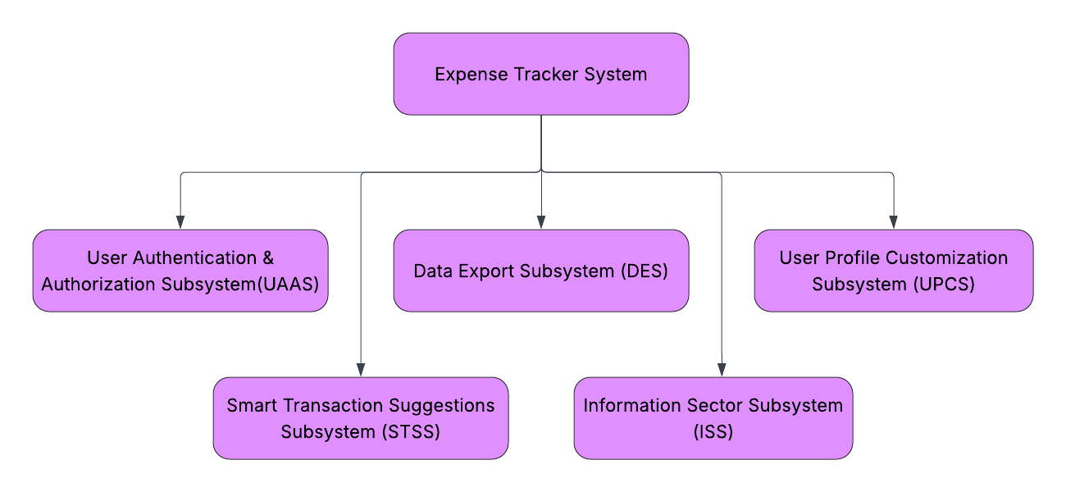
Figure 1: Functional Decomposition Diagram (FDD)
User Authentication & Authorization Subsystem (UAAS)
Req. Code | Req. Description | Use Case
UAAS-F-3.0[EXP-114] | The system should allow users to log in using their Google Account through the Google OAuth process. | Sign in with Google
UAAS-NF-3.1 | The Google OAuth login should comply with Google OAuth 2.0 security standards.
UAAS-UR-3.2 | If the user cancels the sign-in process, the system must display user user-friendly message such as ‘Sign in cancelled by user’.
UAAS-F-6.0[EXP-216] | The app must allow the user to set up a 4-digit PIN. | Set PIN
UAAS-NF-6.1 | The PIN must be securely stored using device-level encryption to prevent unauthorized access.
UAAS-UR-6.2 | The entered PIN must be visually masked to protect user privacy during input.

Smart Transaction Suggestions Subsystem (STSS)
Req. Code | Req. Description | Use Case
STSS-F-1.0[EXP-201] | The app must monitor the incoming and outgoing SMS from the bank, extract merchant details, amount, and date, and prompt the user asking, “Do you want to add this transaction?” | Extract Transaction details
STSS-NF-1.1 | The app must request explicit user consent to SMS messages and handle transactions securely, ensuring compliance with data protection regulations.
STSS-UR-1.2 | The app must display a clear notification to the user with the extracted transaction details, offering an option to either confirm or cancel transaction logging in an easily understandable manner.

Data Export Subsystem (DES)
Req. Code | Req. Description | Use Case
DES-F-1.0[EXP-205] | The system must allow the user to select specific financial data and convert it into a PDF with clearly formatted documents, including tables and headings. | Generate PDF
DES-NF-1.1 | The exported PDF must be ready within 3 seconds.
DES-UR-1.2 | The export interface should provide the user with dropdowns and must be completed within 3 clicks.

Information Sector Subsystem (ISS)
Req. Code | Req. Description | Use Case
ISS-F-1.0 [EXP-208] | The system shall provide an ‘Information Sector’ section where users can read full-length financial management blogs. | Read the Full article
ISS-NF-1.1 | The system shall update its contents every 7 days.
ISS-UR-1.2 | The user shall be able to open blogs within 2 clicks.

User Profile Customization Subsystem (UPCS)
Req. Code | Req. Description | Use Case
UPCS-F-2.0 [EXP-210} | The system must allow user to update their username, profile picture & permanently delete their account. | Edit avatar, nickname & Delete account Operation
UPCS-NF-2.1 | Account deletion procedure shall be processed, and the user redirected to the sign-in/register/sign-in with Google page within 3 seconds.
UPCS-UR-2.2 | The avatar editing, nickname editing, and account deletion operations must be displayed in a well-organized layout and must be completed within 2 steps.

Design

Use Case Diagram
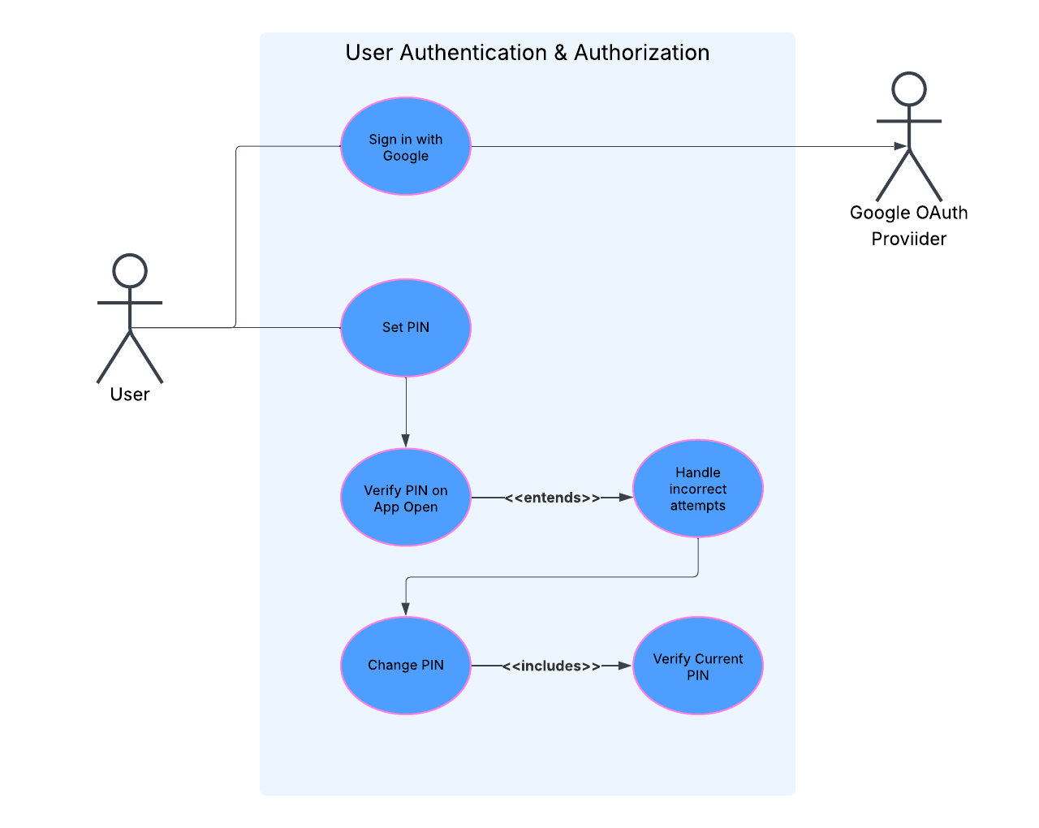
Figure 2: UD-User Authentication & Authorization
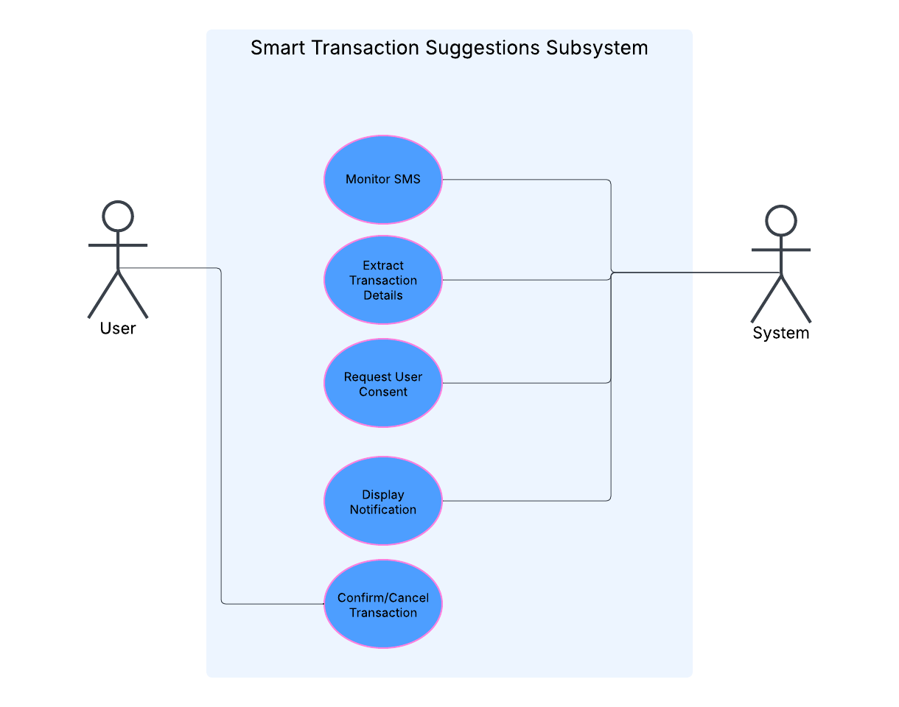
Figure 3: UD-Smart Transaction Suggestions
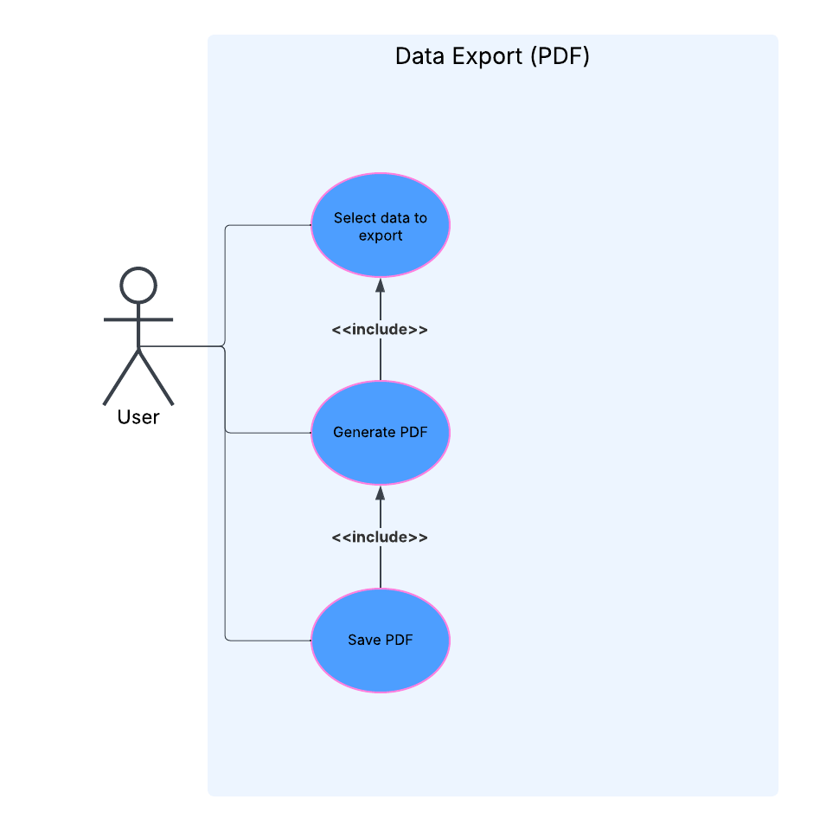
Figure 4: UD-Data Export (PDF)
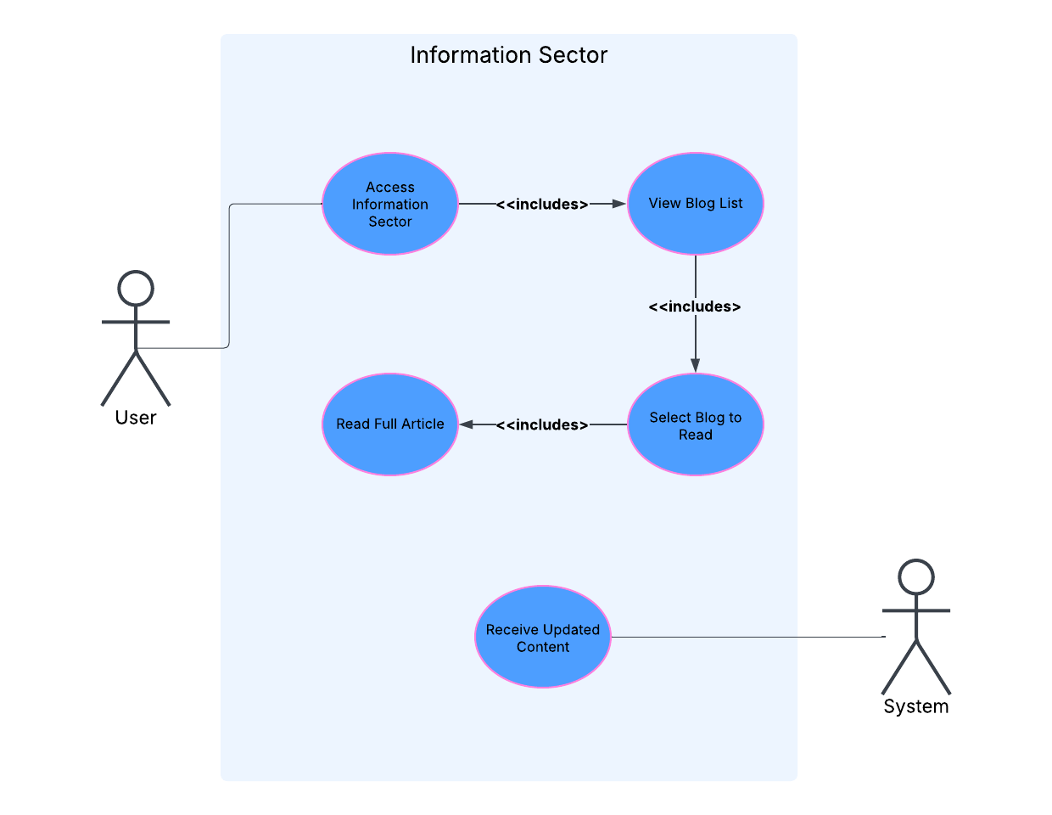
Figure 5: Information Sector
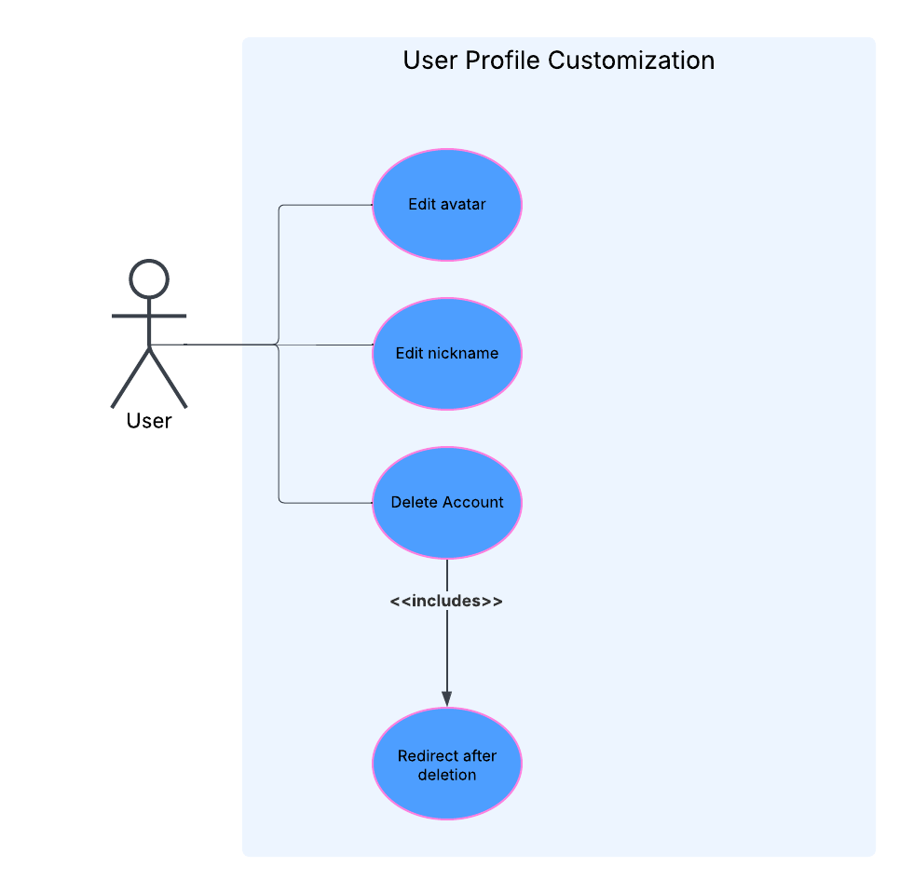
Figure 6: User Profile Customization

Activity Diagram
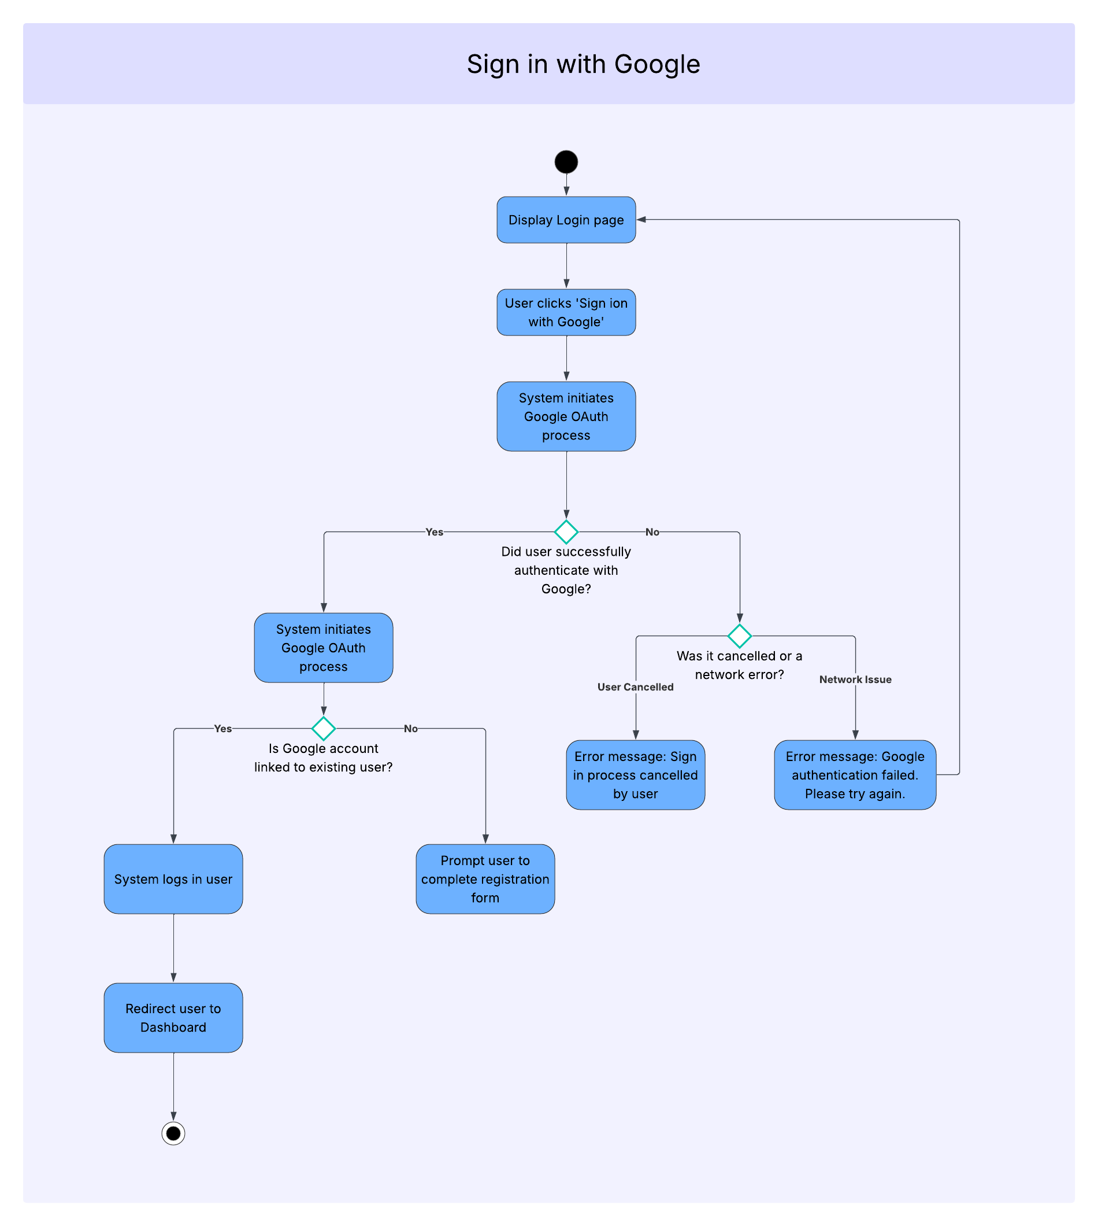
Figure 7: AD-Sign-in with Google
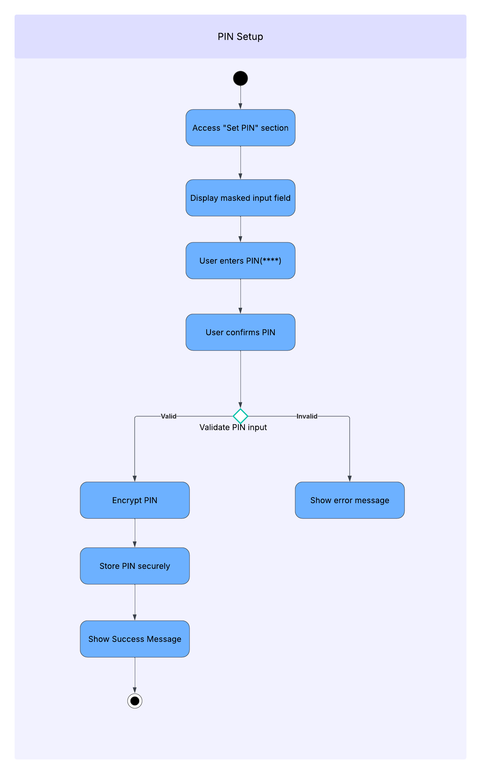
Figure 8: AD-PIN Setup
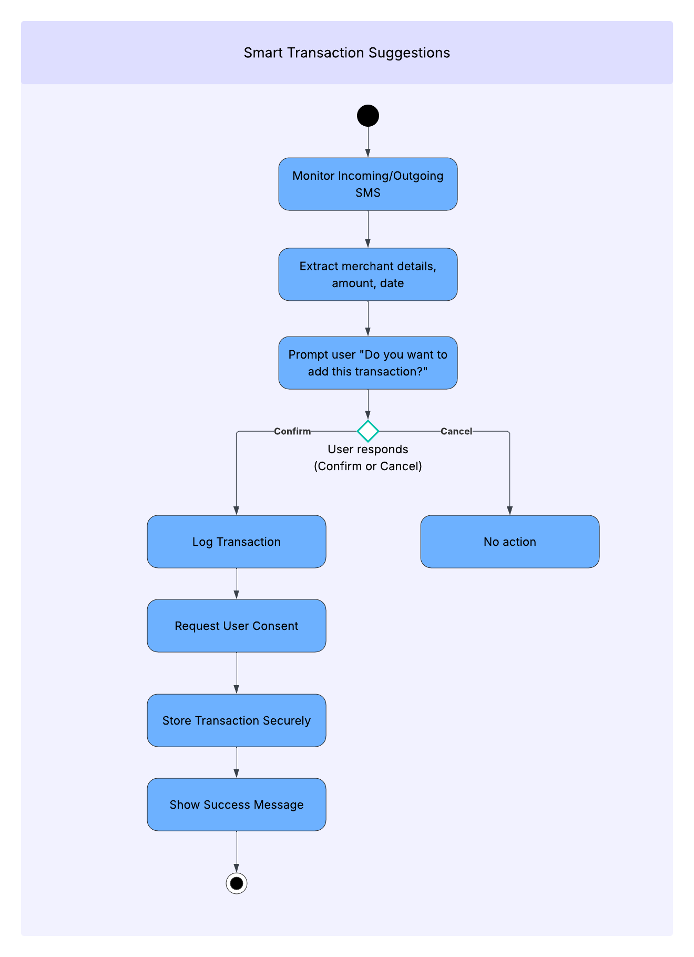
Figure 9: AD-Smart Transaction Suggestions
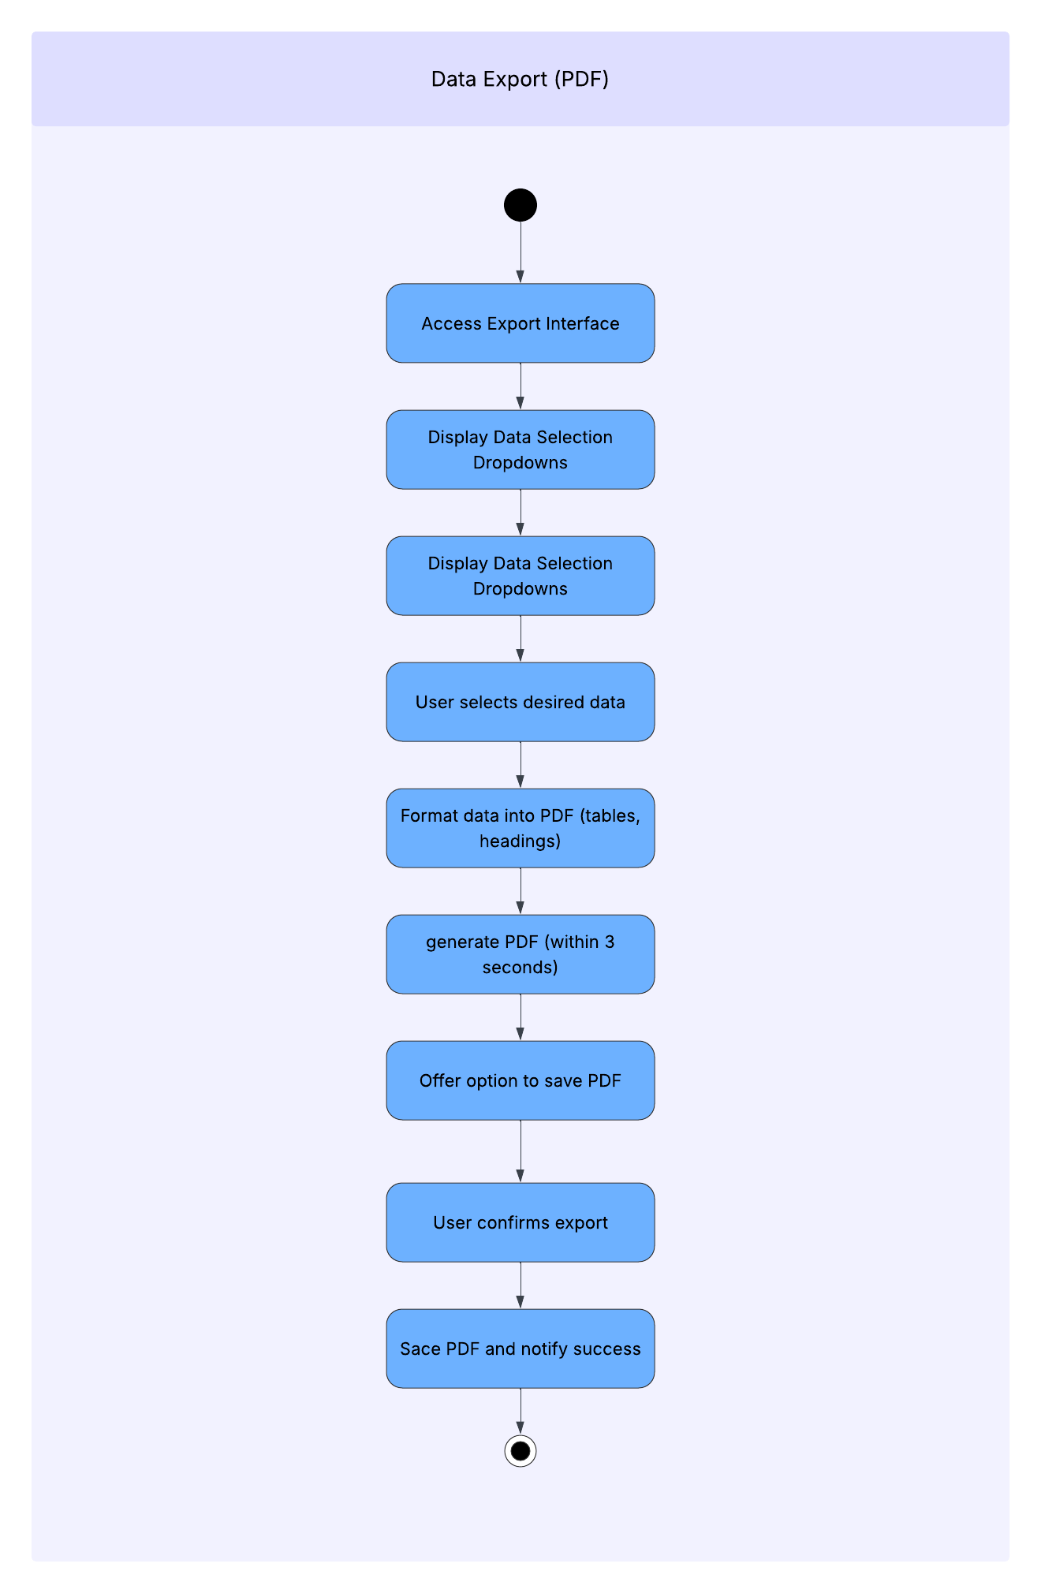
Figure 10: AD-Data Export (PDF)
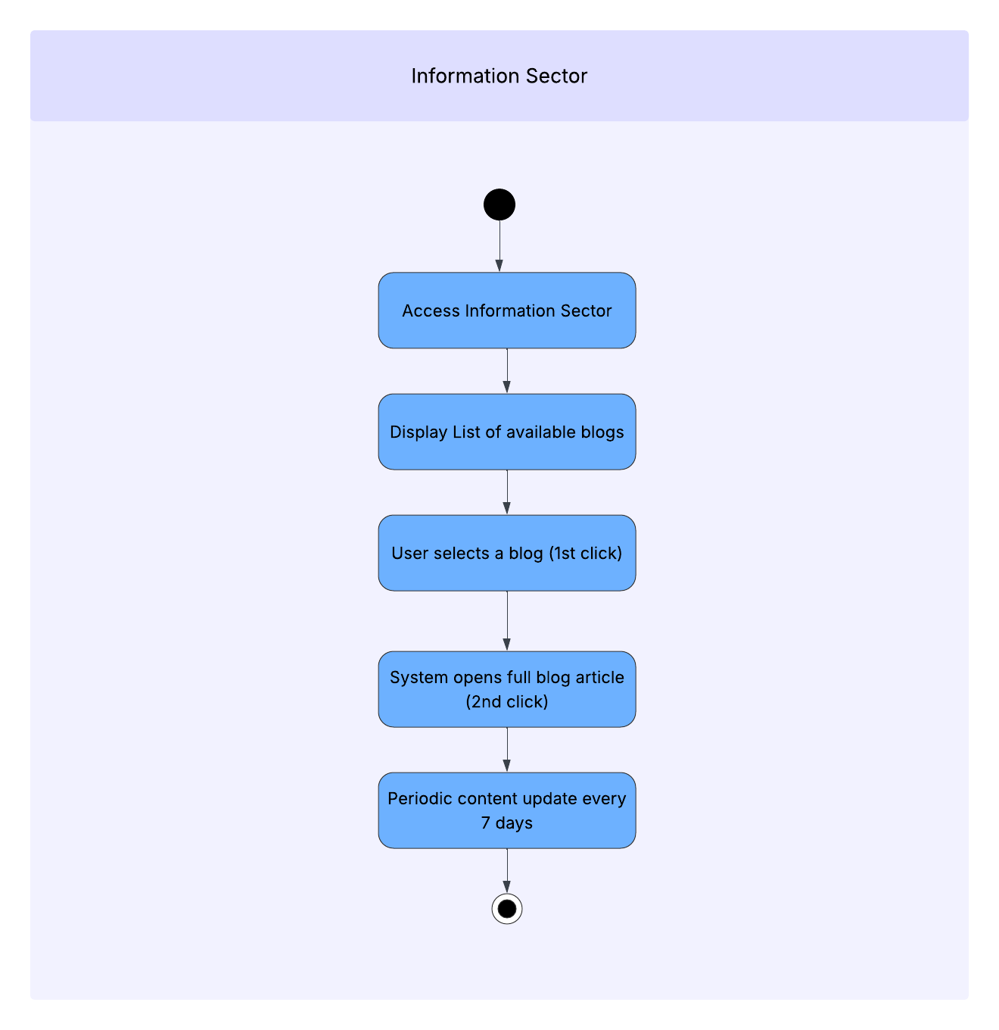
Figure 11: AD-Information Sector
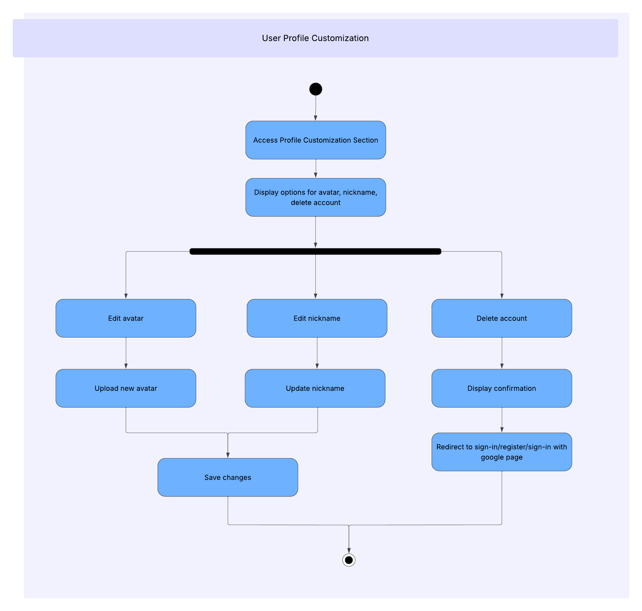
Figure 12: AD-User Profile Customization

ERD (Entity Relationship Diagram)
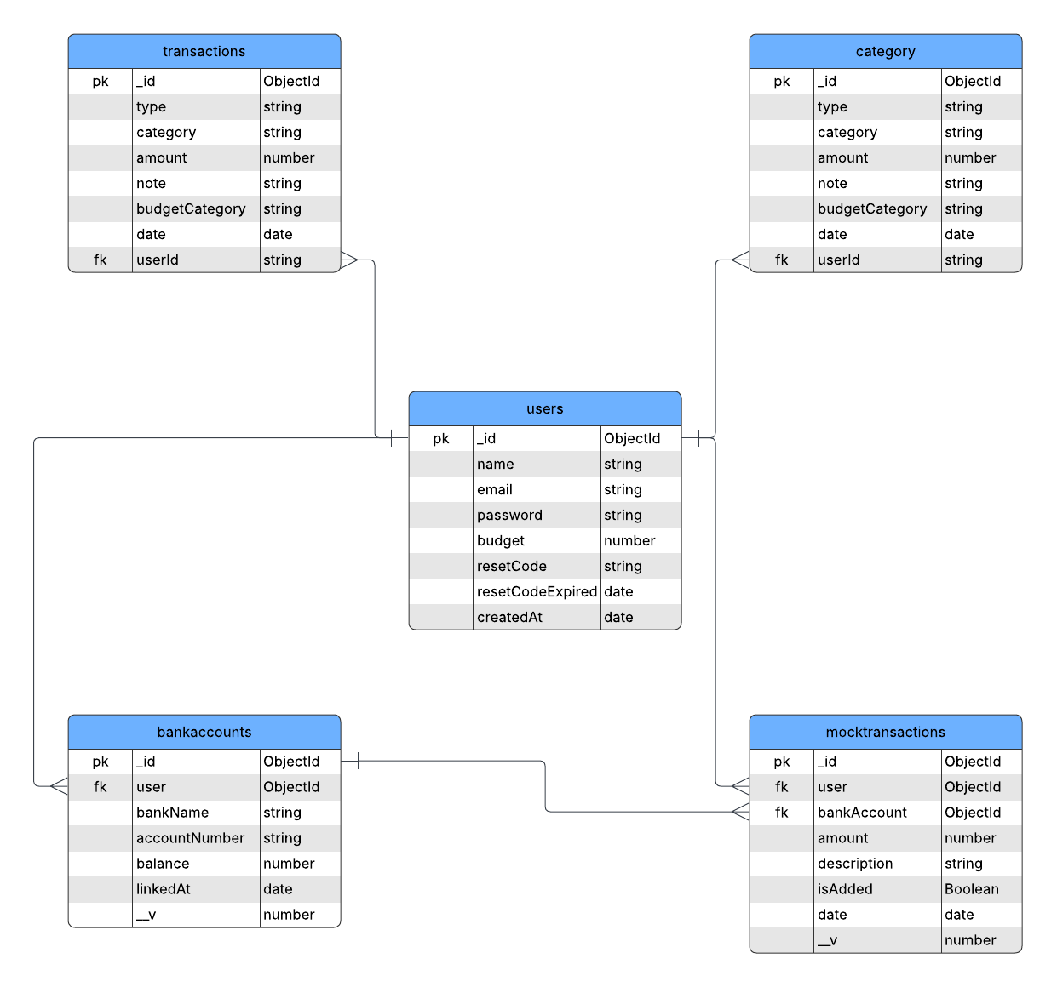
Figure 13: Entity Relationship Diagram (ERD)

Wireframes (Figma Design)
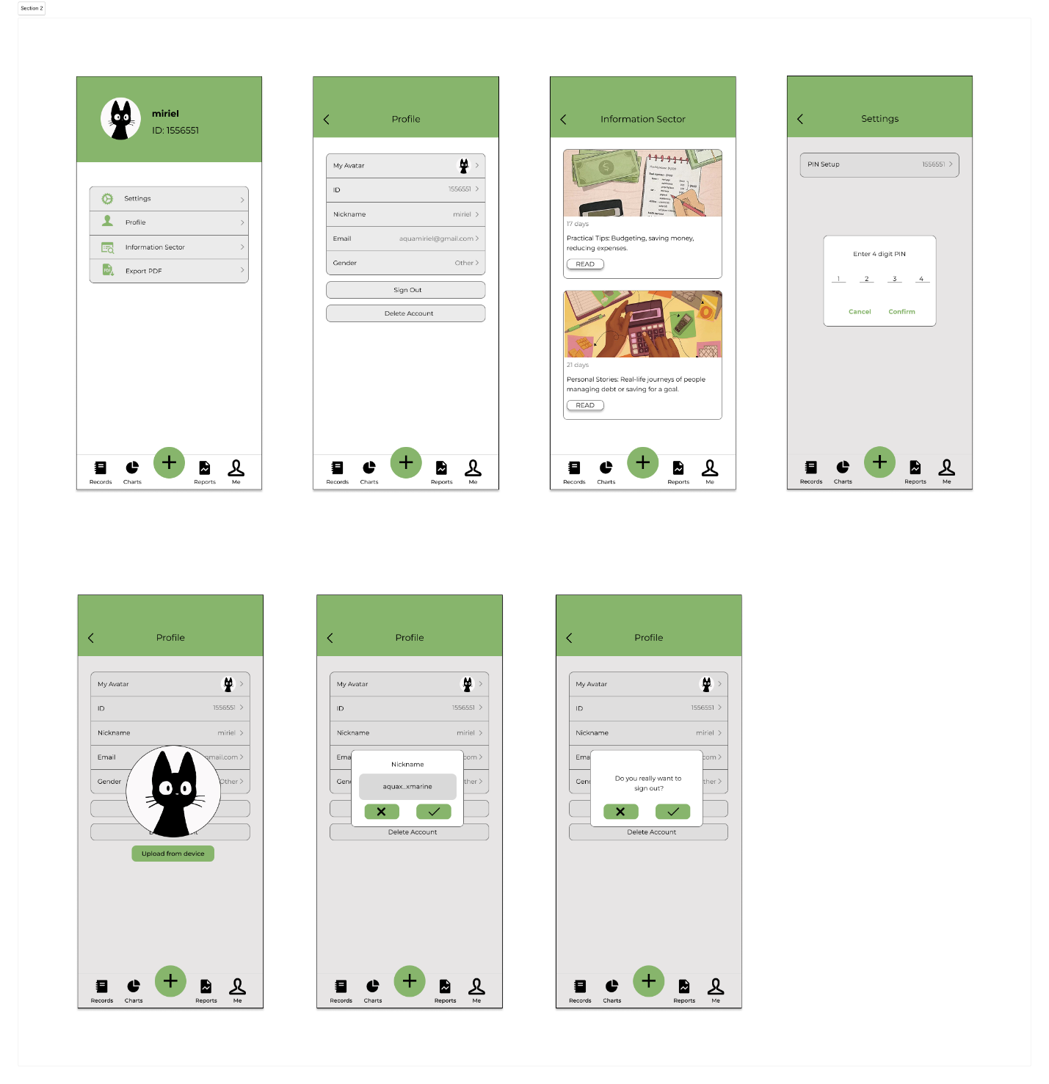
Figure 14: Wireframes/Figma Design

Appendix B

Functional Testing

Index
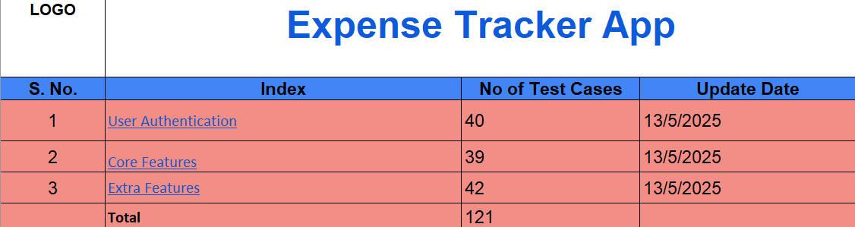
Figure 15: Functional Testing-Index
TestCase Data
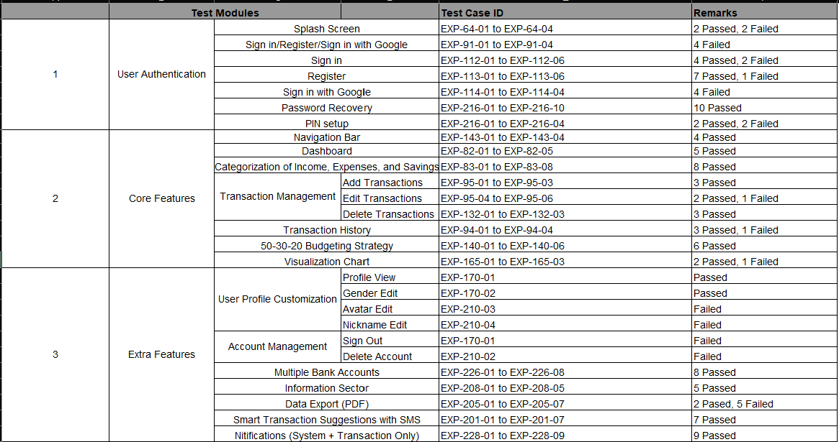
Figure 16: Functional Testing-TestCase Data
Test cases – User Authentication
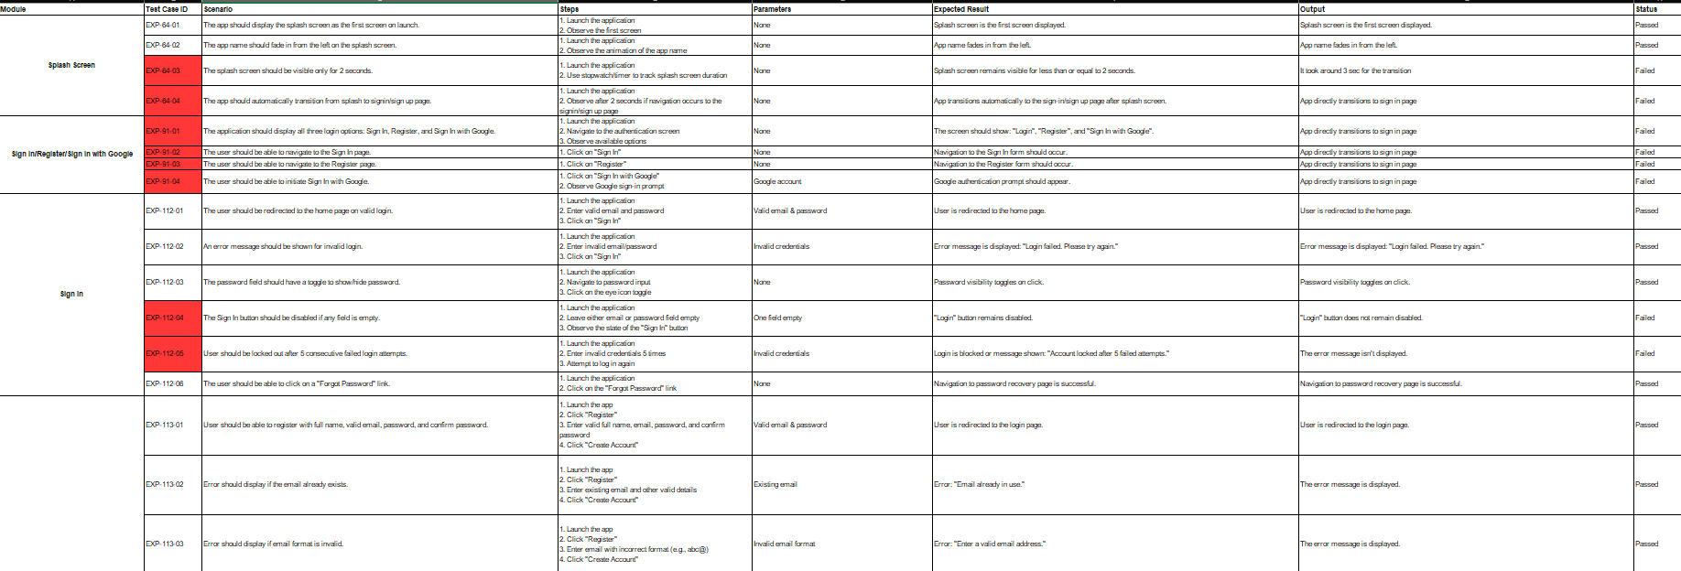
Figure 17:Functional Testing-User Authentication (1)
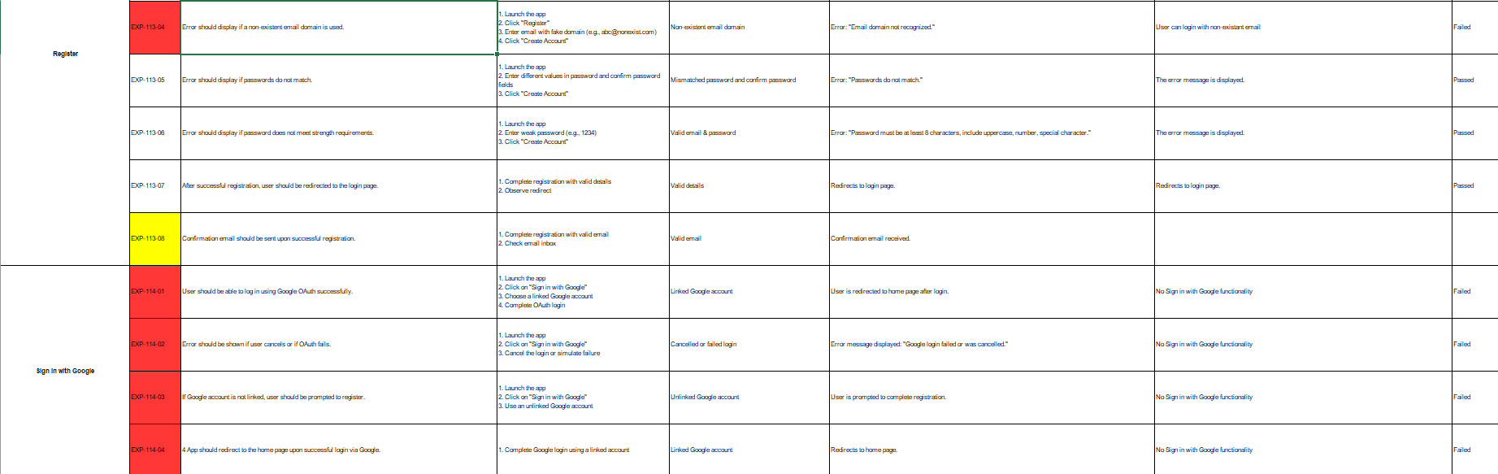
Figure 18:Functional Testing-User Authentication (2)
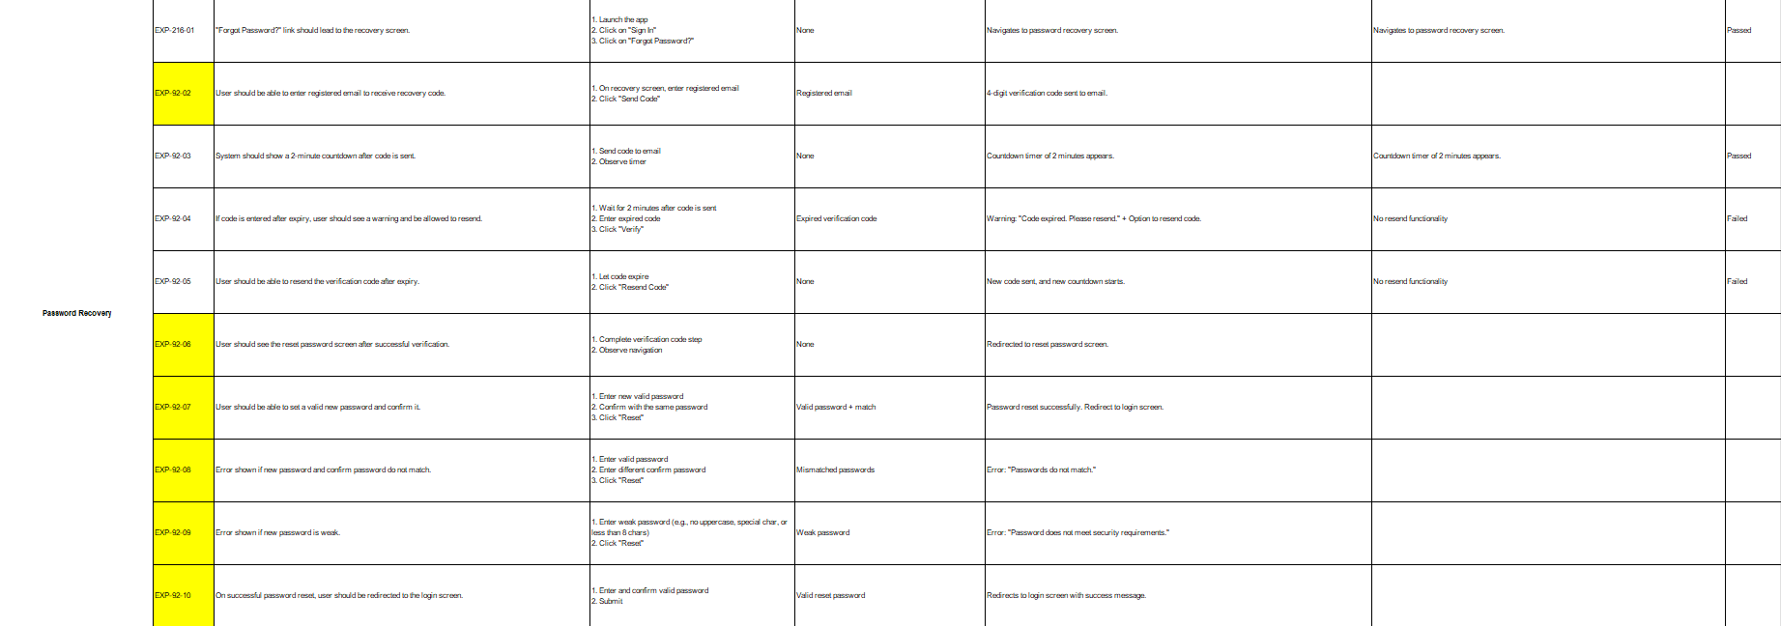
Figure 19:Functional Testing-User Authentication (3)
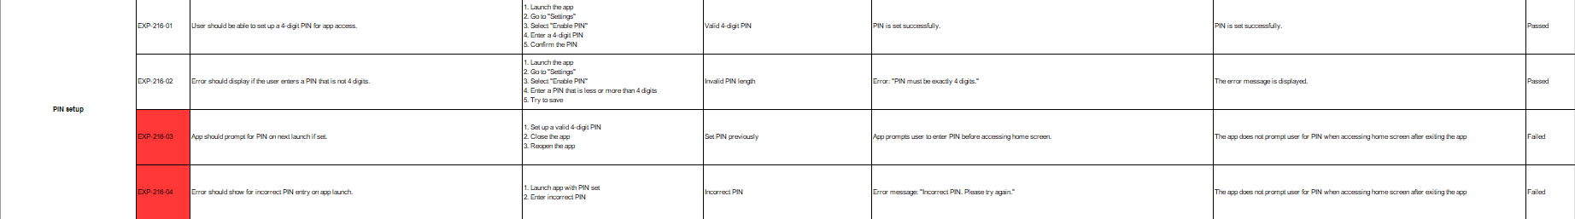
Figure 20:Functional Testing-User Authentication (4)
Test cases – Core Features
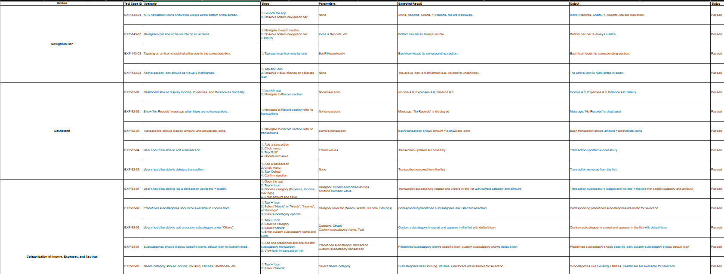
Figure 21:Functional Testing-Core Features (1)
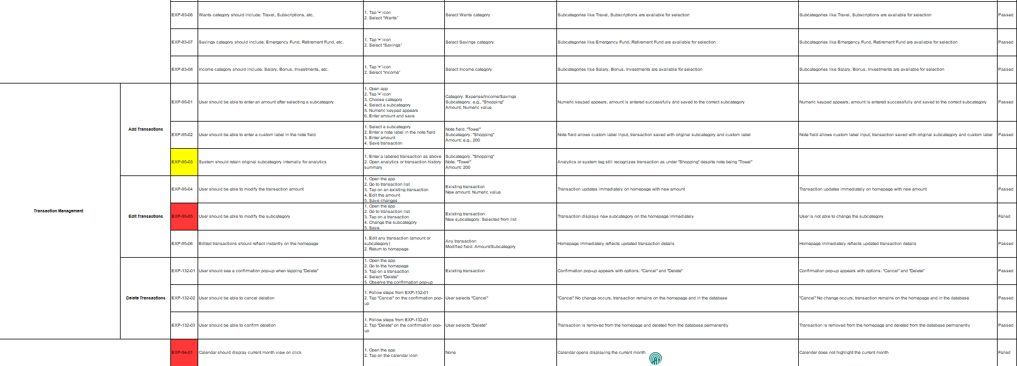
Figure 22:Functional Testing-Core Features (2)
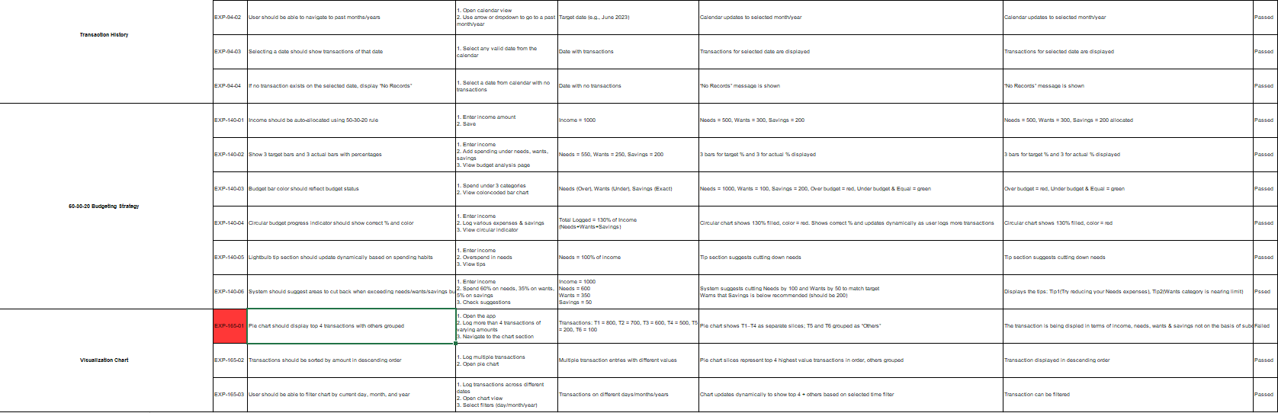
Figure 23:Functional Testing-Core Features (3)
Test cases – Extra Features
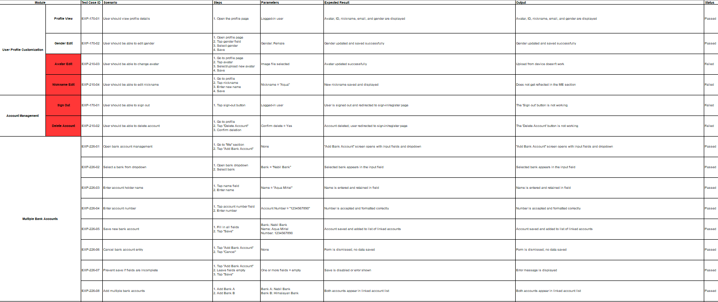
Figure 24:Functional Testing-Extra Features (1)
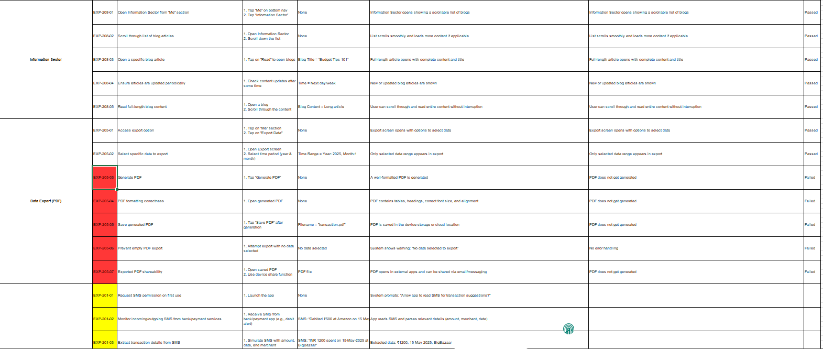
Figure 25:Functional Testing-Extra Features (2)
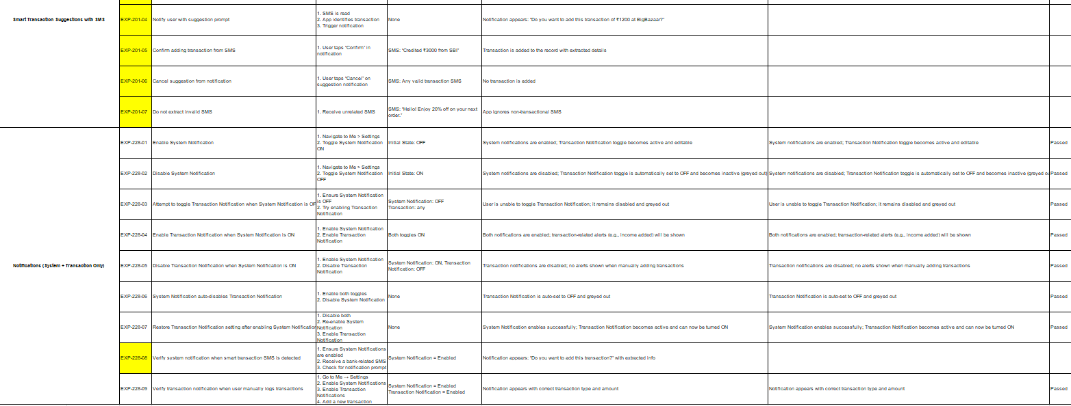
Figure 26:Functional Testing-Extra Features (3)

Test Report
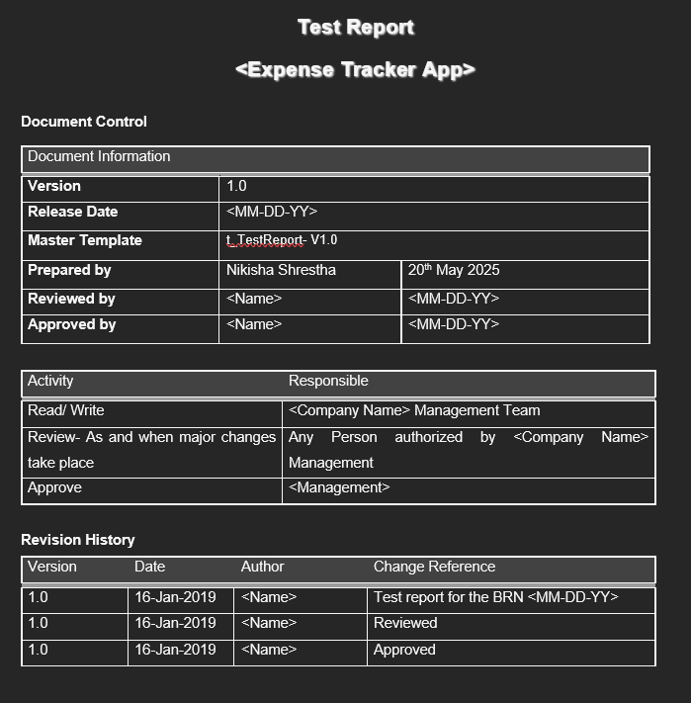
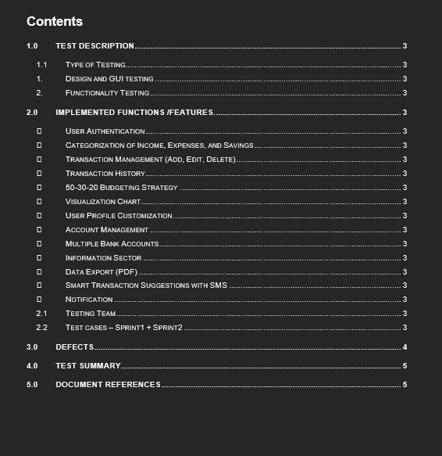
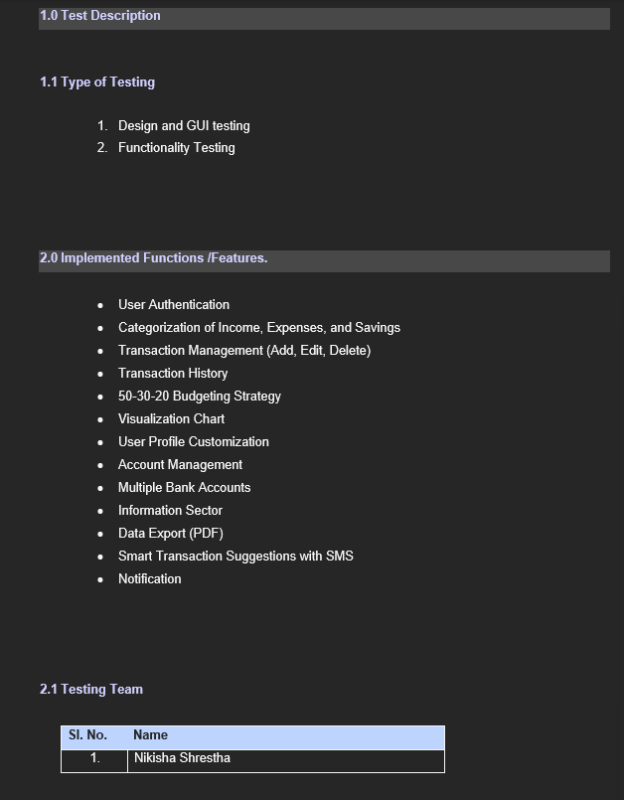
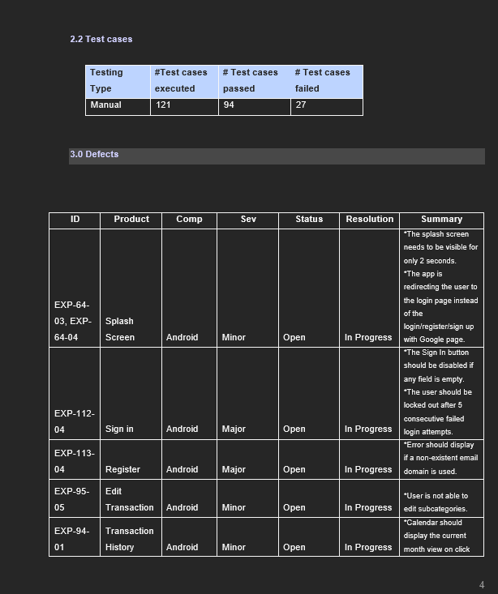
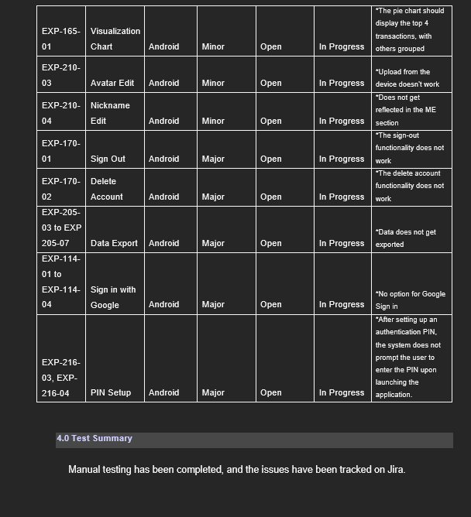
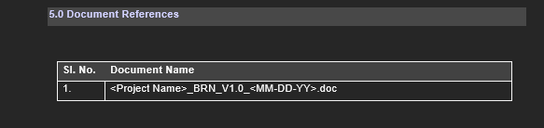

Appendix C

Evidence of Good Communication and File Sharing
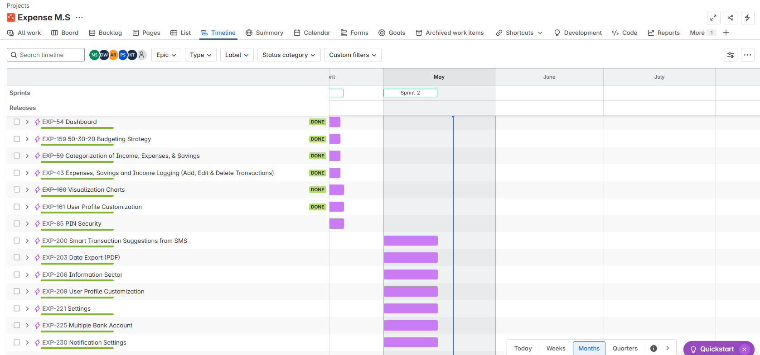
Figure 27: Task management via Jira
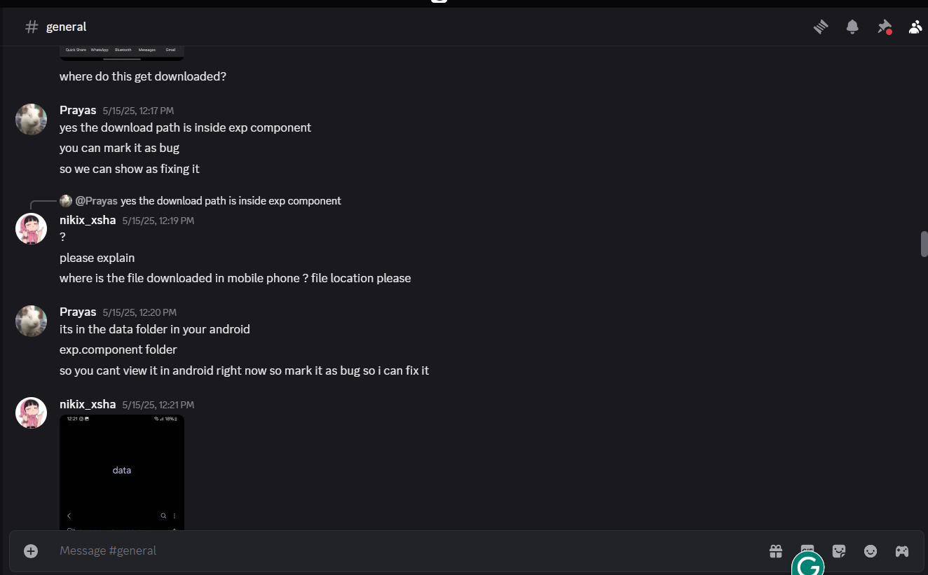
Figure 28: Communication via Discord
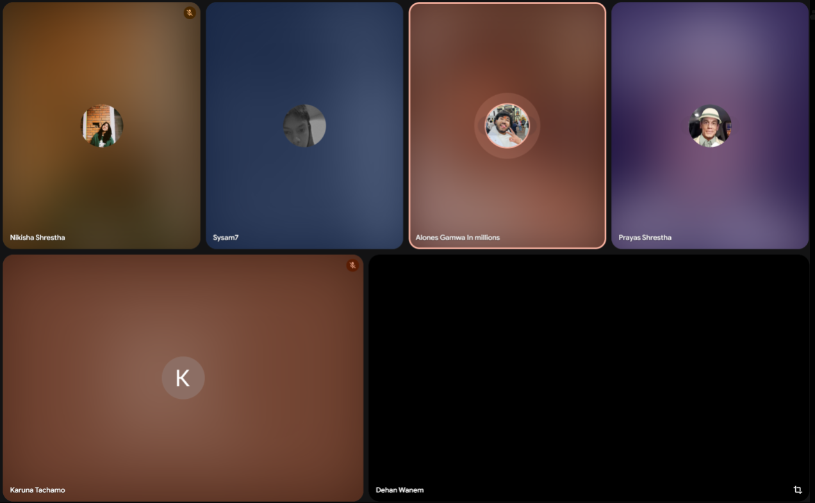
Figure 29: Online meeting via Google Meet
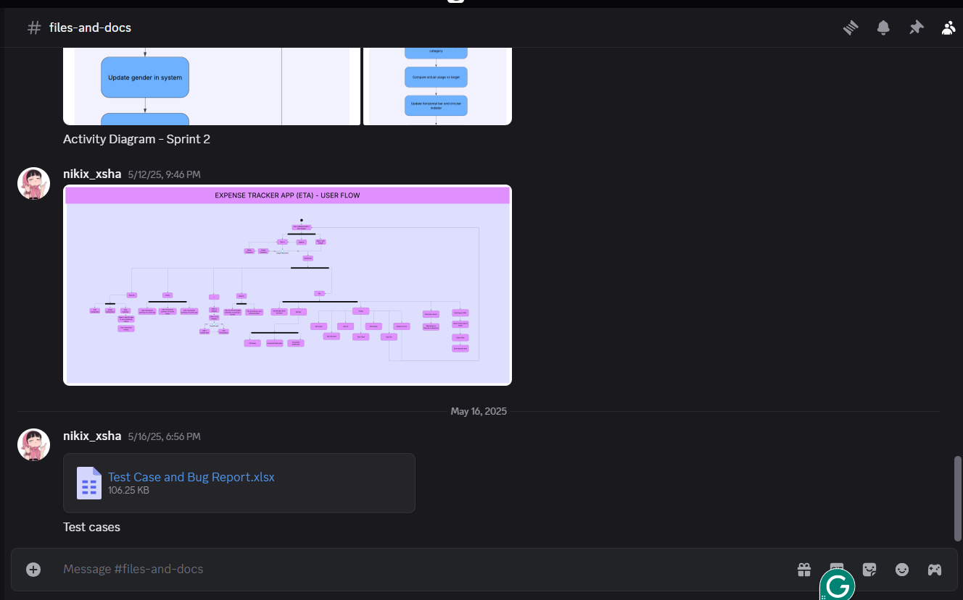
Figure 30: File Sharing
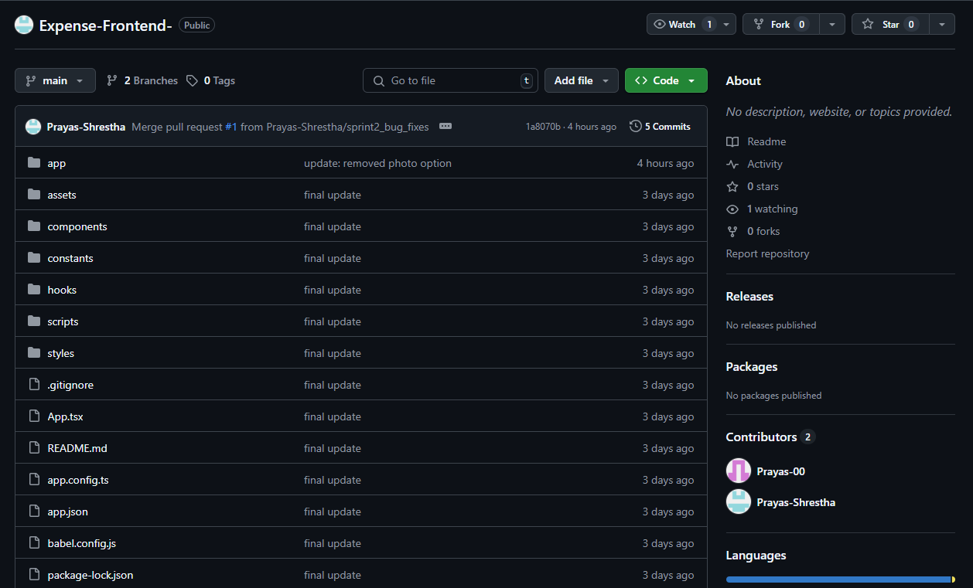
Figure 31: Collaboration via Github

Evidence of Continuing Personal Development (CPD)
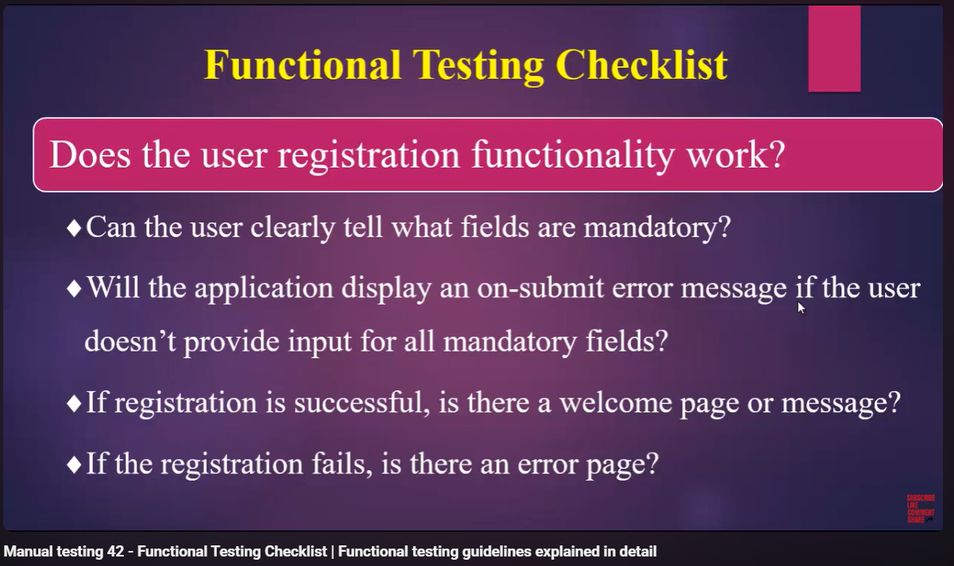
(Training, 2019)

Evidence of Issue Tracking
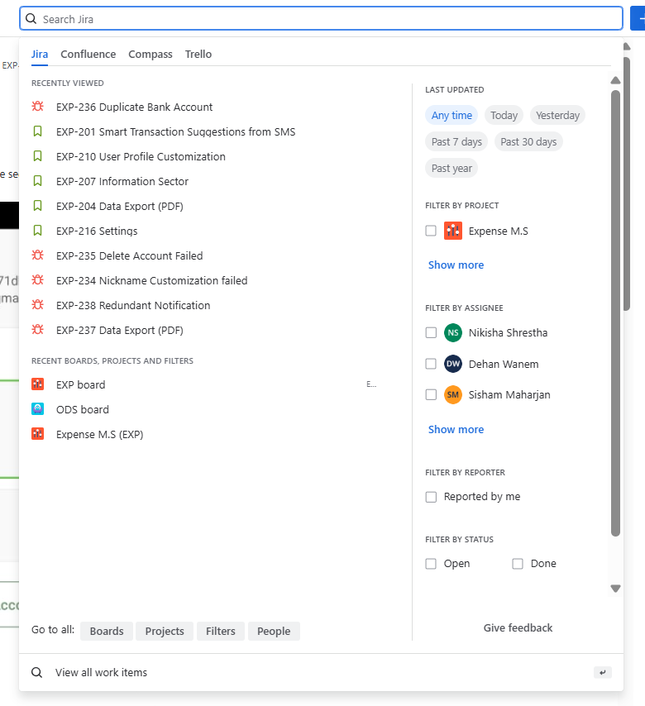
Figure 32: Issued Bugs
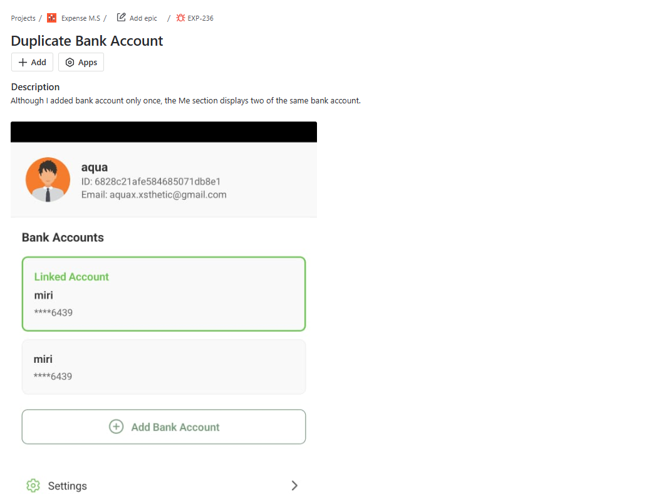
Figure 33: Snapshot of an Individual Bug

Appendix D

Sprint Retrospective
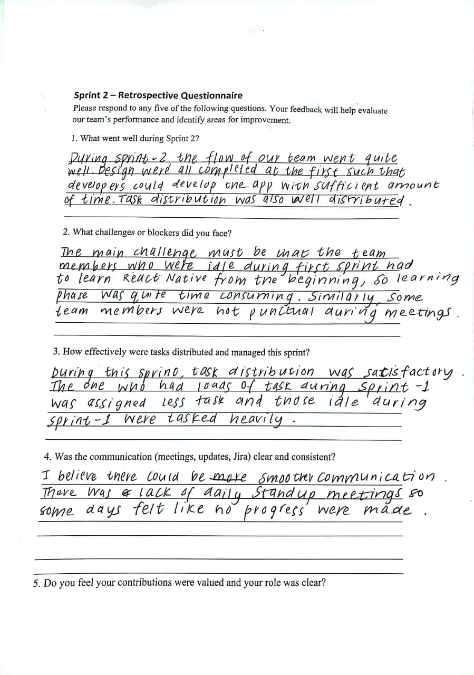
Figure 34: Sprint Retrospective Questionnaire (1)
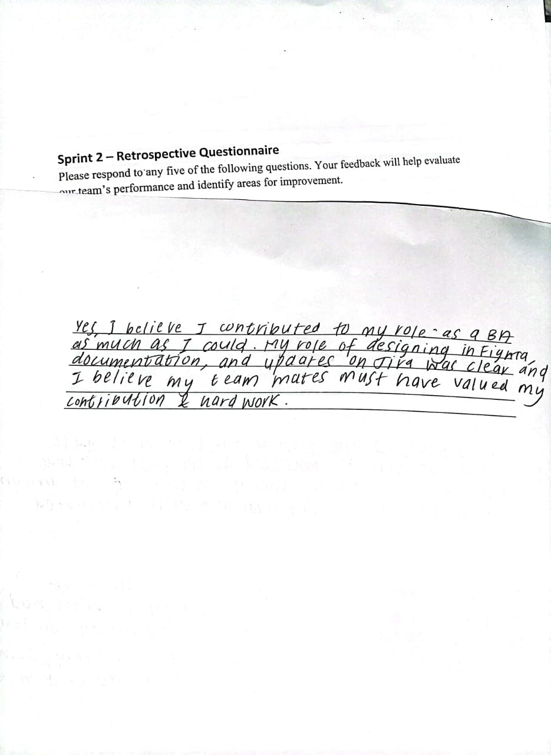
Figure 35: Sprint Retrospective Questionnaire (2)

References
Training, A., 2019. Manual testing 42 - Functional Testing Checklist | Functional testing guidelines explained in detail. s.l.:s.n.
https://www.youtube.com/watch?v=lnGZxpfVbRs

