Google trends on Climate change

import packages

library("gtrendsR")

## Warning: package 'gtrendsR' was built under R version 3.6.3

## Registered S3 methods overwritten by 'ggplot2':  
## method from   
## [.quosures rlang  
## c.quosures rlang  
## print.quosures rlang

library("ggplot2")  
library("dplyr")

## Warning: package 'dplyr' was built under R version 3.6.1

##   
## Attaching package: 'dplyr'

## The following objects are masked from 'package:stats':  
##   
## filter, lag

## The following objects are masked from 'package:base':  
##   
## intersect, setdiff, setequal, union

require(maps)

## Loading required package: maps

Function to plot trends over a period of time (5 years) and over different regions

plot_trends_time <- function(search_term){  
   
 trends=gtrends(keyword=search_term)  
 plot(trends)  
}

plot_trends_geo <- function(search_term){  
   
 trends=gtrends(keyword=search_term)  
 #plot(trends)  
   
 world_map <- map_data("world")  
 t_countries<-trends$interest_by_country  
 t_countries$hit_levels<-"NA"  
   
 #class(t_countries$hits)  
  
 #t_countries$hits[is.na(t_countries$hits)] <- 0  
 t_countries$hits[t_countries$hits == "<1"] <- 0  
 t_countries$hits<-as.numeric(t_countries$hits)  
   
 # NAs introduced at this stage  
  
 t_countries$hit_levels[t_countries$hits == 0] <- "Less than 1"  
   
 t_countries$hit_levels[(t_countries$hits>=1) & (t_countries$hits <= 10)] <- "1-10"  
 t_countries$hit_levels[ (t_countries$hits>10) & (t_countries$hits <= 25)] <- "10-25"  
 t_countries$hit_levels[ (t_countries$hits>25) & (t_countries$hits <=50) ] <- "25-50"  
 t_countries$hit_levels[ (t_countries$hits>50) & (t_countries$hits <=75) ] <- "50-75"  
 t_countries$hit_levels[ (t_countries$hits>75) & (t_countries$hits <=100) ] <- "75-100"  
   
 t_countries$location[t_countries$location=="United States"]<- "USA"  
 t_countries$location[t_countries$location=="United Kingdom"]<- "UK"  
   
 g<-ggplot() +  
 geom_map(data = world_map, map = world_map,  
 aes(x = long, y = lat, group = group, map_id=region),  
 fill = "white", colour = "#7f7f7f", size=0.5) +   
 geom_map(data = t_countries, map=world_map,  
 aes(fill=hit_levels, map_id=location),  
 colour="#7f7f7f", size=0.5)  
 print(g)  
  
}

Search trends (interest over time and region) for keywords

keywords= c("control pollution","pollution hoax","clean plastic","energy transition", "plastic pollution ","global warming","carbon footprint","greta thunberg","greta thunberg fraud","climate change", "climate change hoax","solve global warming",  
"global warming hoax","improve energy sustainability","green new deal",  
"renewable energy pros","renewable energy cons","wind energy cons",  
"wind energy pros","solar energy pros","solar energy cons")

for (k in keywords){  
   
 plot_trends_time(k)  
 plot_trends_geo(k)  
}

## Warning: Ignoring unknown aesthetics: x, y

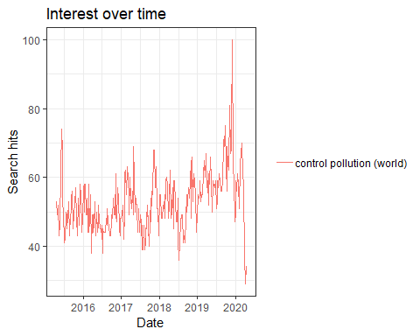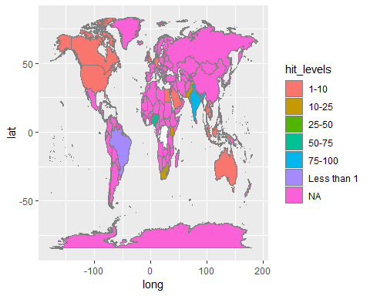

## Warning: Ignoring unknown aesthetics: x, y

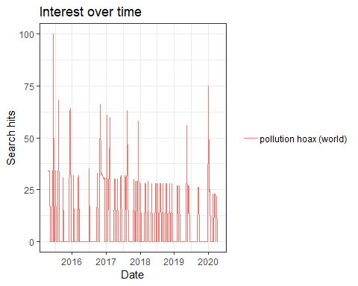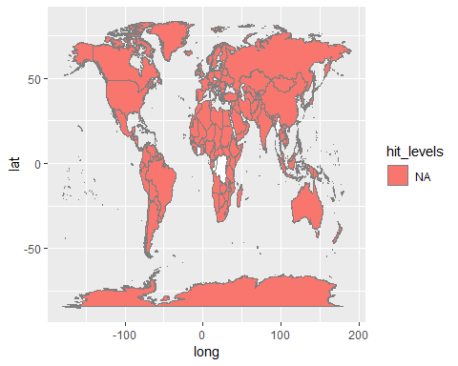

## Warning: Ignoring unknown aesthetics: x, y

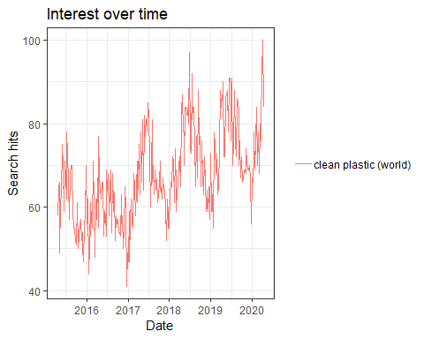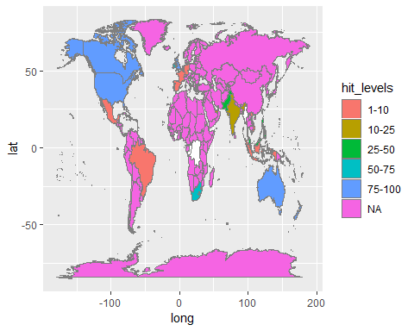

## Warning: Ignoring unknown aesthetics: x, y

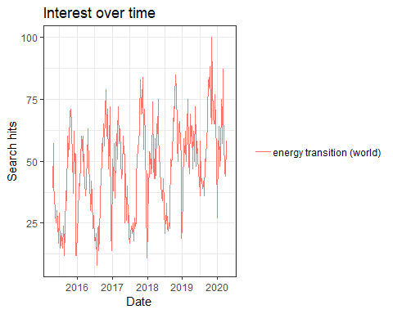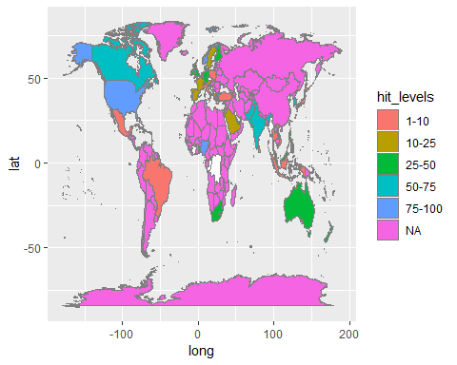

## Warning: Ignoring unknown aesthetics: x, y

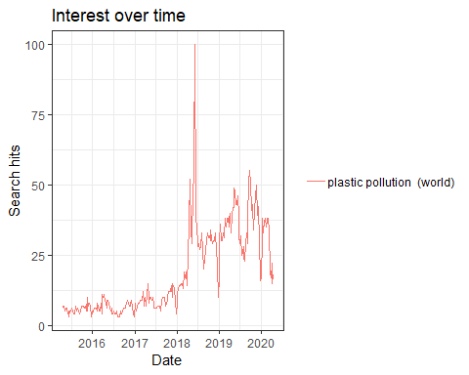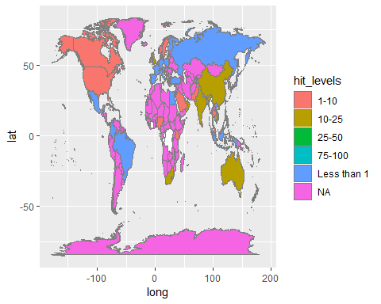

## Warning: Ignoring unknown aesthetics: x, y

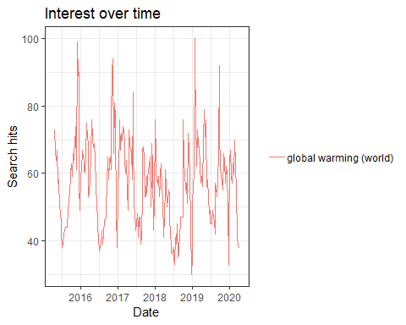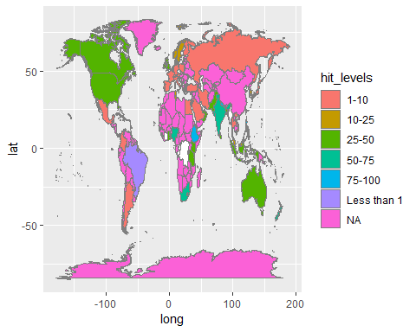

## Warning: Ignoring unknown aesthetics: x, y

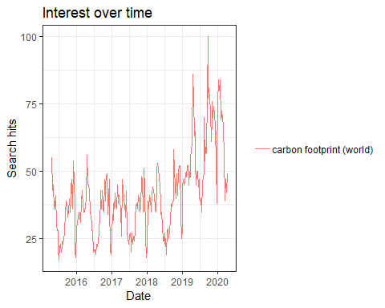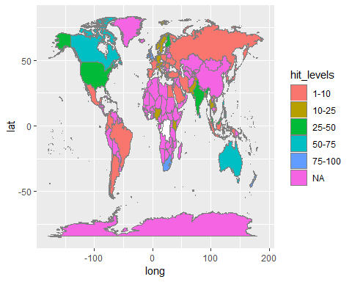

## Warning: Ignoring unknown aesthetics: x, y

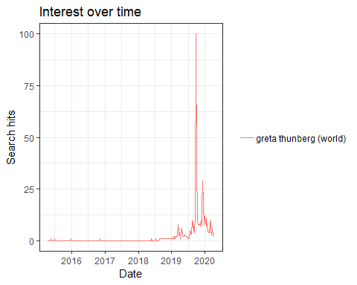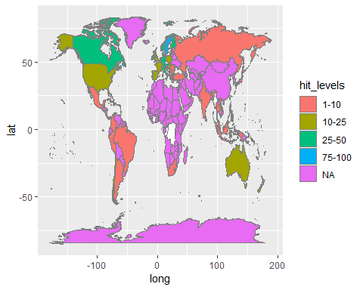

## Warning: Ignoring unknown aesthetics: x, y

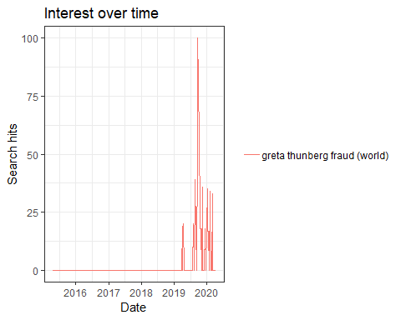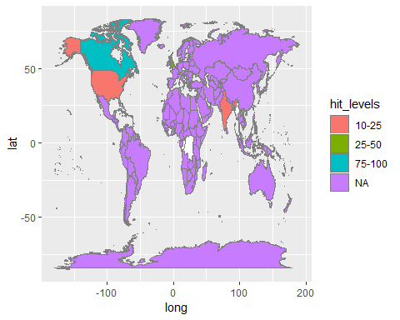

## Warning: Ignoring unknown aesthetics: x, y

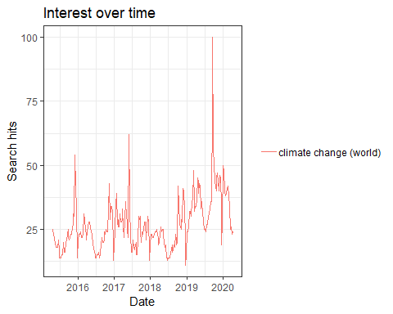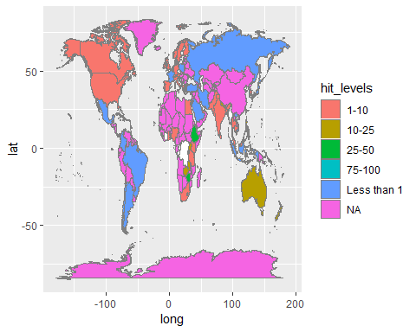

## Warning: Ignoring unknown aesthetics: x, y

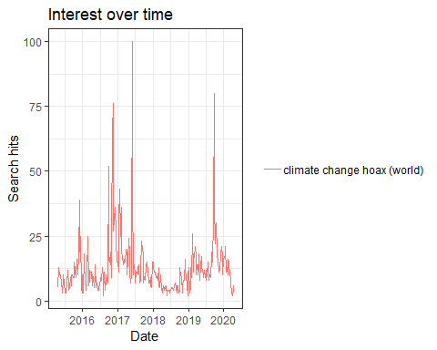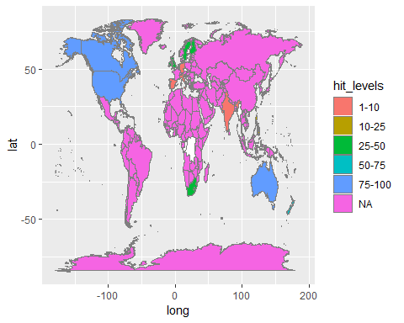

## Warning: Ignoring unknown aesthetics: x, y

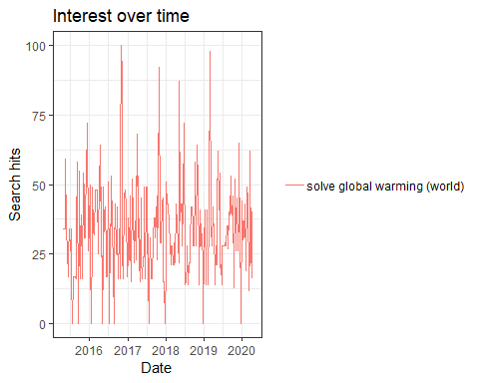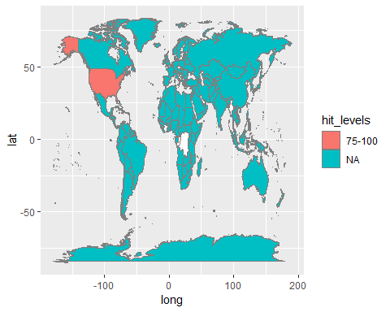

## Warning: Ignoring unknown aesthetics: x, y

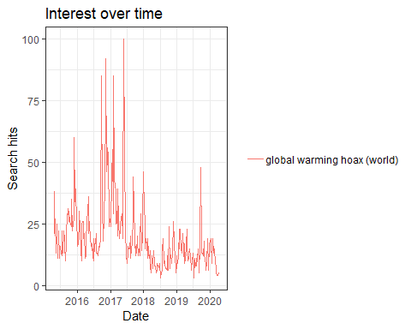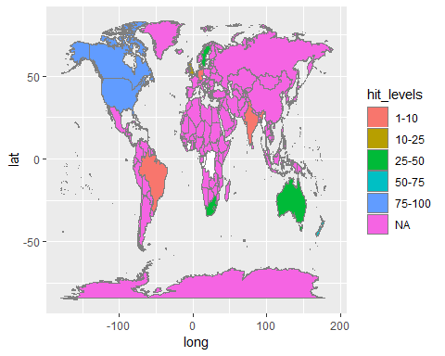

## Warning: Ignoring unknown aesthetics: x, y

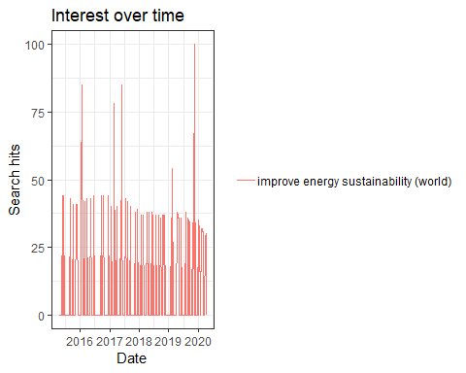

## Warning: Ignoring unknown aesthetics: x, y

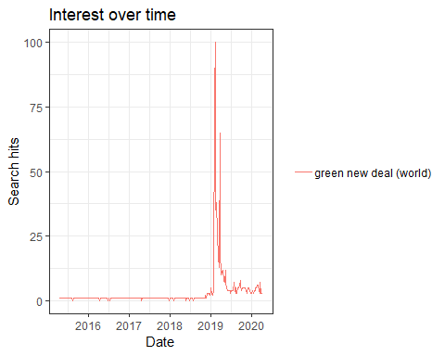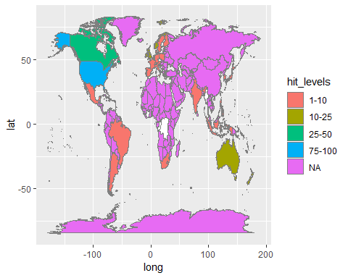

## Warning: Ignoring unknown aesthetics: x, y

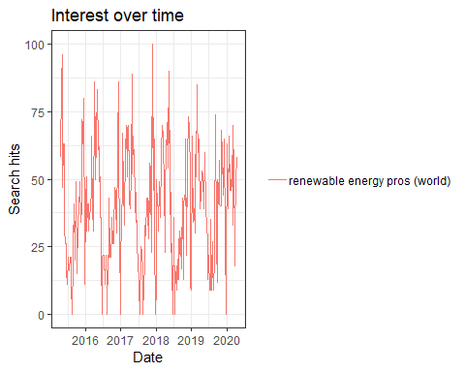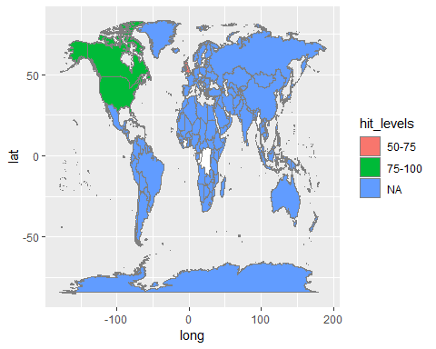

## Warning: Ignoring unknown aesthetics: x, y

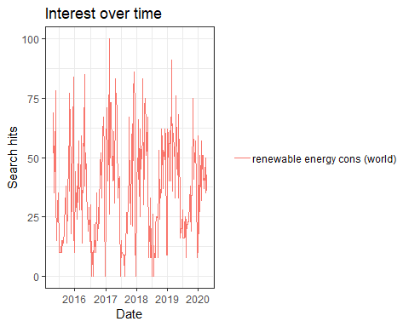

## Warning: Ignoring unknown aesthetics: x, y

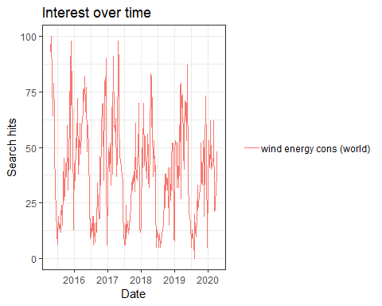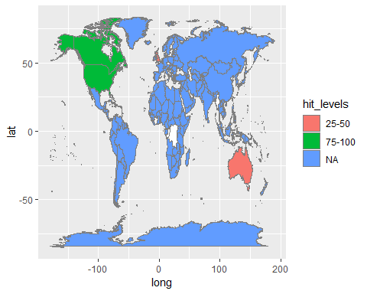

## Warning: Ignoring unknown aesthetics: x, y

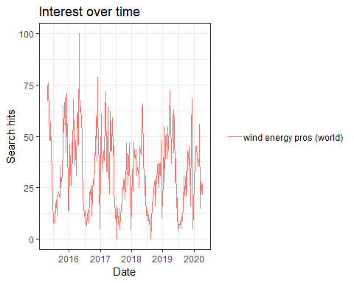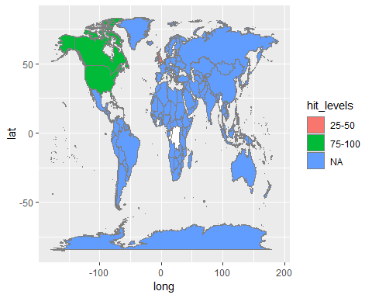

## Warning: Ignoring unknown aesthetics: x, y

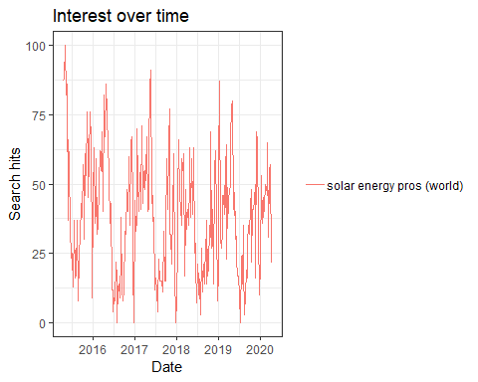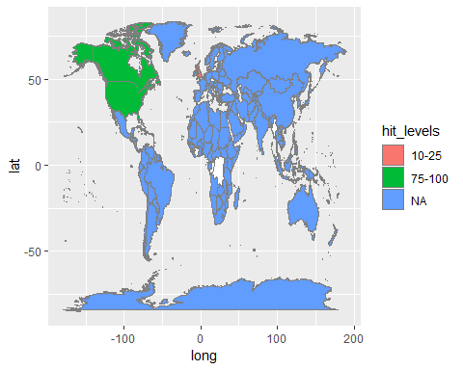

## Warning: Ignoring unknown aesthetics: x, y

