## Architecture

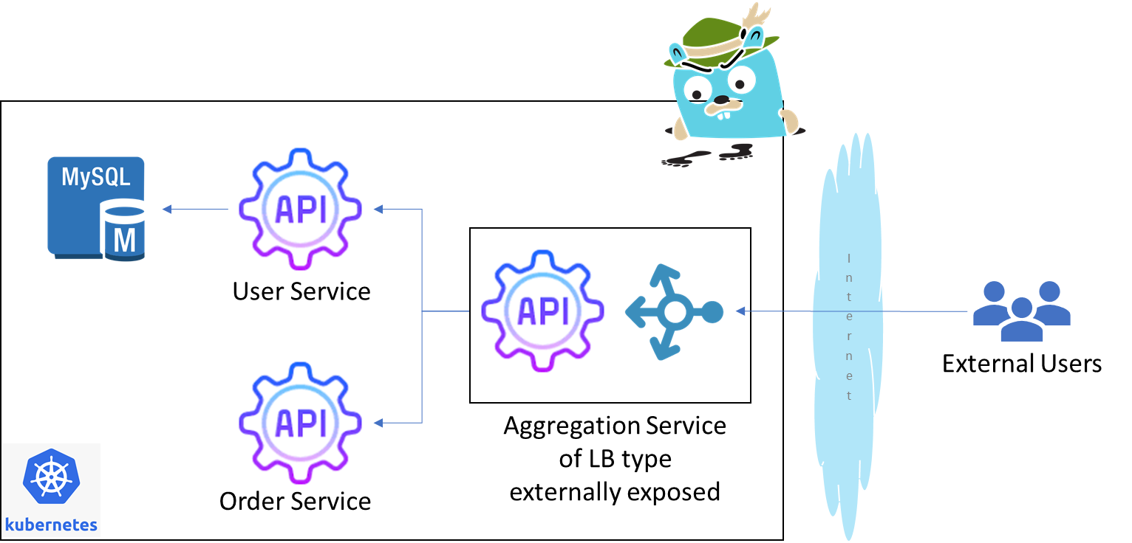

## Docker Images

* User Service : <https://hub.docker.com/r/aquibchiniwala/userservicejaeger> (use v2)
* Order Service : <https://hub.docker.com/r/aquibchiniwala/orderservice>jaeger
* Aggregator Service : <https://hub.docker.com/r/aquibchiniwala/aggregatorservice>jaeger

## Screenshots

### Pods

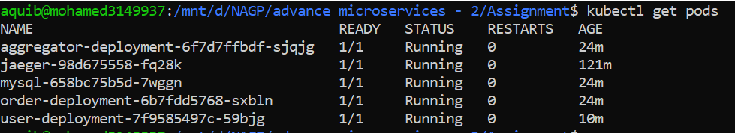

### Services

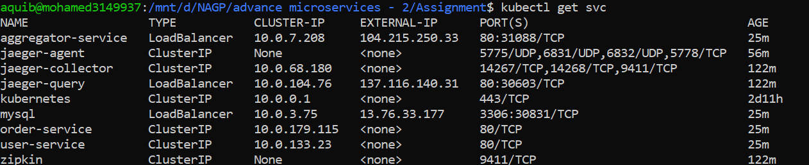

### Deployments

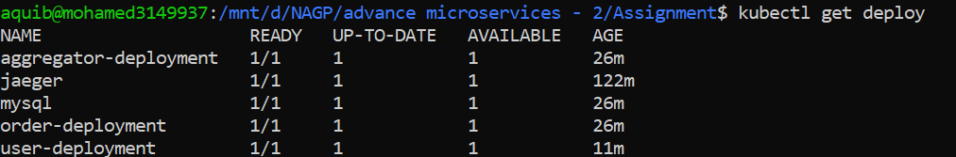

### REST Endpoints : <http://104.215.250.33/orderdetails/1> (Will not work as k8s cluster is down)

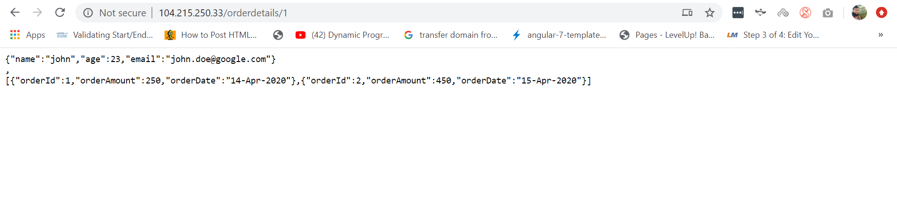

# 

## Github Link: https://github.com/aquibchiniwala/NAGP-K8s-Microservices-Jaeger.git