## Architecture

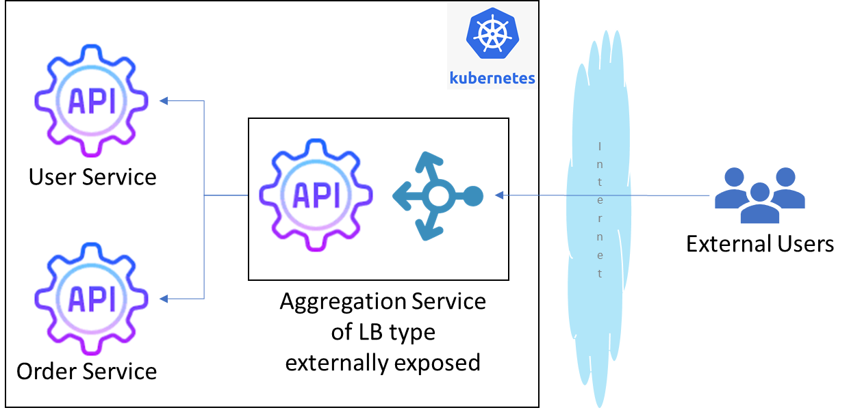

## Docker Images

* User Service : <https://hub.docker.com/r/aquibchiniwala/userservice>
* Order Service : <https://hub.docker.com/r/aquibchiniwala/orderservice>
* Aggregator Service : <https://hub.docker.com/r/aquibchiniwala/aggregatorservice>

## Screenshots

### Services

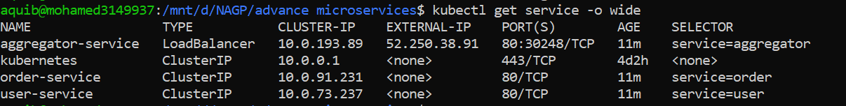

### Deployments



### REST Endpoints

