Practical 1

Introduction to Android, Introduction to Android Studio IDE, Application Fundamentals: Creating a Project, Android Components, Activities, Services, Content Providers, Broadcast Receivers, Interface overview, Creating Android Virtual device, USB debugging mode, Android Application Overview. Simple “Hello World” program

1.Create new project

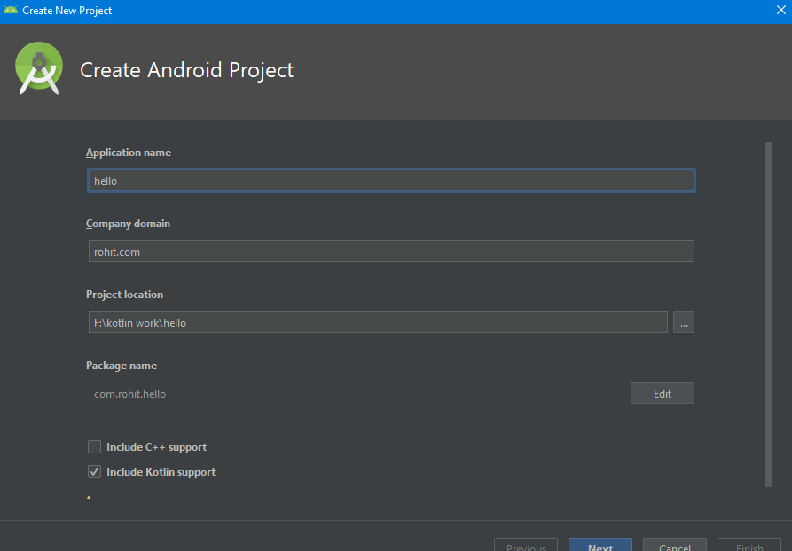

2. Add an activity to mobile (select empty activity)

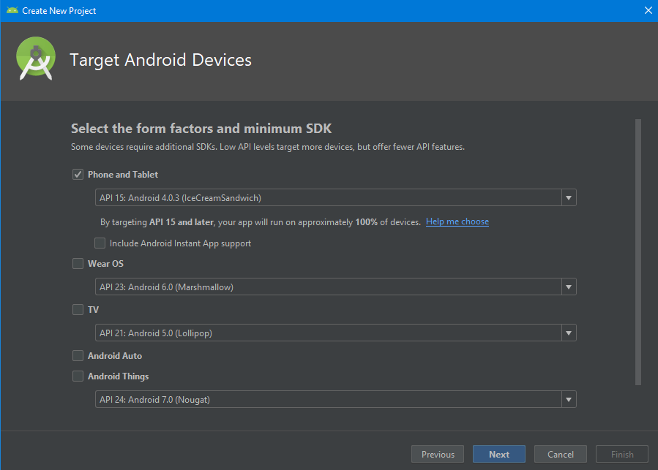

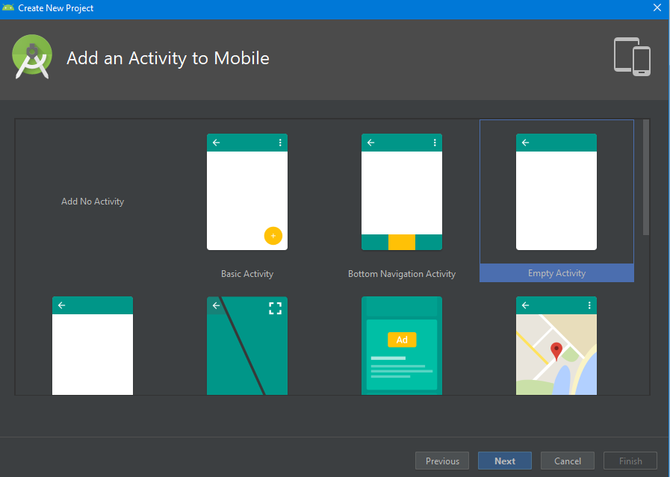

3.Select activity name “hello world”

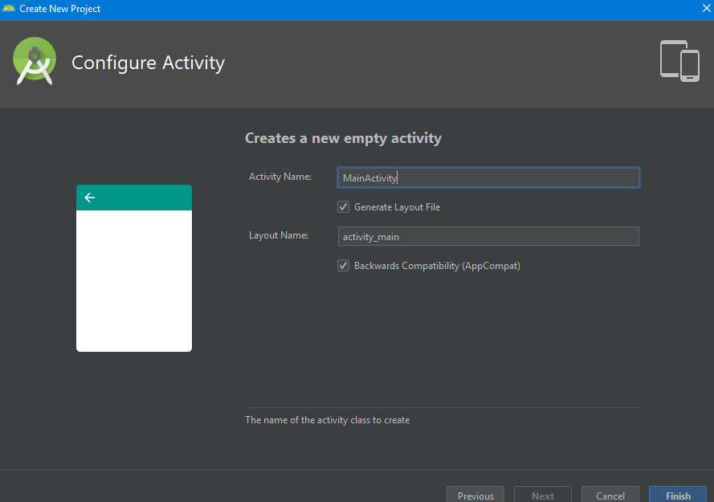

4.Package Name-com.example.hello world

language- java

Minimum SDK (choose basic) (4.4 kitkat)

Finish

5.Go to page (activity-main.xml)

package com.rohit.hello  
  
import android.support.v7.app.AppCompatActivity  
import android.os.Bundle  
  
class MainActivity : AppCompatActivity() {  
  
 override fun onCreate(savedInstanceState: Bundle?) {  
 super.onCreate(savedInstanceState)  
 setContentView(R.layout.*activity_main*)  
 }  
}

6.Go to design (can change text)

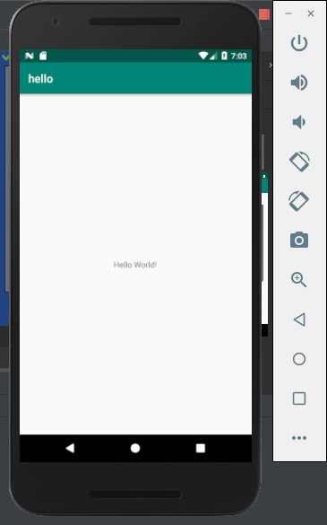

7.To see code – go to split

8.Drag and drop text

9.Select tools >AVD Manager

10.Click AVD Manager AVD Manager icon in toolbar.

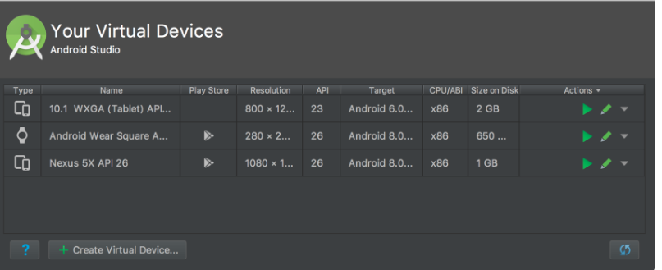

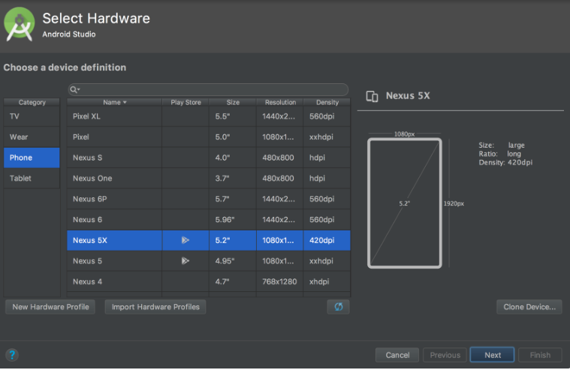

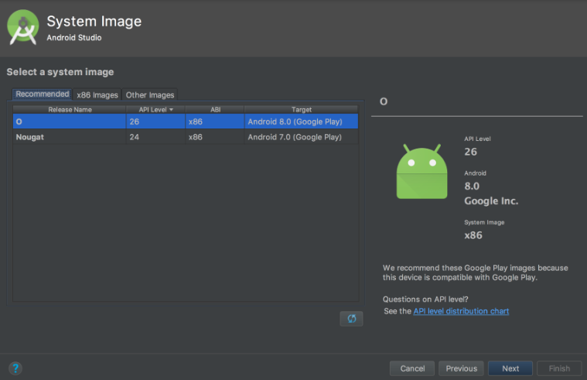

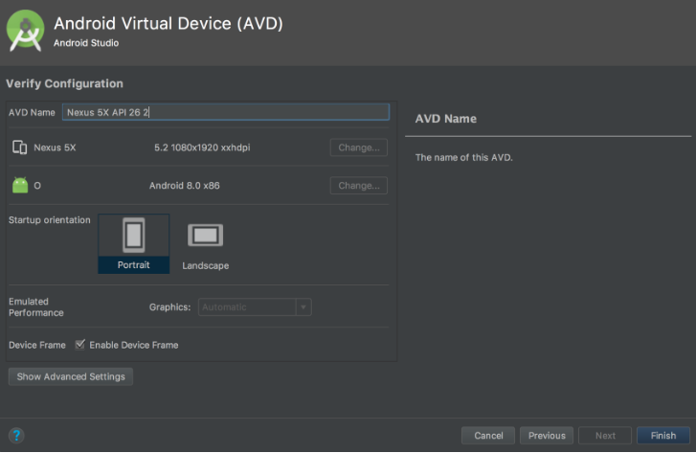

Practical 2

Android Resources: (Color, Theme, String, Drawable, Dimension, Image).

Color

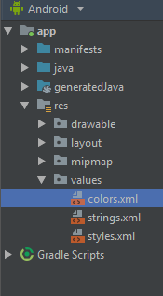

Color.xml

<?xml version="1.0" encoding="utf-8"?>  
<resources>  
 <color name="colorPrimary">#008577</color>  
 <color name="colorPrimaryDark">#00574B</color>  
 <color name="colorAccent">#D81B60</color>  
</resources>

Theme:

Style.xml

<resources>  
  
 <!-- Base application theme. -->  
 <style name="AppTheme" parent="Theme.AppCompat.Light.DarkActionBar">  
 <!-- Customize your theme here. -->  
 <item name="colorPrimary">@color/colorPrimary</item>  
 <item name="colorPrimaryDark">@color/colorPrimaryDark</item>  
 <item name="colorAccent">@color/colorAccent</item>  
 </style>  
  
</resources>

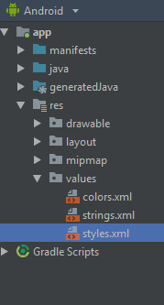

String

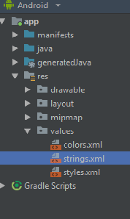

String.xml

<resources>  
 <string name="app_name">hello</string>  
 <string name="numbers">  
 <item>1</item>  
 <item>2</item>  
 <item>3</item>  
 </item>  
 </string>  
</resources>

Drawable:

Right click on drawable folder

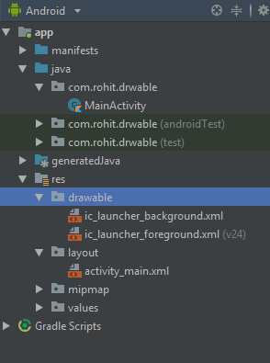

1. Copy the image if you want to create image drawable
2. Paste that image file inside the drawable folder

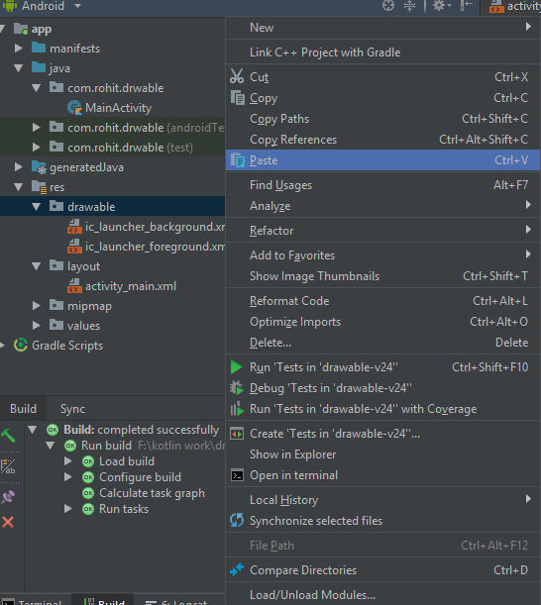

**Select /drawable then click on ok button**

**(Name without space)**

**Dimension, Image:**

**Main_Activity.kt:**

package com.rohit.drwable  
  
import android.support.v7.app.AppCompatActivity  
import android.os.Bundle  
  
class MainActivity : AppCompatActivity() {  
  
 override fun onCreate(savedInstanceState: Bundle?) {  
 super.onCreate(savedInstanceState)  
 setContentView(R.layout.*activity_main*)  
 }  
}

**activity_main.xml:**

<?xml version="1.0" encoding="utf-8"?>  
<LinearLayout  
 xmlns:android="http://schemas.android.com/apk/res/android"  
 xmlns:tools="http://schemas.android.com/tools"  
 xmlns:app="http://schemas.android.com/apk/res-auto"  
 android:layout_width="match_parent"  
 android:layout_height="match_parent"  
 tools:context=".MainActivity"  
 android:background="@drawable/one">  
  
 <TextView  
 android:layout_width="wrap_content"  
 android:layout_height="wrap_content"  
 android:text="Hello World!"  
 app:layout_constraintBottom_toBottomOf="parent"  
 app:layout_constraintLeft_toLeftOf="parent"  
 app:layout_constraintRight_toRightOf="parent"  
 app:layout_constraintTop_toTopOf="parent"/>  
  
</LinearLayout>

Output:

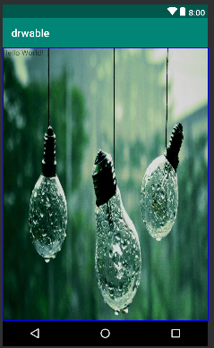

Practical 3

Programming Activities and fragments

Activity Life Cycle, Activity methods, Multiple Activities, Life Cycle of fragments and multiple fragments.

<LinearLayout  
 xmlns:android="http://schemas.android.com/apk/res/android"  
 xmlns:tools="http://schemas.android.com/tools"  
 xmlns:app="http://schemas.android.com/apk/res-auto"  
 android:layout_width="match_parent"  
 android:layout_height="match_parent"  
 tools:context=".MainActivity">  
  
 <TableLayout android:layout_width="wrap_content"  
 android:layout_height="wrap_content"  
 android:layout_marginLeft="50dp"  
 android:layout_marginTop="150dp">  
 <TableRow>  
 <Button  
 android:id="@+id/btn1"  
 android:text="1"  
 android:layout_gravity="center"  
 />  
 <Button  
 android:id="@+id/btn2"  
 android:text="2"  
 android:layout_gravity="center"  
 />  
 <Button  
 android:id="@+id/btn3"  
 android:text="3"  
 android:layout_gravity="center"  
 />  
 </TableRow>  
 <TableRow>  
 <Button  
 android:id="@+id/btn4"  
 android:text="4"  
 android:layout_gravity="center"  
 />  
 <Button  
 android:id="@+id/btn5"  
 android:text="5"  
 android:layout_gravity="center"  
 /><Button  
 android:id="@+id/btn6"  
 android:text="6"  
 android:layout_gravity="center"  
 />  
 </TableRow>  
 <TableRow>  
 <Button  
 android:id="@+id/btn7"  
 android:text="7"  
 android:layout_gravity="center"  
 />  
 <Button  
 android:id="@+id/btn8"  
 android:text="8"  
 android:layout_gravity="center"  
 /><Button  
 android:id="@+id/btn9"  
 android:text="9"  
 android:layout_gravity="center"  
 />  
 </TableRow>  
 </TableLayout>  
  
</LinearLayout>

Activity_main.kt

package com.r.table_view  
  
import android.support.v7.app.AppCompatActivity  
import android.os.Bundle  
import kotlinx.android.synthetic.main.activity_main.*  
import org.jetbrains.anko.toast  
  
class MainActivity : AppCompatActivity() {  
  
 override fun onCreate(savedInstanceState: Bundle?) {  
 super.onCreate(savedInstanceState)  
 setContentView(R.layout.*activity_main*)  
  
 btn1.setOnClickListener **{** *toast*("1")  
 **}** btn2.setOnClickListener **{** *toast*("2")  
 **}** btn3.setOnClickListener **{** *toast*("3")  
 **}** btn4.setOnClickListener **{** *toast*("4")  
 **}** btn5.setOnClickListener **{** *toast*("5")  
 **}** btn6.setOnClickListener **{** *toast*("6")  
 **}** btn7.setOnClickListener **{** *toast*("7")  
 **}** btn8.setOnClickListener **{** *toast*("8")  
 **}** btn9.setOnClickListener **{** *toast*("9")  
 **}** }  
}

Output:

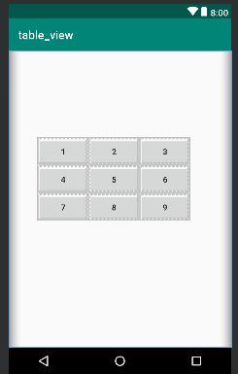

Practical 4

Different Layouts:

Coordinate, Linear, Relative, Table, Absolute, Frame, List View, Grid View.

1.Linear

<?xml version="1.0" encoding="utf-8"?>  
<LinearLayout xmlns:android="http://schemas.android.com/apk/res/android"  
android:layout_width="fill_parent"  
android:layout_height="fill_parent"  
android:orientation="vertical" >  
  
<Button android:id="@+id/btnStartService"  
android:layout_width="270dp"  
android:layout_height="wrap_content"  
android:text="start_service"/>  
  
<Button android:id="@+id/btnPauseService"  
android:layout_width="270dp"  
android:layout_height="wrap_content"  
android:text="pause_service"/>  
  
<Button android:id="@+id/btnStopService"  
android:layout_width="270dp"  
android:layout_height="wrap_content"  
android:text="stop_service"/>  
  
</LinearLayout>

2.Relative

<RelativeLayout xmlns:android="http://schemas.android.com/apk/res/android"  
android:layout_width="fill_parent"  
android:layout_height="fill_parent"  
android:paddingLeft="16dp"  
android:paddingRight="16dp" >  
  
<EditText  
android:id="@+id/name"  
android:layout_width="fill_parent"  
android:layout_height="wrap_content"  
android:hint="@string/reminder" />  
  
<LinearLayout  
android:orientation="vertical"  
android:layout_width="fill_parent"  
android:layout_height="fill_parent"  
android:layout_alignParentStart="true"  
android:layout_below="@+id/name">  
  
<Button  
android:layout_width="wrap_content"  
android:layout_height="wrap_content"  
android:text="New Button"  
android:id="@+id/button" />  
  
<Button  
android:layout_width="wrap_content"  
android:layout_height="wrap_content"  
android:text="New Button"  
android:id="@+id/button2" />  
  
</LinearLayout>  
  
</RelativeLayout>

3. Table:

Activity_main.xml

<?xml version="1.0" encoding="utf-8"?>  
<LinearLayout  
 xmlns:android="http://schemas.android.com/apk/res/android"  
 xmlns:tools="http://schemas.android.com/tools"  
 xmlns:app="http://schemas.android.com/apk/res-auto"  
 android:layout_width="match_parent"  
 android:layout_height="match_parent"  
 tools:context=".MainActivity">  
  
 <TableLayout android:layout_width="wrap_content"  
 android:layout_height="wrap_content"  
 android:layout_marginLeft="50dp"  
 android:layout_marginTop="150dp">  
 <TableRow>  
 <Button  
 android:id="@+id/btn1"  
 android:text="1"  
 android:layout_gravity="center"  
 />  
 <Button  
 android:id="@+id/btn2"  
 android:text="2"  
 android:layout_gravity="center"  
 />  
 <Button  
 android:id="@+id/btn3"  
 android:text="3"  
 android:layout_gravity="center"  
 />  
 </TableRow>  
 <TableRow>  
 <Button  
 android:id="@+id/btn4"  
 android:text="4"  
 android:layout_gravity="center"  
 />  
 <Button  
 android:id="@+id/btn5"  
 android:text="5"  
 android:layout_gravity="center"  
 /><Button  
 android:id="@+id/btn6"  
 android:text="6"  
 android:layout_gravity="center"  
 />  
 </TableRow>  
 <TableRow>  
 <Button  
 android:id="@+id/btn7"  
 android:text="7"  
 android:layout_gravity="center"  
 />  
 <Button  
 android:id="@+id/btn8"  
 android:text="8"  
 android:layout_gravity="center"  
 /><Button  
 android:id="@+id/btn9"  
 android:text="9"  
 android:layout_gravity="center"  
 />  
 </TableRow>  
 </TableLayout>  
  
</LinearLayout>

Activity_main.kt

package com.r.table_view  
  
import android.support.v7.app.AppCompatActivity  
import android.os.Bundle  
import kotlinx.android.synthetic.main.activity_main.*  
import org.jetbrains.anko.toast  
  
class MainActivity : AppCompatActivity() {  
  
 override fun onCreate(savedInstanceState: Bundle?) {  
 super.onCreate(savedInstanceState)  
 setContentView(R.layout.*activity_main*)  
  
 btn1.setOnClickListener **{** *toast*("1")  
 **}** btn2.setOnClickListener **{** *toast*("2")  
 **}** btn3.setOnClickListener **{** *toast*("3")  
 **}** btn4.setOnClickListener **{** *toast*("4")  
 **}** btn5.setOnClickListener **{** *toast*("5")  
 **}** btn6.setOnClickListener **{** *toast*("6")  
 **}** btn7.setOnClickListener **{** *toast*("7")  
 **}** btn8.setOnClickListener **{** *toast*("8")  
 **}** btn9.setOnClickListener **{** *toast*("9")  
 **}** }  
}

Output-



4.Frame-

Activity_main.xml

<?xml version="1.0" encoding="utf-8"?>  
<FrameLayout  
 xmlns:android="http://schemas.android.com/apk/res/android"  
 xmlns:tools="http://schemas.android.com/tools"  
 android:layout_width="match_parent"  
 android:layout_height="match_parent"  
 tools:context=".MainActivity">  
  
 <ImageView android:layout_width="match_parent"  
 android:layout_height="match_parent"  
 android:src="@drawable/red"  
 android:scaleType="centerCrop"/>  
 <TextView  
 android:textSize="100dp"  
 android:layout_width="wrap_content"  
 android:layout_height="wrap_content"  
 android:text="Hello World!"  
 android:gravity="center"  
 android:textColor="@color/rohit"  
 android:layout_marginTop="220dp"  
 />  
  
</FrameLayout>

Activity_main.kt

package com.rohit.frame_layout  
  
import android.support.v7.app.AppCompatActivity  
import android.os.Bundle  
  
class MainActivity : AppCompatActivity() {  
  
 override fun onCreate(savedInstanceState: Bundle?) {  
 super.onCreate(savedInstanceState)  
 setContentView(R.layout.*activity_main*)  
 }  
}

output-

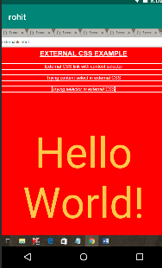

5.List View:

Activity_main.xml

<?xml version="1.0" encoding="utf-8"?>  
<LinearLayout  
 xmlns:android="http://schemas.android.com/apk/res/android"  
 xmlns:tools="http://schemas.android.com/tools"  
 xmlns:app="http://schemas.android.com/apk/res-auto"  
 android:layout_width="match_parent"  
 android:layout_height="match_parent"  
 tools:context=".MainActivity">  
  
 <Button android:layout_width="wrap_content"  
 android:layout_height="wrap_content"  
 android:id="@+id/btn"  
 android:text="Click me to view list"  
 android:layout_marginTop="200dp"  
 android:layout_marginLeft="90dp"/>  
</LinearLayout>

String.xml

<resources>  
 <string name="app_name">list</string>  
  
 <array name="insert_list">  
 <item>one</item>  
 <item>two</item>  
 <item>three</item>  
 <item>four</item>  
 <item>five</item>  
 <item>six</item>  
 <item>seven</item>  
 <item>eight</item>  
 <item>nine</item>  
 <item>ten</item>  
 </array>  
</resources>

Activity_list_view.xml:

<?xml version="1.0" encoding="utf-8"?>  
<ListView  
 xmlns:android="http://schemas.android.com/apk/res/android"  
 xmlns:tools="http://schemas.android.com/tools"  
 xmlns:app="http://schemas.android.com/apk/res-auto"  
 android:layout_width="match_parent"  
 android:layout_height="match_parent"  
 tools:context=".list_view" android:entries="@array/insert_list">  
  
</ListView>

List_view. kt

package com.rohit.list  
  
import android.support.v7.app.AppCompatActivity  
import android.os.Bundle  
  
class list_view : AppCompatActivity() {  
  
 override fun onCreate(savedInstanceState: Bundle?) {  
 super.onCreate(savedInstanceState)  
 setContentView(R.layout.*activity_list_view*)  
 }  
}

main_Activity.kt

package com.rohit.list  
  
import android.content.Intent  
import android.support.v7.app.AppCompatActivity  
import android.os.Bundle  
import kotlinx.android.synthetic.main.activity_main.*  
  
class MainActivity : AppCompatActivity() {  
  
 override fun onCreate(savedInstanceState: Bundle?) {  
 super.onCreate(savedInstanceState)  
 setContentView(R.layout.*activity_main*)  
  
 btn.setOnClickListener **{** val intent =Intent(this, list_view::class.*java*)  
 startActivity(intent)  
 **}** }  
}

Output-

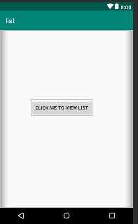

Grid layout

<?xml version="1.0" encoding="utf-8"?>  
<GridLayout  
 xmlns:android="http://schemas.android.com/apk/res/android"  
 xmlns:tools="http://schemas.android.com/tools"  
 xmlns:app="http://schemas.android.com/apk/res-auto"  
 android:layout_width="match_parent"  
 android:layout_height="match_parent"  
 tools:context=".MainActivity"  
 android:rowCount="3"  
 android:columnCount="3"  
 android:padding="20dp">  
  
 <Button  
 android:layout_width="110dp"  
 android:layout_height="100dp"  
 android:text="1"/>  
  
 <Button  
 android:layout_width="110dp"  
 android:layout_height="100dp"  
 android:text="2"/>  
 <Button  
 android:layout_width="110dp"  
 android:layout_height="100dp"  
 android:text="3"/>  
 <Button  
 android:layout_width="110dp"  
 android:layout_height="100dp"  
 android:text="4"/>  
  
 <Button  
 android:layout_width="110dp"  
 android:layout_height="100dp"  
 android:text="5"/>  
 <Button  
 android:layout_width="110dp"  
 android:layout_height="100dp"  
 android:text="6"/>  
 <Button  
 android:layout_width="110dp"  
 android:layout_height="100dp"  
 android:text="7"/>  
  
 <Button  
 android:layout_width="110dp"  
 android:layout_height="100dp"  
 android:text="8"/>  
 <Button  
 android:layout_width="110dp"  
 android:layout_height="100dp"  
 android:text="9"/>  
  
</GridLayout>

mainActvity.kt:

package com.rohit.grid_layout  
  
import android.support.v7.app.AppCompatActivity  
import android.os.Bundle  
  
class MainActivity : AppCompatActivity() {  
  
 override fun onCreate(savedInstanceState: Bundle?) {  
 super.onCreate(savedInstanceState)  
 setContentView(R.layout.*activity_main*)  
 }  
}

output:

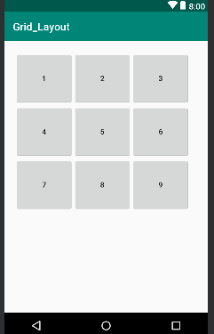

Practical 5

Programming UI elements

Design App With UI:

package rohit.technobeat  
  
import android.content.Intent  
import android.support.v7.app.AppCompatActivity  
import android.os.Bundle  
import kotlinx.android.synthetic.main.activity_login.*  
import kotlinx.android.synthetic.main.activity_main.*  
import kotlinx.android.synthetic.main.activity_register.*  
import rohit.technobeat.R.id.login  
import rohit.technobeat.R.id.newaccount  
  
class MainActivity : AppCompatActivity() {  
  
 override fun onCreate(savedInstanceState: Bundle?) {  
 super.onCreate(savedInstanceState)  
 setContentView(R.layout.activity_main)  
 login.setOnClickListener **{** val intent = Intent(this, LoginActivity::class.java)  
 // start your next activity  
 startActivity(intent)  
 **}** newaccount.setOnClickListener **{** val intent = Intent(this, RegisterActivity::class.java)  
 // start your next activity  
 startActivity(intent)  
 **}** }  
}

activity_main.xml

<?xml version="1.0" encoding="utf-8"?>  
<LinearLayout xmlns:android="http://schemas.android.com/apk/res/android"  
 xmlns:tools="http://schemas.android.com/tools"  
 android:layout_width="match_parent"  
 android:layout_height="match_parent"  
 android:gravity="center_horizontal"  
 android:orientation="vertical"  
 android:paddingBottom="@dimen/activity_vertical_margin"  
 android:paddingLeft="@dimen/activity_horizontal_margin"  
 android:paddingRight="@dimen/activity_horizontal_margin"  
 android:paddingTop="@dimen/activity_vertical_margin"  
 android:background="@drawable/home"  
 tools:context=".MainActivity">  
  
 <ScrollView  
 android:id="@+id/login_form"  
 android:layout_width="match_parent"  
 android:layout_height="match_parent">  
 <LinearLayout  
 android:layout_width="match_parent"  
 android:layout_height="wrap_content"  
 android:orientation="vertical"  
 android:gravity="center">  
  
  
 <android.support.v7.widget.AppCompatTextView  
 android:layout_width="wrap_content"  
 android:layout_height="wrap_content"  
 android:layout_marginTop="210dp"  
 android:alpha="0.7"  
 android:text="TECHNOBEAT"  
 android:textColor="#000000"  
 android:textSize="33dp"  
 android:textStyle="bold"  
 tools:layout_marginLeft="85dp" />  
  
  
 <Button  
 android:id="@+id/login"  
 style="?android:textAppearanceSmall"  
 android:layout_width="match_parent"  
 android:layout_height="wrap_content"  
 android:layout_marginTop="16dp"  
 android:text="Login"  
 android:background="@drawable/round_button"  
 android:alpha="0.8"  
 android:textStyle="bold" />  
 <Button  
 android:id="@+id/newaccount"  
 style="?android:textAppearanceSmall"  
 android:layout_width="match_parent"  
 android:layout_height="wrap_content"  
 android:layout_marginTop="16dp"  
 android:text="REGISTER"  
 android:background="@drawable/round_button"  
 android:alpha="0.8"  
 android:textStyle="bold" />  
  
 </LinearLayout>  
 </ScrollView>  
</LinearLayout>

Output-

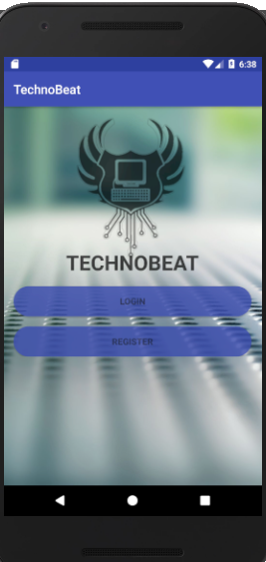

Practical 6

Programming menus, dialog, dialog fragments

Alert-

val *alertDialog*: AlertDialog? = activity?.let **{** val builder = AlertDialog.Builder(it)  
 builder.apply **{** setPositiveButton(R.*string*.*ok*,  
 DialogInterface.OnClickListener **{** dialog, id **->** // User clicked OK button  
 **}**)  
 setNegativeButton(R.*string*.*cancel*,  
 DialogInterface.OnClickListener **{** dialog, id **->** // User cancelled the dialog  
 **}**)  
 **}** // Set other dialog properties  
 ...  
  
 // Create the AlertDialog  
 builder.create()  
**}**

Output-

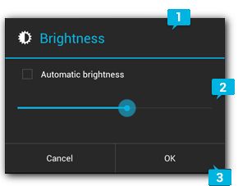

Menu

Menu.xml-

<?xml version=”1.0″ encoding=”utf-8″?>  
<menu xmlns:android=”http://schemas.android.com/apk/res/android&#8221;  
xmlns:app=”http://schemas.android.com/apk/res-auto”&gt;  
  
<item  
android:id=”@+id/menu_1″  
android:icon=”@drawable/ic_menu_1″  
android:title=”Menu 1″  
app:showAsAction=”always” />  
  
<item  
android:id=”@+id/menu_2″  
android:icon=”@drawable/ic_menu_2″  
android:title=”Menu 2″ />  
  
<item  
android:id=”@+id/menu_3″  
android:icon=”@drawable/ic_menu_3″  
android:title=”Menu 3″ />  
  
<item  
android:id=”@+id/menu_4″  
android:icon=”@drawable/ic_menu_4″  
android:title=”Menu 4″ />  
  
</menu>

Mainactivity.kt-

package rohit.com  
  
import android.os.Bundle  
import android.support.v7.app.AppCompatActivity  
import android.view.Menu  
import android.view.MenuItem  
import android.widget.Toast  
class MainActivity : AppCompatActivity() {  
  
 override fun onCreate(savedInstanceState: Bundle?) {  
 super.onCreate(savedInstanceState)  
 setContentView(R.*layout*.*activity_main*)  
 }  
  
 override fun onCreateOptionsMenu(menu: Menu): Boolean {  
 *menuInflater*.inflate(R.*menu*.*main*, menu)  
 return true  
 }  
  
 override fun onOptionsItemSelected(item: MenuItem): Boolean {  
 when (item.*itemId*) {  
 R.*id*.*menu_1* -> {  
 Toast.makeText(this, “Menu 1 is selected”, Toast.LENGTH_SHORT).show()  
 return true  
 }  
 R.*id*.*menu_2* -> {  
 Toast.makeText(this, “Menu 2 is selected”, Toast.LENGTH_SHORT).show()  
 return true  
 }  
 R.*id*.*menu_3* -> {  
 Toast.makeText(this, “Menu 3 is selected”, Toast.LENGTH_SHORT).show()  
 return true  
 }  
 R.*id*.*menu_4* -> {  
 Toast.makeText(this, “Menu 4 is selected”, Toast.LENGTH_SHORT).show()  
 return true  
 }  
 else -> return super.onOptionsItemSelected(item)  
 }  
 }  
}

Output-

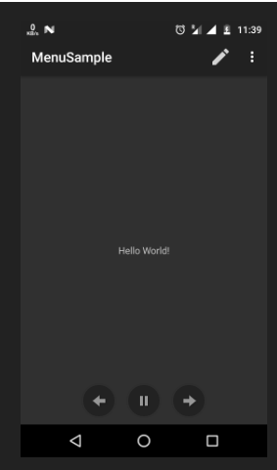

Practical 7

Programs on services, notifications and broadcast receivers

1. Programs on Services:

Services are commands which are used by kotlin in functions to execute the task. They are: IntentService, onStartCommand(),onHandleIntent() etc.

1. notification and broadcast receivers:

Step 1. Create an android app, For creating an Android app with kotlin read this tutorial.

Step 2. Creating Broadcast Receiver Create and extend Subclass and Broadcast Receiver implement.onReceive(Context, Intent) where onReceive method each message is received as an Intent object parameter.

MyReceiver.kt:

package `in`.eyehunt.androidbroadcasts  
  
import android.content.BroadcastReceiver  
import android.content.Context  
import android.content.Intent  
import android.widget.Toast  
  
class MyReceiver : BroadcastReceiver() {  
  
 override fun onReceive(context: Context, intent: Intent) {  
 // *TODO: This method is called when the BroadcastReceiver is receiving* // an Intent broadcast.  
 Toast.makeText(context, "Broadcast : Flight mode changed.",  
 Toast.*LENGTH_LONG*).show()  
 }  
}

Step 3. Declare a broadcast receiver in the manifest file add the element<receiver> in your app’s manifest. Here is code snap

AndroidManifest.xml:

<?xml version="1.0" encoding="utf-8"?>  
<manifest xmlns:android="http://schemas.android.com/apk/res/android"  
package="in.eyehunt.androidbroadcasts">  
  
<application  
android:allowBackup="true"  
android:icon="@mipmap/ic_launcher"  
android:label="@string/app_name"  
android:roundIcon="@mipmap/ic_launcher_round"  
android:supportsRtl="true"  
android:theme="@style/AppTheme">  
<activity android:name=".MainActivity">  
<intent-filter>  
<action android:name="android.intent.action.MAIN" />  
  
<category android:name="android.intent.category.LAUNCHER" />  
</intent-filter>  
</activity>  
  
<receiver  
android:name=".MyReceiver"  
android:enabled="true"  
android:exported="true">  
<intent-filter>  
<action android:name="android.intent.action.AIRPLANE_MODE"/>  
</intent-filter>  
</receiver>  
</application>  
  
</manifest>

Step 4. MainActivity code, no needs to do anything

MainActivity.kt:

package `in`.eyehunt.androidbroadcasts  
  
import android.support.v7.app.AppCompatActivity  
import android.os.Bundle  
  
class MainActivity : AppCompatActivity() {  
  
 override fun onCreate(savedInstanceState: Bundle?) {  
 super.onCreate(savedInstanceState)  
 setContentView(R.*layout*.*activity_main*)  
 }  
}

Step 5. Add following code in main_activity.xml add <ImageView> and <TextView>widget layout file.

main_activity.xml:

<?xml version="1.0" encoding="utf-8"?>  
<android.support.constraint.ConstraintLayout xmlns:android="http://schemas.android.com/apk/res/android"  
xmlns:app="http://schemas.android.com/apk/res-auto"  
xmlns:tools="http://schemas.android.com/tools"  
android:layout_width="match_parent"  
android:layout_height="match_parent"  
android:background="@color/colorPrimary"  
tools:context="in.eyehunt.androidbroadcasts.MainActivity">  
  
<ImageView  
android:id="@+id/imageView"  
android:layout_width="40dp"  
android:layout_height="40dp"  
android:layout_margin="8dp"  
android:layout_marginTop="16dp"  
app:layout_constraintStart_toStartOf="parent"  
app:layout_constraintTop_toTopOf="parent"  
app:srcCompat="@mipmap/baseline_airplanemode_active_white_24" />  
  
<TextView  
android:id="@+id/textView"  
android:layout_width="300dp"  
android:layout_height="36dp"  
android:layout_marginEnd="8dp"  
android:layout_marginStart="8dp"  
android:gravity="center_vertical"  
android:text="Flight Mode"  
android:textColor="@color/colorWhite"  
android:textSize="24dp"  
app:layout_constraintEnd_toEndOf="parent"  
app:layout_constraintStart_toEndOf="@+id/imageView"  
app:layout_constraintTop_toTopOf="@+id/imageView" />  
</android.support.constraint.ConstraintLayout>

Output-

