[Document Title]
Process Documentation | v1.0 | [Date]

Section Heading:
Replace this paragraph with the section text. Body copy is Times New Roman 11 pt, justified, with a little space between paragraphs. Headings are the bold, underlined style above — type your text and apply the “Section Heading” style, or just overwrite this sample and keep going.
A second paragraph looks like this. Keep sentences plain and specific; this template only carries the formatting.
Bulleted List:
Intro line before a list reads naturally, then the points follow:
- First point — filled round bullet, hanging indent.
- Second point, one or two lines each.
- Third point.
Three-Column Table:
Field | Required | How it is filled
Sample Field | Yes | What goes in this cell — shaded header row, thin grey borders, 10 pt text.
Another Field | No | Add rows by copying an existing one.

Two-Column Table:
Required practice | Not permitted
The good practice, stated plainly. | The thing to avoid.
Second practice. | Its counter-example.

Diagrams:
Process flowcharts use the plain box-and-arrow style shown below — clean rectangles, a hexagon for the start, and short labels on the arrows. Insert yours as an image (Insert → Pictures), centred and sized to the text width; replace the example below with your own.
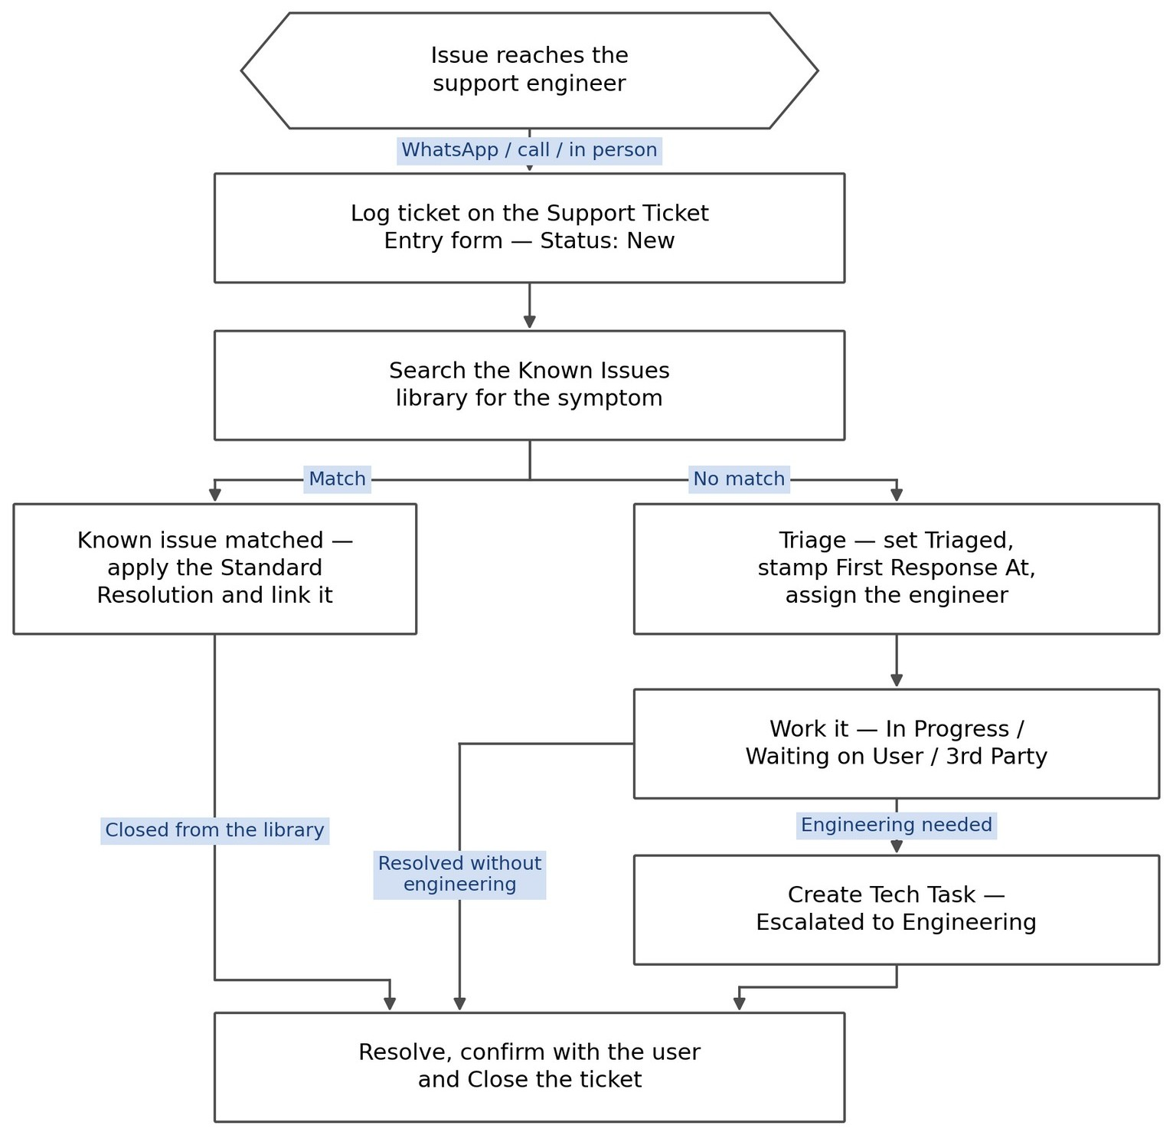
Example — process-flowchart style (replace with your own).
When a flow spans more than one team, draw it as a swimlane instead — one lane per team, with the same clean boxes flowing left to right.

