Setting up ODT2.0 for particle-laden HST and HIT in Ubuntu

Compile ODT 2.0

- Install Cantera
  - sudo apt-add-repository ppa:speth/cantera
  - sudo apt-get update
  - sudo apt-get install cantera-dev
  - Add directory to build/make.FSL

- Install yaml, lboost, and lboost-system
  - sudo apt-egt install libyaml-dev libboost-dev libboost-system-dev

- Compile yaml files for reading input files
  - cd build
  - make yaml

- Compile ODT code
  - make

Set up particle-laden HIT/HST

- cd ..
- cd input/shearFlow/

- Choose HIT (“00_HIT_odt_input.yaml”) or HST (“02_HST_odt_input.yaml”) case
  - cp 00_HIT_odt_input.yaml odt_input.yaml
  - For single-phase: Set “partCoupl: 0” in “input/shearFlow/odt_input.yaml”
  - For particle-laden: Set “partCoupl: 2” and “Lrestart: true”
- Run code for single-phase and particle-laden test case
  - ./runMultiRlzn.sh <name>
- Post-processing
  - Choose file for test case: cd post/00_forcedHIT or cd post/01_shearFlow
  - Change directories in 01_checkParticlePhase.py files and execute

Benchmark results for Re=80, St=5, ml=0.8 below

#### Single-phase HIT ####
#### Input ####
Density: 1.0
Viscosity: 0.002
Production of TKE: 0.11

#### Output ####
Turbulent kinetic energy: 0.4761840923271355
Dissipation rate: 0.10158251867722819
Reynolds number: 86.25906916945866
<u2>/k: 0.6694715249979086
<v2>/k: 0.6686864437330793
<w2>/k: 0.6618420312690123

#### Particle-laden HIT ####
#### Input ####
No. of particles: 159138
Density of particle: 800
Particle diameter: 0.0055

#### Based on single-phase values ####
Stokes no.: 4.790792441914125
Mass loading: 0.7921775632642623

#### Output ####
Dissipation rate: 0.10200852772887174
TKE of gas phase: 0.4230288396599295
TKE of particles: 0.15186352940090253
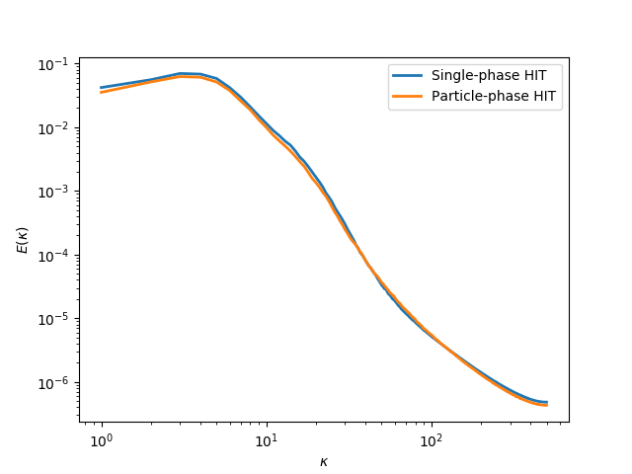

#### Single-phase HST ####
#### Input ####
Density: 1.0
Viscosity: 0.002
Shear Rate: 0.5

#### Output ####
Turbulent kinetic energy: 0.4705268065026096
Dissipation rate: 0.09600166584429844
Reynolds number: 87.67673301072612
<u2>/k: 1.1173440012605556
<v2>/k: 0.33021724704581673
<w2>/k: 0.552438751693628

#### Particle-laden HST ####
#### Input ####
No. of particles: 143156
Density of particle: 800
Particle diameter: 0.0057

#### Based on single-phase values ####
Stokes no.: 5.002206132197037
Mass loading: 0.7932218992135106

#### Output ####
Dissipation rate: 0.07034214570033123
TKE of gas phase: 0.3597205401917835
TKE of particles: 0.20817977162809795
