**Ghud Music**

Ghud Music Player is a proudly Ghanaian wordpress plugin for integrating GhudMusic audio player service to posts on a wordpress site.

**Description**

The plugin adds an audio player element to wordpress posts. The Ghud Music player comes with extra services such as usage data analytics.

This plugin sends client information to the Ghud Music servers for usage data analytics for artistes to know more about their music reach.

**Installation**

You may install the plugin using the following procedures:

1. Locate the GhudMusic player zip file enclosed in this package
2. In your wordpress Plugin window, selecting Add new, then select upload plugin and then choose file.
3. Navigate to the GhudMusic zip file and click open. This would upload the GhudMusic plugin.
4. Activate the plugin through the ‘Plugins’ menu in Wordpress after the upload.
5. Install and activate [ShortCake](https://wordpress.org/plugins/shortcode-ui/) 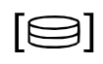 and [tinymce](https://wordpress.org/plugins/tinymce-advanced/)  plugins from [WordPress Plugin](https://wordpress.org/plugins/) Directory.

**Usage**

To add Ghud Music player to a post

1. In the wordpress classic Editor, select Add block and choose “Classic Paragraph”

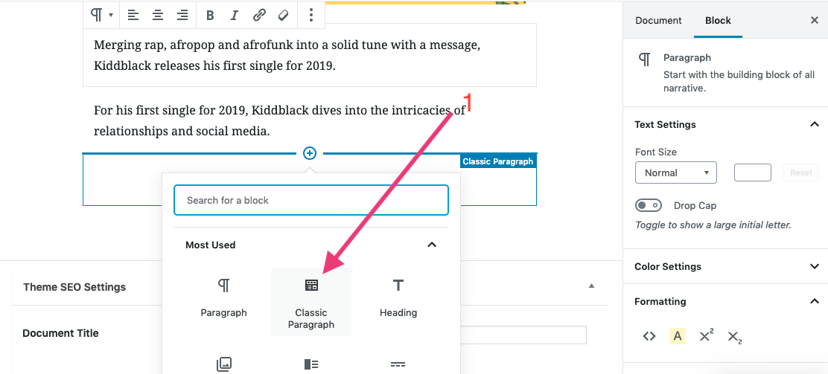

1. In the Classic paragraph, click on the “Add Media icon”

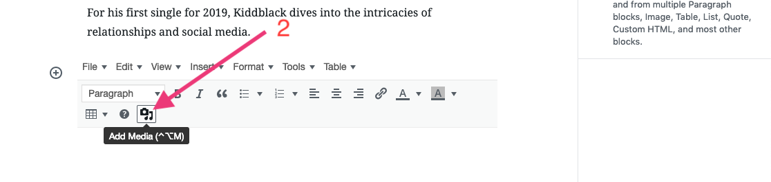

1. Select “Insert Post Element” on the sidebar of the Add Media dialog

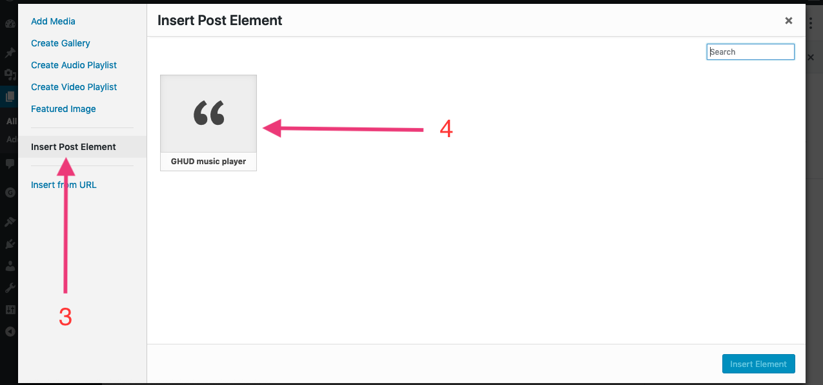

1. Select the Ghud Music player element from the list.
2. This opens up a form. Fill in all the form fields with appropriate info and click on “Insert Element”

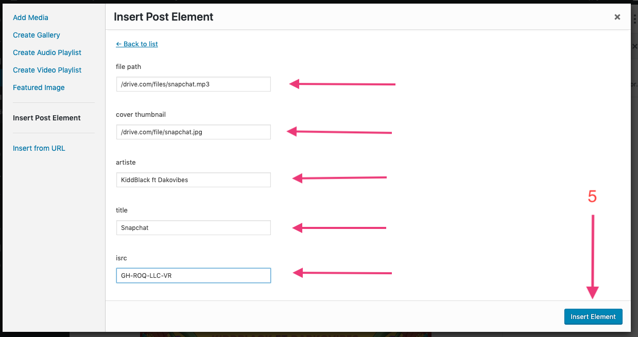

1. Save and publish Post to see the Ghud Music player in action

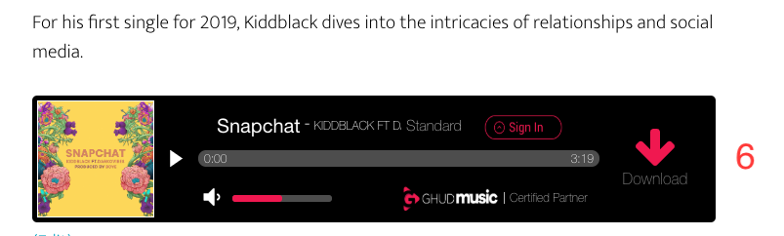

GhudMusic Player Form Fields:

1. file path: the path to music file

2. cover path: the path to the music thumbnail

3. artiste: the name of the artiste

4. title: title of the song

5. isrc: isrc code of music file.

**Frequently Asked Questions**

Q) Can I add more than one GhudMusic audio elements to single post?

A) No you cannot. You can only add one GhudMusic element per post

Q) Does this plugin collect data?

A) Yes, it does. It sends usage data such us country of user, city of user, download count to the GhudMusic server

Requires WordPress 3.0 +