AI Pioneers Internship: Week 2 Supervised Learning Report
Intern Name: Aquine Roshan Pais
Project Track: Machine Learning Internship
Dataset: Credit Card Fraud Detection (10k Records)
Date: October 2026

1. Objective
The primary objective of Week 2 is to train at least two supervised machine learning models (Classification) using Scikit-Learn, evaluate their performance using metrics like precision, recall, and f1-score, and explore techniques to handle highly imbalanced datasets.

2. Data Splitting & Model Selection
The preprocessed dataset from Week 1 was separated into feature variables (X) and the target variable (y = 'is_fraud'). To ensure the models were evaluated fairly on unseen data, the dataset was split into an 80% training set and a 20% testing set.
For the classification task, two contrasting algorithms were selected: Logistic Regression (a linear model) and Random Forest (an ensemble tree-based model).

3. Baseline Model Evaluation (The Accuracy Trap)
Initially, both models were trained on the standard, imbalanced dataset. At first glance, both models achieved a 99% overall accuracy. However, this metric is highly misleading due to the 'Accuracy Trap'. Since only 31 out of 2000 test transactions were fraudulent, a model could simply guess 'Normal' every time and achieve over 98% accuracy.
Evaluating the true metrics:
- • Logistic Regression heavily favored the majority class. It missed most of the fraud, achieving a Recall of only 0.29 (catching 29% of fraudulent transactions).
- • Random Forest proved much more robust. It achieved a Recall of 0.58 and a flawless Precision of 1.00 (100%), meaning it caught double the amount of fraud without making a single false accusation.

4. Handling Imbalance: The SMOTE Effect
To improve the models' ability to detect the minority class (fraud), I applied SMOTE (Synthetic Minority Over-sampling Technique) exclusively to the training data. This generated synthetic fraud examples, creating a perfectly balanced training set.

5. The Precision-Recall Trade-off
Applying SMOTE demonstrated the classic Precision-Recall Trade-off:
The Good: It completely cured the Logistic Regression model's 'blindness'. By forcing the model to study synthetic fraud, its Recall skyrocketed to 0.77 (catching 77% of all fraud).
The Bad: The model became overly paranoid. Because it was highly sensitized to fraud, its Precision plummeted to 0.16. In a real-world scenario, this means 84% of the accounts it flags for fraud would actually belong to innocent customers, leading to a massive spike in false alarms.
Below is the visual Confusion Matrix comparison detailing the performance before and after SMOTE:
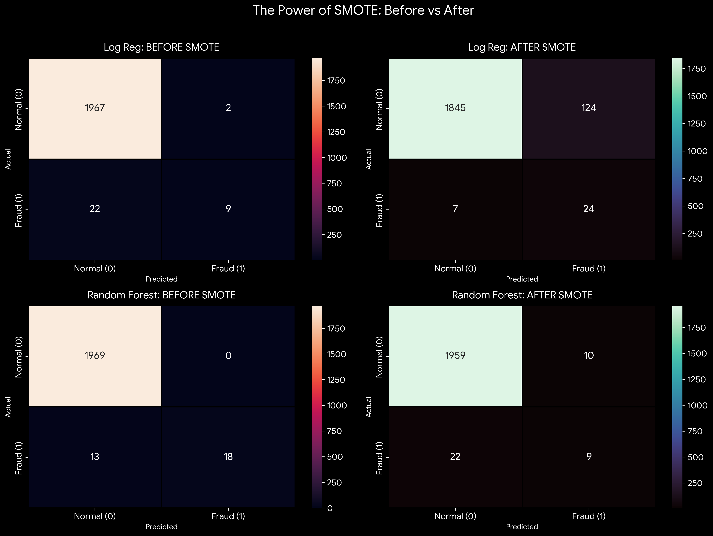

6. Final Business Verdict
While SMOTE successfully boosted recall for the linear model, the resulting drop in precision makes it too aggressive for real-world banking deployment. The baseline Random Forest model remains the superior choice, as decision trees naturally handle imbalanced datasets effectively and provide a much safer, more profitable balance between catching financial thieves and protecting the customer experience.

