AI Pioneers Internship: Week 1 Preprocessing Report
Intern Name: Aquine Roshan Pais
Project Track: Machine Learning Internship
Dataset: Credit Card Fraud Detection (10k Records)
Date: October 2026

1. Introduction & Objective
The primary objective of Week 1 is to build a robust foundation in data preprocessing using Python, Pandas, and NumPy. Real-world datasets are rarely ready for machine learning algorithms out of the box. They contain noise, missing values, incompatible data types, and varying scales. This report details the comprehensive step-by-step data cleaning and transformation pipeline applied to the Credit Card Fraud Detection dataset to prepare it for predictive modeling in the subsequent weeks.

2. Data Loading and Initial Exploration
The project began by loading the 'credit_card_fraud_10k.csv' file into a Pandas DataFrame. The dataset consists of 10,000 transaction records and 10 columns, including numerical features (e.g., amount, device_trust_score, cardholder_age), categorical features (e.g., merchant_category), and a binary target variable (is_fraud) indicating whether the transaction was fraudulent (1) or legitimate (0).
Below is a snapshot of the raw dataset immediately after loading, displaying the unscaled numerical values and text-based categorical columns:
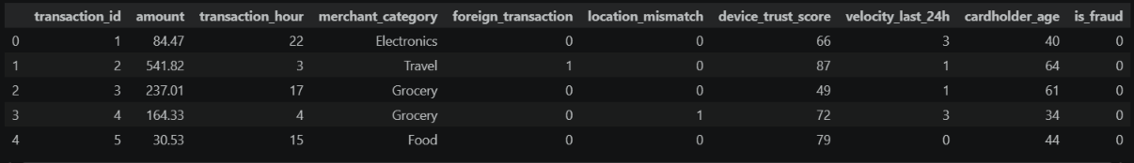

3. Missing Value Analysis
Machine learning algorithms cannot process records with null or missing data (NaN). The first crucial step in data cleaning is identifying these gaps. I utilized the df.isnull().sum() method in Pandas to calculate the exact number of missing entries across all features.
The analysis revealed that this dataset is structurally complete, with zero missing values in all 10 columns. Consequently, advanced imputation techniques (such as mean/median replacement or K-Nearest Neighbors imputation) were not required.

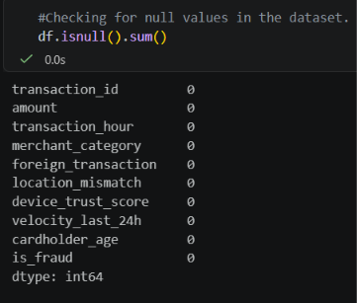

4. Feature Selection and Dimensionality Reduction
Feature selection involves isolating the variables that actually contribute predictive power to the model. The 'transaction_id' column was identified as a nominal identifier. Because it is simply a sequential reference number and holds no behavioral or financial significance regarding the transaction, keeping it would only introduce noise into the model. I removed this column from the DataFrame using the df.drop() function.

5. Encoding Categorical Variables
Predictive models mathematically calculate patterns, meaning they strictly require numerical inputs. The dataset contained a 'merchant_category' column featuring text data such as 'Electronics', 'Travel', 'Grocery', 'Food', and 'Clothing'.
To solve this, I applied One-Hot Encoding using Pandas' get_dummies() method. This technique transforms each category into its own binary column (1 or 0). To avoid the 'dummy variable trap' (perfect multicollinearity), I used the drop_first=True parameter, which removes one of the encoded columns, as its value can be inherently inferred from the others. The output was explicitly cast to integers to ensure compatibility with Scikit-Learn.

6. Data Normalization and Feature Scaling
A significant issue in the raw data was the massive disparity in scale between different features. For example, the 'amount' column contained values in the hundreds or thousands, whereas binary columns like 'foreign_transaction' contained only 0s and 1s.
Machine learning algorithms (especially distance-based ones like KNN or gradient-based ones like Logistic Regression) are highly sensitive to these scales. A feature with larger numbers will disproportionately influence the model. To mitigate this, I applied Z-score Normalization (Standardization) using Scikit-Learn's StandardScaler. This algorithm transformed the selected numerical columns ('amount', 'transaction_hour', 'device_trust_score', 'velocity_last_24h', 'cardholder_age') to have a mean of 0 and a standard deviation of 1.

7. Final Prepared Dataset
The culmination of these preprocessing steps is a fully optimized, numerically scaled, and machine-readable dataset. All text has been successfully encoded, meaningless identifiers have been dropped, and scale variances have been neutralized.
Below is a snapshot of the final DataFrame, showing the transformed features:
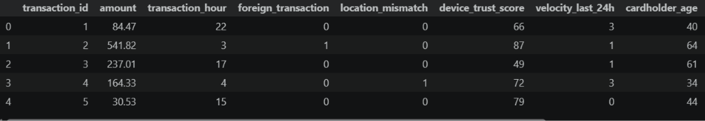
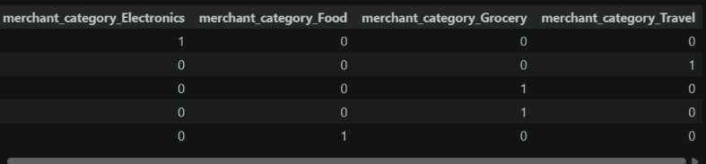
The cleaned dataset was exported as 'cleaned_credit_card_fraud_10k.csv' and is primed for the supervised machine learning tasks scheduled for Week 2.

