Week 3 Task: Advanced Data Analysis and Visualization in Logistics
This report contains the Exploratory Data Analysis (EDA) for the logistics network, focusing on cost drivers, weather impacts, and vehicle efficiency.

1. Correlation Analysis & Cost Drivers
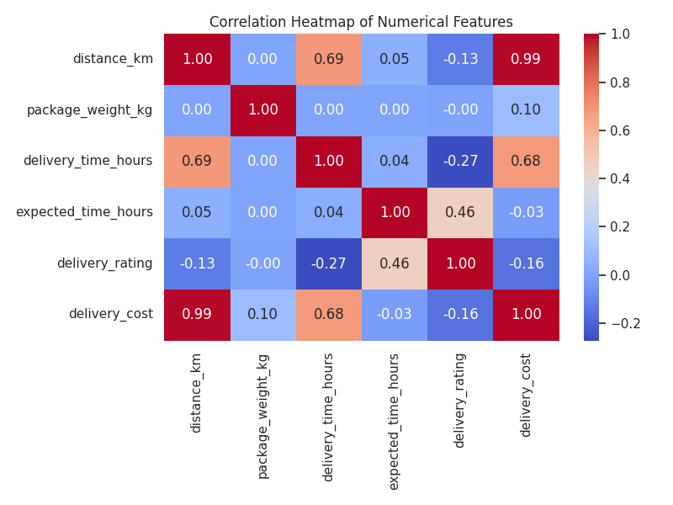
Observation 1: Distance is the Only Cost Driver
The heatmap shows an almost perfect positive correlation (0.99) between distance_km and delivery_cost. This reveals that the logistics network's pricing model is driven entirely by how far a package travels, while completely ignoring package_weight_kg (which has a near-zero 0.10 correlation with cost).
Observation 2: The Expectation Game
Actual delivery time hurts customer satisfaction, shown by the negative correlation (-0.27) between delivery_time_hours and delivery_rating. However, there is a strong positive correlation (0.46) between expected_time_hours and delivery_rating. Customers rate the delivery higher when they are given a longer expected delivery window upfront. Adding a deliberate 12-to-24 hour buffer to expected delivery times can manage expectations and improve feedback.

2. Impact of Weather on Delays
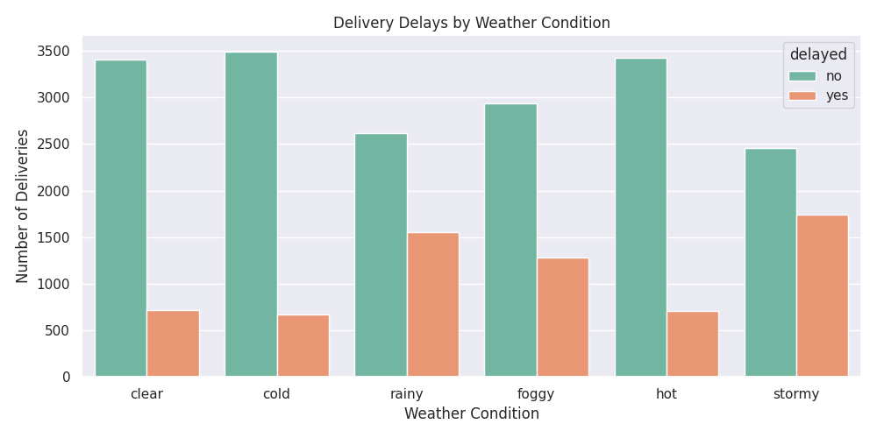
Observation: Precipitation and Visibility Drive Delays
Adverse weather conditions—specifically stormy, rainy, and foggy weather—are the primary catalysts for delivery delays. While stable conditions like clear, cold, and hot weather maintain strong on-time performance, stormy weather causes a massive disruption, spiking to over 1,500 delayed deliveries.

3. Vehicle Vulnerability in Adverse Weather
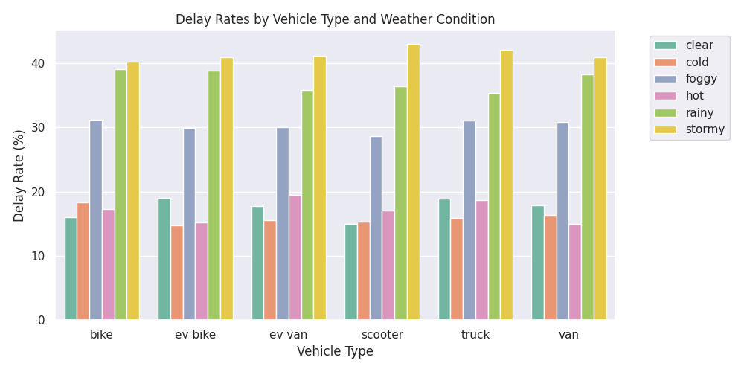
Observation: The Storm Bottleneck for Two-Wheelers
Stormy weather pushes delay rates past 40% across almost every vehicle type. The most severe bottleneck happens with scooters, which face a massive 43.05% delay rate during storms. The business should temporarily halt scooter dispatches during severe storms, relying instead on larger, enclosed vans.

4. Network Reliability and Asset Management
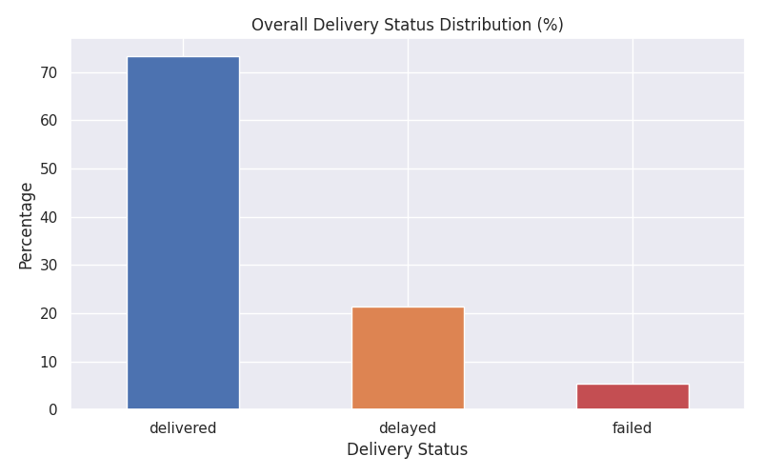
Observation: Network Reliability and the Failure Threshold
73.32% of all deliveries are successful and on time, and 21.36% are successful but delayed. However, there is an absolute failure rate of 5.31%. Regionally, the Central (5.65%) and West (5.63%) regions have the highest failure rates.
Observation: The Misalignment of Vehicle Assets
There is almost zero differentiation in how different vehicles are utilized. The average distance traveled by a heavy-duty truck (150.26 km) is almost identical to a light-duty scooter (150.16 km). The business must implement an automated dispatch algorithm that restricts scooters to local, lightweight routes, reserving trucks for heavy, long-distance freight.

