Week 3 Task: Root Cause Analysis and Hypothesis Testing
Prepared by: Aquine Roshan Pais
Virtual Data Analysis Associate Intern - YuvaIntern

1. Root Cause Analysis Preparation
This week transitions the project into the 'Analyze' phase of the DMAIC framework. The objective is to identify the root causes driving the high order picking times identified in the Define phase. To structure this analysis, a Cause-and-Effect (Fishbone/Ishikawa) diagram was developed.

2. Cause-and-Effect (Fishbone) Diagram
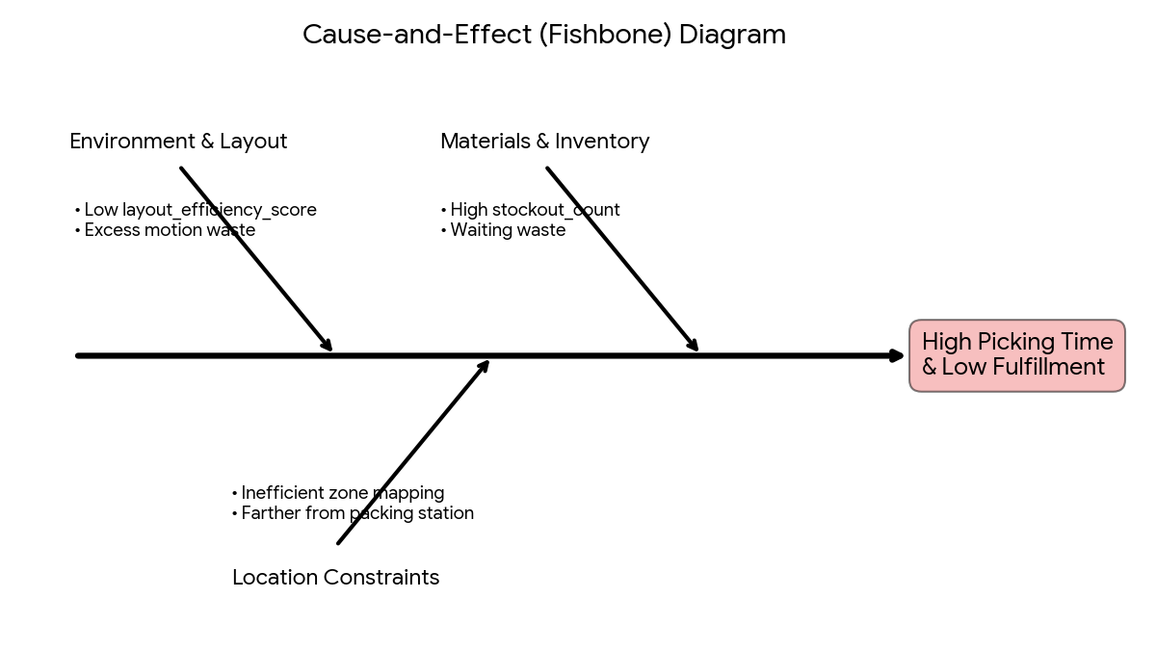

3. Hypothesis Testing & Disproven Assumptions
Based on the Fishbone diagram, two initial hypotheses were formulated to test if physical warehouse layout or inventory stockouts were causing delays. Python and pandas were used to statistically evaluate these assumptions:
- • Hypothesis 1 (Motion Waste): Null Hypothesis (H0) tested the relationship between layout_efficiency_score and picking_time_seconds. The correlation calculation returned exactly 0.00.
- • Hypothesis 2 (Waiting Waste): H0 tested the impact of stockout_count_last_month on order_fulfillment_rate. The correlation also returned 0.00.
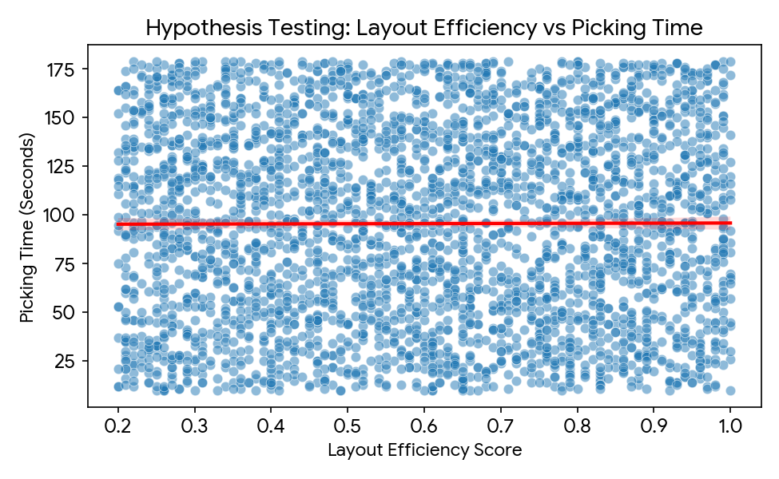
Insight: The completely flat trendline and 0.00 correlation scores are massive findings. They mathematically disprove our initial hypotheses. A poor layout score and empty shelves are NOT the root causes of the 45-minute picking times. This data-driven elimination allows us to pivot to advanced exploratory data analysis.

4. Advanced Data Analysis & True Root Causes
With initial assumptions disproven, deeper statistical grouping revealed three hidden root causes:

A. Warehouse Slotting is Misaligned
The data reveals a clear mismatch between where items are stored and how efficiently they can be picked. Zone C has the highest average orders per item (529.98) but is the slowest zone in the facility (96.73 seconds). Conversely, Zone A is the most efficient picking area (93.81 seconds) but holds items with lower average order volumes. Forcing workers to constantly visit the slowest zone for high-demand items creates a massive daily delay.
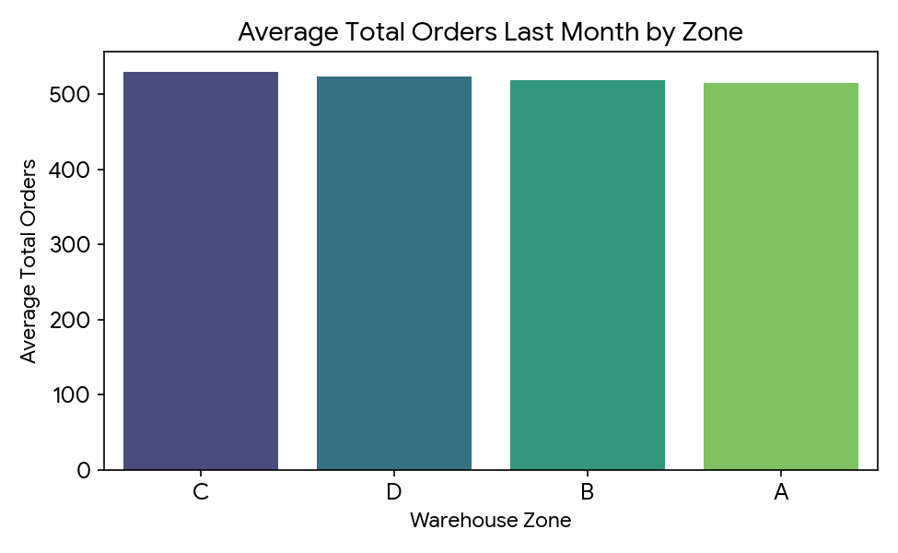

B. Item Category Bottlenecks
Grouping by item category shows that 'Apparel' is the slowest category, taking 97.08 seconds per pick, while 'Groceries' average 94.37 seconds. The physical nature of clothing (hangers, polybags, hard-to-scan barcodes) creates a specific handling bottleneck.

C. The 'Hidden Variance' (Process Inconsistency)
A correlation matrix generated across all numerical variables against picking time showed scores near 0.00 (e.g., stock levels at -0.029, total orders at -0.009). Because no system metrics explain the delays, the root cause is human inconsistency. Workers are picking the exact same items at wildly different speeds, pointing to a lack of Standard Operating Procedures (SOP).

5. Conclusion
Through rigorous Python analysis, we successfully eliminated false assumptions and identified the true bottlenecks: misaligned slotting, category-specific handling issues, and human inconsistency. This sets the perfect foundation for Week 4's Improve and Control phases.

