**Natural Language Processing:**

**Classify Amazon reviews based on the customer's ratings.**

**What is the business problem?**

Many times, ratings are represented by a numerical value (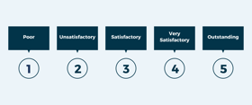) or stars (). However, the text feedback holds more value than the quantified ratings. Sometimes, the rating given may not accurately reflect the experience of the product.

**Who are the intended stakeholders, and why is this problem relevant to the**  Manufacturer, Sellers, Marketing and Customers

**Where are the datasets available from?** There are available at

142.8 million reviews (http://jmcauley.ucsd.edu/data/amazon)

**Which one do you like the most?**

NLP: Classify Amazon reviews based on the customer's ratings.

**What type of data science approach would you use?**

Natural Language Processing and Feature Engineering

**How many rows and how many columns does the dataset have?**

In this project, we use 5-core dataset of reviews from electronics which is subset of the data in which all users and items have at least 5 reviews.