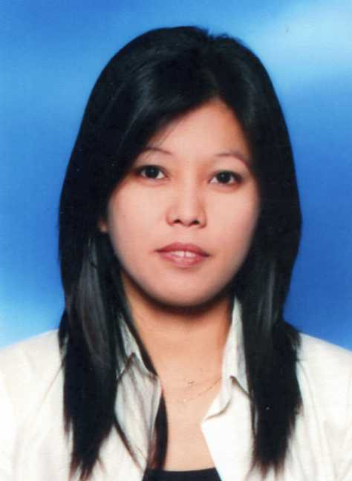
MARY GRACE (Grace) A. ARTIENDA
33 Spoonbill Avenue, Woronora Heights

Sydney, NSW, Australia 2233
Mobile No.: +614-4852 3023 Home No.: 9542 6934
grace3018@yahoo.com

PERSONAL DATA:

Date of Birth : March 30, 1978
Place of Birth : Quezon City, Philippines
Age : 32

Sex : Female
Civil Status : Single
Passport No. : XX2803638
Spoken Language(s) : English, Filipino and Thai (Basic)
Permanent Address : #22 5-E Doña. Hemady Street
E. Rodriguez Sr. Blvd., Quezon City, Philippines 1112
Tel. No. (+63) 917 9442384

WORK EXPERIENCES:

May 2010 to Present FOOTPRINTS CHILDCARE CENTRE
53 Bundanoon Road, Woronora Heights
Sydney, NSW, Australia 2233

Tel. No. +612 9521 4476

Position: NURSERY ASSISTANT TEACHER

Duties and Responsibilities:
- To provide professional high quality care and developmental experiences to children in the nursery room.
- To plan for, implement, observe, document an evaluate information on these children to create a holistic picture of their development.
- To work with management, co-workers, children and their families to reach personal and centre goals.
- To establish and maintain the daily rhythm and routine of the room.
- To provide, maintain and monitor all centre resources.
- To draw upon my previous learning and experiences regarding children and education.
- Work with staff members to ensure the smooth operation of the centre subject to service policies and procedures in the Parent Handbook and the Long Day Care Manual.
- Supervise the activities of a group of children during the day (eg. language / music groups).
- Assist in implementing the daily routines eg. bathroom, lunch and rest times.
- Participate in supervising indoor/outdoor environments to provide safety for the child at all times.
- Positively interact with the children nurturing their confidence and self esteem giving each child individual attention and comfort as required.

Sept 2004 to May 2009 ST. JOHN’S INTERNATIONAL SCHOOL
1110/3 Vipavadi-Rangsit Rd. Ladprao,
Bangkok, Thailand 10900

Tel. No. +66 (02) 513-8575

Position: SEN SUPPORT TEACHER (SECONDARY DEPT.)

Duties and Responsibilities:
- To develop an understanding of the specific needs of the children concerned.
- To help the children learn effectively as possible both in groups and on their own.
- Clarify and explain instructions.
- Assist in weak areas e.g. language, reading, spelling, handwriting and presentation.
- Helping pupils to set realistic targets.
- In-charge of updating the schools database making sure all student files are updated.
- Helping the IT staff in setting up computers making sure all the programs needed are working.
- Establishing a supportive relationship with the pupil.
- To encourage integration of children with learning difficulties.
- To help promote the child’s self-esteem.

Sept 2001 to Aug 2004 ST. JOHN’S INTERNATIONAL SCHOOL
1110/3 Vipavadi-Rangsit Rd. Ladprao,

Bangkok, Thailand 10900
Tel. No. +66 (02) 513-8575

Position: TEACHING ASSISTANT / SEN SUPPORT
(PRIMARY DEPT.)
Duties and Responsibilities:
- Helping class teachers both in and outside the classroom with such tasks as supervising activities, preparation of materials and working with small groups under the teacher’s direction.
- Accompany students on outings and help to supervise them.
- Required to cover for the class teacher in the event of the class teacher being unable to report for duty.
- To support the teacher as required in creating an effective and stimulating learning environment for the children.
- To report all accidents promptly and ensure that children are given immediate support.
- Keep records where required pertaining to student accidents, behaviour and progress.
- Carry out the duties of basic first aid in the Reception and KS 1 Department.
- Helping the IT staff with regards in backing-up student files and transferring them in a new hard drive.
- Taking full responsibility towards the children during break, lunchtime and playtime.
- To support children in their learning.
- Implement any school policies on supervising student behaviour and welfare.

Apr 1996 to Aug 2001 BLUE CROSS HEALTH CARE, INC.
Blue Cross Centre, Makati City
Philippines

Tel. No. +63 (02) 899-8001

Position: DATA VERIFICATION OFFICER /
ASSISTANT SECRETARY
Duties and Responsibilities:
- Responsible for monitoring all of Blue Cross membership cards
- Encodes and process every Blue Cross cards
- Admits the in and out processing of membership cards
- Back-up on checking of billings according to the draft before signing them.
- Back-up on releasing of debit notes for New Business, Renewals, Regular Billings and Endorsements.
- Answering phone calls for other inquiries.
- Lay-out of design for both HMO/Insurance Membership ID’s
- In charge of overall production of Blue Cross Membership cards.
- Assistant Secretary to the IT Vice - President

SCHOLASTIC RECORD:

COLLEGE LEVEL: TECHNOLOGICAL INSTITUTE OF THE PHILIPPINES
Quezon City, Philippines
Standard Achieved: Bachelor of Science in Computer Engineering
June 1994 – March 1999

SECONDARY LEVEL: QUEZON CITY HIGH SCHOOL
Quezon City, Philippines
Outstanding Student
June 1990 – March 1994

PRIMARY LEVEL: TOMAS MORATO ELEMENTARY SCHOOL
Quezon City, Philippines
Outstanding Student
June 1984 – March 1990

SEMINARS and OTHER COURSES ATTENDED:

Nov. 02, 2010 to Feb. 15, 2011 MEGT INSTITUTE
Level 470 Riley Street
Darlinghurst , NSW, Australia 2010
Course: Diploma in Children’s Services

Oct. 28, 2008 to Dec. 16, 2008 NATIONAL ACCREDITATION AUTHORITY for TRANSLATORS and INTERPRETERS LTD. (NAATI)
Suite 1 Level 5, 280-282 Pitt Street
Sydney, NSW 2000, Australia
Tel. No. 02 92671357
Course: Behaving Ethically (online course)

Oct. 25, 2008 INTERNATIONAL ENGLISH LANGUAGE TESTING SYSTEM (IELTS)
4th Floor C.P. Tower, 313 Silom Road
Silom Bangrak, Bangkok 10500 Thailand
Score: Listening: 6.5, Reading: 5.5, Writing: 5.5
Speaking: 7.5, Overall Band Score: 6.5

Sept. 02, 2006 TEST OF ENGLISH FOR INT’L. COMMUNICATION
(TOIEC)
Suite 1907, Bangkok Business Building, 54 Asoke Road,
Sukhumvit, Bangkok 10110 Thailand
Score: Listening: 440 out of 500
Reading: 365 out of 500

Oct. 10, 2001 to Mar. 2003 CAMBRIDGE SKILLS AWARD IN INFORMATION TECHNOLOGY (online course)

St. John’s International School
1110/3 Vipavadi-Rangsit Rd. Ladprao,
Bangkok, Thailand 10900
Tel. No. (02) 513-8575 Course: MS-Word and Excel

SPECIAL SKILLS:

Has broad knowledge in Life, Non-Life and Health Insurances. Proficient in Microsoft Word, Excel, PowerPoint, Microsoft Publisher, Photoshop, Access, Dream weaver & MS – DOS. Knowledge in Scanning Images, Visual Basic 6, Crystal Reports, Minor Troubleshooting of PC hardware, Installation of software’s and Fox-Pro. Can operate fax, laminator and photocopying machine. Record Keeping.

CHARACTER REFERENCES:

Ms. Lisa Clancy
Owner / Director

Footprints Child Care Centre
53 Bundanoon Road, Woronora Heights

Sydney, NSW, Australia 2233

Email add.: lisa137@bigpond.com

Ms. Lissa Kasim

Supervisor

Footprints Child Care Centre
53 Bundanoon Road, Woronora Heights
Sydney, NSW, Australia 2233

Mrs. Juliette van Eerdewijk
Deputy Head of School

PDO School, PDO LLC, HRO/5
Po Box 81, Muscat, Oman
Email add.: jvane26@mac.com

Mr. John Patrick
Primary Teacher (Y3)

St. John’s International School
1110/3 Vipavadi-Rangsit Rd. Ladprao,

Bangkok, Thailand 10900

Email add.: johnp555@hotmail.com

“I hereby certify that all information provided in the foregoing are true and correct to the best of my knowledge and ability.’’

Mary Grace (Grace) A. Artienda

