Address India - Resident:
Flat 301, A Block, Fortune Enclave,
Road no. 12, Banjara Hills,
500 034 Hyderabad, AP
INDIA

Address Italy:
Via Lumumba, 5
42122 Reggio Emilia (RE)
ITALY

Cell. India +91 9618474789
Office India: +91 40 27160156

Cell. Italy: +39 347 8768501
E-mail: federico.maurilli@libero.it

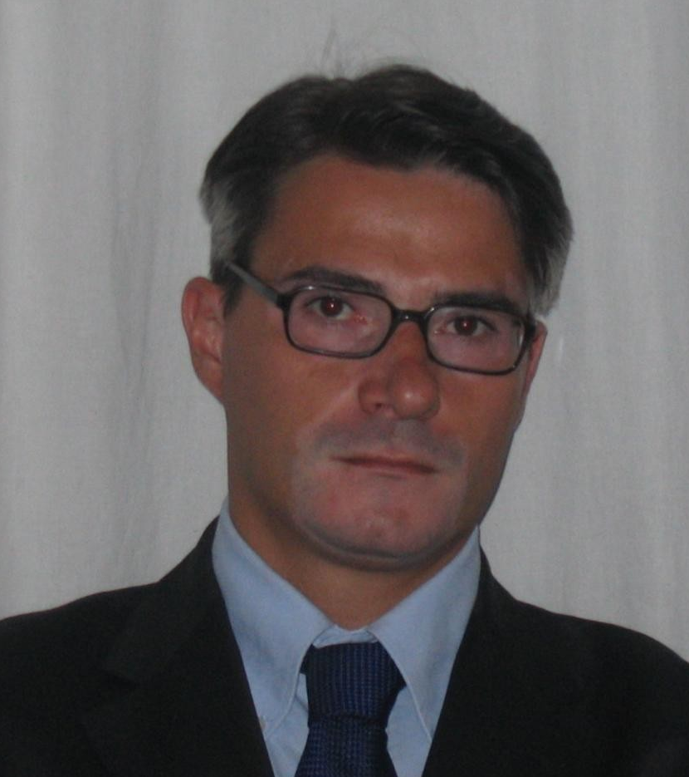

Mr. Federico Maurilli – Curriculum Vitae

Personal details
- Nationality: Italian
- Date of birth: September 20, 1972
- Place of birth: Reggio Emilia, Italy

Education
2009 Engineers Australia assessment as Mechanical Engineer Professional
(ASCO 2621-11 or ANZCO 233512)
2000 Member of the Engineers Association “Ordine degli Ingegneri” of Reggio Emilia, ITALY - (no. 1333 of the professional register, Reggio Emilia)
1999 Government Exam, University of Parma, Italy - to be qualified for the profession of Engineer. Score: 82/100
1999 University name: “University of Parma, Faculty of Engineering” Parma, Italy
University degree in Mechanical Engineering (Master Engineer, Laurea 5 years)
Graduation thesis: “Air condition system for Hybrid Bus”, final grade 95/110
1991 College name: “A. Secchi” high school of Reggio Emilia,
School-levelling certificate of Surveyor/Geometric final grade 56/60 (5 years)
(Primary school 5 years, middle school 3 years; total 18 years schooling legal last)
1998-1999 Military-Social Service in Italy

Language Italian mother tongue; fluent English

Professional experience
- 05/2010 – present BERCO - THYSSENKRUPP – Earthmoving and Mining machine Components – Undercarriage components manufacturing, sales and trading: Track chains, idlers, track rollers, and carrier rollers for excavators and dozers. (Ferrara, Italy and Hyderabad, India)
Department: Berco Undercarriages India Pvt. Ltd.
Role: MANAGING DIRECTOR (CEO) – Hyderabad Plant, India resident

Main activities:
- New company start up in India, part of 7.5 million € Foreign Investment
- Customers portfolio: 2010-2011 10,0 million € - next year 15,0 million €; listing price composition; marketing and sales strategies, Berco representative in India, press agency speeches
- Production implementation: Lines and Investments for manufacturing excavator undercarriage components, lay out improvement
- Quality: quality lab to be made totally within one year, hiring people and buying equipments
- HR: increasing personnel from 15 to 150 people (now 40)
- Purchasing relocation in India, finding new suppliers, logistic income and outcome materials
- Finance: Investments planned in 2010-2011 for 1.500.000 €; Cash flow analysis; Assets, Balance sheet and Audits approval; Budgeting and actual check as well as taking corrective actions and making blueprint for short and long term plan. Service and trading activity start up.
- Reporting to Berco Board of Directors and to Shareholders

- 10/2007 – 04/2010 BUCHER HYDRAULICS (Italy) – part of BUCHER INDUSTRY (Germany) – Automotive and Tractor Components – Machining, Assembly and testing Hydraulics Valves and Pumps for Earthmoving, Tractors and Mining machines. (Reggio Emilia, Italy and Gurgaon-New Delhi, India)
Department: Bucher Hydraulics Pvt. Ltd. India - Production
Role: PRODUCTION MANAGER
New Delhi Plant, India Resident
Main activities:
- Start up new products lines: production, quality, purchasing, logistics and engineering/design dept. management as well as suppliers’ management.
- Transfer Mechanical Engineering knowledge: Testing benches, manufacturing and assembly methods, design lay out and tools.
- Control of the Product cost analysis.
- Manage and control local production resources (workers and staff, precision machines – Honing and Grinding - materials, equipments), ensuring best utilization of resources. Implementation of all activities in assembly and manufacturing process.
- Monitor the machines shop and assembly dept. performance for the India plant.
- Prepare budget and track plans for investments.
- Ensure that all procedures are adhered to the quality standards and that they are maintained at all times. Improve quality for Indian local market and for European market.
- Ensure that all work is carried out in accordance with Health, Safety & Environmental regulations.
- Develop, cost evaluation and carry out new products.
- Look for, plan and develop a new bigger plant within India.
- Find a local supply chain for European Plants.
- Report to Bucher Italy General Manager and to Bucher Hydraulics German President.

- 01/2002 – 09/2007 LANDINI – ARGOTRACTORS Group – (ex Massey Fergusson) – Automotive/Tractors Sector - Tractors Assembly lines: from gear boxes, transmissions, cabs, axles, hydraulic and electrical lay out, painting, electronic/hydraulics test benches, to the complete tractors, both wheeled and tracked.
Department: Production – Landini (S.Martino in Rio, RE, Italy)

Role: PRODUCTION ENGINEERING MANAGER
Main activities:
- Managing times and methods team, maintenance team, new products team
- Plant Budget and Monthly Actual check and taking corrective actions
- Coordination, Analysis and planning for a work force of 200 workers and staffs coordination.
- Developing, cost evaluation and carrying out new production equipments, fixture and fitting
- Implementation of all technical activities in support of the assembly process:
- Lay-out design and carrying out
- Times & Methods, work-flow and work-loads analysis, organisation of the work locations
- Tools, equipments and fixtures for assembling
- Testing benches
- Insuring a regular maintenance following the quality standards, safety regulations, legal compliance:
- Purchase of components, new tools, fixture and fitting - negotiation
- Managing external contractors and execution
- Managing internal maintenance dept. resources
- Manage health and safety issues
- New products industrialization and start up, product manager
- Coordination of the department heads in relation to:
- Staff training
- Management of the scraps and defects
- Improvement of the work force efficiency and product quality

- 01/2000 - 12/2001 LANDINI-MASSEY FERGUSSON (S. Martino in Rio, RE, Italy)
Department: Production Engineering
Role: PRODUCTION ENGINEER
- Times & Methods Analysis
- Design Lay-out, Benches, Tools, equipments and fixtures for assembling

- 11/1999 - 01/2000 Frigorbox Industrial cold stores (Scandiano, Reggio Emilia – Italy)
Department: Engineering
Role: DESIGNER ENGINEER
- Design and project Industrial cold stores, structures and panels

Skills and personal competencies
- Experience in companies start up and in developing Countries
- Practice to make decisions in solving complex problems in frequently changing conditions and in different Countries and Strong flexibility in new contexts
- Excellent knowledge of lean manufacturing, Kanban, Asaichi meeting, “spaghetti” layout
- Experience in managing a workforce of 200 people
- Long experience in Tractors and Earthmoving machinery components sectors as well as hydraulics

Attended courses
- “Hydraulic systems” 51 hours
- “Lean Production” 8 hours
- “Times and Methods” 30 hours
- “Machines safety: UNI EN safety regulations” 16 hours
- “Quality check in painting processes” 8 hours

Computer literature
- Windows, Word, Excel, Project, Outlook
- Technical: AUTOCAD, Multiframe, ProE (knowledge)
- Systems: JdE, Baan, Navision

Interests and hobbies
- Art and painting
- Playing volleyball
- Travelling, Nature
- Motorbike Riding
- Spending time with my family

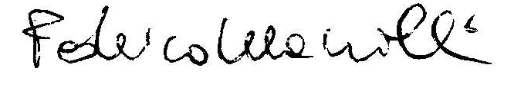
Federico Maurilli

