ZAHRA SHAHSAVANDI
Tel 0098-917-3069322
0098-711-6317677
E-Mail SH.SHAHSAVANDI@GMAIL.COM
Address NO.479, Alley 90.GHASRODASHT ST. Shiraz

PROFILE
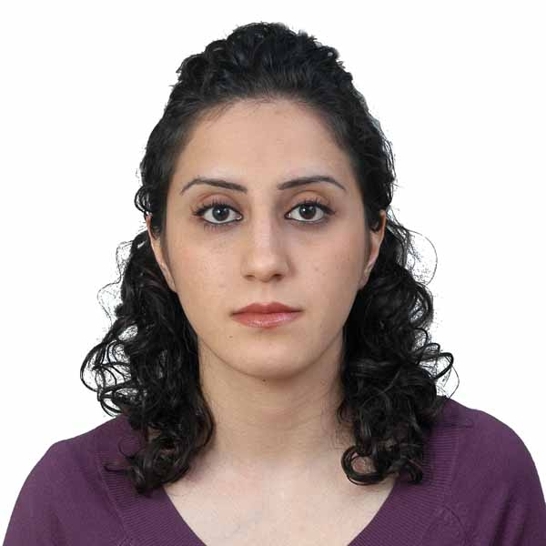
WORK EXPERIENCESex : Female
- Date Of Birth : 10 April 1983
- Marital Status :Married
- Nationality :Iranian
- Country of residence : Iran
- Current position: BSC Supervisor
- Company: Iran Telecommunication Company
- Salary expectation: Not Specified/ Negotiable

June 2006 - Present | Telecommunication Company Of Iran | Shiraz , Iran
 | BSC Supervisor
 | I'm working as a supervisor in Telecommunication Company Of Iran vender Nokia(BSC)

Aug 2005 - Jan 2006 | Fars House Of Industry And Mine | Shiraz , Iran
 | Agent Of Dubai Exhibition
 | I was working as an agent for Dubai exhibition in Iran.

EDUCATION
Oct 2001 - Jun 2005 | Azad University Of Fasa | Fasa , Iran
 | Electronics Engineering, Bachelor(BSc/BA), GPA 15.85

SKILLS
Windows & Office tools
• IT | Intermediate
Operating systems, Networking & Hardware
• NETWORK  Other SKILLS  • GSM  • Robotics  • Instruments  • Data Communication | Intermediate  Advanced  Intermediate  Intermediate  Advanced

LANGUAGES
• English
Working knowledge(speaking,writing,listening,reading)
Score 6.5 in IELTS exam

Bottom of Form

