EUROPEAN FORMAT  curriculum vitae   | 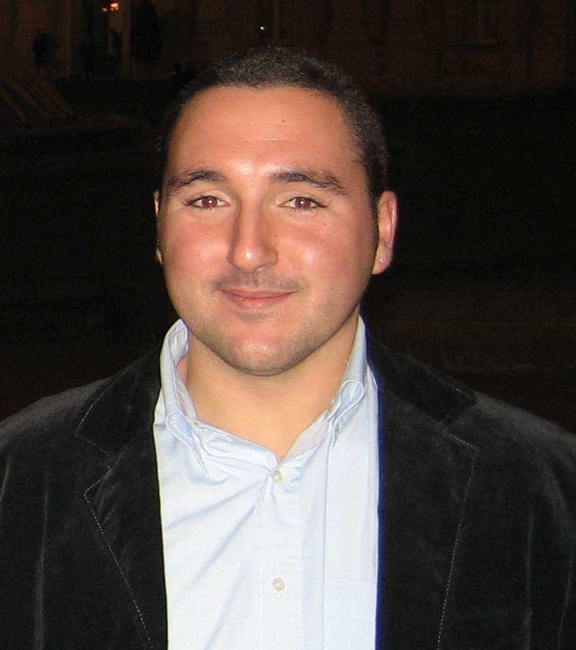
Personal information
First name(s) / Surname(s) | Spessot Emanuele
Address(es) | 14, via Torrente Corno , 33033, Codroipo (UD), Italy
Telephone(s) | - |  |  |  |  | Mobile: |  |  |  | +39 348 0079009
Fax(es) | +39 0431 33168
E-mail | emanuele.spessot@libero.it
Nationality | Italian
Date of birth | 09th November 1981
Gender | Male
Work experience
Dates | From 02/02/09
Occupation or position held | Technical employee
Main activities and responsibilities | R&D and Technical manager, Quality control manager, Supply chain
Name and address of employer | Castalia Srl – 13, via G.Bruno, 33050, Rivignano, Italy – tel: +39 0432 775144
Type of business or sector | Aluminium foundry
Dates | 09/2005 – 31/12/2008
Occupation or position held | Collaborator during PhD
Main activities and responsibilities | R&D, metallurgical lab, quality control
Name and address of employer | Castalia Srl – 13, via G.Bruno, 33050, Rivignano, Italy – tel: +39 0432 775144
Type of business or sector | Aluminium foundry
Dates | 06/2005 – 09/2005
Occupation or position held | Stage during master final project
Main activities and responsibilities | Experimental tests on stress relief treatments
Name and address of employer | Danieli & C. S.p.a, - 41, via Nazionale, 33042, Buttrio, Italy
Type of business or sector | Machinery and plants design and manufacturing for the steel industry.
Dates | 18/12/2001 – 11/2005
Occupation or position held | Administrator member
Main activities and responsibilities | Non destructive testing, execution and certification
Name and address of employer | TecnoControl Snc – 1, via Fredda, 33052, Cervignano del Friuli, Italy – tel: +39 0431 31779
Type of business or sector | Non destructive testing on metallic structures or components
Dates | 08/1999 – 18712/2001
Occupation or position held | Employee
Main activities and responsibilities | Non destructive testing, execution and certification
Name and address of employer | TecnoControl Snc – 1, via Fredda, 33052, Cervignano del Friuli, Italy – tel: +39 0431 31779
Type of business or sector | Non destructive testing on metallic structures or components
Education and training
Dates | 01/01/2006 – 02/04/09
Title of qualification awarded | PhD in industrial engineering, specialization metallurgy
Principal subjects/occupational skills covered | Metallurgy of aluminium casting alloys, foundry technology and materials.  Thesis: “Development of innovative technologies in foundry”
Name and type of organisation providing education and training | University of Padua, Technique and management of industrial systems department
Dates | 29/01/2004 – 17/10/2005
Title of qualification awarded | Master’s degree in mechanical engineering
Principal subjects/occupational skills covered | Materials and Metallurgy, Foundry, Steelmaking  Thesis: “Industrial techniques for stress relieving in welds”
Name and type of organisation providing education and training | University of Udine, Faculty of engineering
Dates | 20/09/2000 – 26/01/04
Title of qualification awarded | Bachelor’s degree in mechanical engineering
Principal subjects/occupational skills covered | Mathematics, Technical drawing, Thermodynamics, Electrotechnics, Mechanics.
Name and type of organisation providing education and training | University of Udine, Faculty of engineering
Dates | 09/1995 – 07/2000
Title of qualification awarded | Industrial expert specialized in Electronics and telecommunications
Principal subjects/occupational skills covered | Chemistry, Electronics, Telecommunications, Mechanics, Technical drawing, English
Name and type of organisation providing education and training | Technical industrial institute “Malignani 2000” - Cervignano del Friuli, Italy
Personal skills and competences
Mother tongue(s) | Italian
Other language(s)
Self-assessment |  | Understanding |  |  |  |  | Speaking |  |  |  |  | Writing
European level (*) |  | Listening |  | Reading |  |  | Spoken interaction |  | Spoken production
English |  | B2 | Intermediate | C1 | Advanced |  | B2 | Intermediate | B2 |  | Intermediate | B2 | Intermediate
 | (*) Common European Framework of Reference for Languages
Social skills and competences | Capacity to live and work in team acquired through university career and in the spare time thanks to cultural exchanges with foreign people but also taking part in sport team life. The direct contact with people of difference origin (workers, suppliers, customers, researchers, professors) has improved this capacity in work experience. Communications skills have been enhanced by writing articles, thesis, also relations and making some presentations.
Organisational skills and competences | Capacity to supervise a work or a project born during school career, improved during PhD studies (setting up of foundry course at University of Udine) and continually applied in everyday activities, like the production planning and the scheduling and management of R&D projects (also in collaboration with different organizations).  Some experiences about coordination of municipal events.
Technical skills and competences | Competence in non destructive testing (ultrasonic, radiographic, liquid penetrant, magnetic testing and some others), metrology (coordinate measure machines and anthropomorphic arms), metallurgical lab and other material testing.  In-depth knowledge of many foundry themes and other topics directly connected to them (plant and layout of foundry shop, materials, pattern making, rapid prototyping, machining…). This is based on studies, visits, researches during PhD and direct experiences (collaborations during PhD and actual job in an aluminium foundry). Sensibility to themes about quality and quality systems, innovation management and sustainability acquired during courses and workshops.
Computer skills and competences | Optimum knowledge about Microsoft Windows, Microsoft Office and multimedia management. Familiarity with other operative systems and network configuration and connection.  Common use of 2D and 3D modelling software (AutoCad, SolidEdge, Solidworks), and coordinate measure machines software (PC-Dimis, Surfer or Tutor). Scholastic knowledge of simulation software like Matlab, Ansys and other specific foundry simulation software (ProCast and Magmasoft).
Other skills and competences | Travels, music and films, many sports (football, cycling, running, trekking, sailing, …)
Driving licence | Italian driving license A and B (motorbike and car)
Additional information | Contact persons or referees:  Prof. Franco Bonollo  Metallurgy  DTG - University of Padua  Stradella S. Nicola, 3 - 36100 Vicenza  Tel: (+39) 0444 998743  e-mail: bonollo@gest.unipd.it  Patents  - Spessot E., Miani F., Patrizi P. Nr UD2007A000219, 21 November 2007, patent for industrial invention titled "Permanent mold with controlled porosity and thickness”  Publications  - Timelli G., Kral G., Bonollo F., Spessot E. “Setting up of a system to get the cooling curves of aluminium alloys and its application in foundry”, 32° national convention of AIM (Metallurgic Italian association)  - Spessot E., Muneratti G., Moretto M., “Application of aluminium alloys castings in naval sector”, AIM (Metallurgic Italian association) workshop “Aluminium alloys in naval application”  Courses  - “Metallography”, AIM, Milano  - “Casting defects”, AFS, On line  - “Support – Sustainable innovation tools”, AREA, Trieste  - “Product industrialization metodology”, KEYMEC, San Vito al Tagliamento  - “Aluminium alloys cleanliness”, AIM, Imola  - “Heat treatments”, AIM, Milano  - “Metals and Alloys: an introduction“, prof. Bonollo, on line, METRO project  - “Solidification of metals“, prof. Arnberg, on line, METRO project  - “Aluminium and magnesium foundry alloys“, prof. Arnberg, on line, METRO project  - “Chemical analysis of metallic materials”, AIM, Milano  - Others

